INTERNAL — EASY-READ EDITION

Profound vs. Evidence-GEO
A Plain-Language, Illustrated Guide
The same comparison as our detailed report — explained simply, with diagrams

For anyone who wants the picture without the jargon
August 2026

What's inside

1. The big picture (start here) 3
2. How each one works 4
3. The one difference that matters most 5
4. Who is better at what 6
5. What Profound has that we don't 7
6. What we should do about it 8
7. The bottom line 10
8. A quick word-list (plain meanings) 11

1. The big picture (start here)
We compared two tools that do a similar thing: they watch what AI assistants (like ChatGPT) say about a company or its products.
Profound is a finished product that companies already pay for. It helps them see how they show up in AI answers — and even helps them improve it. It is built mainly for marketing and online-shopping teams.
Evidence-GEO is the tool we built. It does something similar, but it is aimed at the drug industry. It watches what AI assistants say about specific medicines and flags anything that is wrong, risky, or unfairly favours a competitor, so the right team can look into it.
The goal of this guide is simple: show what Profound can do that our tool can't yet, show what our tool already does better, and suggest what to build next. Here is the quick version:
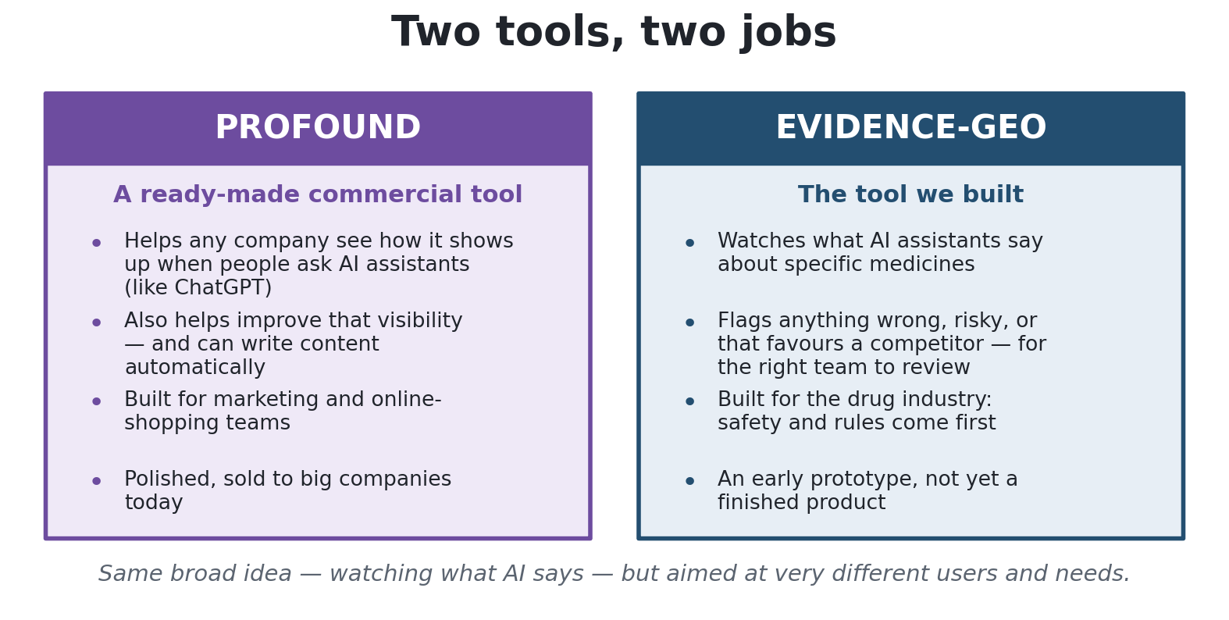
Figure 1 — The two tools do a similar thing, but for very different users.
Because they are aimed at such different users, this is not really a race. The smart move is to borrow a few of Profound's best ideas — without trying to copy the whole thing.

2. How each one works

Profound: measure, improve, act
Profound works in three stages. First it measures how a brand shows up in AI answers. Then it can create new content to improve that. Finally it turns the findings into a to-do list and even does some of the work automatically.
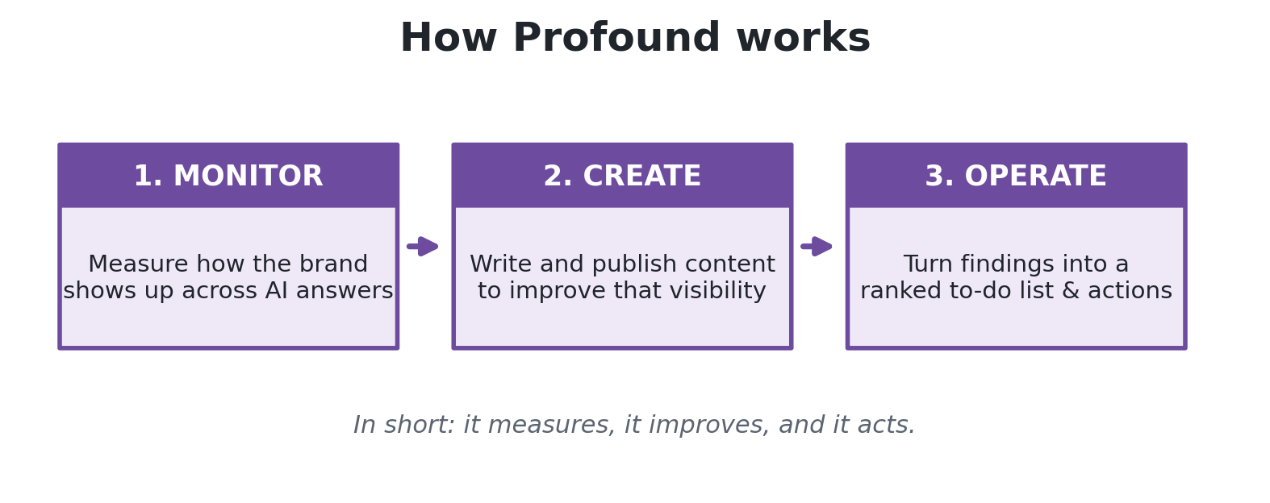
Figure 2 — Profound doesn't just report; it also helps you act.

Evidence-GEO: watch carefully, keep proof
Our tool follows six steps. It starts by collecting real questions people ask about a medicine, has the medical team approve them, then asks several AIs the same questions. It rates each answer, compares the AIs to spot disagreement or risk, and shows everything on a dashboard. Crucially, every answer is stored safely so it can be checked later — which matters a lot in a regulated industry like medicine.
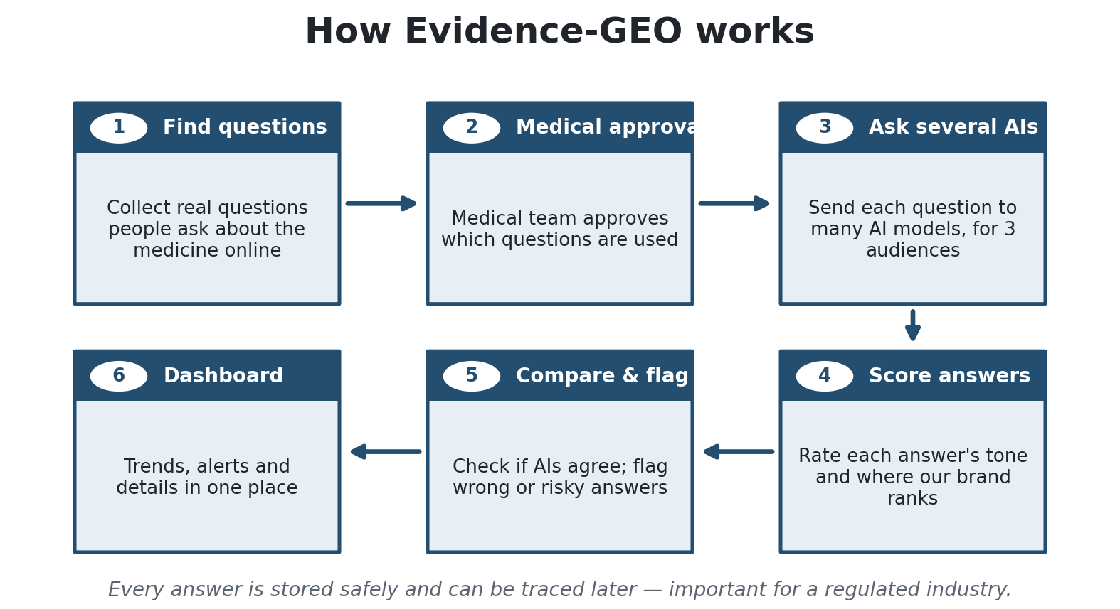
Figure 3 — Our tool is careful and keeps a full, checkable record.

3. The one difference that matters most
If you remember only one thing from this guide, make it this.
Profound checks the real AI products people actually use — the answers a person sees inside ChatGPT, Google's AI answers, Perplexity, and so on. Our tool, today, asks the AI engine directly — the model that sits behind those products. That is not quite the same as what a patient sees on screen, because the finished product adds its own steps on top.
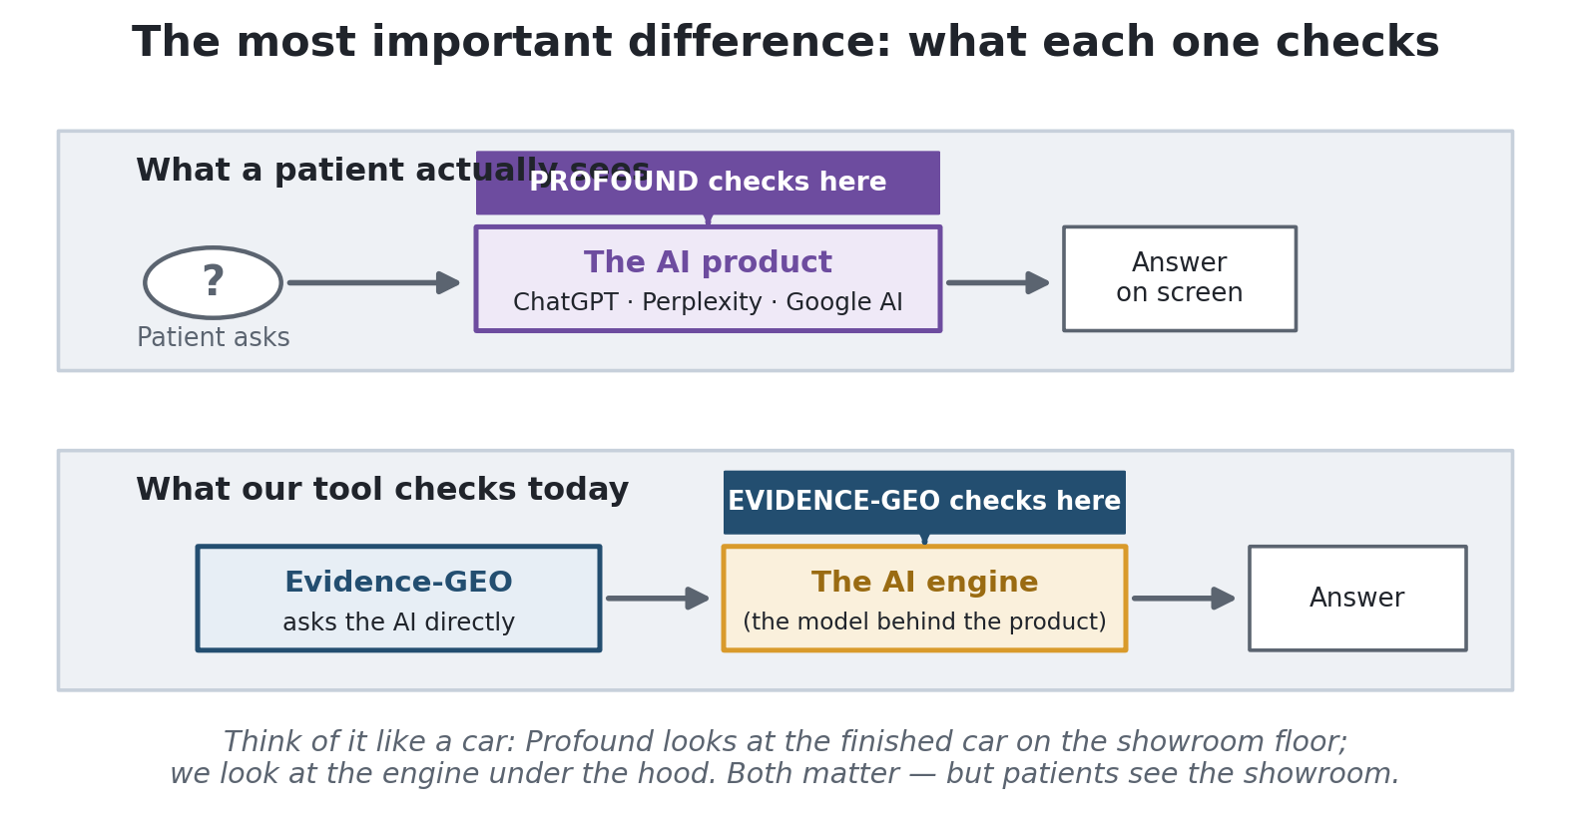
Figure 4 — Profound looks at the showroom; we look at the engine. Patients see the showroom.
This one choice explains several of the gaps later in this guide. It's the most important thing to fix, because the whole point of our tool is to measure what patients and doctors really see.

4. Who is better at what
Both tools have real strengths. Profound is broader and more polished. Our tool is more careful and better suited to medicine. Here is the balance:
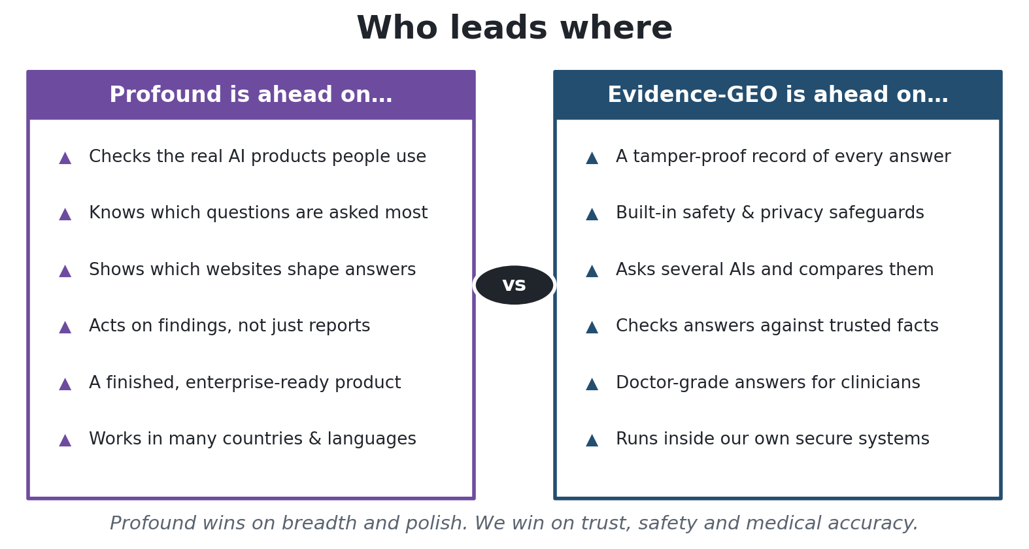
Figure 5 — Profound wins on breadth and polish; we win on trust, safety and accuracy.

Where Profound is stronger
In plain terms, Profound is ahead because it watches the real AI products people use, it knows which questions are asked most, it shows which websites shape the answers, it acts on its findings instead of only reporting them, and it is a finished product that already works in many countries and languages.

Where we are stronger
Our tool keeps a tamper-proof record of every answer — the kind of paper trail regulators expect. It has safety and privacy checks built in, it asks several AIs and compares them, and it checks answers against trusted medical facts when the AIs disagree. It can also give doctor-grade answers and run inside our own secure systems. Profound doesn't do these things — and for a drug company, they are exactly what's needed.

5. What Profound has that we don't
These are the main things Profound can do that our tool can't yet. They are written in plain terms, with a note on how much they matter to us and whether we should build them.
The gap (plain words) | Why it matters to us | How big a job | Worth doing?
Check the real AI products people use | We'd measure what patients actually see, not just the engine behind it | Big | Yes — first
Show which websites shape the answers | Tells the medical team where to publish and what to correct | Medium | Yes — first
Know which questions are asked most | Helps us focus on what people really ask, not guesswork | Medium | Yes — soon
Act on findings (a to-do list) | Turns insight into action, with people still in control | Medium | Yes — soon
Be a finished, secure product | Logins, security, reliability — needed for real company use | Big | Yes — first
Work in more languages / countries | Patients abroad use AI too; today we only see English | Medium | Later
Track AI visits to our own websites | Shows if our corrected information is being picked up | Medium | Later
Online-shopping & advertising tools | Built for shops and ads — not for medicine | N/A | No — skip
Publish content automatically | Clashes with strict medical review rules | N/A | No — skip

The short version. A few of these are genuinely important and we should build them. Several are "nice to have." And a few we should deliberately skip, because they were built for online shops and ads, or because they would clash with the strict rules around medical content.

6. What we should do about it
Not everything is worth building, and not everything is equally hard. This map sorts the ideas by how much value they add (up) against how much work they take (right). The best things to do first sit near the top.
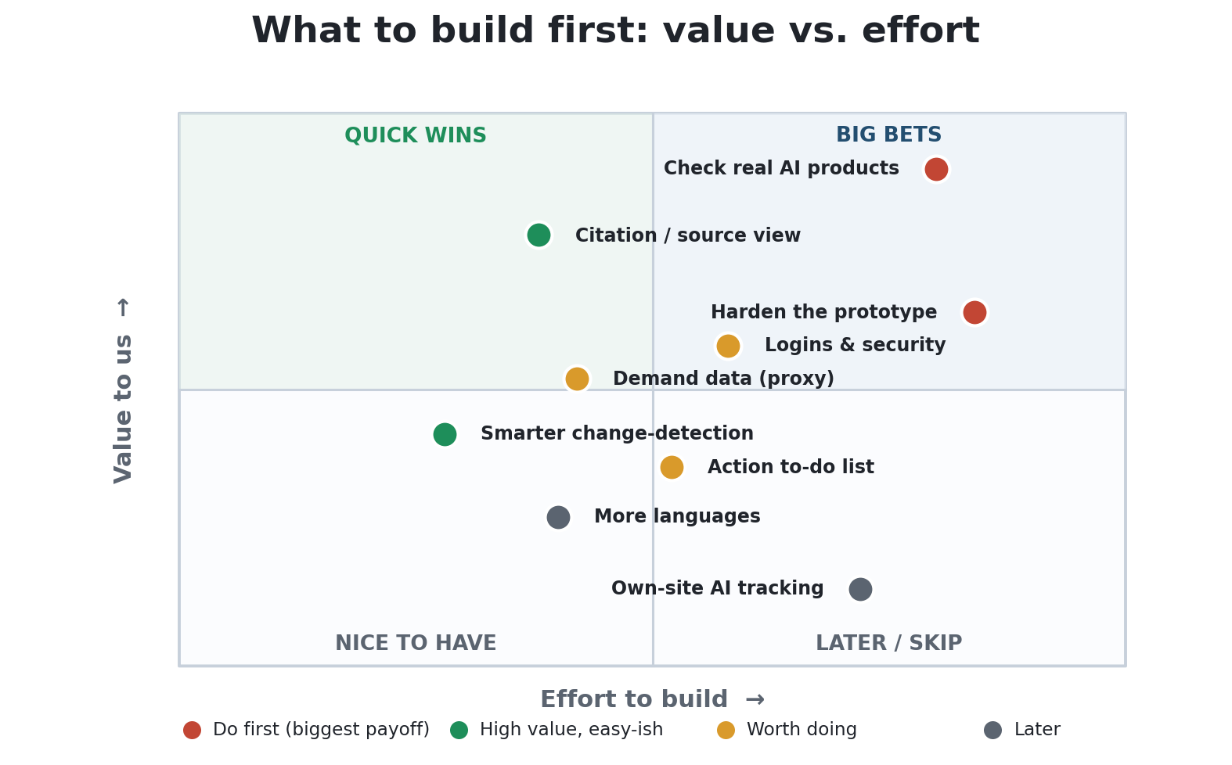
Figure 6 — Do the high-value items first. A few big jobs are still worth it.
Turning that into a simple plan: do a few high-value things now, line up the next batch, leave the rest for later, and deliberately skip what doesn't fit a medical setting.
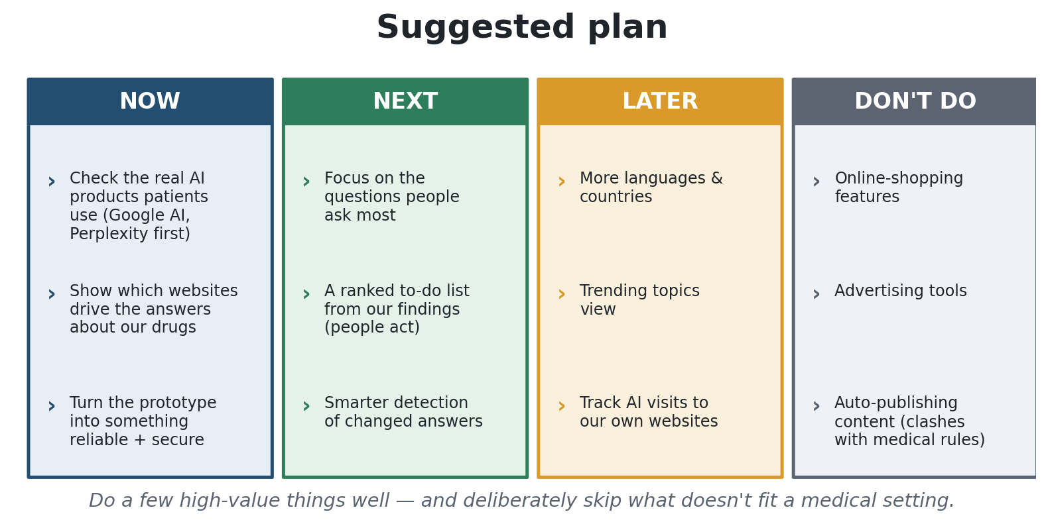
Figure 7 — A simple plan: Now, Next, Later, and Don't.
Now. Make our tool check the real AI products patients use (starting with Google's AI answers and Perplexity), show which websites drive the answers about our medicines, and turn the prototype into something reliable and secure that a real company can trust.
Next. Focus on the questions people ask most, build a ranked to-do list from our findings (with people still doing the work), and get smarter at spotting when an AI's answer has changed.
Later. Add more languages and countries, a trending-topics view, and tracking of AI visits to our own websites.
Don't. Chase online-shopping features, advertising tools, or automatic publishing. They don't fit a medical setting and would waste effort — or create risk.

7. The bottom line
We are not behind because we built the wrong thing. We built a more careful, rule-ready tool for a harder job.
Profound is broader, more polished, and already sells to big companies. But it was built for marketing and online shops — not for medicine. Our tool is narrower, but it does the things a drug company actually needs: it keeps proof, it protects safety and privacy, and it checks answers for medical accuracy.
To make our tool something a pharmaceutical company would buy, we need to close a small number of specific gaps — mainly watching the real AI products, showing which websites shape the answers, and firming up the prototype — while keeping the safety-and-trust advantages that are already our strongest selling point.
In one line: borrow Profound's best ideas where they fit, protect what makes us trustworthy, and skip what doesn't belong in medicine.

8. A quick word-list (plain meanings)
A few terms show up in this guide. Here is what they mean in everyday language.
Term | What it means
AI assistant / answer engine | A tool that answers questions in plain language — like ChatGPT, Google's AI answers, or Perplexity.
The AI "engine" (or model) | The core AI that generates text. The finished product (like ChatGPT) is built on top of it and adds extra steps.
Citation / source | The website an AI used to build its answer. Knowing these tells you what's shaping the answer.
Sentiment | Whether an answer sounds positive, neutral, or negative about a product.
Share of voice | How often your brand comes up compared with competitors.
Prototype | An early, unfinished version — proves the idea works but isn't ready for everyday company use.
Logins & permissions | Controls for who can sign in and what they're allowed to see or do.
Security certifications | Official stamps (like SOC 2 or HIPAA) that prove a product handles data safely — important in healthcare.
Regulated industry | A field with strict rules — medicine is one, so extra care and record-keeping are required.
GEO / AEO | Two names for the same idea: making sure your information shows up well in AI answers.

Internal guide — plain-language edition. A longer, detailed version is available separately. Prepared August 2026.

