ARCHITECTURE GUIDELINE
AWS Bedrock AgentCore
vs.
Snowflake Cortex Agents
A decision framework for selecting the agent platform for AbbVie Commercial AI use cases
Field | Value
Document title | Architecture Guideline: AWS Bedrock AgentCore vs. Snowflake Cortex Agents
Version | 1.0 (supersedes the Cortex Agents vs. Bedrock Agent Core working note)
Status | Draft for review
Owner | APEX Commercial AI — Architecture
Audience | Solution architects, AI engineers, data engineering leads, Enterprise Architecture, CARB reviewers, funding sponsors
Date | 31 July 2026
Facts verified as of | 31 July 2026. Vendor pricing and feature availability change frequently — re-verify before funding decisions.
Review cycle | Quarterly, or on any material platform release from AWS or Snowflake
Related material | AbbVie Semantic in a Box POV; July 2026 Cortex AI Cost Calculator; LaaS / Innovation Zone architecture documentation; CARB path-to-production standard

Contents

1. Executive Summary
AbbVie now has two credible enterprise agent platforms available: Snowflake Cortex Agents and Amazon Bedrock AgentCore. Both are generally available. Both are supported by existing AbbVie contracts. Teams are asking which one to use, and the answer has so far been decided case by case, without a shared rule. This document gives that rule.
The one-line rule
If the agent's job is to REASON over governed AbbVie data, use Cortex Agents. If the agent's job is to ACT across systems, use Bedrock AgentCore. If it must do both — which is most real Commercial use cases — use the hybrid pattern: AgentCore orchestrates, and the Cortex Agent is called as the governed data tool.

1.1 Five findings
- Neither platform is a superset of the other. Cortex Agents wins on governed data reasoning because governance is inherited, not rebuilt. AgentCore wins on orchestration, session control, and reach into non-Snowflake systems. Choosing on brand preference, or on which vendor presented most recently, produces predictable rework.
- The hybrid pattern is the expected answer, not the exception. Most AbbVie Commercial use cases have high data gravity in Snowflake and a real action surface outside it. Section 14 defines the hybrid pattern in detail and should be the default starting assumption for new builds.
- Run cost is closer than teams assume. Build cost is not. The worked example in Section 21 shows monthly run cost within roughly five percent of each other for the same workload. The material difference is engineering effort and governance debt. Cost should therefore not be the primary selection criterion.
- The semantic layer is a gating prerequisite, not an enhancement. An agent pointed at raw schemas produces syntactically valid SQL and business-wrong answers. This risk applies to BOTH platforms, and it is the single largest source of avoidable harm in this space. Section 24 makes this a hard gate in the decision tree.
- Both platforms have matured significantly since the first draft of this guidance. Cortex has added Guardrails, Agent Identity, agent evaluations, MCP connectors and agent toolsets. AgentCore has added Policy, Evaluations, Optimization and an agent registry. Guidance written before late 2025 is now materially out of date.

1.2 Summary recommendation by use case class
Use case class | Platform | Primary reason
Governed analytics and KPI question answering | Cortex Agents | Reasoning is over Snowflake data; RBAC and masking are inherited
MMx ARD generation and response curve analysis | Cortex Agents | Structured analytics against governed semantic views
Document intelligence over Snowflake stages | Cortex Agents | Cortex Search plus Analyst in one governed workflow
Field intelligence with CRM write-back | Hybrid | Reads governed data, writes to Veeva or Salesforce
Patient Journey Twin style reasoning | Hybrid | Graph and model services sit outside Snowflake
Launch readiness orchestration across functions | Hybrid | Long-running, multi-system, human approval gates
Evidence Monitoring Agent (external LLM probing) | Bedrock AgentCore | Primary work is calling external systems, not Snowflake data
Cross-system task and workflow automation | Bedrock AgentCore | Action surface dominates; little Snowflake reasoning
Bulk text classification or extraction over tables | Neither — use AISQL | No planning loop needed; an agent adds cost without value

Section 25 maps each of these to a named AbbVie use case and shows the placement visually.

2. Purpose, Scope and Audience

2.1 Purpose
This guideline exists to make the platform choice repeatable. Before this document, each team reached its own conclusion, using its own criteria, at a different point in time. That produced three problems: inconsistent architecture across the portfolio, duplicated governance work, and funding conversations that could not be compared side by side.
The document has four jobs:
- Describe both platforms accurately and at equal depth, using primary vendor sources.
- Give a decision method that a team can apply in under an hour and defend in review.
- Define the hybrid pattern precisely enough to build from, including the trust boundary.
- Set out the cost, governance and semantic-layer prerequisites that apply to both platforms.

2.2 In scope
- Snowflake Cortex Agents, including Cortex Analyst, Cortex Search, agent skills, agent toolsets and MCP connectors.
- Amazon Bedrock AgentCore, including Runtime, Gateway, Identity, Memory, Policy, Code Interpreter, Browser, Observability and Evaluations.
- Selection criteria, hybrid integration, governance comparison, cost modelling and path to production.

2.3 Out of scope
- Model selection within either platform. Model choice is a separate decision and changes faster than platform choice.
- Legacy Bedrock Agents (the pre-AgentCore InvokeAgent API). References to "Bedrock Agents" in older AbbVie material usually mean this legacy service. It has a different billing model and different capabilities. New builds should target AgentCore.
- Snowflake Intelligence as an end-user product. It is the natural language front end over Cortex Agents, not a separate platform decision.
- Non-agentic AI. If the task has no planning loop, neither platform is the right answer. See Section 12.3.
- Vendor contract commercial terms. Rates quoted here are list or AbbVie-contracted rates as at the date on the cover, and are indicative only.

2.4 Audience and how to read
Reader | Read these sections | Time
Executive sponsor, funding decision maker | 1, 8, 21, 23, 25 | 15 minutes
Solution architect selecting a platform | All of Parts A to C, then 26 | 60 minutes
AI engineer implementing a hybrid build | 5, 6, 14, 15, 16, 17 | 45 minutes
Governance, CARB or Enterprise Architecture reviewer | 17, 18, 24, 26, 27 | 30 minutes
FinOps or capacity planning | 19, 20, 21, 22, 23, Appendix B | 30 minutes

2.5 A note on sources and neutrality
The first draft of this material was assembled with input from Snowflake, and parts of it read as vendor positioning. This version rewrites that content in AbbVie's voice. Vendor claims that could not be confirmed against primary documentation have been removed or marked. Where a vendor's own product limitation is relevant to the decision, it is stated plainly, including for Snowflake.

3. How to Use This Document
The intended path through the decision is:
Step | Action | Section | Output
1 | Confirm the work actually needs an agent | 12.3 | Go / no-go
2 | Confirm a governed semantic view exists or is funded | 24 | Hard gate — stop if no
3 | Walk the decision tree | 10 | Candidate platform
4 | Score the use case on seven dimensions | 11 | Confirmed platform, with evidence
5 | If hybrid, define the trust boundary and ownership split | 14, 15 | Architecture sketch
6 | Model the cost both ways | 19 to 22 | Funding estimate
7 | Complete the checklist and take it to review | 26, 27 | CARB submission pack

Do not skip step 2
The semantic layer gate sits before the platform choice on purpose. A team that picks a platform first, then discovers there is no governed definition of the KPIs it needs, will spend the project's remaining time rebuilding definitions inside the agent. Those definitions are then invisible to every other agent, and the problem repeats.

4. Glossary
Terms are kept exactly as the vendors use them. Where AbbVie uses a different word for the same idea, both are given.
Term | Meaning
Agent | A system that plans, calls tools, evaluates the result, and repeats until it can answer. The planning loop is what separates an agent from a prompt.
Orchestration | The plan, use tools, reflect loop the agent runs. Both platforms provide this as a managed service.
Tool | Anything the agent can call: a SQL generator, a search index, a REST API, a Lambda function, a stored procedure, another agent.
Cortex Analyst | Snowflake's natural language to SQL tool. It generates SQL against a semantic view, not against raw tables.
Cortex Search | Snowflake's managed retrieval service over unstructured content, used for RAG grounding.
Semantic view | The Snowflake object that defines entities, metrics and relationships for Cortex Analyst. This is where a governed KPI definition actually lands.
Agent skills | Packaged bundles of instructions and scripts that give a Cortex Agent a repeatable, task-specific capability.
Agent toolsets | A Cortex Agent referencing another agent, inheriting its tools at run time. This enables composable multi-agent designs inside Snowflake.
MCP | Model Context Protocol. The open standard for exposing tools to agents. Both platforms speak it, which is what makes the hybrid pattern practical.
AgentCore Runtime | The serverless execution environment for agent code on AWS. Provides microVM session isolation and long sessions.
AgentCore Gateway | Turns APIs, Lambda functions and existing MCP servers into agent-callable tools behind one endpoint.
AgentCore Identity | Manages who the agent is acting as, including OAuth on behalf of a user, against Okta, Entra ID or Cognito.
AgentCore Policy | Cedar-based rules checked on every Gateway tool call, to allow or deny an action before it executes.
microVM isolation | Each session runs in its own lightweight virtual machine. This is a physical boundary, stronger than a logical one.
AI Credits | Snowflake's separate currency for AI consumption, introduced 1 April 2026, priced independently of Platform Credits.
Data gravity | How much of the reasoning depends on data that already lives in one place. High Snowflake data gravity favours Cortex.
Action surface | The set of systems the agent must write to or trigger. A wide action surface favours AgentCore.
Semantic in a Box | AbbVie's internal point of view on governed definitions, covering Alation, CENtree / SciBite TERMite, the knowledge bank, and semantic APIs.
CARB | AbbVie's architecture review and path-to-production governance forum.

PART A
The Platforms
Sections 5 to 7 describe each platform at equal depth, then place them side by side. The aim is a shared factual base before any judgement is applied.

5. Snowflake Cortex Agents

5.1 What it is
Cortex Agents is a fully managed agentic platform that runs inside Snowflake's governed environment. An agent reasons over a request, plans the work, calls tools, can execute code, and produces a response. Snowflake operates the orchestration loop, the runtime and the sandbox. The team does not build or run any of that.
The defining characteristic is where the agent sits. It runs inside the same security perimeter as the data. Access is governed by Snowflake privileges and by the execution context of each configured tool. There is no new access layer to design, review and maintain.
Cortex Agents reached general availability on 4 November 2025.

5.2 The agent object and the reasoning loop
An agent is a schema-level object. It bundles the model, the tools, the orchestration instructions, and the natural-language guidance that shapes its behaviour. Because it is a database object, it is created once and reused across applications, and it is versioned and permissioned like any other Snowflake object.
To answer a request the agent runs a three-step loop, repeating as needed within a single request:
- Plan. The agent parses the request and decides how to answer. It can disambiguate a vague question, split a complex request into subtasks, and choose which tool serves each part.
- Use tools. The agent calls the tools it selected — Cortex Analyst for structured data, Cortex Search for unstructured data, code execution to process results, and so on.
- Reflect and respond. The agent evaluates each tool result and decides what to do next: ask a clarifying question, call another tool, or generate the final answer.
Threads persist conversation context across turns, so the client application does not manage state. This removes a meaningful amount of application code compared with a self-built agent.
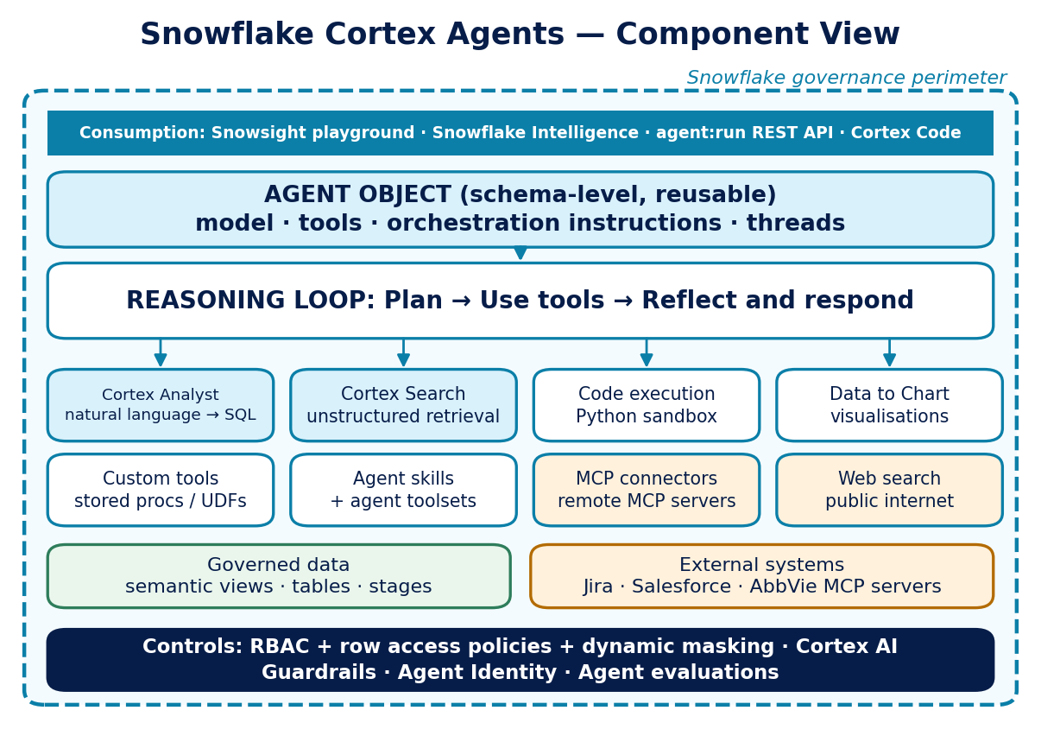
Figure 1. Snowflake Cortex Agents component view. Everything inside the dashed line inherits Snowflake governance.

5.3 Tools available to a Cortex Agent
Tool | What it does | Notes for AbbVie
Cortex Analyst | Generates SQL over structured data from natural language, using a semantic view | Quality depends entirely on the semantic view. See Section 24.
Cortex Search | Retrieves from unstructured data; the agent can adjust filters, retrieved columns, result counts and time-decay per query | Suits promotional material, medical documents, call notes held in Snowflake
Code execution | Runs Python in a secure isolated sandbox to process data and perform calculations | Useful for statistical work the SQL layer cannot express
Data to Chart | Generates visualisations from data returned by other tools | Reduces the need for a custom charting layer in the front end
Custom tools | Stored procedures and UDFs implementing business logic or calling backend systems | The route to limited external calls without leaving Snowflake
Agent skills | Packaged bundles of instructions and scripts for repeatable task-specific capability | A good home for approved reasoning patterns from the knowledge bank
Agent toolsets | Reference another agent and inherit its tools at run time | Enables composable multi-agent design within Snowflake
MCP connectors | Call tools on remote MCP servers such as Atlassian Jira, Salesforce, or AbbVie's own | Narrows, but does not close, the gap with AgentCore on action
Web search | Real-time public internet information; must be enabled at account level | Requires review before enabling for regulated content

5.4 Governance and safety controls
Cortex has closed most of the enterprise-readiness gap that existed in early 2025:
- Access control. Calling an agent requires the SNOWFLAKE.CORTEX_USER or SNOWFLAKE.CORTEX_AGENT_USER database role, privileges on the agent object, and privileges on every object the agent's tools touch. Session permissions come from the querying user's default role.
- Cortex AI Guardrails. Run-time protection against prompt injection and jailbreak attacks, generally available for Cortex Agents and Snowflake Intelligence since May 2026. Part of the Horizon Catalog.
- Agent Identity. Gives security teams visibility into agent activity, and allows data access policies that apply specifically when an agent is in the session — including when the agent runs on behalf of a privileged user.
- Agent evaluations. Generally available since March 2026. Provides answer correctness against a prepared dataset, reference-free logical consistency across instructions, planning and tool calls, and custom LLM-judged metrics.
- Cortex AI Gateway. Announced at Black Hat 2026, adding MCP governance and data exfiltration prevention at the control plane.

5.5 Known limits
- Cortex Agents APIs are not supported from a Streamlit in Snowflake application using a warehouse runtime. A container runtime is required.
- Reasoning is anchored to Snowflake. Querying external databases directly is not supported; external reach is via MCP connectors or custom tools, and both are narrower than a general orchestration layer.
- Model and feature availability vary by region and georegion. This matters for AbbVie's non-US deployments and must be checked per region.
- Snowflake states explicitly that the accuracy of LLM responses and citations is not guaranteed, and that answers should be reviewed before being served to users. For regulated content this means a human approval gate is mandatory, not optional.
- Complex multi-step reasoning and long-horizon sessions are weaker than a purpose-built orchestration runtime. Session length is not controlled by the team.

6. Amazon Bedrock AgentCore

6.1 What it is
Amazon Bedrock AgentCore is a fully managed service for deploying and operating agents at scale, using any framework and any model. It is not a single service. It is a set of composable services that can be used independently or together, and each is billed separately.
The defining characteristic is that AbbVie writes the agent. AgentCore provides production infrastructure around it: a runtime, a tool surface, identity, memory, policy enforcement, observability and evaluation. This is more control and more responsibility than Cortex offers.
AgentCore reached general availability in October 2025.

6.2 The services
Service | What it does | Why it matters here
Runtime | Serverless environment with microVM session isolation, supporting any framework; sessions up to eight hours; A2A protocol support | The strongest isolation boundary of the two platforms, and the only one that supports genuinely long-running work
Gateway | Turns APIs, Lambda functions and existing MCP servers into agent-callable tools behind one secure endpoint; semantic search over tools | This is how a Snowflake Cortex Agent becomes one tool among many in a hybrid design
Identity | Agent identity and delegated access; inbound and outbound auth; OAuth 2LO and 3LO; works with Okta, Entra ID, Cognito | Carries the end user's identity through to the downstream system, which is what makes the audit chain hold
Memory | Short-term events within a session and long-term records across sessions, with built-in or self-managed extraction strategies | Removes the need to build a memory store, but adds a data classification question for patient-adjacent content
Policy | Cedar-based rules checked on every Gateway tool call, allowing or denying the action before it executes; natural language policy authoring | The mechanism for enforcing "this agent may read but never write" at the platform level
Code Interpreter | Sandboxed code execution in Python, JavaScript and TypeScript | Equivalent in intent to the Cortex code execution tool
Browser | Managed headless browser runtime for agents that must interact with websites | No Cortex equivalent; relevant to external monitoring use cases
Observability | OpenTelemetry traces, metrics and logs into CloudWatch, with step-by-step visualisation of agent execution | Traces are OTel-native, so they can feed existing AbbVie tooling such as Arize Phoenix
Evaluations | Thirteen built-in evaluators plus custom evaluators; CI/CD integration with quality thresholds; production sampling | Enables quality gates in the deployment pipeline, which CARB review will expect
Optimization | Insights, prompt and tool-description recommendations, and A/B testing on live traffic | Preview and post-GA; useful but should not be assumed in a funding case yet
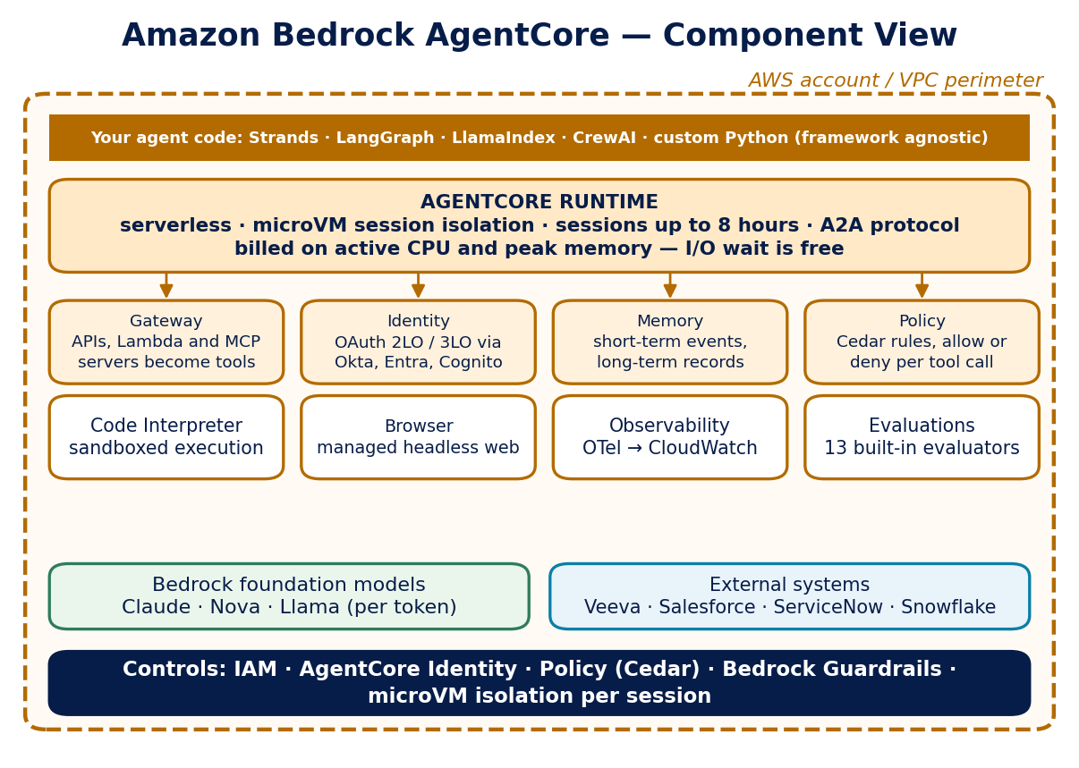
Figure 2. Amazon Bedrock AgentCore component view. AbbVie owns the agent code; AWS provides the production infrastructure around it.

6.3 Framework freedom
AgentCore is framework agnostic. Strands, LangGraph, LlamaIndex, CrewAI and plain Python agents all run on it. For APEX this is significant: existing AbbVie work built on LangGraph — including the Field Intelligence Coach Agent and the Evidence Monitoring Agent — can be deployed onto AgentCore Runtime without being rewritten into another framework's idioms.
Cortex offers no equivalent. A Cortex Agent is configured, not coded. That is a strength when the requirement fits, and a hard ceiling when it does not.

6.4 Known limits
- Governance is not inherited. Every data access rule that Snowflake would have applied automatically must be designed, implemented and reviewed. This is the single largest hidden cost in an AgentCore-only design over Snowflake data.
- Billing is fragmented across many independently metered components. Forecasting requires modelling each meter. See Section 20.
- Observability costs route through CloudWatch and are not included in AgentCore rates.
- Several capabilities — Optimization Insights, the AWS Agent Registry and Payments — are in preview. Preview features should not carry a production dependency in a CARB submission.
- Operational burden is real. Containers, deployment pipelines, IAM roles, secrets and network paths are AbbVie's responsibility.

7. Capability Comparison Matrix
The table below compares the two platforms across the dimensions that change an architecture decision. Where one platform is clearly stronger, that is stated. Where they are equivalent, that is stated too — several rows that were differentiators a year ago no longer are.

7.1 Core platform
Dimension | Cortex Agents | Bedrock AgentCore
Delivery model | Configured. The agent is a database object. | Coded. AbbVie writes the agent; AWS runs it.
Managed orchestration loop | Yes — plan, use tools, reflect | Optional. Bring your own, or use Strands
Framework choice | None. Snowflake's loop only | Any — LangGraph, Strands, LlamaIndex, CrewAI, custom
Model choice | Claude, GPT, Grok, Gemini families; auto-select available | Any Bedrock model; auto-select not applicable
Session length | Not team-controlled; suited to interactive turns | Up to eight hours; asynchronous sessions supported
Session isolation | Logical — role and warehouse boundary | Physical — microVM per session
State across turns | Threads, managed by Snowflake | AgentCore Memory, short-term and long-term
Multi-agent composition | Agent toolsets — inherit another agent's tools | A2A protocol; any supervisor pattern the framework supports
Front end included | Yes — Snowsight playground and Snowflake Intelligence | No. AbbVie builds the interface

7.2 Data and tools
Dimension | Cortex Agents | Bedrock AgentCore
Natural language to SQL | Cortex Analyst, native, over semantic views | Build it — no managed equivalent
Retrieval over unstructured data | Cortex Search, managed and governed | Bedrock Knowledge Bases, or a self-managed vector store
Reasoning over structured plus unstructured together | Native strength | Achievable, but assembled by the team
Reach into external systems | MCP connectors and custom tools (SP / UDF) | Gateway over any API, Lambda or MCP server — much wider
Write-back to CRM or operational systems | Possible via custom tools; not the design centre | Design centre. Policy gates each write
Web browsing | Web search tool (account-level enable) | Web Search plus a full managed headless Browser
Code execution | Python sandbox | Code Interpreter — Python, JavaScript, TypeScript
Tool discovery at scale | Tools declared on the agent object | Gateway semantic search over indexed tools; Agent Registry (preview)

7.3 Governance, security and operations
Dimension | Cortex Agents | Bedrock AgentCore
Row and column level data control | Inherited — RBAC, row access policies, masking | Must be built and maintained by AbbVie
Identity carried to the data | Snowflake role of the calling user | AgentCore Identity, OAuth 3LO on behalf of user
Prompt injection defence | Cortex AI Guardrails (GA, May 2026) | Bedrock Guardrails, configured per agent
Action-level authorisation | Tool allow-list on the agent object | AgentCore Policy — Cedar rules per tool call
Audit evidence | Query history, access history, thread logs | OTel traces in CloudWatch
Built-in evaluation | Agent evaluations (GA, March 2026) | Evaluations — 13 built-in evaluators, CI/CD gates
Data residency control | Cross-region inference setting per account | Region selection per AWS deployment
Operational burden on AbbVie | Low | Moderate to high
Time to first governed POC | Days to weeks | Weeks to months
Reading the matrix honestly
The rows do not carry equal weight, and no team should count them. Two rows decide most cases: "row and column level data control" and "reach into external systems". If both matter, the answer is the hybrid pattern rather than a compromise on either.

PART B
Making the Decision
Sections 8 to 13 turn the comparison into a method: one core question, seven dimensions, a decision tree, and a scorecard that produces a defensible answer.

8. The Core Question
Most platform debates start from the wrong question. "Which platform is more capable?" has no useful answer, because capability is not the constraint. Both platforms can technically do most things. The constraint is where the work naturally belongs.
Ask this instead
Where does the reasoning live, and where does the data gravity sit?
If the reasoning is mostly about AbbVie data that already lives in Snowflake, moving that reasoning out of Snowflake means rebuilding governance somewhere else. If the reasoning is mostly about coordinating systems, forcing it into Snowflake means bending a data platform into an integration platform.

8.1 Two forces
Data gravity is how much of the answer depends on data that already sits in one governed place. High data gravity pulls the agent toward Cortex, because that is where the KPI definitions, the row access policies and the masking rules already are. Every step the reasoning takes away from that location is a step where governance must be recreated.
Action surface is the set of systems the agent must write to, trigger or coordinate. A wide action surface pulls the agent toward AgentCore, because that is where the tool integration, the delegated identity and the per-action policy enforcement already are.
These forces are independent. A use case can be high on both. That is not a conflict to resolve by picking a winner — it is the signal for the hybrid pattern.

8.2 The failure modes at each extreme
Wrong choice | What actually happens
AgentCore over Snowflake data, without Cortex | The team rebuilds text-to-SQL, retrieval and access control. KPI definitions get re-invented inside prompts. Row-level security becomes application logic. Six months later nobody can prove which rows a given answer was allowed to see.
Cortex for a workflow that is mostly action | The team writes progressively larger stored procedures to reach external systems. Retry logic, long-running work and human approval steps get pushed into SQL. The data platform becomes an integration platform, badly.
Either platform with no semantic layer | The SQL is valid. The business answer is wrong. This failure is silent, confident and repeatable. See Section 24.
An agent where no agent was needed | Cost and latency rise, quality does not. A scheduled AISQL job or a single model call would have been better. See Section 12.3.

9. The Seven Decision Dimensions
The core question is usually enough. When it is not — because the use case genuinely straddles both — score it against these seven dimensions. Each has a clear signal in one direction.

9.1 The dimensions
# | Dimension | Pulls toward Cortex when... | Pulls toward AgentCore when...
1 | Data gravity | Most of the answer comes from Snowflake tables and stages | Most of the answer comes from systems outside Snowflake
2 | Action surface | The agent reads and reports; writes are rare and simple | The agent must write to CRM, ticketing, email or workflow systems
3 | Governance model | Existing Snowflake roles and policies are the control that matters | Control must span systems, or needs per-action allow / deny rules
4 | Session profile | Interactive question and answer; seconds to a few minutes | Long-running, asynchronous, or human approval in the middle
5 | Framework need | The managed loop is sufficient; no custom control flow | Custom control flow, existing LangGraph code, or specific agent patterns
6 | Isolation requirement | Logical role separation is acceptable | Per-user physical isolation is required by the risk assessment
7 | Team capability | Team is SQL and analytics strong; limited platform engineering capacity | Team has Python, container and AWS operational depth

9.2 How to use the dimensions
Score each dimension from minus three to plus three. Negative scores point to Cortex, positive to AgentCore, zero is neutral. Then apply the weights in Section 11. Dimensions 1, 2 and 3 carry the most weight, because they are the hardest to change later. Dimension 7 carries the least, because capability can be built or borrowed.
A caution on dimension 7
Team capability is a real constraint and should be scored honestly. But it should never be the deciding dimension on its own. Choosing the wrong platform because it is the one the team already knows creates an architecture that is expensive to unwind. If capability is the only thing pointing one way, the right answer is usually to keep the architecture and close the skills gap.

10. The Decision Tree
The tree below resolves the majority of cases in four questions. Question 3 is a gate, not a preference — if it fails, no platform choice is safe until it is fixed.
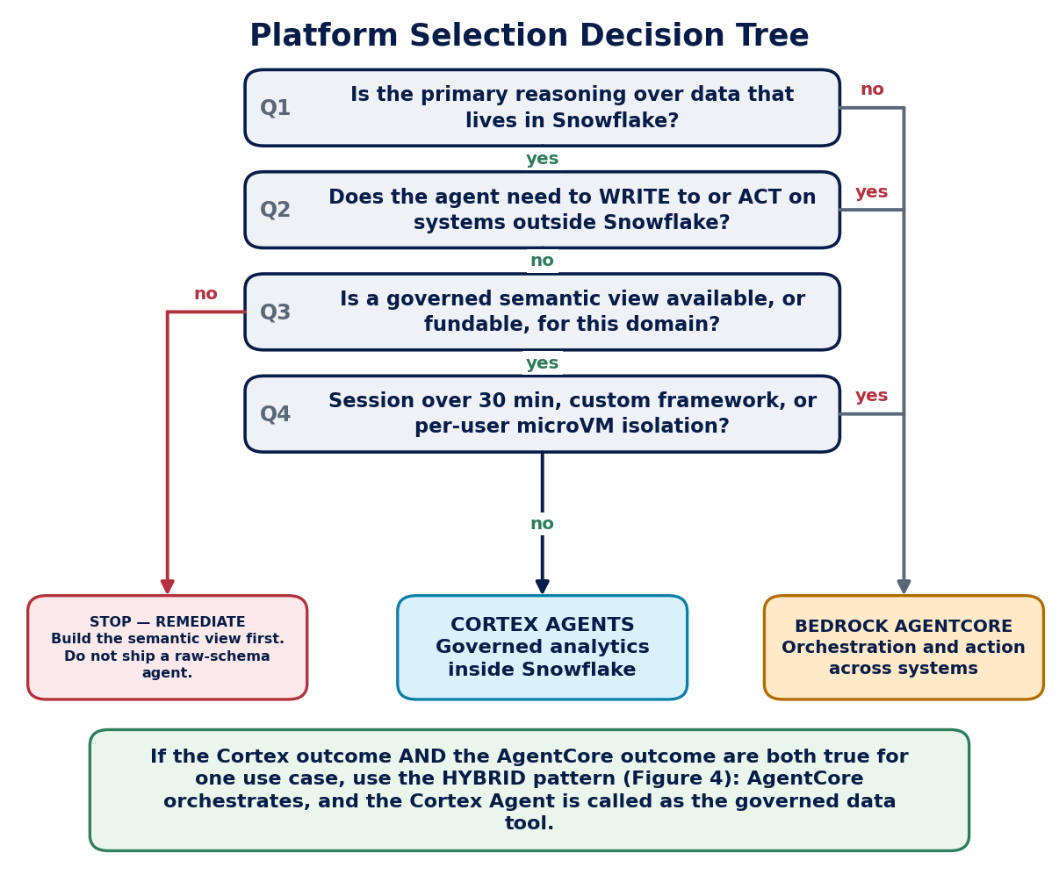
Figure 3. Platform selection decision tree. The semantic layer question is a hard gate.

10.1 The questions explained

Q1 — Is the primary reasoning over data that lives in Snowflake?
"Primary" means more than half of the reasoning steps, not more than half of the data volume. An agent that reads one Snowflake table and then does ten things elsewhere is not a Snowflake-primary agent.

Q2 — Does the agent need to write to or act on systems outside Snowflake?
Reading from an external system is not the same as acting on it. Reading can often be handled by an MCP connector inside Cortex. Writing carries transactional, authorisation and audit weight, and that is where AgentCore's Policy and Identity services earn their place.

Q3 — Is a governed semantic view available, or fundable in this project?
If neither is true, the correct outcome is to stop and remediate. Shipping an agent over raw schemas is not a smaller version of the right answer; it is a different and worse outcome. Section 24 sets out why.

Q4 — Does it need long sessions, a custom framework, or per-user microVM isolation?
Any single yes here moves the workload to AgentCore, even when data gravity is high. In that situation the hybrid pattern applies: AgentCore provides the session and isolation properties, and the Cortex Agent still provides the governed data reasoning.

10.2 When the tree gives an uncomfortable answer
If the tree points somewhere the team did not expect, the usual cause is that the use case is really two use cases. Split it. A common example: a launch tracking agent that answers performance questions AND creates follow-up tasks is one Cortex Agent for the analytics and one AgentCore workflow for the tasks, joined by the hybrid pattern — not one agent forced onto one platform.

11. The Weighted Scorecard
Use the scorecard when the decision will be challenged, when funding depends on it, or when the tree result and the team's instinct disagree. It takes about thirty minutes and produces evidence that survives review.

11.1 Method
- Score each dimension from -3 to +3. Negative points to Cortex. Positive points to AgentCore.
- Multiply each score by its weight.
- Sum the weighted scores.
- Read the result against the bands in Section 11.3.
- Write one sentence of evidence for every score of +2, +3, -2 or -3. Unevidenced extreme scores are the main way this instrument gets gamed.

11.2 The scoring sheet
Dimension | Weight | Score (-3 to +3) | Weighted | Evidence required?
1. Data gravity | 5 |  |  | Yes if |score| >= 2
2. Action surface | 5 |  |  | Yes if |score| >= 2
3. Governance model | 4 |  |  | Yes if |score| >= 2
4. Session profile | 3 |  |  | Yes if |score| >= 2
5. Framework need | 3 |  |  | Yes if |score| >= 2
6. Isolation requirement | 2 |  |  | Always — cite the risk assessment
7. Team capability | 1 |  |  | No
TOTAL | 23 max

11.3 Reading the result
Weighted total | Outcome | What to do next
-69 to -25 | Cortex Agents | Proceed on Cortex. Document the external reach plan in case it grows.
-24 to -10 | Cortex, hybrid-ready | Build on Cortex, but expose it through an MCP-callable interface from day one.
-9 to +9 | Hybrid | Go to Section 14. Do not force a single platform.
+10 to +24 | AgentCore, Cortex-backed | Build on AgentCore, but call Cortex for governed data rather than querying Snowflake directly.
+25 to +69 | Bedrock AgentCore | Proceed on AgentCore. Confirm no governed data reasoning has been missed.

11.4 Worked example — Field Intelligence Coach Agent
Dimension | Weight | Score | Weighted | Reasoning
Data gravity | 5 | -2 | -10 | Performance, call and target data are governed in Snowflake
Action surface | 5 | +3 | +15 | Must create coaching plans and write follow-ups to CRM
Governance model | 4 | +1 | +4 | Needs per-action rules across two systems, not just data access
Session profile | 3 | +2 | +6 | Coaching sessions span a manager's working day, with pauses
Framework need | 3 | +3 | +9 | Existing implementation is LangGraph with six capabilities
Isolation requirement | 2 | +1 | +2 | Manager-level data separation; not patient-level
Team capability | 1 | +2 | +2 | Team has FastAPI, Python and Bedrock experience
TOTAL |  |  | +28 | AgentCore, with Cortex called for governed performance data

Note that data gravity still scored negative. That is exactly why the outcome is AgentCore calling Cortex, not AgentCore querying Snowflake tables directly.

12. When to Use Cortex Agents

12.1 Positive signals
Choose Cortex Agents when several of the following are true:
- The reasoning is data-centric and governed by Snowflake. Text-to-SQL through Cortex Analyst, structured analytics, MMx ARD generation, KPI question answering.
- The question spans structured tables and unstructured stage documents. This combination is Cortex's clearest single advantage. Doing it well on AgentCore means building and governing two retrieval paths.
- Governance should be inherited, not designed. Existing Snowflake roles and privileges are the control that matters, and no new access layer is wanted.
- Infrastructure management should be minimal. Snowflake handles orchestration, runtime and sandboxing. There is no container, no deployment pipeline and no IAM design work.
- Time to a governed POC matters more than architectural flexibility. Days to weeks, not weeks to months.
- The consumption surface is already Snowflake. Users work in Snowsight or Snowflake Intelligence, so no separate front end is needed.
- External reach is limited and read-shaped. MCP connectors to Jira, Salesforce or an AbbVie MCP server are enough, and the agent does not need to own a transactional write.

12.2 Anti-signals — do not choose Cortex when
- The agent must own writes to systems of record. Stored procedures reaching outward is a workaround, not an architecture.
- Sessions must run for hours, or must pause for human approval and resume later.
- An existing LangGraph or custom agent implementation would have to be rewritten as configuration and would lose behaviour in the process.
- The risk assessment requires per-user physical isolation.
- Most of the reasoning is over systems Snowflake does not hold.
- The use case needs a managed headless browser.

12.3 Before choosing either platform — does this need an agent at all?
A meaningful share of requests that arrive as "we need an agent" do not need a planning loop. An agent is worth its cost and latency only when the path to the answer is not known in advance. If the steps are fixed, a simpler tool is better, cheaper and easier to validate.
If the work is... | Use this instead | Why
Classifying or extracting over many rows, same operation each time | AISQL functions (AI_COMPLETE, AI_CLASSIFY, AI_SENTIMENT) | No planning needed. Runs in the data path at a fraction of the cost
One fixed question against one known dataset | A parameterised query plus a single model call | The planning loop adds latency and cost, and adds a failure mode
A fixed multi-step pipeline with no branching | A scheduled task or DAG | Deterministic, testable, auditable
Document parsing at volume | AI_PARSE_DOCUMENT | Purpose-built and priced per page
A genuinely open-ended question needing tool selection | An agent — continue with this document | This is the case agents are for

13. When to Use Bedrock AgentCore

13.1 Positive signals
Choose Bedrock AgentCore when several of the following are true:
- The agent orchestrates across external systems, APIs or automation layers. The work is coordination, and Snowflake is one participant among several rather than the centre.
- Workflows are long-running or asynchronous. Runtime supports sessions up to eight hours, which covers work that pauses for a human, waits on a batch job, or spans a working day.
- The risk assessment requires per-user session isolation. microVM isolation per session is a physical boundary and is the stronger of the two available options.
- Framework freedom is required. LangGraph, Strands, LlamaIndex, CrewAI or custom Python. Existing AbbVie agent code runs without rewriting.
- The agent must coordinate cross-system workflows. Triggering CRM updates, calling external APIs, performing CDL writes, driving a ticketing system.
- Per-action authorisation is required. AgentCore Policy checks each Gateway tool call against Cedar rules before it executes — a control Cortex does not offer at that granularity.
- Multi-agent supervision is central to the design. A2A protocol support and any supervisor pattern the chosen framework provides.

13.2 Anti-signals — do not choose AgentCore when
- The reasoning is overwhelmingly over governed Snowflake data and the plan is to query tables directly. This recreates governance that already exists, and does so less completely.
- The team has no capacity for containers, IAM, deployment pipelines and CloudWatch operations, and no plan to acquire it.
- The requirement is a fast governed POC and infrastructure work would consume the timeline.
- The design depends on a preview capability such as Optimization Insights, the Agent Registry or Payments.
- The use case is really a scheduled data transformation with a language model in it.

13.3 A specific warning on re-implementing Cortex Analyst
The most expensive mistake in this space
Building text-to-SQL on AgentCore over AbbVie Snowflake data is technically straightforward and strategically costly. The SQL generation is the easy part. The hard parts are the governed KPI definitions, the row access policies, the masking rules and the audit lineage — all of which already exist on the Snowflake side and none of which transfer.
If an AgentCore agent needs governed AbbVie numbers, it should call a Cortex Agent as a tool. That is the hybrid pattern, and it is the reason Section 14 exists.

PART C
The Hybrid Pattern
Sections 14 to 16 define the pattern that most AbbVie Commercial use cases should adopt, including the trust boundary, the ownership split, and the mistakes that undo it.

14. The Hybrid Pattern

14.1 The idea in one sentence
Hybrid pattern
AgentCore orchestrates and acts. The Cortex Agent is registered as one tool among many, and it remains the only path to governed AbbVie data. Neither side re-implements the other.
This is not a compromise between two platforms. It is a separation of concerns that matches how AbbVie's estate is actually built. The governed definitions of net revenue, iROI, UPT and NBRx live in Snowflake. The systems that need to be updated — Veeva, Salesforce, ticketing, workflow — live elsewhere. Forcing either side to host the other's job produces the failure modes in Section 8.2.
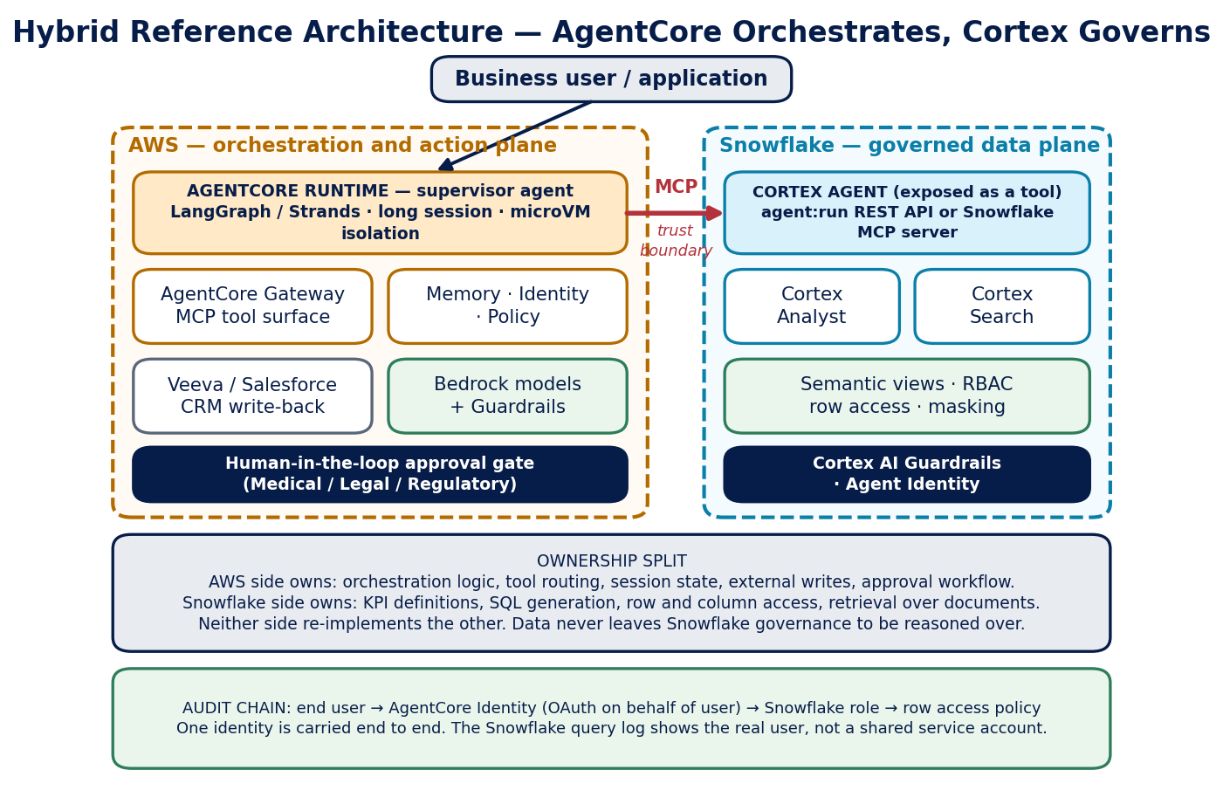
Figure 4. Hybrid reference architecture. The MCP call is the trust boundary; the user identity is carried across it.

14.2 Ownership split
Concern | Owned by AgentCore side | Owned by Cortex side
Planning and task decomposition | Yes | Sub-planning within a data question only
Tool routing across systems | Yes | No
Session state and long-running work | Yes | Thread state within a single data conversation
Writes to systems of record | Yes | No
Human approval workflow | Yes | No
KPI and metric definitions | No | Yes
SQL generation over AbbVie data | No | Yes
Row and column level access control | No | Yes
Retrieval over governed documents | No | Yes
Data lineage and query audit | Trace of the call | Yes — the authoritative record

14.3 Why the identity chain is the whole point
The pattern only delivers governance if the end user's identity reaches Snowflake. If the AgentCore side authenticates to Snowflake with a shared service account, every row access policy collapses to whatever that account can see, and the Snowflake query log records the service account rather than the person. The audit trail becomes useless at exactly the moment it is needed.
The correct chain is:
- The user authenticates to the application through the AbbVie identity provider.
- AgentCore Identity performs OAuth on behalf of that user (3LO), not client credentials (2LO).
- The Cortex Agent call carries that user's token.
- Snowflake resolves the user's role, and row access policies and masking apply to that role.
- The Snowflake query history and access history record the real user.
Design review question
For any hybrid design, ask one question first: if a Medical Affairs reviewer asks which rows a specific answer was permitted to touch, and for which named user, can we answer from the logs? If the answer depends on a shared service account, the design is not ready.

14.4 Where the Cortex Agent is exposed from
Option | How it works | When to choose it
Snowflake MCP server | The Cortex Agent is exposed as an MCP tool; AgentCore Gateway connects to it as an existing MCP server | Default choice. Least custom code, and Gateway handles auth and tool discovery
agent:run REST API | The AgentCore agent calls the Cortex Agents REST endpoint directly, managing threads itself | When fine control over thread lifecycle or streaming events is needed
Lambda wrapper behind Gateway | A Lambda function calls Cortex and normalises the response, exposed as a Gateway target | When response shaping, caching or additional policy logic is required

15. Integration Mechanics

15.1 Sequence for a typical hybrid request
Step | Where | What happens | Control applied
1 | Application | User asks a question that needs data and an action | Application-level authentication
2 | AgentCore Runtime | Supervisor agent plans and decomposes the request | microVM session isolation begins
3 | AgentCore Policy | Planned tool calls are checked against Cedar rules | Allow or deny before execution
4 | AgentCore Gateway | Cortex Agent tool is invoked over MCP | AgentCore Identity issues an on-behalf-of token
5 | Cortex Agent | Plans, calls Analyst and Search, reflects | Cortex AI Guardrails; agent tool allow-list
6 | Snowflake data | SQL executes and documents are retrieved | RBAC, row access policy, masking
7 | Cortex Agent | Returns a grounded answer with citations | Access history records the real user
8 | AgentCore Runtime | Supervisor reflects and decides on the action | Bedrock Guardrails on generated content
9 | Human gate | Regulated output is routed for approval | Medical, Legal, Regulatory sign-off
10 | AgentCore Gateway | Approved write is executed against the CRM | Policy re-check; OTel trace written

15.2 What has to be built
Component | Effort | Notes
Semantic view for the domain | High, and shared | Reused by every future agent. Should be funded as platform work, not project work
Cortex Agent definition and tools | Low | Configuration, plus instruction tuning
MCP exposure of the Cortex Agent | Low | Snowflake MCP server, or a thin Lambda wrapper
Supervisor agent on AgentCore | Medium | Existing LangGraph code can usually be lifted onto Runtime
Gateway targets for external systems | Medium | One target per system; auth configured per target
Cedar policy set | Medium | The place to encode "read always, write only after approval"
Identity federation and on-behalf-of flow | Medium, one time | Reusable across agents once established
Human approval workflow | Medium | Often the longest lead-time item because it needs business process agreement
Evaluation harness | Medium | Cortex agent evaluations for the data side, AgentCore Evaluations for the orchestration side

15.3 Evaluating a hybrid system
Hybrid systems fail in a specific way: each half passes its own tests and the whole still gives a wrong answer. Evaluate at three levels.
- Data layer. Use Cortex agent evaluations. Answer correctness against a prepared question set, and reference-free logical consistency across instructions, planning and tool calls. This catches semantic drift.
- Orchestration layer. Use AgentCore Evaluations with built-in evaluators for goal success and trajectory quality. This catches wrong tool selection and bad decomposition.
- End to end. A held-out set of real business questions with known correct answers and known correct actions, run through the whole chain. This is the only level that catches the interaction failures, and it is the one teams most often skip.

16. Anti-Patterns
These are the recurring mistakes. Each has been observed in practice, either at AbbVie or in comparable pharma implementations.
Anti-pattern | Why it fails | Do this instead
Shared service account to Snowflake | Row access policies collapse; audit trail names a robot, not a person | OAuth 3LO on behalf of the user; verify in access history
Text-to-SQL rebuilt on AgentCore | KPI definitions are re-invented in prompts and become invisible to governance | Call the Cortex Agent as a tool
Cortex custom tools used as an integration layer | Stored procedures accumulate retry, auth and workflow logic they were never meant to hold | Move orchestration to AgentCore; keep Cortex for data
Agent chosen where AISQL would do | Cost and latency rise, quality does not, and a planning loop adds a failure mode | Apply the test in Section 12.3
Semantic layer deferred to phase two | Phase one ships confident wrong answers and sets the expectation that they are correct | Treat the semantic view as a gate, not a backlog item
Both platforms holding the same definition | The two definitions drift, and nobody notices until two reports disagree | One definition, in the semantic view, referenced by both
Evaluating each half separately only | Both halves pass; the system still gives wrong answers | Add end-to-end evaluation on real business questions
Preview features in the funding case | Scope and pricing change before GA | Depend only on GA capabilities; note previews as upside
Platform chosen by team familiarity | The architecture becomes expensive to unwind, for a reason that expires in a quarter | Score dimension 7 honestly, weight it at 1, and close the skills gap
Human approval bolted on at the end | The business process is not agreed, and go-live slips | Design the approval gate in the first architecture sketch

PART D
Governance and Cost
Sections 17 to 23 cover the two areas that decide whether a design survives review and survives its second year.

17. Governance Comparison
Both platforms are now enterprise-credible. They are credible in different ways, and the difference matters more than the feature counts suggest.
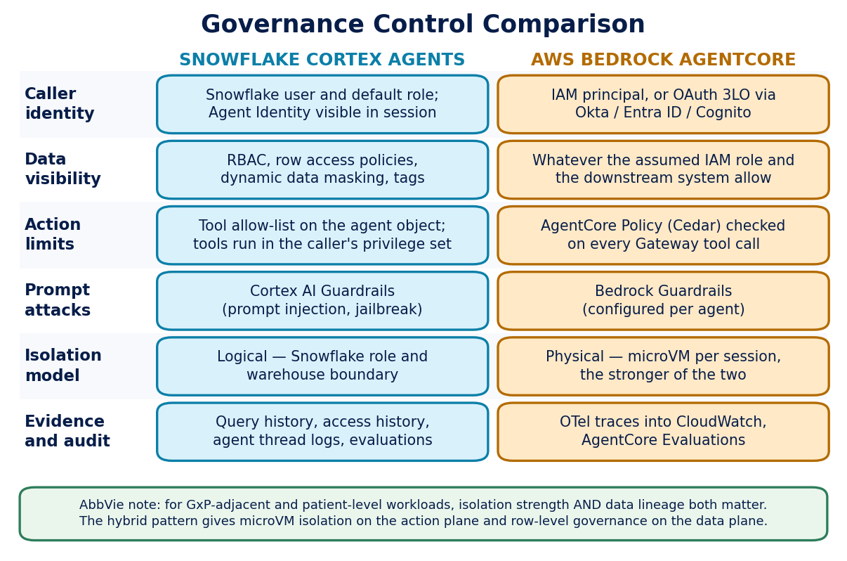
Figure 5. Governance control comparison across six questions a reviewer will ask.

17.1 The structural difference
Cortex governance is inherited. The controls already exist because the data already lives there. A team that adds a Cortex Agent does not add a new access surface — it adds a new caller to an existing one. The review burden is proportionally small.
AgentCore governance is constructed. The controls are more granular and, in some respects, stronger — per-action Cedar policy and per-session microVM isolation have no Cortex equivalent. But they exist only to the extent the team builds them. The review burden is proportionally large, and it recurs with every new data source.
Neither is better in the abstract. Inherited governance is better when the data is already governed. Constructed governance is better when there is no existing perimeter to inherit from, or when the required control is finer than the perimeter provides.

17.2 Control mapping
Control objective | Cortex Agents | Bedrock AgentCore | Hybrid
Restrict which rows a user may see | Row access policy — native | Build it | Cortex owns this
Mask sensitive columns | Dynamic data masking — native | Build it | Cortex owns this
Prevent an agent taking a specific action | Tool allow-list on the agent | Cedar policy per call — finer | AgentCore owns this
Isolate one user's session from another's | Logical role boundary | microVM — physical | AgentCore owns this
Defend against prompt injection | Cortex AI Guardrails | Bedrock Guardrails | Both, at each boundary
Prove who asked and what was returned | Query and access history | OTel traces in CloudWatch | Correlate on a shared request ID
Continuously test answer quality | Agent evaluations | 13 built-in evaluators plus custom | Both, plus end-to-end
Control data residency | Cross-region inference setting | AWS region selection | Must agree across both
Residency needs an explicit decision in hybrid designs
The two platforms control residency through different settings, and they can silently disagree. Setting CORTEX_ENABLED_CROSS_REGION to a global option lowers the Snowflake AI Credit rate, but it also changes where inference happens. If the AWS side is pinned to a region for a regulatory reason, the Snowflake side must be pinned consistently. Record the decision, including the cost consequence, in the architecture sketch.

18. Regulated Workload Considerations
This section applies to any agent touching patient-level data, promotional content, medical information, or anything that could be read as a claim about an AbbVie therapy.

18.1 Non-negotiables for both platforms
- Human approval before regulated output leaves the system. Snowflake states plainly that LLM response and citation accuracy are not guaranteed and that answers should be reviewed before being served. Treat that as a design requirement, not a disclaimer. The Evidence Monitoring Agent's Medical Affairs approval gate is the right model to follow.
- No autonomous writes to regulated systems. The agent may prepare an action. A person approves it. On AgentCore, encode this as a Cedar policy so it is enforced by the platform rather than by convention.
- Complete, user-attributable audit trail. See Section 14.3. A shared service account fails this requirement.
- Version pinning and change control. Model auto-selection is convenient and is not appropriate for a validated workflow. Pin the model, and treat a model change as a change requiring re-validation.
- Evaluation evidence at release and in production. A stored, dated evaluation run against a fixed question set, plus ongoing production sampling.
- Documented failure behaviour. What the agent does when a tool fails, when retrieval returns nothing, and when confidence is low. Silence and confident invention are both unacceptable.

18.2 Where each platform helps
Requirement | Stronger platform | Why
Patient-level data segregation | Cortex | Row access policies apply at the data, not at the application
Per-user isolation of processing | AgentCore | microVM per session is a physical boundary
Preventing an unapproved action | AgentCore | Cedar policy is evaluated before every tool call
Proving which data an answer used | Cortex | Query and access history give the authoritative record
Consistent KPI definitions across agents | Cortex | Semantic view is the single definition point
Auditable orchestration decisions | AgentCore | OTel traces capture the reasoning trajectory step by step

18.3 Questions to answer before CARB submission
- Which regulation applies, and who has confirmed that reading?
- Can the system name the user for any given answer, from platform logs alone?
- Where is the human approval gate, and who staffs it?
- Which model version is pinned, and what triggers re-validation?
- What is the documented behaviour when a tool fails or retrieval is empty?
- Where does inference physically happen, on both sides of a hybrid design?
- What evaluation evidence exists, and when was it last run?
- If the agent is wrong in production, how is that detected, and by whom?

19. Cost Model — Snowflake Cortex
Expect incremental spend
Adding Cortex will increase Snowflake consumption. Embeddings, vector indexing and LLM inference all consume AI Credits. The relevant question is not whether cost rises, but whether the rise is proportionate to the governance and engineering effort it replaces.

19.1 The AI Credits model
As of 1 April 2026, Snowflake separated AI consumption into a distinct currency called AI Credits, priced independently of Platform Credits and independently of Snowflake edition. AbbVie's contracted rate is below list.
Credit type | List rate | AbbVie contracted rate
AI Credits — global inference | $2.00 per credit | $1.94 per credit
AI Credits — regional processing | $2.20 per credit | $2.16 per credit

AbbVie rates are based on the current active capacity contract. Authoritative rates are in the Snowflake credit consumption guide, table 2b. All dollar figures below use the AbbVie global rate of $1.94.

19.2 What consumes AI Credits

Cortex Agents
Component | Basis | Rate (claude-haiku-4-5) | At $1.94/credit
Agent orchestration | Tokens, at the orchestration model rate | 0.65 in / 3.25 out credits per 1M | $1.261 in / $6.305 out per 1M
Cortex Analyst (as a tool) | Tokens, same rate as orchestration | 0.65 in / 3.25 out credits per 1M | $1.261 in / $6.305 out per 1M
Cortex Search — embedding | Tokens embedded (arctic-embed-l-v2.0) | 0.05 credits per 1M tokens | $0.097 per 1M tokens
Cortex Search — index storage | Index size and persistence time | 6.33 credits per GB per month | $12.28 per GB per month
Custom tools | Warehouse compute | Standard warehouse rates | Depends on size and runtime

AISQL and other services
Service | Rate | At $1.94/credit
AI_COMPLETE (claude-4-sonnet) | 1.8 in / 9.0 out credits per 1M tokens | $3.492 in / $17.46 out per 1M
Simple functions (e.g. AI_SENTIMENT) | approx. 1.6 credits per 1M tokens | approx. $3.10 per 1M tokens
AI_PARSE_DOCUMENT | 3.66 credits per 1,000 pages | $7.10 per 1,000 pages
Cortex Code (claude-haiku-4-5) | 0.55 in / 2.75 out credits per 1M tokens | $1.067 in / $5.335 out per 1M

19.3 What drives cost up
- Token volume above all. Long system prompts, large retrieved context and verbose responses dominate the bill.
- Search index size and persistence. Index storage is billed per GB per month and accrues whether or not the index is queried.
- Re-embedding on refresh. Frequent full re-indexing of a large corpus is a recurring cost that is easy to overlook at design time.
- Warehouse compute behind custom tools, which is billed separately from AI Credits.
A correction to earlier guidance
Earlier AbbVie material listed Snowpark-optimized warehouses as a Cortex cost driver. That is not accurate — Snowpark-optimized warehouses are not part of Cortex Agents consumption. They are 1.5 times standard warehouse rates and are relevant to large-memory ML workloads such as model training in stored procedures. What the 1.5x premium buys is sixteen times more memory per node by default (the MEMORY_16X resource constraint) and configurable CPU architecture. Include it in a cost model only if the use case actually trains models.

20. Cost Model — AWS Bedrock AgentCore
AgentCore has no single rate. It meters each capability independently, on top of foundation model token spend. There are no upfront commitments and no minimum fees. Forecasting therefore means modelling each meter that the design actually uses.

20.1 The billing pattern that matters most
I/O wait is free on Runtime
Runtime, Browser and Code Interpreter bill on active resource consumption, not pre-allocated capacity. CPU is charged only when the agent is actually processing. Agent workloads typically spend 30 to 70 percent of session time waiting on model responses, tool calls or database queries, and that wait costs nothing on CPU.
Memory is different. It is billed on peak memory consumed up to each second, across the whole session lifetime including idle. So session duration and peak memory size both matter even during wait periods. A long-running agent holding a large context is a memory cost, not a CPU cost.

20.2 Rate table
Component | Basis | Rate
Runtime — CPU | Active vCPU-hour, per second, 1 second minimum | $0.0895 per vCPU-hour
Runtime — memory | Peak GB-hour, 128 MB minimum | $0.00945 per GB-hour
Browser / Code Interpreter | Same active consumption basis as Runtime | $0.0895 per vCPU-hour, $0.00945 per GB-hour
Gateway — tool invocations | API operations such as ListTools, InvokeTool, Ping | $0.005 per 1,000 invocations
Gateway — search API | Semantic tool search calls | $0.025 per 1,000 invocations
Gateway — tool indexing | Tools indexed for semantic search | $0.02 per 100 tools per month
Identity | OAuth token or API key requests for non-AWS resources | $0.010 per 1,000 — free via Runtime or Gateway
Memory — short-term | Raw events created | $0.25 per 1,000 new events
Memory — long-term storage | Records stored, billed hourly | $0.75 per 1,000 (built-in) / $0.25 per 1,000 (self-managed)
Memory — long-term retrieval | Retrieval calls | $0.50 per 1,000 retrievals
Policy — authorisation | Cedar checks per tool call | $0.000025 per request
Policy — NL authoring | Input tokens converted to Cedar | $0.13 per 1,000 tokens
Web Search | Queries submitted | $7.00 per 1,000 queries
Evaluations — built-in | Tokens processed; model cost included | $0.0024 per 1,000 in / $0.012 per 1,000 out
Evaluations — custom | Per evaluation; model billed separately | $1.50 per 1,000 evaluations
Evaluations — batch | Discounted rate | $0.0018 per 1,000 in / $0.009 per 1,000 out
Observability | Spans, logs and metrics | Amazon CloudWatch rates — not an AgentCore rate
Foundation models | Input and output tokens | Amazon Bedrock model rates — the largest line for most agents

20.3 Where the money actually goes
For most production agents, two lines dominate. Foundation model tokens are typically 50 to 70 percent of total spend. Runtime duration and long-term Memory make up most of the remainder. Gateway, Identity and Policy are usually rounding errors at AbbVie's expected volumes — the Policy example on the AWS pricing page costs $12.50 for half a million authorisation checks.
The practical consequence is that AgentCore cost optimisation is mostly model optimisation, plus attention to session duration and peak memory. Tuning the small meters is not where the savings are.

20.4 Costs outside the AgentCore meters
- Vector store for self-managed retrieval. If the design does not call Cortex Search, something must hold the embeddings. This is frequently the largest surprise line in an AgentCore-only design.
- CloudWatch ingestion, storage and query for observability.
- ECR storage for container deployments, or S3 Standard for direct code deployment artifacts.
- Network data transfer at standard EC2 rates, including $0.006 per GB for Gateway egress to customer-owned VPCs.
- Preview services. Agent Registry, Optimization Insights and Payments are free or unpriced today; that will change.

21. Worked Cost Comparison
Illustrative only
The figures below are a modelling exercise built from published rates, not a quote. They exist to show the shape of the difference, not to fix a budget. Validate any funding case against the July 2026 Cortex AI Cost Calculator and the AWS pricing calculator, using the real token profile of the workload.

21.1 The scenario
Assumption | Value
Use case | Brand performance question answering, structured plus document grounding
Monthly sessions | 50,000
Tokens per session | 12,000 input, 1,500 output
Tool calls per session | 4
Document corpus | 20 GB indexed
Model class | Claude Haiku 4.5 equivalent on both platforms
Session wall time | 45 seconds, of which 30 percent is active CPU

21.2 Path A — Cortex Agents
Line | Calculation | Monthly
Orchestration + Analyst, input | 600M tokens x 0.65 credits per 1M = 390 credits x $1.94 | $756.60
Orchestration + Analyst, output | 75M tokens x 3.25 credits per 1M = 243.75 credits x $1.94 | $472.88
Cortex Search index storage | 20 GB x 6.33 credits x $1.94 | $245.60
Embedding refresh | approx. 200M tokens x 0.05 credits x $1.94 | $19.40
Warehouse compute for tools | Estimated | $420.00
TOTAL |  | $1,914.48

21.3 Path B — AgentCore, equivalent capability self-built
Line | Calculation | Monthly
Foundation model, input | 600M tokens at approx. $1.00 per 1M | $600.00
Foundation model, output | 75M tokens at approx. $5.00 per 1M | $375.00
Runtime CPU | 50,000 x 13.5s x 1 vCPU x ($0.0895/3600) | $16.78
Runtime memory | 50,000 x 45s x 2 GB x ($0.00945/3600) | $11.81
Gateway | 200,000 InvokeTool + 50,000 Search | $2.25
Memory (short, long, retrieval) | 50,000 events + 20,000 records + 100,000 retrievals | $77.50
Policy | 200,000 authorisation checks x $0.000025 | $5.00
Self-managed vector store | Estimated, serverless vector search | $690.00
Observability (CloudWatch) | Estimated spans and logs | $12.00
Evaluations | 1 percent production sampling, 3 built-in evaluators | $59.40
TOTAL |  | $1,849.74

21.4 What this shows
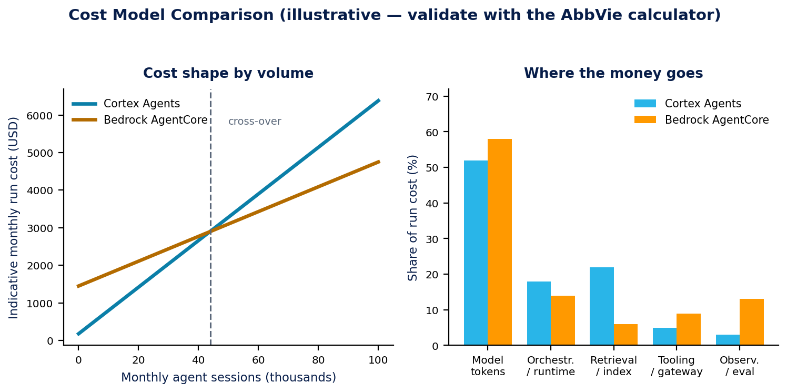
Figure 6. Cost shape comparison. Left: how run cost scales with volume. Right: where the spend concentrates.
- Run cost is roughly a wash. The two paths land within about four percent of each other. Anyone presenting a large run-cost advantage for either platform is probably comparing different scopes.
- Snowflake charges a premium on the same models. For the equivalent Anthropic model, Snowflake's token rates run roughly 16 to 26 percent above the underlying Bedrock rates. That premium is not waste — it is the price of the managed governance, retrieval and orchestration that the AgentCore path had to build separately, at $690 a month for the vector store alone plus the engineering behind it.
- The cost profiles differ in shape. Cortex concentrates spend in tokens and index storage. AgentCore concentrates it in tokens, external retrieval infrastructure and observability. AgentCore has a higher fixed floor and a lower marginal rate, so it becomes relatively cheaper at high volume — see the crossover in the left-hand chart.
- Neither figure includes the cost that actually differs. See Section 23.

22. Cost Optimization Levers

22.1 Snowflake Cortex
Lever | How it works | Typical effect
Prompt caching | Repeated prompt prefixes — system prompts, few-shot examples, large fixed context — are cached and served at a reduced token rate on subsequent calls | Up to 90 percent off input tokens on cache hits; strongest for agents with stable instructions
Model routing | Cheaper models for simple tasks, frontier models reserved for complex reasoning. Route classification and extraction through claude-haiku-4-5 rather than claude-4-sonnet | Around 64 percent reduction on input tokens for tasks that do not need top-tier reasoning
Global inference routing | Set CORTEX_ENABLED_CROSS_REGION to a global option such as ANY_REGION or AWS_GLOBAL | Moves the AI Credit rate from $2.16 to $1.94 — check residency constraints first
Route Analyst through Agents | The standalone Cortex Analyst API uses legacy per-message Platform Credit pricing. Invoking Analyst as a tool inside a Cortex Agent converts it to token-based AI Credit pricing | More cost-efficient at high analytical volume, and it inherits caching and routing
Index discipline | Scope the Search index to what is actually queried, and control refresh frequency | Directly reduces the per-GB-per-month line and re-embedding cost
Snowflake indicates that these levers combined can reduce AI workload cost by more than 70 percent against pre-April 2026 baselines. That figure is a vendor claim measured against an old pricing model; treat it as directional rather than as a planning assumption.

22.2 AWS Bedrock AgentCore
Lever | How it works | Typical effect
Prompt caching | Bedrock prompt caching on repeated context | Up to 90 percent off repeated input tokens
Model routing | Smaller models for routing, extraction and classification steps | The largest single lever, since models are 50 to 70 percent of spend
Shorten session lifetime | Terminate sessions promptly. Memory is billed on peak footprint for the whole session, including idle | Direct reduction of the memory line on long sessions
Right-size peak memory | Avoid loading large context into memory when a retrieval call would do | Memory is billed on peak, so one spike sets the rate for the rest of the session
Self-managed memory strategies | Long-term memory at $0.25 per 1,000 records instead of $0.75 | Two-thirds off storage, at the cost of running your own extraction model
Sampling on evaluations | Percentage-based and conditional sampling in production | Evaluations can exceed runtime cost if run on every interaction
Batch evaluations | Batch rates are 25 percent below standard Evaluations rates | Meaningful for CI/CD quality gates run at volume
Call Cortex instead of self-hosting retrieval | Removes the vector store line entirely | In the Section 21 example this was $690 a month plus its engineering

23. Total Cost of Ownership
Section 21 compared run cost and found them close. That is the least important part of the comparison. The costs that differ materially do not appear on either vendor's invoice.

23.1 The costs that actually differ
Cost element | Cortex Agents | Bedrock AgentCore | Notes
Initial build to governed POC | 3 to 4 engineer-weeks | 10 to 12 engineer-weeks | Assumes the semantic view already exists for both
Access control implementation | Inherited — near zero | 2 to 3 engineer-weeks, then recurring | Recurs with each new data source on the AgentCore side
Retrieval pipeline build | Configuration | 3 to 4 engineer-weeks | Chunking, embedding, index management, refresh
Deployment and CI/CD | Not required | 1 to 2 engineer-weeks | Containers, ECR, IAM, pipelines
Ongoing operations | approx. 0.05 FTE | approx. 0.2 FTE | Patching, monitoring, incident response, cost review
Governance review effort | Low — new caller on an existing surface | High — new access surface each time | This is where CARB cycle time is consumed
Cost of a wrong answer | Identical | Identical | Driven by the semantic layer, not by the platform

23.2 The honest summary
What the TCO comparison really says
For a workload that sits squarely in Snowflake, Cortex is materially cheaper in total, and the saving is almost entirely engineering time and governance review — not tokens.
For a workload that must act across systems, AgentCore is materially cheaper in total, because the alternative is bending a data platform into an integration platform and paying for that in maintenance forever.
For a workload that does both, the hybrid pattern is cheaper than either single-platform approach, because each side does only the part it does not have to build.

23.3 A note on lock-in
Both platforms create dependency, in different places. A Cortex Agent is a Snowflake object; its instructions and tool configuration do not port. An AgentCore deployment depends on AWS identity, gateway and memory services, though the agent code itself — LangGraph, Strands, custom Python — is portable by design.
The most portable asset in either design is the semantic view, because it encodes AbbVie's own business definitions rather than a vendor's abstraction. This is another reason to fund it as platform work: it is the part of the investment that survives a platform change.

PART E
Applying the Guideline
Sections 24 to 28 cover the prerequisite that gates everything, the mapping to AbbVie's active portfolio, and the route through review.

24. The Semantic Layer Prerequisite
This is the most strategically important section in the document, and the one most likely to be skipped. It applies equally to both platforms. Neither Cortex Agents nor Bedrock AgentCore solves the problem described here, and a well-chosen platform pointed at ungoverned definitions will fail just as completely as a poorly chosen one.

24.1 What goes wrong without it
An agent operating against raw schemas without semantic governance does not produce marginal errors. It produces catastrophic ones, and it produces them confidently. Three AbbVie-relevant examples:
Question asked | What can go wrong | Business consequence
"How is Skyrizi performing?" | The agent blends brand, molecule and indication-level views, mixing risankizumab sales across dermatology and gastroenterology | Indication-specific performance questions get an aggregated answer that is wrong for the decision being made
"How many patient starts last month?" | The agent returns NBRx, TRx, enrollments or hub starts depending on which raw table it selects | Launch tracking and field execution decisions are made on materially different numbers
"What is the ROI on this channel?" | Spend and response definitions differ across brands and channels; the agent picks one | Incorrect investment recommendations, produced by technically valid SQL
The failure is silent
Cortex Analyst pointed at EMMA outputs or Snowflake tables without governed KPI definitions will confidently produce incorrect ROI curves, response curves and channel attribution numbers. The SQL will be syntactically valid. The business answer will be wrong. Nothing in the output signals the error, and the fluency of the response actively increases the reader's confidence in it.
This is why Section 10 treats the semantic layer as a gate rather than a preference. A wrong answer that looks right is worse than no answer.

24.2 What changes with a semantic layer
AbbVie's Semantic in a Box work tested this directly. The semantic layer version won 13 of 15 business questions and improved answer quality by roughly 19 percent on average. The average improvement matters less than what happened to the failure modes: they disappeared.
- Governed KPI definitions are inherited from Alation. Net revenue, iROI, UPT and NBRx are defined once and resolved consistently, so Cortex Analyst cannot invent a variant at query time.
- CENtree and SciBite TERMite handle synonym resolution. A query about "Skyrizi", "risankizumab" and "anti-IL-23" resolves to the same canonical graph node, so the same question phrased three ways returns the same answer.
- The knowledge bank supplies approved reasoning patterns. Agents reason from approved prompt examples and patterns rather than inventing logic at query time.
- MCP servers and semantic APIs expose the layer as consumable tools. Critically, this serves both Cortex Agents and Bedrock AgentCore — one definition surface, two consumers. This is what makes the hybrid pattern governable.

The Semantic in a Box thesis
Without a semantic layer, every new agent recreates its own definitions. With Semantic in a Box, AbbVie's agents reason against approved definitions, approved rules and approved relationships — by design, not by hope.

24.3 How this changes the platform decision
It does not change which platform wins. It changes whether the project should proceed at all.
Semantic layer status | What to do
Exists and covers the domain | Proceed. Apply the decision tree normally.
Exists but does not cover this domain | Proceed only if the semantic view for this domain is funded and in the project plan, with a defined owner. Otherwise treat as "does not exist".
Does not exist | Stop. Do not select a platform. The remediation is to build the semantic view, and that work should be funded as platform work because every future agent depends on it.

25. Use Case Placement
The two forces from Section 8 — data gravity and action surface — place a use case on a simple map. The map is directional. It replaces a debate with a starting position, and the scorecard in Section 11 confirms or overturns it.
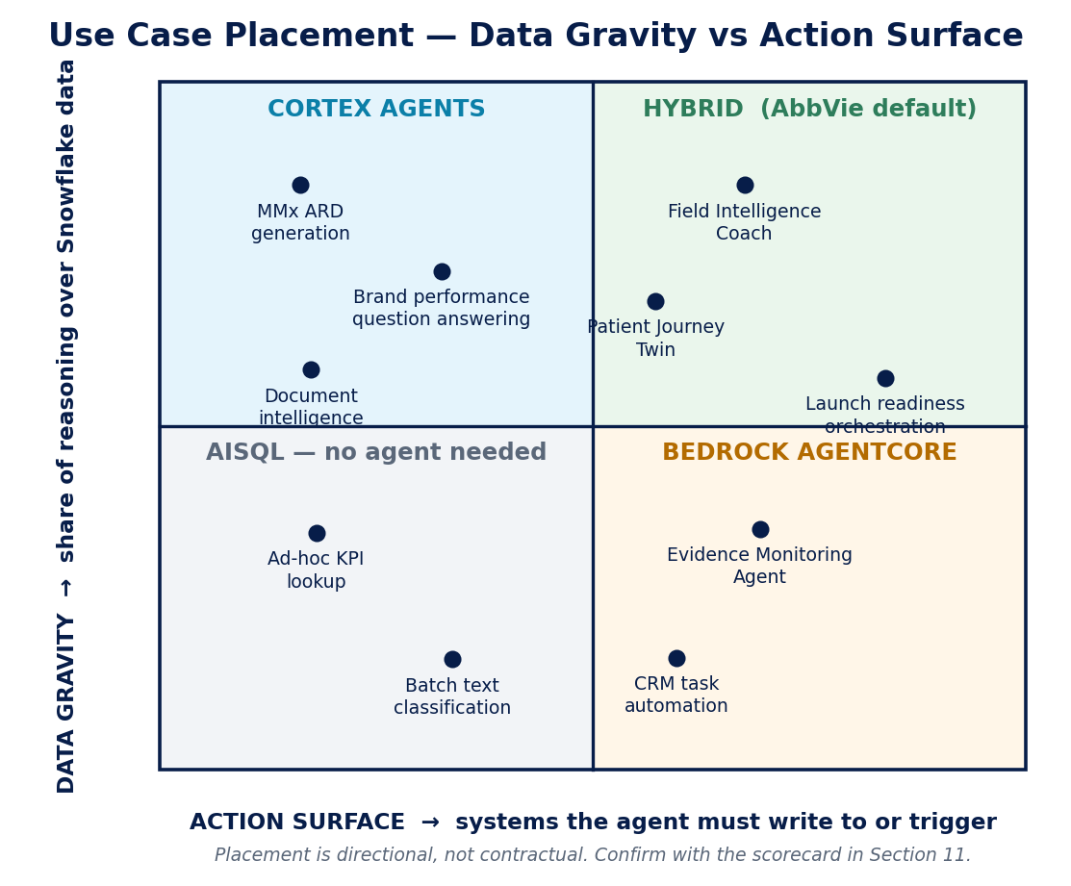
Figure 7. Use case placement by data gravity and action surface. Most AbbVie Commercial work sits in the upper right.

25.1 AbbVie use case mapping
Use case | Data gravity | Action surface | Recommendation | Key reason
MMx ARD generation | High | Low | Cortex | Governed structured analytics against semantic views
Brand performance question answering | High | Low | Cortex | Pure governed analytics; Snowflake Intelligence is the front end
Document intelligence over stages | High | Low | Cortex | Search plus Analyst in one governed workflow
Field Intelligence Coach Agent | Medium | High | Hybrid | LangGraph implementation, long sessions, CRM write-back
Patient Journey Twin | Medium | High | Hybrid | Neptune, SageMaker and Bedrock services sit outside Snowflake
Launch readiness orchestration | Medium | High | Hybrid | Cross-functional, long-running, human approval gates
Evidence Monitoring Agent | Low | High | AgentCore | Probes external LLM providers; little Snowflake reasoning
CRM task automation | Low | High | AgentCore | Action surface dominates entirely
Ad-hoc KPI lookup | High | None | No agent | A governed query or Snowflake Intelligence turn is sufficient
Batch text classification | Medium | None | AISQL | Fixed operation over many rows; no planning loop needed

Placements reflect the current understanding of each use case and should be re-checked when scope changes. A use case that gains a write-back requirement moves right on the map, and that can change the answer.

26. Decision Checklist
One page. Complete it before the architecture review. Every "no" needs either a mitigation or a decision to stop.

26.1 Gate — before any platform choice
# | Check | Yes / No | Evidence
G1 | This work genuinely needs a planning loop (Section 12.3)
G2 | A governed semantic view exists, or is funded with a named owner
G3 | The KPI definitions this agent needs are in Alation
G4 | Synonym resolution is handled for the therapy and indication terms in scope
G5 | The regulatory classification of this use case has been confirmed

26.2 Platform selection
# | Check | Yes / No | Evidence
P1 | The decision tree has been walked and the result recorded
P2 | The scorecard has been completed, with evidence for extreme scores
P3 | Tree result and scorecard result agree, or the difference is explained
P4 | If hybrid, the ownership split has been drawn (Section 14.2)
P5 | No design dependency on a preview capability

26.3 Governance
# | Check | Yes / No | Evidence
V1 | End user identity reaches the data layer; no shared service account
V2 | Row and column level controls are applied at the data, not the application
V3 | Prompt injection defence is enabled at every boundary
V4 | A human approval gate exists for regulated output, with a named owner
V5 | The model version is pinned, and re-validation triggers are documented
V6 | Failure behaviour is documented for tool failure and empty retrieval
V7 | Data residency is consistent across both sides of a hybrid design
V8 | Any answer can be traced to a named user and a specific data access

26.4 Cost and operations
# | Check | Yes / No | Evidence
C1 | Cost has been modelled on the real token profile, not a rule of thumb
C2 | Prompt caching and model routing are designed in, not deferred
C3 | Index size, refresh frequency and session duration have been sized
C4 | TCO includes engineering and operational effort, not only run cost
C5 | An owner is named for ongoing cost review

26.5 Quality
# | Check | Yes / No | Evidence
Q1 | An evaluation question set exists with known correct answers
Q2 | Data layer evaluation is configured (Cortex agent evaluations)
Q3 | Orchestration layer evaluation is configured (AgentCore Evaluations)
Q4 | End-to-end evaluation runs on real business questions
Q5 | Production sampling is enabled, with a threshold that raises an alert

27. Path to Production and CARB Alignment
The platform decision is one input to the CARB submission, not a substitute for it. This section maps the artefacts this guideline produces onto what the review will ask for.

27.1 Artefact mapping
CARB expects | Produced by | Section
A justified platform selection | Decision tree result plus completed scorecard | 10, 11
An architecture sketch with trust boundaries | Hybrid ownership split and sequence | 14, 15
Data access control design | Governance control mapping | 17
Regulatory position and approval design | Regulated workload questions | 18
A cost model with named assumptions | Cost sections and worked example | 19 to 23
Evidence of data definition governance | Semantic layer status and owner | 24
Quality evidence and monitoring plan | Evaluation design at three levels | 15.3, 26.5
A completed pre-review checklist | Decision checklist | 26

27.2 Suggested stage gates
Stage | Exit criteria
Concept | G1 to G5 answered. If G2 is no, the project becomes a semantic layer project.
Architecture | P1 to P5 complete. Ownership split drawn. Trust boundary identified.
Build | V1 to V8 designed and demonstrable in a non-production environment.
Pre-production | Q1 to Q5 evidenced with a dated evaluation run. C1 to C5 complete.
Production | Human approval gate staffed. Monitoring live. Cost owner named.

27.3 Where teams usually lose time
- Discovering at build stage that no governed definition exists for a needed KPI. This is a concept-stage question and belongs in G2.
- Agreeing the human approval business process. This is a people and process negotiation, not a technical task, and it has the longest lead time in most regulated builds.
- Retrofitting on-behalf-of identity after building with a service account. The rework touches every layer.
- Building an evaluation set after the system is complete, when there is no baseline to compare against.

28. Maintaining This Document
Both platforms are moving quickly. Cortex Agents went GA in November 2025 and has since added evaluations, Guardrails, MCP connectors, agent toolsets, Agent Identity and the Cortex AI Gateway. AgentCore went GA in October 2025 and has since added Policy, Evaluations, Optimization, an agent registry and Payments. Guidance in this space has a short half-life.
Trigger | Action
Quarterly review | Re-verify all rates and re-check the capability matrix against current vendor documentation
Either vendor announces a major agent capability | Assess whether any matrix row or decision-tree branch changes
Snowflake or AWS changes pricing structure | Rebuild the worked example in Section 21
A preview capability reaches GA | Move it from a noted upside into the matrix
An AbbVie build contradicts this guidance | Treat as evidence. Update the document or record the exception with its reasoning
Semantic in a Box scope changes | Update Section 24 and re-check the gate wording

28.1 Open questions for the next revision
- What does Cortex agent toolset composition look like in practice at AbbVie scale, and does it reduce the need for AgentCore supervision in some hybrid designs?
- Does the Cortex AI Gateway change the MCP governance story enough to alter the hybrid trust boundary?
- What are the real observed token profiles from the Evidence Monitoring Agent and the Field Intelligence Coach Agent, so Section 21 can be rebuilt on measured rather than assumed numbers?
- Do AgentCore Evaluations and Cortex agent evaluations produce comparable quality signals, or does the hybrid pattern need a third harness?
- How should the semantic layer gate be evidenced in a way CARB can audit consistently across teams?

Appendix A. Extended Capability Reference
Consolidated view of all comparison rows, for reference during review.
Area | Dimension | Cortex Agents | Bedrock AgentCore
Platform | General availability | 4 November 2025 | October 2025
Platform | Delivery model | Configured database object | Coded agent on managed infrastructure
Platform | Framework support | Snowflake loop only | Any — LangGraph, Strands, LlamaIndex, CrewAI, custom
Platform | Model families | Claude, GPT, Grok, Gemini | Any Bedrock model
Platform | Auto model selection | Yes | No
Platform | Max session length | Not team-controlled | 8 hours
Platform | Async sessions | No | Yes
Platform | Session isolation | Logical | microVM — physical
Platform | State management | Threads | Memory — short and long term
Platform | Multi-agent | Agent toolsets | A2A protocol
Platform | Included front end | Snowsight, Snowflake Intelligence | None
Data | Text to SQL | Cortex Analyst | Build it
Data | Managed retrieval | Cortex Search | Bedrock Knowledge Bases or self-managed
Data | Structured + unstructured together | Native | Assembled
Data | Semantic definition point | Semantic view | None native
Tools | External API reach | MCP connectors, custom tools | Gateway — API, Lambda, MCP
Tools | Tool discovery at scale | Declared on the agent | Gateway semantic search; Registry (preview)
Tools | Code execution | Python sandbox | Python, JavaScript, TypeScript
Tools | Managed browser | No | Yes
Tools | Web search | Yes, account-level enable | Yes, $7 per 1,000 queries
Tools | Charting | Data to Chart | Build it
Governance | Row level control | Row access policy — inherited | Build it
Governance | Column masking | Dynamic data masking — inherited | Build it
Governance | Per-action authorisation | Tool allow-list | Cedar policy per call
Governance | Prompt injection defence | Cortex AI Guardrails | Bedrock Guardrails
Governance | Delegated identity | Snowflake role of caller | OAuth 3LO via Okta, Entra, Cognito
Governance | Agent activity visibility | Agent Identity | OTel traces
Quality | Built-in evaluation | Agent evaluations | 13 built-in evaluators plus custom
Quality | CI/CD quality gates | Not native | Yes
Quality | Production sampling | Feedback and monitoring | Sampling rules with thresholds
Quality | Automated optimisation | No | Optimization (preview and GA mix)
Operations | Infrastructure burden | None | Containers, IAM, pipelines, CloudWatch
Operations | Time to governed POC | Days to weeks | Weeks to months
Operations | Ongoing FTE (indicative) | approx. 0.05 | approx. 0.2

Appendix B. Pricing Reference
Verify before use
All rates below were checked on 31 July 2026. Vendor pricing changes without notice. Re-verify against the primary sources in Appendix C before any funding decision.

B.1 Snowflake — AI Credit rates
Item | Rate in AI Credits | AbbVie USD at $1.94
AI Credits, global inference | n/a | $1.94 per credit
AI Credits, regional processing | n/a | $2.16 per credit
Cortex Agents orchestration (claude-haiku-4-5), input | 0.65 per 1M tokens | $1.261 per 1M tokens
Cortex Agents orchestration (claude-haiku-4-5), output | 3.25 per 1M tokens | $6.305 per 1M tokens
Cortex Analyst as a tool | Same as orchestration model | Same as orchestration model
Cortex Search embedding (arctic-embed-l-v2.0) | 0.05 per 1M tokens | $0.097 per 1M tokens
Cortex Search index storage | 6.33 per GB per month | $12.28 per GB per month
Cortex Code (claude-haiku-4-5), input | 0.55 per 1M tokens | $1.067 per 1M tokens
Cortex Code (claude-haiku-4-5), output | 2.75 per 1M tokens | $5.335 per 1M tokens
AI_COMPLETE (claude-4-sonnet), input | 1.8 per 1M tokens | $3.492 per 1M tokens
AI_COMPLETE (claude-4-sonnet), output | 9.0 per 1M tokens | $17.46 per 1M tokens
Simple AI functions (e.g. AI_SENTIMENT) | approx. 1.6 per 1M tokens | approx. $3.10 per 1M tokens
AI_PARSE_DOCUMENT | 3.66 per 1,000 pages | $7.10 per 1,000 pages

B.2 AWS — AgentCore rates
Component | Unit | Rate
Runtime CPU | vCPU-hour, active only | $0.0895
Runtime memory | GB-hour, peak, 128 MB minimum | $0.00945
Browser | Same basis as Runtime | $0.0895 / $0.00945
Code Interpreter | Same basis as Runtime | $0.0895 / $0.00945
Gateway API invocations | per 1,000 | $0.005
Gateway search API | per 1,000 | $0.025
Gateway tool indexing | per 100 tools per month | $0.02
Gateway VPC egress | per GB | $0.006
Identity token requests | per 1,000 (free via Runtime or Gateway) | $0.010
Memory, short-term | per 1,000 new events | $0.25
Memory, long-term storage, built-in | per 1,000 records per month | $0.75
Memory, long-term storage, self-managed | per 1,000 records per month | $0.25
Memory, long-term retrieval | per 1,000 retrievals | $0.50
Policy authorisation | per request | $0.000025
Policy NL authoring | per 1,000 input tokens | $0.13
Web Search | per 1,000 queries | $7.00
Evaluations, built-in input | per 1,000 tokens | $0.0024
Evaluations, built-in output | per 1,000 tokens | $0.012
Evaluations, custom | per 1,000 evaluations | $1.50
Evaluations, batch input | per 1,000 tokens | $0.0018
Evaluations, batch output | per 1,000 tokens | $0.009
Agent Registry records (preview) | per 1,000 above 5,000 free | $0.400
Observability | Spans, logs, metrics | Amazon CloudWatch rates
Foundation models | Input and output tokens | Amazon Bedrock model rates

Appendix C. Sources

C.1 Primary vendor documentation
- Snowflake Documentation — Cortex Agents (overview, tools, access control, limitations, cost considerations)
- Snowflake release notes — Cortex Agents general availability, 4 November 2025
- Snowflake release notes — Cortex Agent evaluations general availability, 13 March 2026
- Snowflake release notes — Cortex AI Guardrails for Snowflake Intelligence and Cortex Agents, 14 May 2026
- Snowflake blog — Cortex AI Gateway and agentic MCP governance, Black Hat 2026
- Snowflake Credit Consumption Table, table 2b — authoritative AI consumption rates
- AWS — Amazon Bedrock AgentCore pricing page, including per-capability rates and worked pricing examples
- AWS — Amazon Bedrock AgentCore is now generally available (Runtime eight-hour windows, session isolation, A2A, Gateway MCP and IAM support)
- AWS — Amazon Bedrock AgentCore Developer Guide (Runtime, Gateway, Identity, Memory, Observability)

C.2 AbbVie internal material
- Semantic in a Box POV — semantic layer comparison study, Alation, CENtree / SciBite TERMite, knowledge bank, semantic APIs
- July 2026 Cortex AI Cost Calculator — the authoritative internal cost model for Cortex workloads
- Architecture Guideline working note: Cortex Agents vs. Bedrock Agent Core — the draft this document supersedes
- LaaS / Innovation Zone architecture documentation — governed data access, agent orchestration and CARB path to production
- Evidence Monitoring Agent design material — Medical Affairs approval gate pattern
- Field Intelligence Coach Agent design material — LangGraph implementation reference

C.3 Caveats on sources
- Foundation model token rates used in Section 21 for the AgentCore path are indicative list rates for the Claude Haiku class and should be replaced with the current Bedrock rate for the specific model chosen.
- Vendor efficiency claims — including the 70 percent AI workload cost reduction figure and the 90 percent prompt caching figure — are vendor-published and measured against vendor-chosen baselines. They are reproduced here because they are directionally useful, not because they have been independently verified by AbbVie.
- The 19 percent answer quality improvement and the 13 of 15 result come from AbbVie's own Semantic in a Box study and are the most trustworthy numbers in this document.

End of document — Architecture Guideline v1.0 — APEX Commercial AI

