Knowledge Graph × Copilot × Power BI
Strategic Integration Blueprint
Detailed Technical Architecture, Diagrams & Plain-English Explanations
Prepared for CMP — APEX Commercial AI
Knowledge Graph built by Rupesh and Kavita
July 2026

1. The Problem Statement
CMP has made three significant and separate investments:
- Neo4j Knowledge Graphs — a rich map of how CMP's brands, therapies, competitors, clinical data, and patient populations relate to each other (built by Rupesh and Kavita).
- Power BI — the primary reporting and visualisation surface used by the business.
- Microsoft 365 Copilot — rolling out to all CMP employees as the enterprise AI assistant.
Today these three investments do not talk to each other. The result is two friction points:

Friction 1 — Duplicate conversational layer
To expose Knowledge Graph intelligence conversationally, someone would have to build a separate chatbot on top of Neo4j. That is duplicated effort when Copilot is already the enterprise AI surface. The question is: can the Knowledge Graph plug into Copilot directly, making Copilot the one conversational layer instead of building another?

Friction 2 — Context lost between conversation and reporting
When a user gets an insight from a conversational bot powered by the KG — for example, ‘Skyrizi is losing ground among rheumatologists in the Midwest versus Tremfya’ — the natural next step is to see that in Power BI. Today the user must open Power BI manually, find the right report, and re-apply all the filters themselves. The context built in the conversation is thrown away the moment the user switches tools.
Goal
One seamless experience — user asks a smart question → Copilot answers using the Knowledge Graph → Power BI instantly shows the supporting data already filtered to match, in one click.

2. Solution Overview
The solution uses Microsoft's native Copilot extensibility stack — no separate chatbot, no third-party middleware. Seven components work together:
Component | Role | Technology
Graph Connector | Indexes KG entities into M365 Semantic Index so Copilot finds them passively | Microsoft Graph API Connector
Declarative Agent | A domain-scoped Copilot mode for CMP pharma intelligence | Copilot Agent Builder
API Plugin | Connects Copilot's questions to Neo4j's graph traversal engine at query time | OpenAPI + FastAPI on AWS
Neo4j REST API | Translates user intents into Cypher queries; returns clean structured results | FastAPI (Python)
Entity Mapping Table | Bridges Neo4j node labels to Power BI column names | JSON config / lookup table
Adaptive Card + Deep Link | Carries query context from Copilot into a pre-filtered Power BI report | Adaptive Cards v1.5 + Power BI URL filters
OBO Auth Flow | Ensures users only see data they are authorised to see, end to end | Azure AD On-Behalf-Of

End-to-End Data Flow, in Plain Words
1. User types a natural language question in M365 Copilot (Teams, Outlook, etc.)
2. Copilot routes the question to the CMP Declarative Agent, built with Copilot Agent Builder.
3. The agent's LLM extracts entities: brand, competitor, indication, segment, query type.
4. The API Plugin calls the Neo4j REST API with those structured parameters.
5. The REST API translates the request into a Cypher query and runs it against Neo4j.
6. Neo4j returns graph traversal results — nodes, relationships, scores.
7. The REST API formats the results into clean JSON and builds a Power BI filter URL.
8. Copilot renders a natural language insight, plus an Adaptive Card with a ‘View in Power BI’ button.
9. User clicks → Power BI opens with filters already applied, showing the exact supporting view.

Diagram 1 — Solution Overview
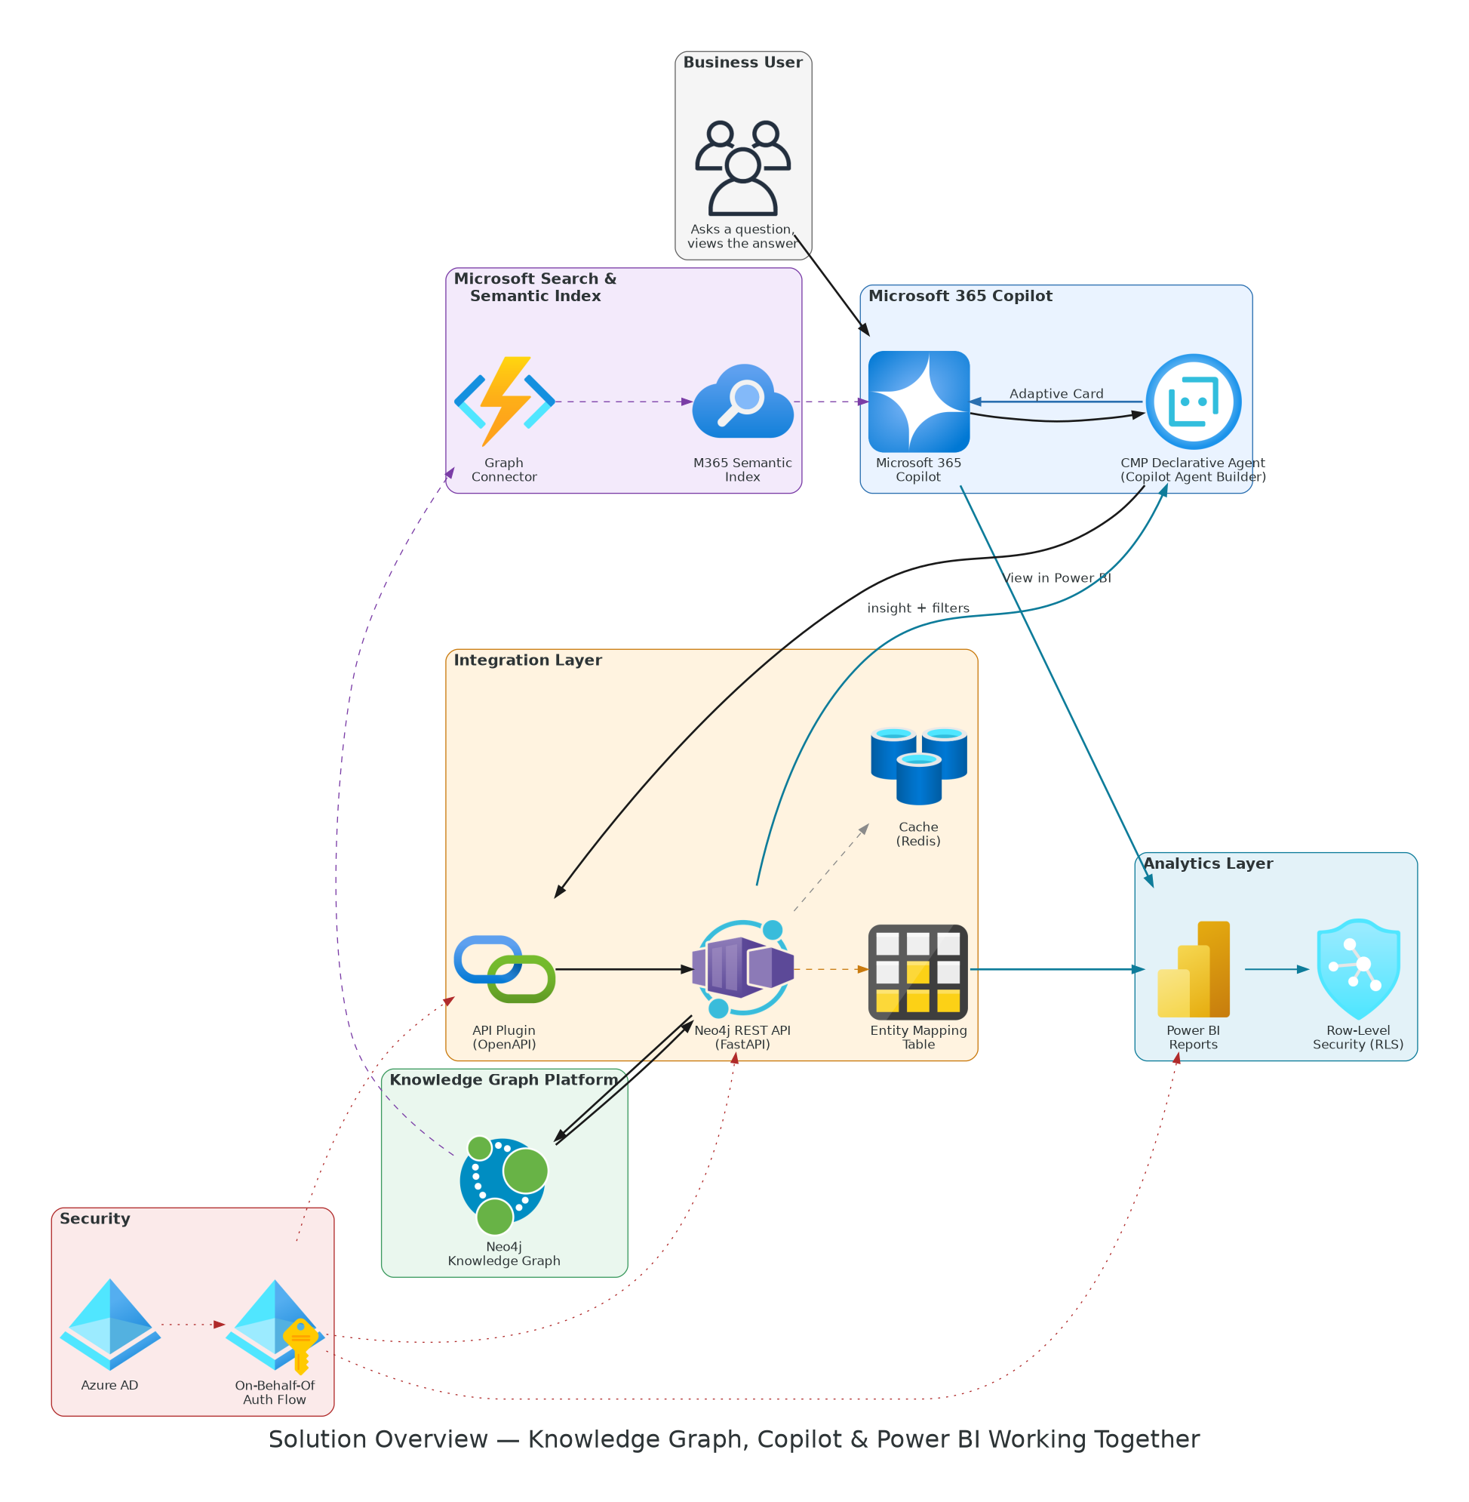
Figure 1. The seven components of the solution, grouped by function.
This diagram shows the big picture. It has seven colored groups.
- The Business User group, on the left, is where a person types a question.
- The Microsoft 365 Copilot group takes the question and hands it to the CMP Declarative Agent — a special, scoped version of Copilot built for CMP pharma questions.
- The Integration Layer group does the real work. The API Plugin passes the question to the Neo4j REST API. This API talks to the Knowledge Graph Platform group, which holds the actual Neo4j Knowledge Graph.
- The Entity Mapping Table, also in the Integration Layer, is a small lookup list. It turns Neo4j names, like ‘SKYRIZI’, into the names Power BI uses, like ‘Skyrizi’.
- The Analytics Layer group is Power BI. Once the mapping is done, Power BI Reports open already filtered to the right view.
- The Microsoft Search & Semantic Index group works differently. It is a slower, background path — shown with purple dashed lines. A Graph Connector copies Neo4j facts into the M365 Semantic Index on a schedule. This lets Copilot find simple facts even without calling Neo4j directly.
- The Security group runs underneath everything. Azure AD checks who the user is. The On-Behalf-Of (OBO) Auth Flow, shown with red dotted lines, carries that identity through every step, all the way to Power BI.
In short: solid black lines are the main path a question takes. Dashed lines are background or supporting flows. Dotted red lines are security and identity checks.

3. Detailed Technical Architecture
Section 2 showed the solution at a business level. This section goes one level deeper, for engineers and architects. It shows exactly where each part runs, in what order messages travel, how security is enforced end to end, and how a Neo4j value becomes a Power BI filter. Four diagrams cover this: a cloud reference architecture, a sequence diagram, a security flow diagram, and an entity-mapping diagram.

3.1 Reference Architecture — Microsoft 365 + AWS
A quick note on the cloud. This solution runs across two clouds, and that split is deliberate. Microsoft 365 Copilot, Copilot Agent Builder, the M365 Semantic Index, and Power BI are Microsoft-managed software as a service (SaaS) — they only exist inside Microsoft 365, so they cannot be moved to AWS. Everything CMP actually builds and deploys — the Neo4j REST API, the Graph Connector service, the Redis cache, and the Neo4j database itself — runs on AWS, in CMP's own AWS account, because that is where CMP deploys its applications. User identity starts in Microsoft Entra ID (Azure AD), because that is where Copilot signs users in; the AWS services simply validate that token. The diagram below shows this hybrid picture — the Microsoft 365 side, the AWS side, and how they connect.
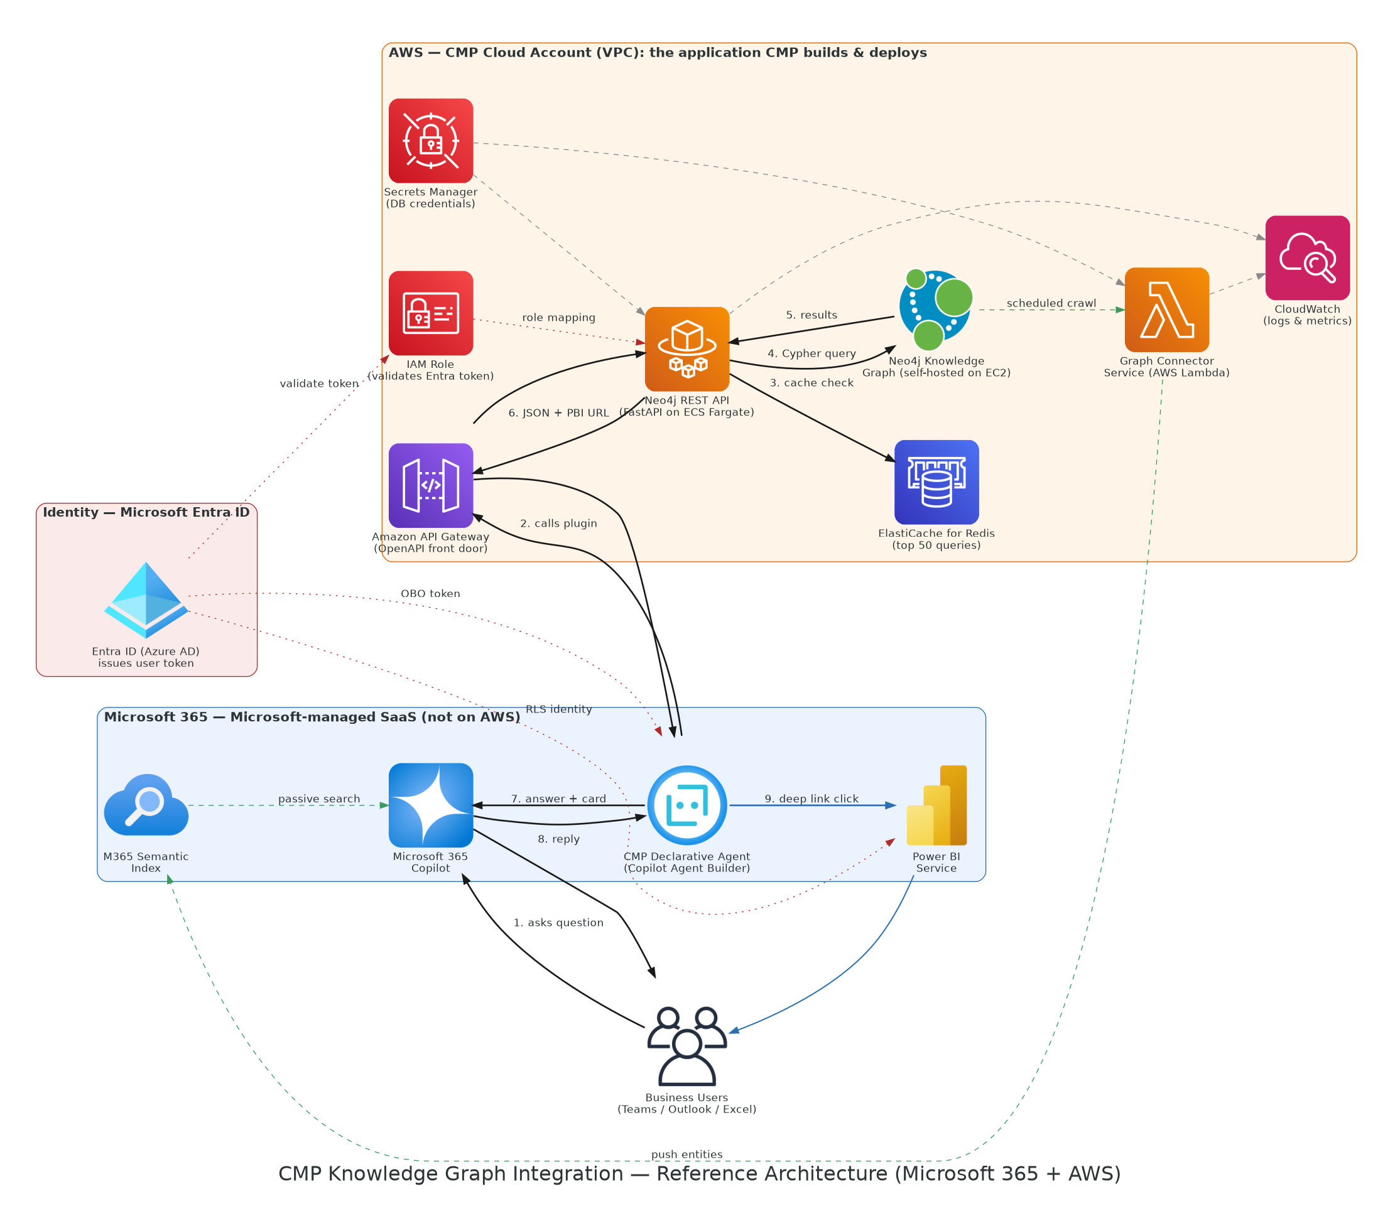
Figure 2. Reference architecture — Microsoft 365 SaaS on one side, the CMP application on AWS on the other.
Follow the numbered arrows in the middle of the picture — they are the main path a question takes:
1. The user asks a question inside Microsoft 365 Copilot.
2. Copilot passes the question to the CMP Declarative Agent, which calls the API Plugin.
3. The request arrives at Amazon API Gateway on AWS. Think of this as a secure front door — it checks the request is well-formed and enforces the OpenAPI contract before letting it through.
4. API Gateway hands the request to the Neo4j REST API. This is a FastAPI (Python) service running as a container on AWS ECS Fargate.
5. The REST API checks the Redis cache first — this is Amazon ElastiCache for Redis. If this exact question was asked recently, the answer comes back immediately, with no need to query Neo4j again.
6. If it is a new question, the REST API sends a Cypher query to the Neo4j Knowledge Graph. CMP self-hosts Neo4j on an EC2 instance inside its own AWS account, so the graph data never leaves CMP's walls.
7. Neo4j sends back the raw graph results — nodes, relationships, and scores.
8. The REST API turns those results into clean JSON and builds the Power BI filter URL, then sends the answer back up through API Gateway to the Agent and Copilot.
9. If the user clicks the ‘View in Power BI’ button, Power BI Service opens, already filtered.
Three more paths run alongside the main one:
- Green dashed line — a separate Graph Connector Service, running on AWS Lambda, copies Neo4j facts into the M365 Semantic Index on a set schedule. This is how Copilot can answer simple ‘what is X’ questions without calling the REST API at all.
- Red dotted line — Microsoft Entra ID (Azure AD) issues an identity token for every user, because Copilot signs users in there. That token travels with the request; on AWS, an IAM role validates the token and maps the user to a Neo4j role, so the REST API and Power BI only show each person the data they are allowed to see.
- Grey dashed line — AWS Secrets Manager holds passwords and connection strings safely, so no secret is ever hard-coded. Amazon CloudWatch watches for errors and slow queries across both the REST API and the Graph Connector.

3.2 End-to-End Sequence — What Happens When a User Asks a Question
A reference architecture diagram shows where things run. A sequence diagram shows the order things happen in, step by step, over time. This is useful for engineers building or debugging the integration.
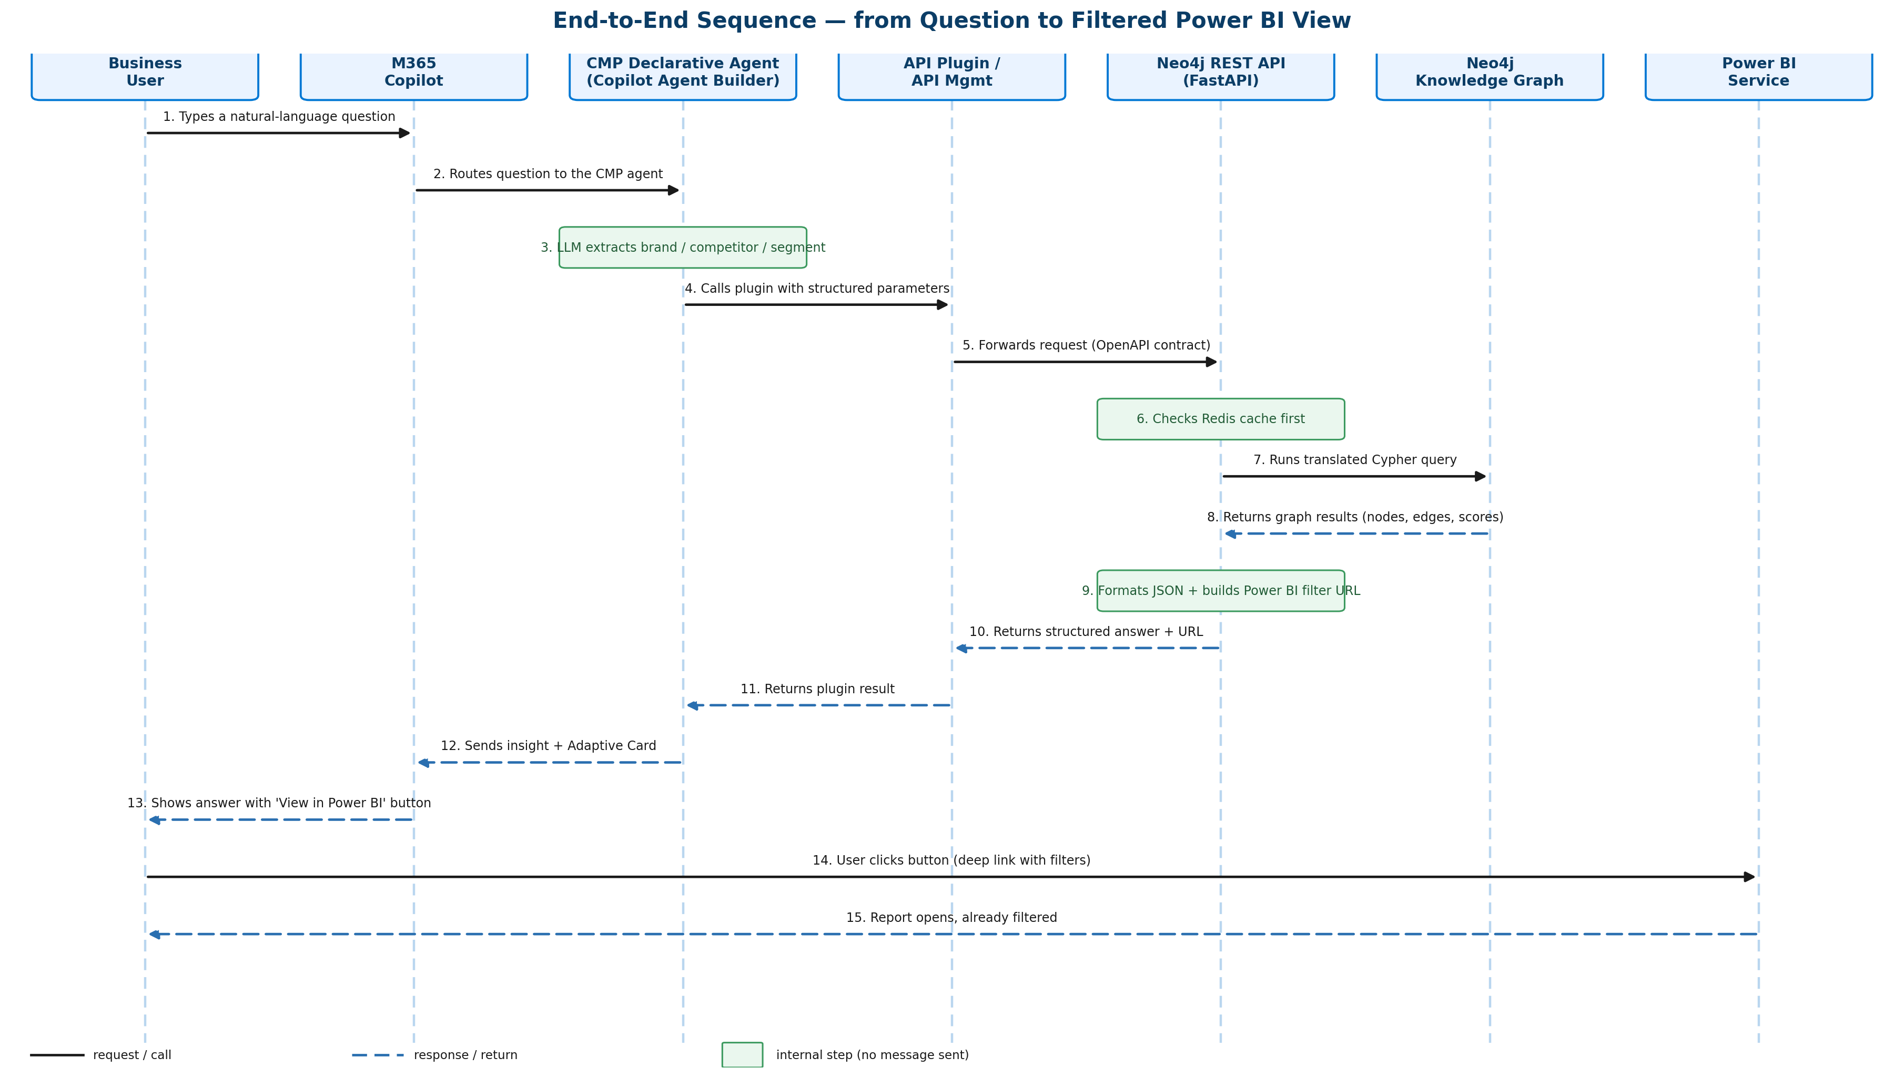
Figure 3. The full sequence of messages, from question to filtered Power BI view.
Time runs down the page. Each column is one part of the system. Each arrow is one message, in the order it happens.
The user types a question (step 1), and it travels through Copilot and the Declarative Agent, which quietly works out the brand, competitor, and region being asked about (step 3). The Agent then calls the API Plugin (step 4), which forwards the request to the Neo4j REST API (step 5).
The REST API first checks its cache (step 6) — a shortcut for questions asked recently. If needed, it runs the real query against Neo4j (step 7) and gets results back (step 8). It then packages the answer and builds the Power BI link (step 9), and the response travels back up through the same chain (steps 10–12) until Copilot shows the user a written answer with a button (step 13).
The last two steps are the pay-off: the user clicks the button (step 14), and Power BI opens already showing the right, filtered view (step 15) — no manual re-filtering needed.

3.3 Security Architecture — Making Sure Users Only See What They Are Allowed To See
This is the same idea as the main sequence, but focused only on identity and permissions. It matters because Copilot will make Knowledge Graph data far easier to reach — so the permission checks have to be airtight, end to end, every single time.
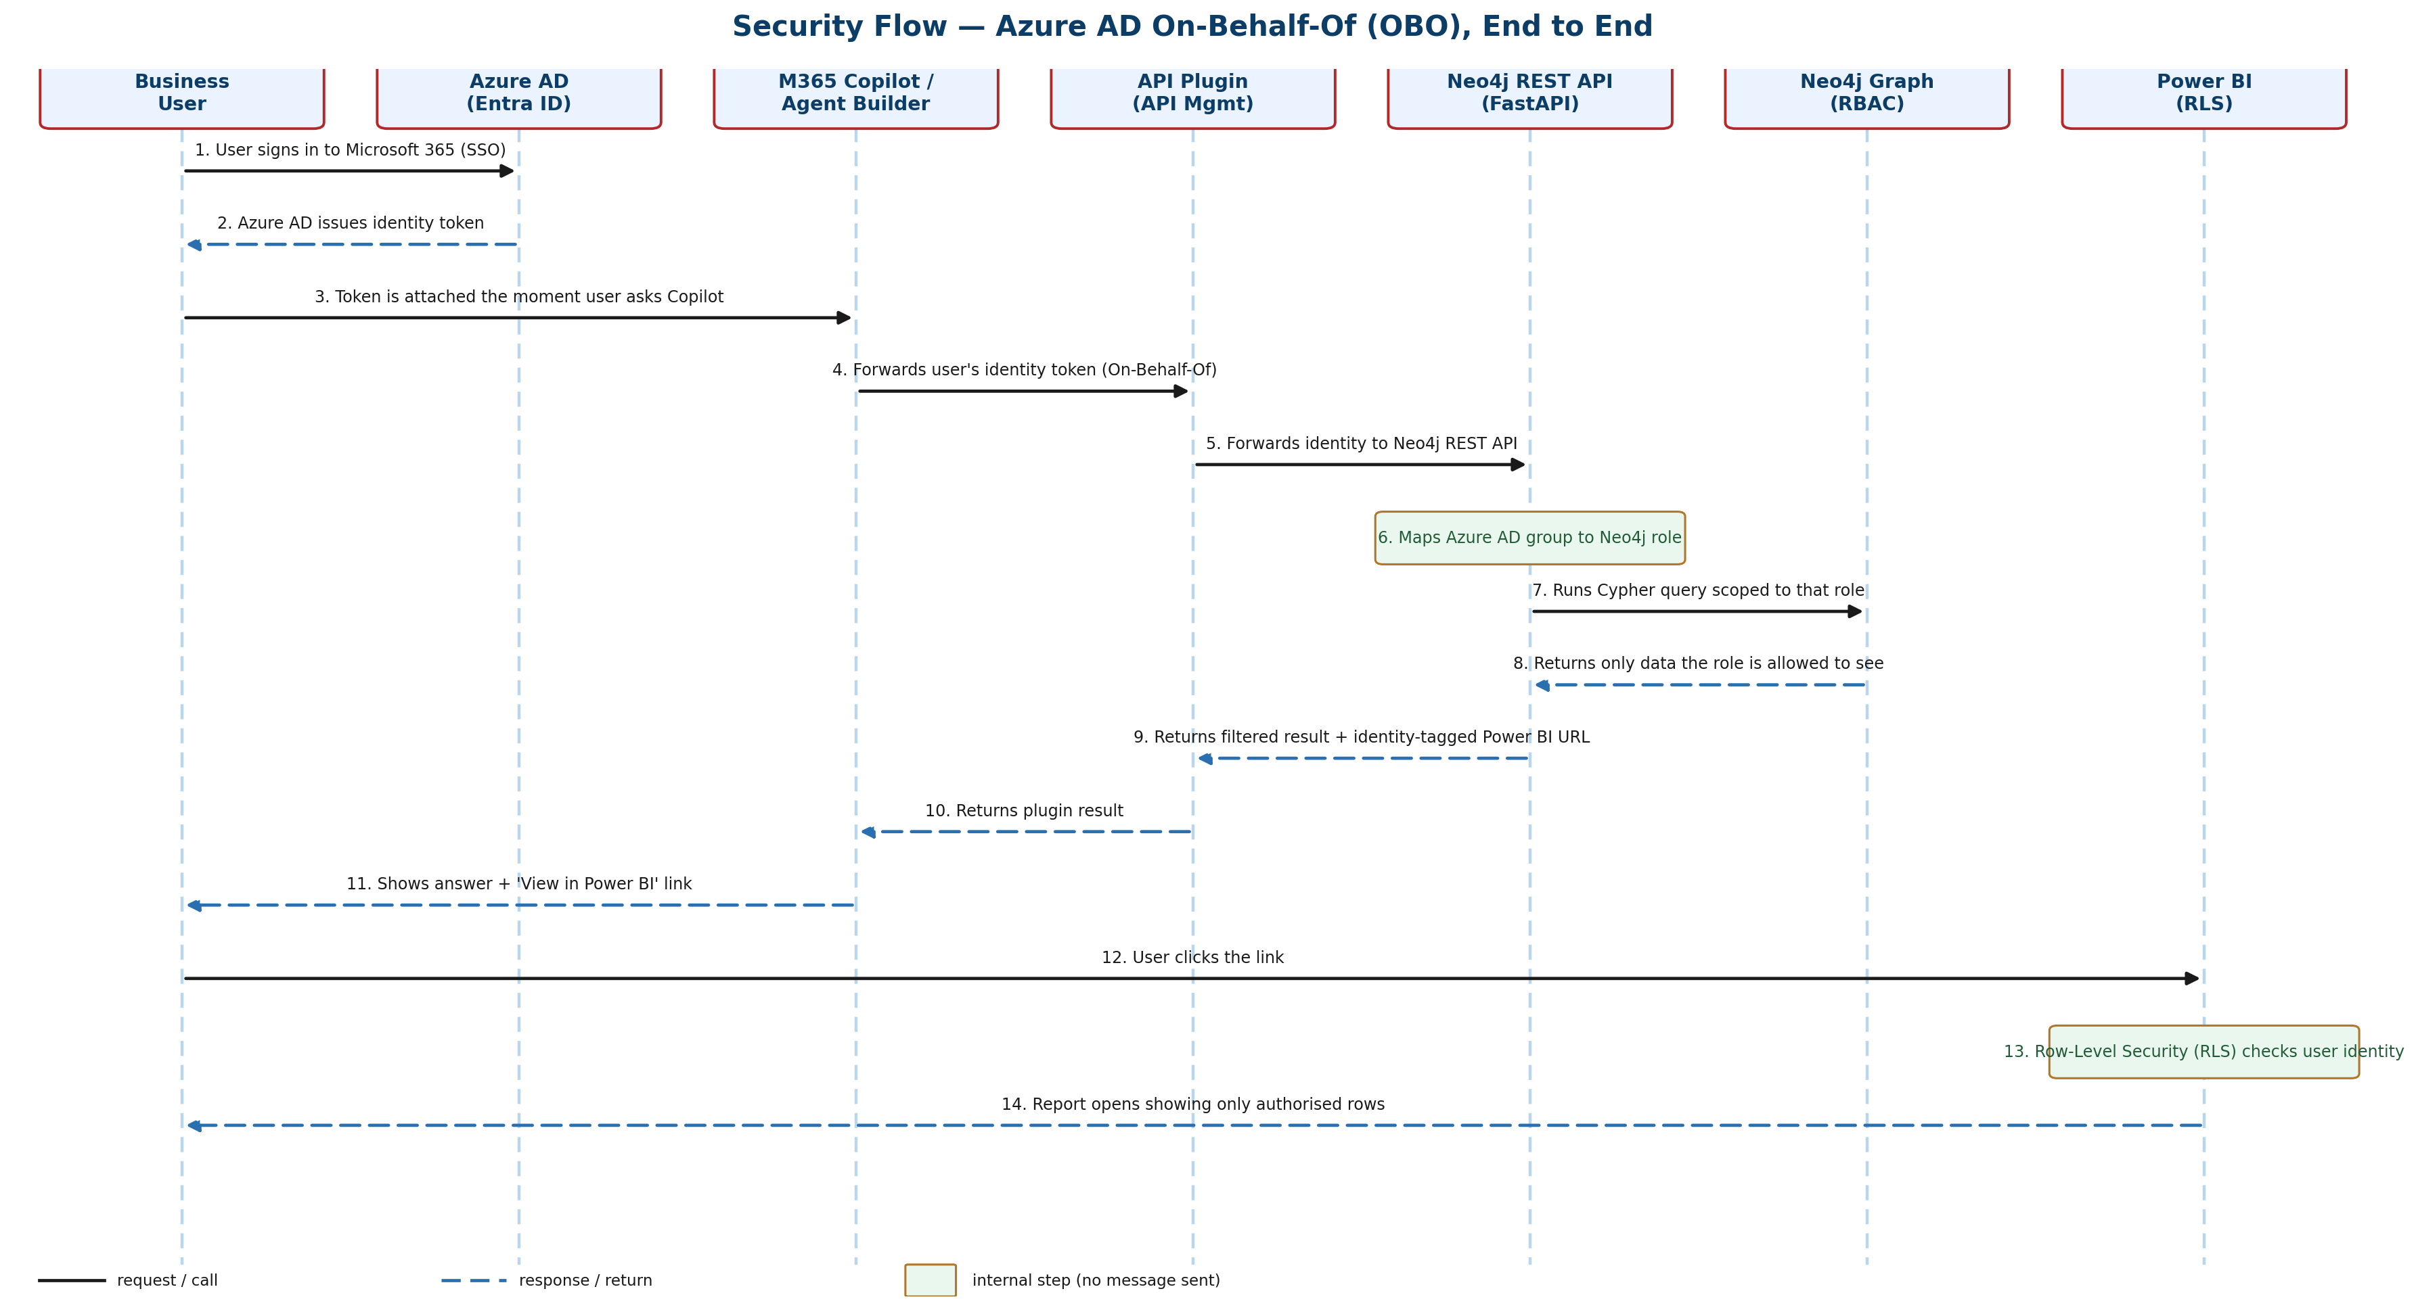
Figure 4. The Azure AD On-Behalf-Of (OBO) flow, from sign-in to Power BI Row-Level Security.
The user signs in to Microsoft 365 once (step 1), and Azure AD (also called Entra ID) issues them an identity token (step 2). From that point on, this token is attached to everything the user does in Copilot (step 3).
When the user asks a question, that same token — not a generic service account — travels with the request. This is called an On-Behalf-Of, or OBO, flow, because the system is always acting on behalf of the real person, never as itself (steps 4–5). The Neo4j REST API maps the user's Azure AD group to a role inside Neo4j (step 6), and only runs the query for the parts of the graph that role can see (steps 7–8).
The same identity is carried into the Power BI link that gets built (step 9), so when the user finally clicks through to Power BI (step 12), Power BI's own Row-Level Security (RLS) applies a second, independent check (step 13) before showing the report (step 14).
Why two checks matter
Neo4j applies its own role check, and Power BI applies RLS again, independently. If either system is ever queried directly — bypassing Copilot — the same user still only sees what they are allowed to see. Security does not depend on the user only ever using Copilot.

3.4 Entity Mapping & Context Passing — Connecting Neo4j Names to Power BI Names
This is the piece the original document calls the hardest part, and it deserves its own diagram. Names in Neo4j and column values in Power BI tables almost never match exactly.
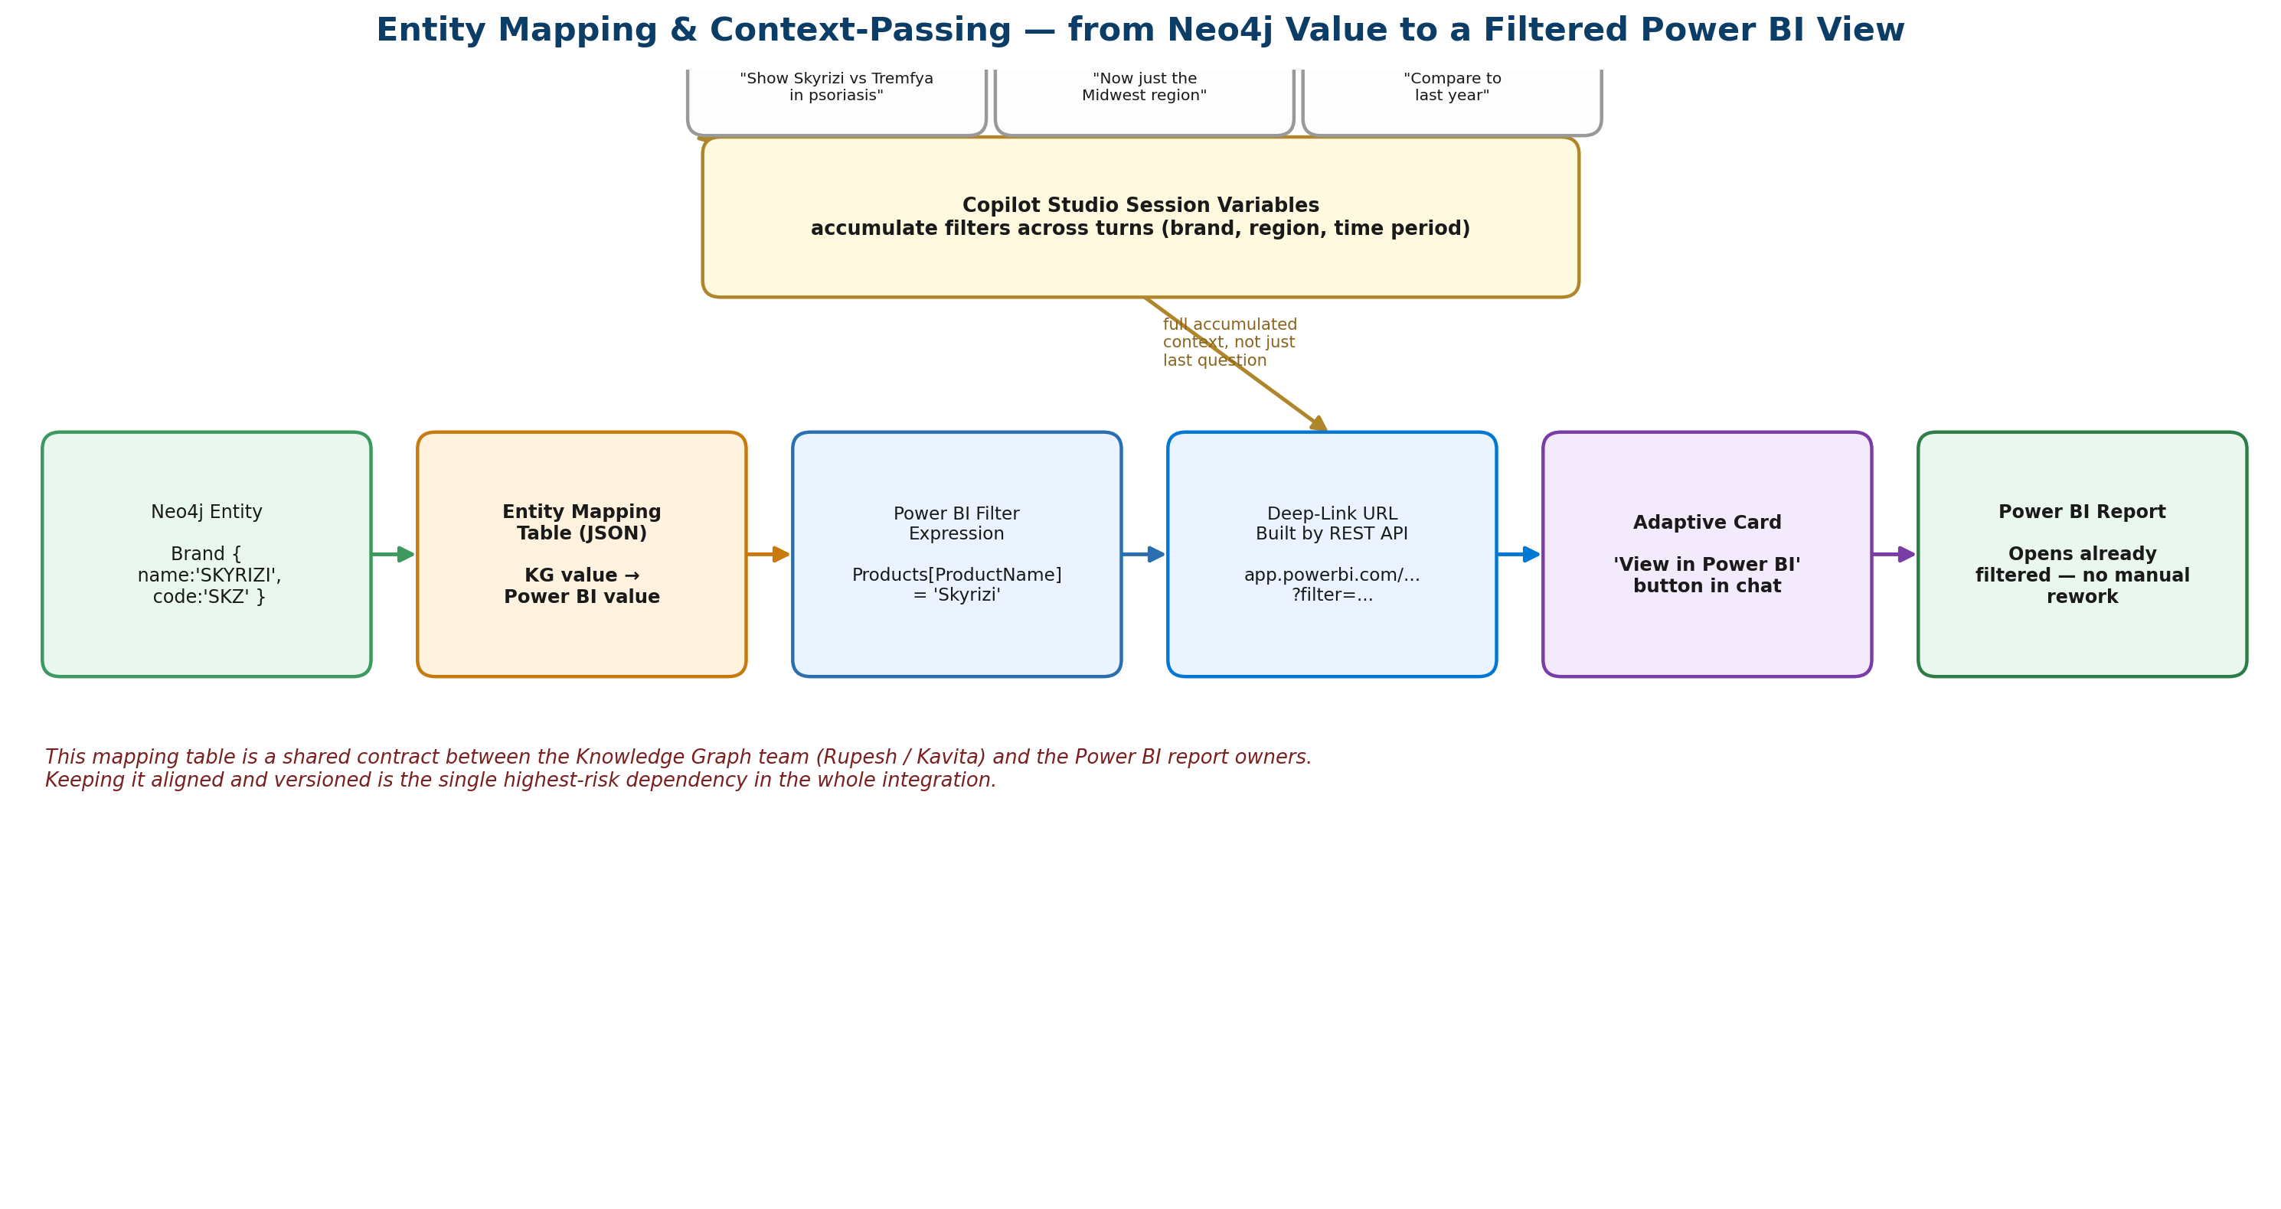
Figure 5. How one Neo4j value becomes a working, pre-filtered Power BI link.
Start on the left. Neo4j stores a brand as a node with properties, for example a code like ‘SKZ’ and a name like ‘SKYRIZI’, written in capital letters.
That value passes through the Entity Mapping Table — a small, deliberately simple lookup list, kept as a JSON file or a database table. It is not clever code; it is just a dictionary that says ‘this Neo4j value equals this Power BI value’, for example ‘SKYRIZI’ becomes ‘Skyrizi’.
Once translated, the value slots into a normal Power BI filter expression, which then becomes part of a Power BI web address — a link that already has the right filters baked in. That link is placed inside an Adaptive Card, which is the button the user sees and clicks inside the Copilot chat. Clicking it opens the Power BI report, already filtered, with no extra work from the user.
The box at the top shows something extra: real conversations rarely stop at one question. If the user follows up with ‘Now just the Midwest region’ and then ‘Compare to last year’, the agent remembers those filters as session variables. Every new Power BI link is built from the full accumulated context, not just the latest sentence — so the second and third clicks are just as accurate as the first.
Highest-risk dependency
This mapping table is a shared contract between the Knowledge Graph team (Rupesh and Kavita) and the Power BI report owners. It must be agreed and versioned before serious build work starts, and re-checked whenever either side renames a field. Getting this alignment right early matters more than any single technical decision in the whole project.

4. Connecting Neo4j to Copilot

4.1 Mechanism A — Microsoft Graph Connector (passive knowledge)
A Graph Connector is a scheduled crawler. It walks through Neo4j periodically, picks up entities and their properties, and pushes them into Microsoft's Semantic Index — the knowledge store that M365 Copilot searches before answering anything. Once indexed, KG entities are findable by Copilot the same way it finds SharePoint documents or Teams messages.
What it is good for:
- Brand profiles, therapy descriptions, competitor overviews
- Stable or slowly-changing facts from the KG
- Any entity a user might search for by name without needing graph traversal
What it cannot do:
- Dynamic graph traversal (e.g. ‘find the path between Drug A and Patient Population B through 3 hops’)
- Real-time aggregation queries
- Anything requiring Cypher-level computation at query time
How to build it: write a connector service (AWS Lambda or a container) that queries Neo4j on a schedule, transforms each node into a Microsoft Search Item (JSON), and pushes it via the Microsoft Graph API to /external/connections/{id}/items. Registration is done in Microsoft Entra ID (Azure AD) and the Microsoft 365 Admin Center.

4.2 Mechanism B — API Plugin with Declarative Agent (active intelligence)
This is where the real power lives. A Declarative Agent is a custom, scoped version of Copilot. It has its own instructions, domain knowledge, and tools — and it looks like native Copilot to the user, not a third-party app. Users access it from the M365 Copilot side rail. The agent is built with Copilot Agent Builder, the tool inside Microsoft 365 Copilot for creating declarative agents.
The agent calls an API Plugin when it needs to answer a question. The API Plugin is the Neo4j REST API described in OpenAPI format, so Copilot understands what questions it can answer and what parameters to pass. This ‘call an external API’ step is an agent action attached to the declarative agent.
Important note on tooling for the API Plugin
The no-code Copilot Agent Builder experience is focused mainly on knowledge sources (SharePoint, Microsoft Graph, files, web). Attaching a custom API Plugin action that calls the Neo4j REST API may not be available in every tenant's Agent Builder. If it is not, the same declarative agent can be authored with the Microsoft 365 Agents Toolkit (in VS Code) or Copilot Studio, both of which fully support custom API Plugin actions. The agent stays a declarative agent either way — only the authoring tool changes. Confirm this capability early, as it is a prerequisite for the active, query-time path.
Both mechanisms are needed
Graph Connector handles passive entity discovery — ‘what is X?’. API Plugin handles dynamic, query-time graph intelligence — ‘what is the relationship between X and Y?’. They complement each other.

4.3 The Neo4j REST API Wrapper — the Most Critical Component
This layer sits between Copilot and Neo4j. It has three jobs.

Job 1 — Intent to Cypher translation
Approach | How it works | Pros | Cons
Template-based | Pre-written Cypher with parameters plugged in | Fast, predictable, safe | Limited to anticipated queries
LLM-generated Cypher | Send NL query to Claude/GPT-4o, get Cypher back, execute | Handles any question | Slower; risk of bad queries
Hybrid (recommended) | Templates for known types, LLM fallback for novel ones | Best of both | More to build initially
Safety rule
The Neo4j database user the API connects with must have read-only access. This prevents any LLM-generated Cypher from accidentally modifying the graph.

Job 2 — Result formatting
Raw Neo4j output is graph data — nodes and relationships. Copilot expects clean JSON that a language model can turn into a sentence. The API must translate graph results into structured, human-readable payloads that include both the insight and the Power BI filter parameters needed to view the supporting data.

Job 3 — Performance
Graph traversals can be slow (2–5 seconds for complex queries). Copilot users expect near-instant responses. Required mitigations:
- Query result caching (Redis or in-memory) for the 50 most common queries
- Pre-computed aggregations stored as node properties in Neo4j, updated nightly
- Traversal depth limits for real-time queries
- Async / streaming responses for queries that genuinely take time

5. Context Passing from Copilot to Power BI

5.1 How Power BI URL Filtering Works
Every Power BI report hosted on Power BI Service has a URL that accepts filter parameters. When a user clicks a link with these parameters, Power BI opens the report with those filters already applied — no manual re-filtering required.
https://app.powerbi.com/groups/{workspaceId}/reports/{reportId}/ReportSection?filter=TableName/ColumnName eq 'Value' and TableName/Column2 eq 'Value2'
The Neo4j REST API builds this URL as part of every response. The Adaptive Card returned by Copilot includes a ‘View in Power BI’ button that carries this pre-constructed URL.

5.2 The Entity Mapping Problem — the Hardest Part
The names in Neo4j and the column names in Power BI tables almost certainly do not match exactly:
- Neo4j: Brand {name: 'SKYRIZI', code: 'SKZ'}
- Power BI: Products[ProductName] = 'Skyrizi'
A canonical mapping table is required — a lookup that translates KG entity values to Power BI filter values. This is a configuration file (JSON or a database table), not code. It must be maintained whenever either system changes. Figure 5 in Section 3.4 walks through this mapping step by step.

5.3 Three Levels of Power BI Integration
Level | What it does | Effort | When to use
1 — Deep Links | Generate filtered URLs; user clicks to open Power BI in browser | Low | Start here — proves concept with zero risk
2 — Power BI in Teams | Report opens inside a Teams tab; no new browser tab needed | Low-Med | After Level 1 adoption is confirmed
3 — Power BI Embedded | Report renders inline inside the Copilot response itself | High | Only if Level 2 shows strong demand; needs Azure A-SKU or Power BI Premium licensing
Recommendation
Start with Level 1. It proves the concept with zero risk and minimal build time. Move to Level 2 once adoption is confirmed. Evaluate Level 3 only if Level 2 shows strong demand.

5.4 Multi-Turn Conversation Context
Real conversations are not single questions. Users follow up:
- ‘Show me Skyrizi vs Tremfya in psoriasis.’
- ‘Now just the Midwest region.’
- ‘Compare to last year.’
The Declarative Agent must accumulate filter context across turns using session variables. The Power BI URL generated at each turn reflects the full accumulated context — not just the most recent question. This is illustrated at the top of Figure 5 in Section 3.4.

6. Excel Integration
Path | What it does | Best for
Copilot in Excel | API Plugin available in Excel's Copilot sidebar; results inserted as tables | Copilot-licensed users already in Excel
Power Query templates | Pre-built Web connector queries for common KG question types; refreshable | Analysts who want self-serve live data extracts
Python in Excel | Python cells call the Neo4j REST API, return DataFrames as Excel tables | Data science / advanced analytics team only
Recommendation
Power Query templates first — lowest barrier to adoption and works without any Copilot licence. Add Copilot in Excel as M365 Copilot rolls out. Python in Excel for the analytics team only.

7. Security Architecture
Every layer must enforce that users only see data they are authorised to see. The On-Behalf-Of (OBO) flow in Azure AD passes the user's identity from Copilot all the way through to Neo4j and Power BI. Section 3.3 (Figure 4) shows this flow end to end, arrow by arrow. In summary:
- User's Azure AD identity token is present from the moment they speak to Copilot.
- The Copilot Agent Builder agent validates the user and passes the token to the API Plugin.
- API Plugin receives the user's identity and forwards it to the Neo4j REST API.
- Neo4j REST API checks the user's role (mapped from Azure AD groups) and filters query results accordingly.
- Power BI URL is generated with the user's identity; Power BI Row-Level Security (RLS) enforces what data they can see.
This means:
- Neo4j needs role-based access control defined (who can see which brands, which therapeutic areas).
- Power BI RLS must already be configured in reports.
- The API Plugin must be registered in Azure AD with proper permission scopes.
- Azure AD groups from CMP's existing directory can map directly to Neo4j roles — no new user management system needed.

8. Challenges and How to Address Them

KG data quality
Problem: Copilot will expose the Knowledge Graph to everyone. Any dirty data, missing relationships, or inconsistent naming in Neo4j will become visible in Copilot responses. Bad KG data is worse than no KG data, because users will trust it.
Mitigation
Conduct a KG quality audit before broad rollout. Define a data quality gate (completeness, naming consistency, relationship coverage) as a prerequisite for production launch.

Question coverage gaps
Problem: Users will ask questions the KG does not have answers for. The agent must gracefully say ‘I don't have that in the knowledge graph’ rather than hallucinating or returning empty results silently.
Mitigation
The REST API must distinguish ‘no data found’ from ‘query failed’ and return explicit messages. Log unanswered questions to inform future KG expansion.

Power BI report maintenance
Problem: Deep-link integration only works if Power BI reports maintain consistent filter columns. If a report owner renames a column, the mapping breaks.
Mitigation
Establish lightweight governance: one person owns the entity mapping table and receives notifications when reports are modified.

Latency expectations
Problem: Complex Neo4j traversals over large graphs can take 2–5 seconds. Copilot users expect 2–3 second total response time.
Mitigation
Implement a caching layer (even simple in-memory caching of the 50 most common queries) before launch. Pre-compute nightly aggregations for known high-traffic query patterns.

Adoption and discoverability
Problem: Users will not use the Declarative Agent if they do not know it exists. Custom agents appear in a side rail in M365 Copilot.
Mitigation
Plan an internal launch: announce in relevant Teams channels, record a 2-minute demo video, pin the agent in key channels.

Natural language entity extraction
Problem: Copilot must correctly extract brand names, TAs, and competitors from free-form text. Medical terminology, abbreviations, and misspellings create ambiguity.
Mitigation
Maintain a brand / term glossary as part of the Declarative Agent's instructions. Include common abbreviations and alternate spellings.

9. What NOT to Build
Avoid | Why
A separate chatbot UI | Copilot is rolling out to everyone — use it as the surface. Building another UI duplicates effort and fragments the user experience.
LLM on top of LLM for KG translation | Copilot already has an LLM. The Neo4j API should return structured data, not prose. Chaining LLMs adds latency and cost.
Power BI Embedded (Level 3) in Phase 1 | Validate the concept cheaply with URL deep-links first. Level 3 requires Azure A-SKU licensing and significant build time.
Unified data warehouse merging Neo4j and Power BI | Tempting but out of scope. The entity mapping table is sufficient to bridge the two systems without a costly migration.
Real-time KG updates via connector | Graph Connectors support scheduled crawls (hourly at fastest). Do not try to make them real-time — use the API Plugin for real-time queries instead.

10. One-Line Summary of Each Component
Component | What it does in one line
Graph Connector | Makes KG entities searchable in Copilot without any user action
Declarative Agent | Gives users a domain-specific Copilot mode for CMP pharma intelligence
API Plugin | Connects Copilot's questions to Neo4j's graph traversal engine
Neo4j REST API | Translates intents into Cypher queries and returns clean structured results
Entity Mapping Table | Bridges Neo4j node labels to Power BI column names — the shared contract between teams
Adaptive Card + Deep Link | Carries query context from Copilot into a pre-filtered Power BI report in one click
OBO Auth Flow | Ensures users only see data they are authorised to see, end to end

KEY RISK
The biggest risk to this architecture is not technical — it is the entity mapping table and KG data quality. Both require active coordination between Rupesh and Kavita's KG team and the Power BI report owners. Getting that alignment before any code is written is more important than any single technical decision.

