Logistics Fleet & Orders Platform - Technical Design Document (TDD)

1. Introduction
This document describes the detailed technical design for the Logistics Fleet and Orders Platform.
The platform manages fleet vehicles, drivers, customer orders, and dispatch operations using a
microservices-based architecture. The system is designed for scalability, fault tolerance,
observability, and high availability.
The goal of the system is to efficiently assign vehicles to customer orders while tracking
vehicle locations and ensuring operational transparency.

2. Scope
The scope of this system includes:
• Fleet management (drivers, vehicles, GPS tracking)
• Order lifecycle management
• Dispatch and assignment logic
• API gateway routing
• Service discovery using Eureka
• Authentication and authorization using JWT
• Monitoring and logging infrastructure
• Deployment using Docker and Kubernetes

3. System Overview
The Logistics platform is designed as a distributed microservices architecture.
Each business capability is implemented as an independent microservice.

Core services:
Fleet Service
Order Service
Dispatch Service
Authentication Service
API Gateway
Service Discovery (Eureka)
Observability Stack

4. Architecture Overview
The system uses a microservices architecture where services communicate via REST APIs.
All services are registered with Eureka and accessed through the API Gateway.
Key architectural goals:
Scalability
Loose coupling
Fault isolation
High availability
Cloud readiness

5. Technology Stack
Backend: Java 8, Spring Boot
Service Discovery: Netflix Eureka
API Gateway: Spring Cloud Gateway
Database: PostgreSQL
Messaging: Kafka (optional future extension)
Authentication: OAuth2 + JWT
Containerization: Docker
Orchestration: Kubernetes
CI/CD: Jenkins
Logging: ELK Stack
Monitoring: Prometheus & Grafana

6. Microservices Description
Fleet Service:
Responsible for managing vehicles, drivers, and GPS updates.
Responsibilities
- Register vehicles
- Register drivers
- Track vehicle GPS location
- Maintain vehicle availability status
- Provide available vehicles for dispatch
- Update vehicle status (AVAILABLE / BUSY / OFFLINE)
Order Service:
Handles order creation, status updates, and lifecycle management.
Responsibilities
- Create orders
- Update order status
- Track order lifecycle
- Emit order events
- Maintain SLA time
Dispatch Service:
Assigns vehicles and drivers to orders based on availability.
Responsibilities
- Find nearest available vehicle
- Assign vehicle to order
- Update dispatch records
- Emit dispatch events
- Handle retry logic
Authentication Service:
Manages login and JWT token generation.
Responsibilities
- User login
- JWT token generation
- Token validation
- Role based access

7. Database Design
Primary Entities:
Driver
Vehicle
Order
Dispatch
Location
AssignmentHistory

Relationships:
Driver -> Vehicle (1:N)
Vehicle -> Location (1:N)
Order -> Dispatch (1:1)
Dispatch -> Vehicle (N:1)
Dispatch -> Driver (N:1)

8. ER Diagram Description
The ER model represents relationships between drivers, vehicles, orders, and dispatch records.
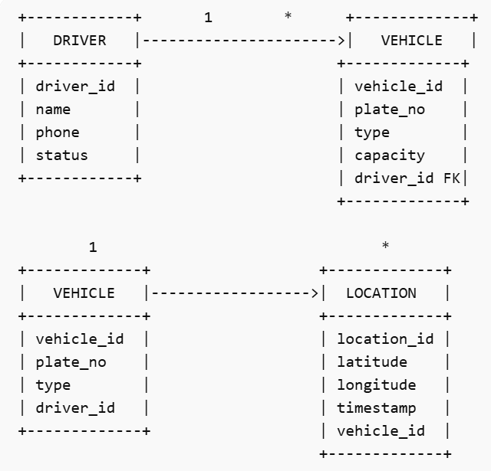
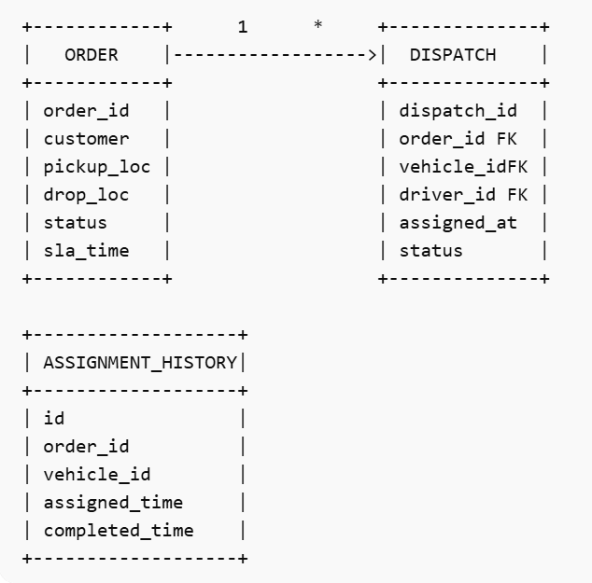
Drivers can operate multiple vehicles.
Vehicles periodically send location updates.
Orders are assigned to vehicles through dispatch records.
Assignment history tracks all assignment events for audit purposes.

9. Class Design
Each microservice follows layered architecture.
Fleet Service | Orders Service | Dispatch Service
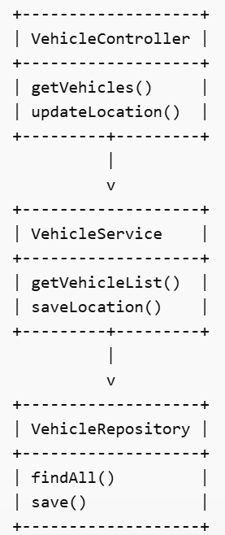 | 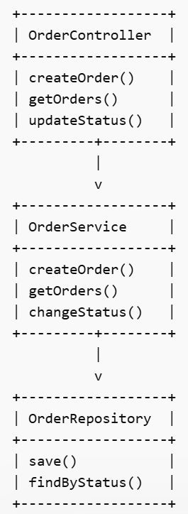 | 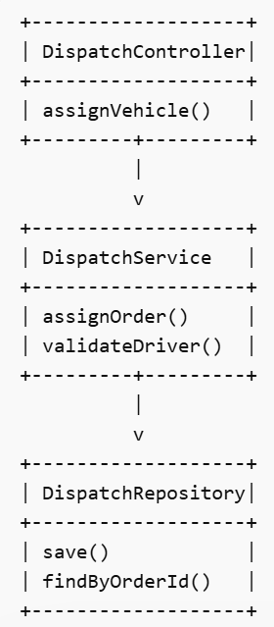

Controller Layer:
Handles HTTP requests.

Service Layer:
Implements business logic.

Repository Layer:
Handles database access.

Entity Layer:
Represents database tables.

10. API Design
Fleet APIs:
GET /api/vehicles
GET /api/drivers
POST /api/location/update

Order APIs:
POST /api/orders
GET /api/orders
GET /api/orders/{id}
PATCH /api/orders/{id}/status

Dispatch APIs:
POST /api/dispatch/assign
GET /api/dispatch/{orderId}

11. Security Design
Security is implemented using OAuth2 and JWT tokens.

Authentication Flow:
User logs in via Auth Service.
JWT token is generated.
Token is validated at API Gateway.
Requests are forwarded to internal services.

Role Based Access Control:

ADMIN
DISPATCHER
DRIVER

12. Sequence Flow
Order Assignment Flow:

1 Dispatcher creates order.
2 Order Service stores order.
3 Dispatch Service requests available vehicles.
4 Fleet Service returns available vehicles.
5 Dispatch Service assigns vehicle.
6 Dispatch record stored.
7 Order status updated.

13. Logging Strategy
Logging framework used: SLF4J with Logback.

Types of logs:

Application logs
Error logs
Audit logs
Security logs

All logs are shipped to ELK stack for centralized monitoring.

14. Monitoring and Observability
Metrics collection is implemented using Prometheus.
Key metrics:
API latency
Error rate
CPU usage
Memory consumption
Vehicle assignment success rate
Dashboards are visualized using Grafana.

15. Fault Tolerance
Resilience is implemented using:
Retry mechanism
Circuit breaker (Resilience4j)
Timeout configuration
Fallback methods

16. Scalability Strategy
Each microservice can scale independently using Kubernetes.

Horizontal scaling is supported via auto scaling policies.
Database read replicas can be added for high read traffic.

17. Deployment Architecture
Deployment pipeline:
Developer -> Git -> Jenkins -> Build -> Docker Image -> Container Registry -> Kubernetes Deployment
Production cluster runs multiple instances of each microservice.

18. CI/CD Pipeline
Steps:
Code commit to Git
Build using Maven
Static code analysis using SonarQube
Docker image creation
Automated testing
Deployment to staging
Approval for production deployment

19. Data Privacy
Sensitive information such as customer phone numbers and driver personal data
is masked in logs.
Encryption is applied for sensitive fields.

20. Performance Optimization
Database indexing
Caching using Redis
Efficient query design
Pagination in APIs
Connection pooling

21. Disaster Recovery
Regular database backups
Multi-zone deployment
Failover strategy
Automated recovery scripts

22. Future Enhancements
AI-based vehicle dispatch optimization
Route optimization algorithms
Real-time analytics dashboards
Integration with IoT devices for vehicle telemetry

23. Risks and Mitigations
Service failure -> use circuit breakers
Database overload -> use caching
Network latency -> use asynchronous messaging
Security threats -> use strict authentication

24. Testing Strategy
Unit testing using JUnit
Integration testing using Testcontainers
API testing using Postman
Performance testing using JMeter

25. Conclusion
This Technical Design Document outlines the complete architecture and design
for the Logistics Fleet and Orders Platform.

The microservices architecture ensures scalability, maintainability,
and resilience while supporting modern cloud deployment practices.

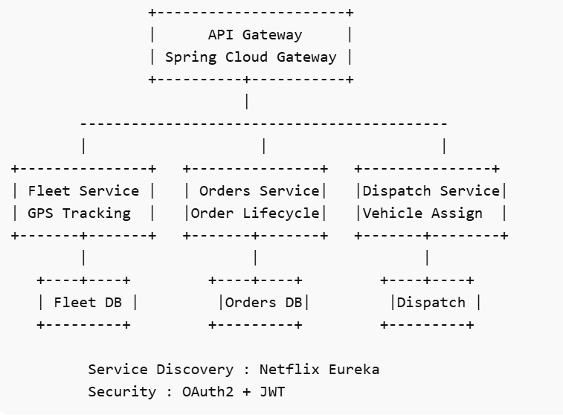



Fleet Service | Orders Service | Dispatch Service
 |  | 

Fleet APIs
GET /api/drivers
GET /api/vehicles
POST /api/location/update
{
"vehicleId":101,
"driverName":"Rahul",
"latitude":18.5204,
"longitude":73.8567,
"status":"AVAILABLE"
}
Orders APIs
POST /api/orders
GET /api/orders
GET /api/orders/{id}
PATCH /api/orders/{id}/status

Dispatch APIs
POST /api/assign
GET /api/dispatch/{orderId}

