**PreparedStatement**:

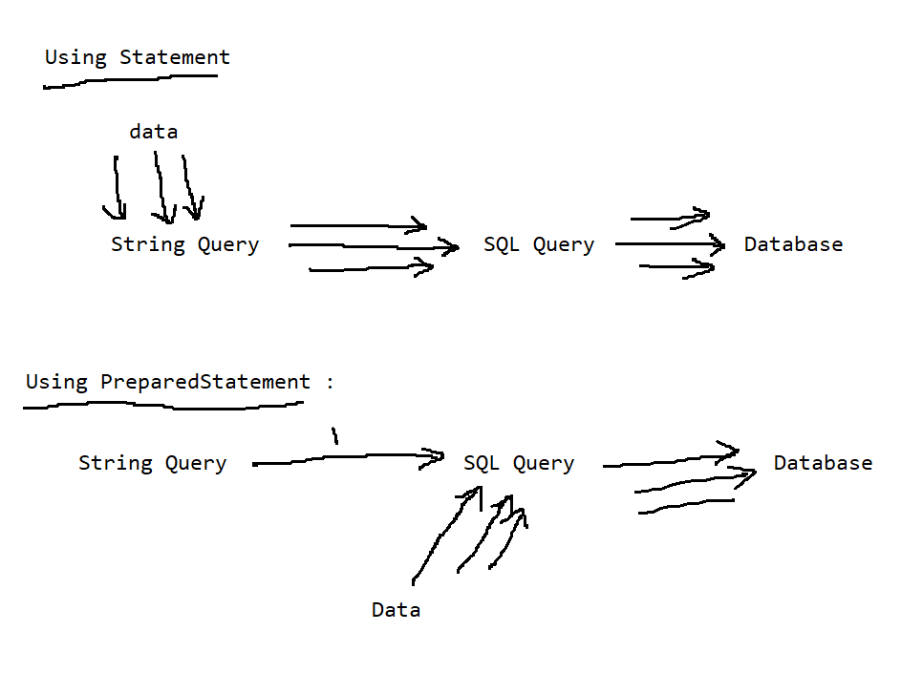

**Using Statement**:

package p1;

import java.sql.Connection;

import java.sql.DriverManager;

import java.sql.SQLException;

import java.sql.Statement;

import java.util.Scanner;

public class Insert {

public static void main(String[] args)throws ClassNotFoundException, SQLException{

Class.forName("oracle.jdbc.driver.OracleDriver");

Connection con = DriverManager.getConnection("jdbc:oracle:thin:@localhost:1521:xe", "system", "manager");

Statement st = con.createStatement();

Scanner sc = new Scanner(System.in);

char choice;

do{

System.out.print("Enter Rno: ");

int rno = sc.nextInt();

sc.nextLine();

System.out.print("Enter Name: ");

String name = sc.nextLine();

System.out.print("Enter Course: ");

String course = sc.nextLine();

System.out.print("Enter Fees: ");

int fees = sc.nextInt();

String q = "insert into students values("+rno+",'"+name+"','"+course+"',"+fees+")";

int count = st.executeUpdate(q);

System.out.println(count+" Row(s) Inserted");

System.out.print("Press 'y' to insert another record: ");

choice = sc.next().charAt(0);

}while((choice=='y')||(choice=='Y'));

con.close();

}

}

**Using PreparedStatement**:

package p1;

import java.sql.Connection;

import java.sql.DriverManager;

import java.sql.PreparedStatement;

import java.sql.SQLException;

import java.sql.Statement;

import java.util.Scanner;

public class Insert {

public static void main(String[] args)throws ClassNotFoundException, SQLException{

Class.forName("oracle.jdbc.driver.OracleDriver");

Connection con = DriverManager.getConnection("jdbc:oracle:thin:@localhost:1521:xe", "system", "manager");

PreparedStatement pst = con.prepareStatement("insert into students values(?,?,?,?)");

Scanner sc = new Scanner(System.in);

char choice;

do{

System.out.print("Enter Rno: ");

int rno = sc.nextInt();

sc.nextLine();

System.out.print("Enter Name: ");

String name = sc.nextLine();

System.out.print("Enter Course: ");

String course = sc.nextLine();

System.out.print("Enter Fees: ");

int fees = sc.nextInt();

pst.setInt(1, rno);

pst.setString(2, name);

pst.setString(3, course);

pst.setInt(4, fees);

int count = pst.executeUpdate();

System.out.println(count+" Row(s) Inserted");

System.out.print("Press 'y' to insert another record: ");

choice = sc.next().charAt(0);

}while((choice=='y')||(choice=='Y'));

con.close();

}

}

**Example 2**:

package p1;

import java.sql.Connection;

import java.sql.DriverManager;

import java.sql.PreparedStatement;

import java.sql.ResultSet;

import java.sql.SQLException;

import java.sql.Statement;

import java.util.Scanner;

public class Select {

public static void main(String[] args)throws ClassNotFoundException, SQLException{

Class.forName("oracle.jdbc.driver.OracleDriver");

Connection con = DriverManager.getConnection("jdbc:oracle:thin:@localhost:1521:xe", "system", "manager");

PreparedStatement pst = con.prepareStatement("select * from students where course=?");

Scanner sc = new Scanner(System.in);

char choice;

do{

System.out.print("Enter Course: ");

String course = sc.nextLine();

pst.setString(1, course);

ResultSet rs = pst.executeQuery();

System.out.println("RNO\tNAME\t\tCOURSE\tFEES");

System.out.println("--------------------------------------");

while(rs.next()){

System.out.println(rs.getInt(1)+"\t"+rs.getString(2)+"\t"+rs.getString(3)+"\t"+rs.getInt(4));

}

rs.close();

System.out.print("Press 'y' continue: ");

choice = sc.next().charAt(0);

sc.nextLine();

}while((choice=='y')||(choice=='Y'));

con.close();

}

}