Error: Reference source not found
INstaller Design Specification
Version <1.0>
<mm/Sep/2018>

Contents

Contents:

1 Introduction

1.1 Purpose

1.2 Revision history

1.3 A Brief History of DataflowML:

1.4 Hardware Requirements

1.5 Dependencies

1.6 Limitations

1.7 Pre-Installation Process:

1.8 Installation Process:

1.9 Post-Installation Process:

Purpose:

Create script-based (Linux) installer for DataFlowML, which should work for both standalone and also distributed (centralized) installations. The framework should be customizable so that any new 3rd party component can be easily added in future.

Revision history:
The Revision history table shows the date, changes, and authors who have worked on this document.

Version  # | Implemented  By | Revision  Date | Approved  By | Approval  Date | Reason
1.0 | <Author name> | <mm/dd/yy> | <name> | <mm/dd/yy> | Initial Design Definition draft

A brief History of DataflowML:

..................................................................................................................................................................................................................................................................................................................................................................................................................................................

Hardware Requirements:-

The first thing that you need to do is understand the requirements for the installation. Critical items such as system and CPU types, amount of physical memory, and types and sizes of hard disks need to be determined. Installation may fail or the system may not function as expected if any of these requirements are not met. The following presents a discussion of these requirements.

CPU Requirements:
RHEL7 is supported on computer architectures with 64-bit Intel

Memory Requirements:

...................................................
......................................

Server/System Configurations
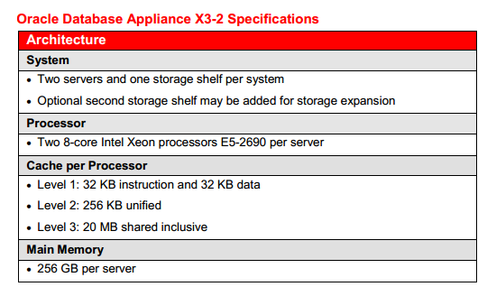

Dependencies
The following components are DataFlowML Installer dependencies:
- JDK 1.8
- PostgreSQL 10.4
- Ambari 2.5.x (it includes spark)
- RabbitMQ 3.3.5
- ElasticSearch 5.6.3
- Tomcat 7.0.68
- FTASecurity 2.0

Limitations
The following components are some limitations while installing through installer:
- JDK 1.8: No Limitation (we can build JDK with installer).
- PostgreSQL 10.4: If we install, the end-user will miss customization to maintain DB server as a separate server and to install PostgreSQL through product installer, the User needs ‘root’ privileges or ‘sudo’ User permissions.
- Ambari 2.5.x: We don't find process for installing or configure through scripts, we checked in vendor documentation. So, Ambari needs to install and configure before installing the product installer.
- RabbitMQ 3.3.5: This needs OpenSSL dependency, so User needs to install "OpenSSL" before installing the product installer.
- ElasticSearch 5.6.3: Need to execute with root privileged user or sudo User.
- FTASecurity 2.0: No Limitations.
- Tomcat 7.0.68: No Limitation.

Installation
We developed installer in 3 stages:

Pre-Installation Process:
Once installer is invoked, the end-user needs to provide the following details:
- Accept License agreement.
- Provide user installation directory.
- Provide Database details like: DB Hostname, Username, DB name, and password.

Installation Process:
The following components are installed at provided user installation directory:
- DataFlowML core component
- Tomcat
- FTASecurity
- RPM Packages like: ElasticSearch and RabbitMQ
- JDK

Post-Installation Process:
At this stage, we modify core component related configuration files and execute DB scripts on provided database:
- Update tomcat server.xml file.
- Update ElasticSearch configuration files and start service.
- Update FTASecurity configuration files.
- Execute DB Load SQL scripts on provided database.
- Update RabbitMQ configuration files.
Once if all above stages are completed successfully, then the status message ‘Product has been installed successfully’ displays.

