**QA Sign-Off for APC 6.12.2 Release**

**Tasks verified by QA:**

|  |  |  |
| --- | --- | --- |
| **TFS #** | **Summary** | **Status** |
| 256536 | APC Veracode Scan - Use of a Broken or Risky Cryptographic Algorithm CWE ID 327 (GeneratePmsKey) | DONE |
| 232851 | Pass 11 digits in CLM02 to TP when present | DONE |
| 253609 | Generated SSO Keys not being saved in Internet Explorer | DONE |
| 235708 | In Master Terminal->View Messages, when From Date is greater than TO Date no Error message shown | DONE |
| 256538 | Link1500: Field 19 : Clicking on the Reset button in link1500 form does not clear the data in data entry popup for couple of fields | DONE |
| 173685 | Link 1500: Field 19 retaining dropdown selection and zip codes for a new claim. Happening only in IE | DONE |
| 258725 | Link1500: Data entry for Field 19 is not getting saved after form save | DONE |

**Bugs raised by QA (Existing):**

|  |  |  |  |
| --- | --- | --- | --- |
| **Defects Identified** | **Defects Closed** | **Defects Deferred** | **Defects As designed** |
| 5 | 1 | 4 | 0 |

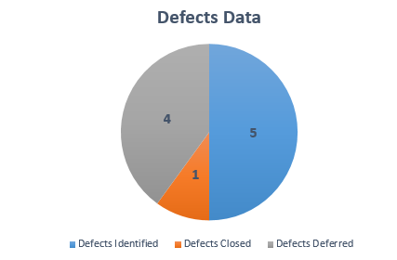

**Deferred defects list:**

|  |  |  |
| --- | --- | --- |
| **Bug ID** | **Description** | **Status** |
| 261136 | Weblink: UI issues on Payer/Claim Stats and Session Reports page when the uploaded data packet has a large dollar amount | Deferred |
| 261140 | Link1500: State field under Supervising Provider (Field 19) is not getting populated correctly | Deferred |
| 261181 | Link1500 Field 19: Calendar is not displaying for Date Last Seen in Firefox Browser | Deferred |
| 261310 | Different success messages are displaying when a payer is added to the Favorite list in LinkUB | Deferred |

**Note**: All these defects were existing ones and moved to Patch Releases (AllPayerClaims\Patch Release)

**Test Cases Designed and Executed by QA:**

|  |  |  |  |  |  |
| --- | --- | --- | --- | --- | --- |
| **TFS Tasks Verified** | **New Test Cases Designed** | **Total Test Cases Executed** | **Manual TC Executed** | **Automation TC Executed** | **TC Blocked** |
| 7 | 16 | 964 | 88 | 876 | 0 |

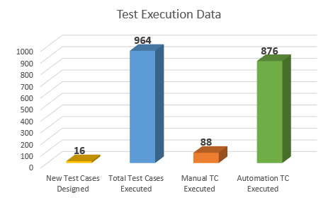

**Automation results:**

** **

**Note**: The failed test case is verified manually and is working fine. Script failure due element properties not identified.