Reviews and Analysis:

In general, the software development work starts from requirement gathering & analysis. In this phase, the business category people prepare BRS and SRS. They conduct review on document for completeness & correctness. The business analyst prepare questions on BRS/SRS
- Are they right requirements?
- Are they complete requirements?
- Are they achievable requirements?
- Are they responsible requirements?
- Are they Testable requirements?
ii. Reviews in Design:
After the completion of analysis & their reviews the designer category people designs the HLD & LLD are the conducts the reviews on the documents for correctness and completeness.
The designer people prepares these questions on HLD& LLD
- Are they understandable designs?
- Are they meeting the right requirements?
- Are they complete design?
- Are they handling errors?
Types of Testing:
- Unit Testing
- Integration testing
- System Testing
- User Acceptance Testing

III. Unit Testing:
After completion of design & their reviews, the programmers start coding, the programmers prepare programs and then test each programs using

Whit Box Testing Technique:
There are four white box testing techniques.
- Basic Path Testing
- Control Structure Testing
- Program Technique Testing
- Mutation Testing
These are applicable for programs.

- Base Path Testing:
During this test developers concentrate on the execution without any runtime errors. To conduct this test, corresponding persons follows the below approach

Approach to conduct base path testing:→

Write a program with respect to LLD
Draw a flow graph for the program
Run that program more than one time to cover
all executable areas.
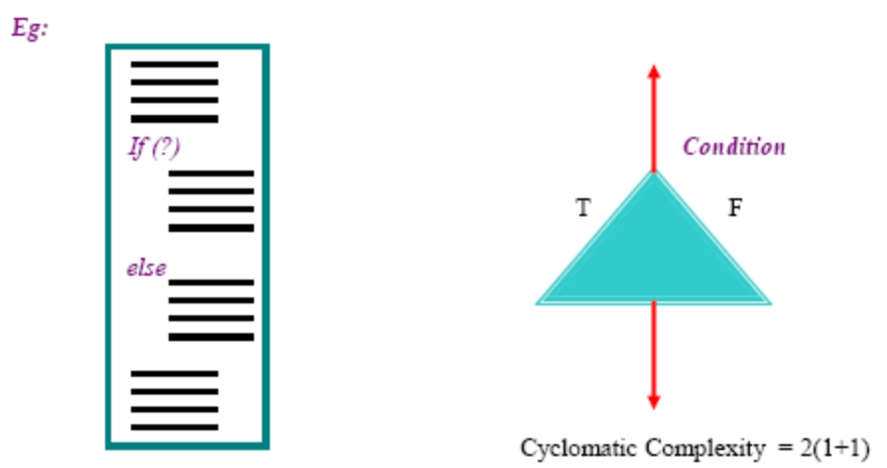
Once should run the above program 2 times to cover all executable areas. A programmer gets confidence that a program is running as properly.

The above program should be run 2 times
- One time to check whether condition is satisfied or not
- Next time to check whether the else condition is satisfied or not without any runtime errors.
II. Control Structure:
During this test, the corresponding programmer concentrates on correctness of program. In the test they verify every program execution, in this test they verify every statement of input & output state.
Ex: Debugging

In general debugging is to troubleshoot programs.
During troubleshoot process programmer check every
Line of program and every input and output of program

III. Program Technique Testing:
During this test, the programmers concentrate on the execution speed of program. The execution speed is not reasonable programmers perform changes in the structure of the program without disturbing functionality of the program.


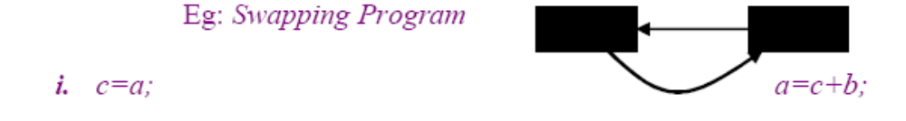

IV. Mutation Testing:

During this test corresponding programmers estimates the correctness & completeness of a program testing.

