**What are sprints?**

* A sprint is a short, time-boxed period when a scrum team works to complete a set amount of work
* “With Scrum, a product is built in a series of iterations called sprints that break down big, complex projects into bite-sized pieces,"

## Do's and Don’ts

* Make sure the team sets and understands the sprint goal and how success will be measured
* Encourage team members to sketch out tasks for all stories, bugs, and tasks that come into the sprint.
* Leave out work where you won’t be able to get the dependencies done, like work from another team, designs, and legal sign-off.
* Don’t pull in too many stories, overestimate velocity, or pull in tasks that can’t be completed in the sprint
* Also, don’t take on a large amount of unknown or high-risk work

# Sprint planning

Sprint planning is done in collaboration with the whole scrum team.

[Sprint planning](https://www.atlassian.com/agile/scrum/sprint-reviews) is a collaborative event where the team answers two basic questions: What work can get done in this sprint and how will the chosen work get done?

* The what
* The How
* The Who
* The Inputs
* The Outputs

Meetings, or "ceremonies":🡪

## Sprint Planning

**Attendees:** development team, scrum master, product owner

**When:** At the beginning of a sprint.

**Duration:** Usually an hour per week of iteration–e.g. a two-week sprint kicks off with a two-hour planning meeting.

**Agile Framework**: Scrum

**Purpose:** the product owner will have a prioritized product backlog. They discuss each item with the development team, and the group collectively estimates the effort involved.

**Daily Stand-up**

**Attendees:**development team, scrum master, product owner

**When:**Once per day, typically in the morning.

**Duration:**No more than 15 minutes.

**Agile Framework:**Scrum

**Purpose:**Stand-up is designed to quickly inform everyone of what's going on across the team.

* What did I complete yesterday?
* What will I work on today?
* Am I blocked by anything?

## Iteration review

**Attendees:**

**Required:** development team, scrum master, product owner  
**Optional:** project stakeholders

**When:** At the end of a sprint or milestone.

**Duration:** 30-60 minutes.

**Agile Framework:** Scrum

**Purpose:**Iteration review is a time to showcase the work of the team. They can be in a casual format like "demo Fridays", or in a more formal meeting structure. This is the time for the team to celebrate their accomplishments, demonstrate work finished within the iteration, and get immediate feedback from project stakeholders.

## Retrospective

**Attendees:** development team, scrum master, product owner

**When:** At the end of an iteration.

**Duration:** 60 minutes.

**Agile Framework:** Scrum

**Purpose:**  Retrospectives help the team understand what worked well–and what didn't.

Retrospectives aren't just a time for complaints without action. Use retrospectives to find out what's working so the team can continue to focus on those areas. Also, find out what's not working and use the time to find creative solutions and develop an action plan.

Scrum Master:🡪

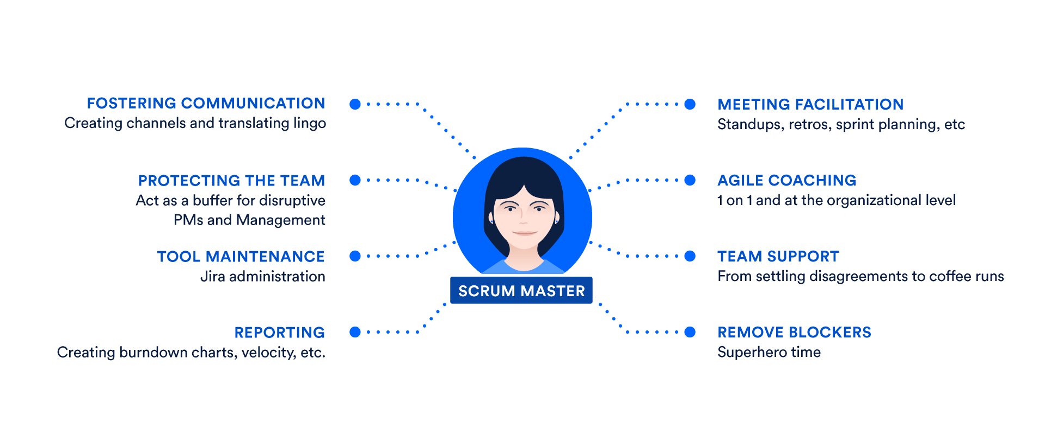

Scum master responsibilities:🡪

1. **Stand-ups** facilitate daily stand-ups (or the daily scrum) as needed.
2. **Iteration/sprint planning meetings** – Protect the team from over-committing, Aid in estimation and sub task creation.
3. **Sprint reviews** – Participate in the meeting and capture feedback.
4. **Retrospectives** – Note areas for improvement and action items for future sprints.
5. **Board administration** – Work as the administrator of the [scrum board](https://www.atlassian.com/agile/tutorials/creating-your-agile-board). Ensure that cards are up to date and the scrum tool, [Jira software](https://www.atlassian.com/software/jira) or otherwise, is working well.
6. **1 on 1s** – Meet individually with team members and stakeholders as needed.
7. **Internal Consulting** – Scrum masters should be prepared to consult with team members and internal stakeholders on how best to work with the scrum team.
8. **Reporting** – Regular analysis of [burndown charts](https://www.atlassian.com/agile/tutorials/burndown-charts) and other portfolio planning tools to understand what gets built and at what cadence.
9. **Blockers** – The scrum master aids the team by eliminating external blockers and managing internal roadblocks through process or workflow improvements.