<http://www.sikulix.com/>

click on Get version 1.3.0

<URl:--> https://launchpad.net/sikuli/+download

**Download**[**sikuli-setup.jar**](https://launchpad.net/sikuli/sikulix/1.0.1)and

* put it in a user writeable folder (preferably home folder in a folder named e.g. SikuliX).
* Do not put it in an existing folder with Sikuli stuff,
* do not put it in any Program folders (Windows) or Applications (Mac).
* just **double click the downloaded sikuli-setup.jar** and follow the dialog.

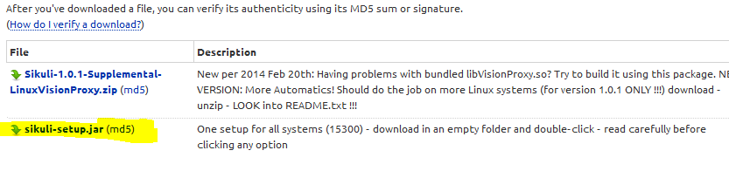

Save file into Disk

home Set Environment path for java:-🡪

Navigation:🡪 windows--🡪 start menu---🡪 Right click on compute-🡪 Properties-----🡪 Advanced systems settings --.click on environment variable,

Create New Variable with Name JAVA_HOME

JAVA_HOME C:\Program Files\Java\jdk1.8.0_65



Double click on Sikuli_setup jar file

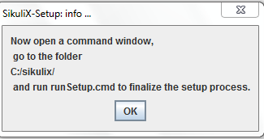

Close Info popup

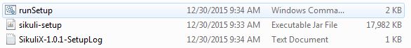

Double click on run setup file

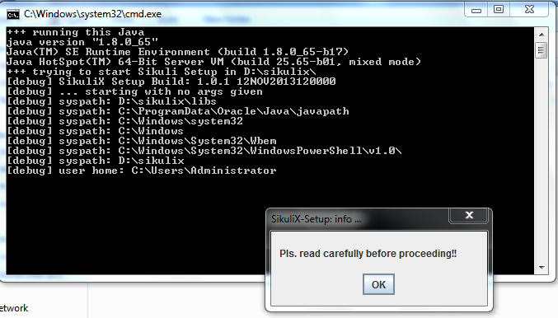

Click on ok

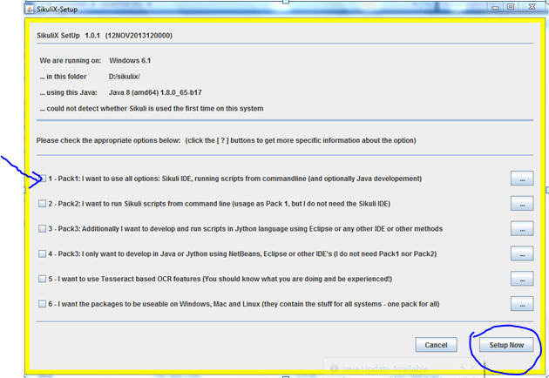

Select All packages, click on setup now

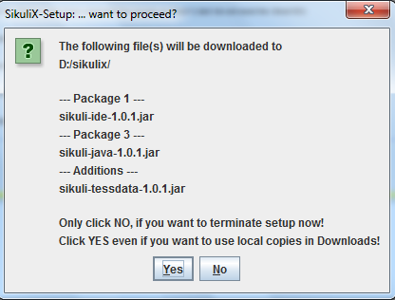

Click Yes to confirm installation

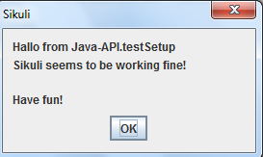

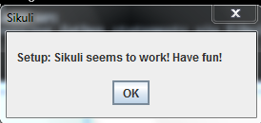

Click ok to complete Installation

* Restart windows once after sikuli installation completed

Once restarted append sikuli working folder path to System path

