**What are sprints?**

* A sprint is a short, time-boxed period when a scrum team works to complete a set amount of work.
* “With Scrum, a product is built in a series of iterations called sprints that break down big, complex projects into bite-sized pieces,"

## Do's and Don’ts

* Make sure the team sets and understands the sprint goal and how success will be measured
* Encourage team members to sketch out tasks for all stories, bugs, and tasks that come into the sprint.
* Leave out work where you won’t be able to get the dependencies done, like work from another team, designs, and legal sign-off.
* Don’t pull in too many stories, overestimate velocity, or pull in tasks that can’t be completed in the sprint
* Also, don’t take on a large amount of unknown or high-risk work

# Sprint planning

Sprint planning is done in collaboration with the whole scrum team.

[Sprint planning](https://www.atlassian.com/agile/scrum/sprint-reviews) is a collaborative event where the team answers two basic questions: What work can get done in this sprint and how will the chosen work get done?

* The what
* The How
* The Who
* The Inputs
* The Outputs

Meetings, or "ceremonies":🡪

## Sprint Planning

**Attendees:** development team, scrum master, product owner

**When:** At the beginning of a sprint.

**Duration:** Usually an hour per week of iteration–e.g. a two-week sprint kicks off with a two-hour planning meeting.

**Agile Framework**: Scrum

**Purpose:** the product owner will have a prioritized product backlog. They discuss each item with the development team, and the group collectively estimates the effort involved.

**Daily Stand-up**

**Attendees:**development team, scrum master, product owner

**When:**Once per day, typically in the morning.

**Duration:**No more than 15 minutes.

**Agile Framework:**Scrum

**Purpose:**Stand-up is designed to quickly inform everyone of what's going on across the team.

* What did I complete yesterday?
* What will I work on today?
* Am I blocked by anything?

## Iteration review

**Attendees:**

**Required:** development team, scrum master, product owner  
**Optional:** project stakeholders

**When:** At the end of a sprint or milestone.

**Duration:** 30-60 minutes.

**Agile Framework:** Scrum

**Purpose:**Iteration review is a time to showcase the work of the team. They can be in a casual format like "demo Fridays", or in a more formal meeting structure. This is the time for the team to celebrate their accomplishments, demonstrate work finished within the iteration, and get immediate feedback from project stakeholders.

## Retrospective

**Attendees:** development team, scrum master, product owner

**When:** At the end of an iteration.

**Duration:** 60 minutes.

**Agile Framework:** Scrum

**Purpose:**  Retrospectives help the team understand what worked well–and what didn't

Scrum Master:🡪

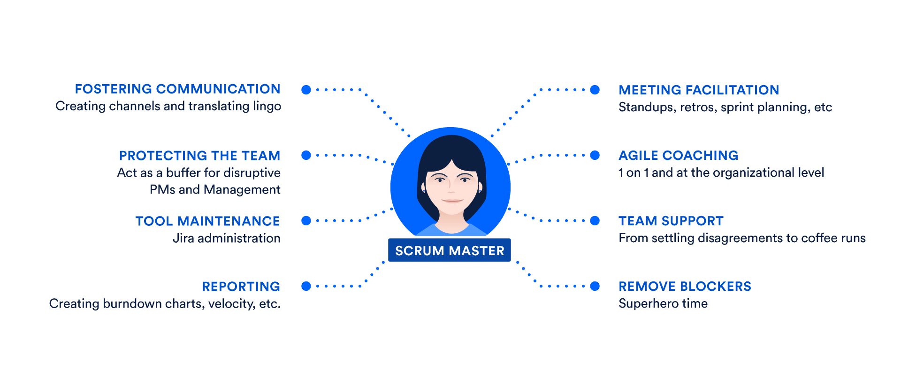

Scum master responsibilities:🡪

1. **Stand-ups** facilitate daily stand-ups (or the daily scrum) as needed.
2. **Iteration/sprint planning meetings** – Protect the team from over-committing, Aid in estimation and sub task creation.
3. **Sprint reviews** – Participate in the meeting and capture feedback.
4. **Retrospectives** – Note areas for improvement and action items for future sprints.
5. **Board administration** – Work as the administrator of the [scrum board](https://www.atlassian.com/agile/tutorials/creating-your-agile-board). Ensure that cards are up to date and the scrum tool, [Jira software](https://www.atlassian.com/software/jira) or otherwise, is working well.
6. **1 on 1s** – Meet individually with team members and stakeholders as needed.
7. **Internal Consulting** – Scrum masters should be prepared to consult with team members and internal stakeholders on how best to work with the scrum team.
8. **Reporting** – Regular analysis of [burndown charts](https://www.atlassian.com/agile/tutorials/burndown-charts) and other portfolio planning tools to understand what gets built and at what cadence.
9. **Blockers** – The scrum master aids the team by eliminating external blockers and managing internal roadblocks through process or workflow improvements.