Download Natural Plugin :🡪

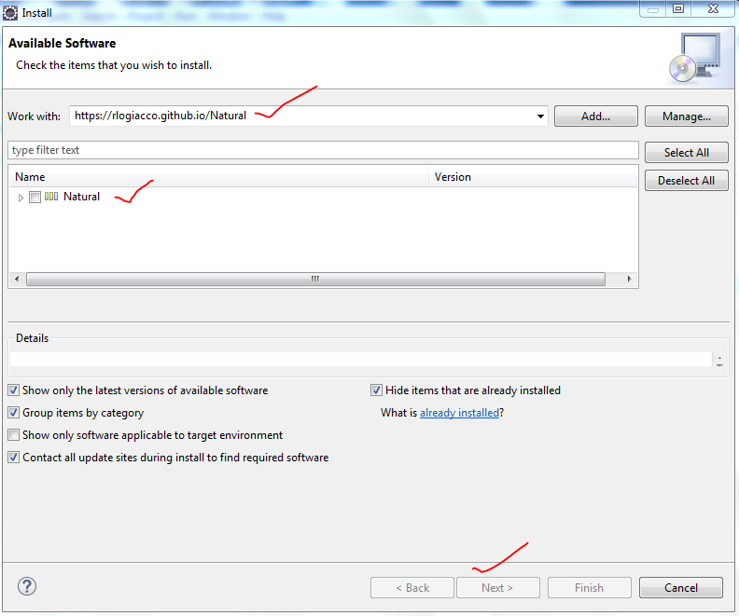

Download Cucumber Jar files: https://jar-download.com/artifacts/io.cucumber/cucumber-java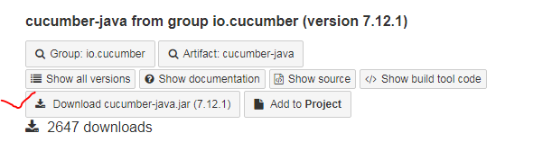

* Click on Download Cucumber java .jar file..
* Unzip file to back up folder

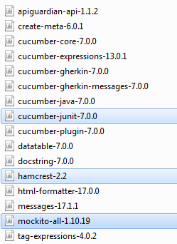

* Download hamcres and ,mockito ,Cucumber junit jar file
* => download from maven repository
* Download selenium jar files in Local folder
* https://www.selenium.dev/downloads/

Download nature plug to write feature files:🡪

http://rlogiacco.github.io/Natural

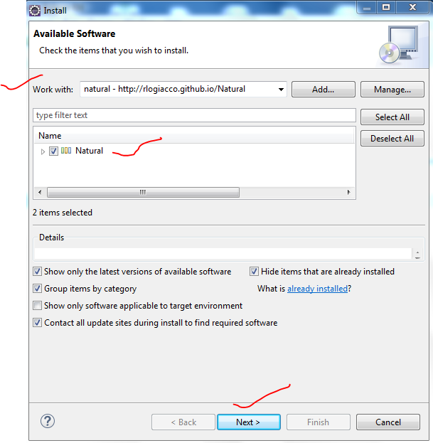

1. Open Eclipse user HELP menu
2. Click on Install New software
3. Type URL at work with click on ADD button
4. Type Key Name as NATURAL and click ok button
5. Select NATUAL check box and proceed for installation
6. After installation restart eclipse

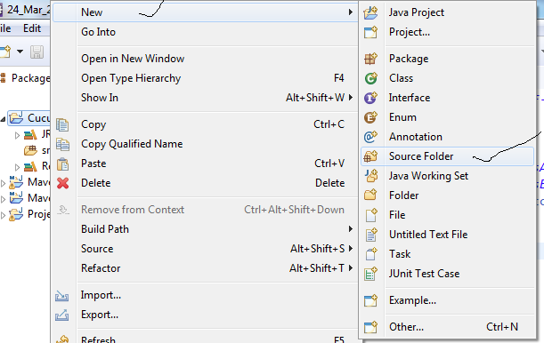

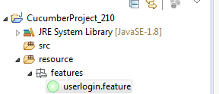

* Create source folder under project and name it as resources
* Crete package under resource folder and name it as “features”
* Create new file and add extension .features [userlogin.features]
* You can find cucumber symbol for file
* It means you natural editor [BDD editor ] is ready to write feature files..
* Enter features file in below format

