Agile Model :

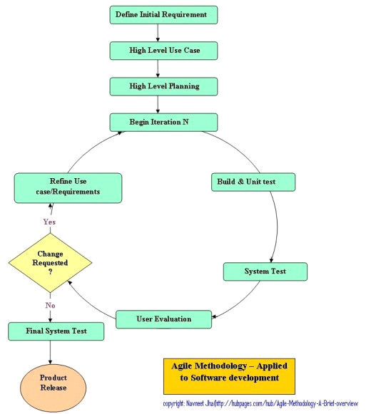

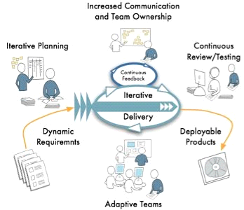

* Agile is most important practical characteristic is that it is based on iterations. An iteration in Agile is a small period of time, usually from 1 week to 4 weeks, where some functionality for the application is built from end to end.
* The agile models, as the title suggest, focuses on 'agility' and 'adaptability' in development.
* Instead of one time consuming and rigid development schedule, agile models involve multiple iterative development schedules that seek to improve the output with every iteration
* Each iteration goes through the all the steps of design, coding and testing. The design is not set in stone and is kept open to last minute changes due to iterative implementation.
* Correcting the various bugs that arise over time.

