Digital Twin Networks: Modeling and Managing Networks Using SDN Principles

Yanala Sunil Reddy
Apex Institute of Engineering Chandigarh University (UGC, AICTE approved)
Mohali, Punjab 22bis70031@cuchd.in

Sonam Sharma
Apex Institute of Engineering Chandigarh University (UGC, AICTE approved)
Mohali, Punjab sonam8805@gmail.com

Abstract—The high pace of the next-generation networks development, such as 5G, IoT, and cloud structures, has led to a high network complexity level and optimization. Conventional methods are usually not real-time adaptive, predictive, and resilient to failures or changing traffic patterns. To overcome such limitations, this paper proposes a Digital Twin Network (DTN) scheme with the use of Software Defined Networking (SDN) concepts. The framework provides the support of scenario- based simulations, persistent monitoring, and predictive decision- making by providing a synchronized virtual replica of the physical network. Different conditions such as load balancing, link failures and congestion were tested with SDN controllers and network simulation tools. Findings show that DTN in combination with SDN improves the use of resources, faster fault recovery, and lowering the latency than traditional SDN methods. These results require rethinking how DTNs can assist the creation of scalable, intelligent, and flexible network infrastructures, and they can be applied to cloud computing and IoT ecosystems, as well as the implementation of 5G and the new 6G networks.
Index Terms—5G/6G, cloud computing, real-time decision- making, software defined networking (SDN), network simulation, virtualisation, predictive modelling

- Introduction
- Background
The development of communication technologies brought more intricate network infrastructures, such as 5G, the Internet of Things (IoT) and mass cloud computing. These networks are defined as high data rate, dynamic traffic patterns and requirements of reliability and low latency. The demands are no longer met by traditional network management techniques that are based on a heavy use of manual intervention and a static network configuration. With the increase in both size and diversity of networks, there is an urgent demand to use intelligent, flexible and automated management systems that can adjust dynamically and simultaneously guarantee the optimal functionality. New paradigms like Software Defined Networking (SDN) and Digital Twin Networks (DTNs) have a positive prospect of solving this since they decouple control and infrastructure and allow virtualized, real-time models of physical networks.
- Problem Statement
Although Software Defined Networking (SDN) has en- hanced network management, much is yet to be done. Tradi-
tional SDN-based systems tend not to cope with dynamic traf- fic volumes, make accurate predictions and recover speedily in case of failure. In addition, lack of a coordinated virtual model constrains the simulation, testing and predicting the behavior of the network in different conditions. These constraints lead to higher latencies, poor use of resources, and decreased resiliency in critical systems, including cloud services, 5G networks, and IoT deployments. It is thus necessary to have a superior architecture that unites the predictive and real-time synchronization features of digital twins and the flexibility and programmability of SDN.
- Objectives
The main aim of this project is to develop and test a Digital Twin Network (DTN) model based on the concept of SDN. The specific objectives are:
  - To create a coordinated model of virtual network to maintain constant monitoring and evaluation.
  - To combine the network management with scenario-based simulations and predictive modeling to make proactive decisions.
  - To evaluate the ability of the DTN-SDN framework to optimize the resources, recover the fault and minimize the latency.
  - To find out the relevance of the proposed framework to more advanced fields like cloud computing, 5G/6G networks, and IoT ecosystems.
- Scope of Study
The study will target developing a proof-of-concept of the DTN-SDN model by evaluating it through simulation. It involves the construction of a software defined network twin and testing it in varied conditions such as load balancing, link failures and the execution of a software defined network during a congested state. The research is not expanded to the large-scale real world implementation although the study is on the simulation and conceptual verification. Furthermore, the energy efficiency and security issues are also not addressed exhaustively and may be the focus of the future research. The key focus is made on the examination of the fundamental network performance metrics such as the resource utilization, the resilience following the failures, and the latency.

- Contribution of the Paper
The key contributions of this study are:
  - Proposing a novel DTN-SDN framework that integrates the predictive capabilities of digital twins with the flexi- bility of SDN.
  - Developing a synchronized virtual twin model with scenario-based analysis and real-time monitoring func- tionalities.
  - Empirically validating the framework through simula- tions, demonstrating improvements over conventional SDN approaches in latency reduction, fault recovery speed, and resource utilization.
  - Highlighting the potential impact of DTNs on future network management, particularly in 5G, IoT, and cloud- based environments.
- Literature Review
- Digital Twin Concept in Networks
Digital Twin (DT) concept has emerged to be a useful method of integrating both physical and virtual systems. According to Tao et al. (2019), a DT is a digital manifestation that can be tracked, simulated, and optimized on-the-fly by providing an indication of the condition and action of physical systems (2019) [7]. Barricelli et al. (2019) [8] provided a deep background on the use of DT in different spheres, claiming that the utilization of DT in networking is in its early stages, and there is a lack of real-life applications. DTs also support predictive analytics and real-time decision-making and are significant to address dynamic network environments (Fuller et al., 2020) [9].
- Software Defined Networking (SDN) Foundations
The Software Defined Networking (SDN) is the network that concentrates the network management and renders it flexible and programmable. Kreutz et al. have disaggregated SDN structure in [10] and observed that the control and data planes are segregated to give greater flexibility in the control. The SDN is programmable thus allowing the network to dynamically respond to the dynamic demands of the traffic as it was noted by Nunes et al. (2014) [11]. Xia et al. (2017) also demonstrated that SDN will play a significant role in the future evolution of the internet, which will enable its subsequent use to the network slicing and allocation of resources (adaptive). The digital twin is a device that is used to simulate the physical environment on a software and technology platform. Digital twin is the method to recreate the real world in software and technology[12].
- Integration of Digital Twins and SDN
The concept of SDN and digital twins integration has be- come recent. The virtualized testbeds that are SDN enabled are capable of behaving like full network replicas so researchers can test out policies prior to deployment [13]. Uddin et al. sug- gested the use of DT-based frameworks of the industrial IoT networks with greater monitoring performance and scalability challenges [14]. Wang et al. (2023) [15] combined DTs with
edge and cloud computing resources to create intelligent and adaptive systems that can react to dynamic network conditions.

- Applications in 5G/6G and IoT
Digital Twin Networking (DTN) has also been researched in new areas, including the IoT, 5G, and 6G. As it was proven by Han et al. (2022) [16], in 5G resource management, DTNs can optimize spectrum allocation and decrease latency. In their model of IoT security, Shi et al. (2021) [17] noted that DT applications can be used to proactively identify vulnerabilities. Jacoby et al. (2020) [18] demonstrated that DTNs are more scalable and resistant to managing massive IoT traffic, especially in real-time smart city networks.

- Research Gaps Identified
  - Limited extension of Digital Twins (DTs) to networks: Although DTs have been extensively studied in manufacturing and industrial systems, their application in communication networks is still in its infancy [19].
  - SDN studies lack predictive DT integration: SDN re- search has improved centralised control and programmability, but it does not use DT-based predictive models for proactive decision-making.
  - Absence of a holistic SDN-driven DTN framework: Existing works focus on discrete aspects (e.g., simulation, monitoring, or testbeds) rather than offering a unified architec- ture that integrates policy, real-time insights, and simulation [20].
  - Insufficient validation under dynamic conditions: Cur- rent DTN studies rarely evaluate fault tolerance, scalability, and adaptability in large-scale, unpredictable traffic environ- ments [21].
  - Need for future-ready resilience: Without this type of integration, DTNs cannot offer the intelligence, flexibility, and reliability required to build 5G, 6G, and IoT ecosystems.

- Methodology
- Proposed DTN-SDN Architecture
The proposed framework is designed as a multi-layered architecture consisting of four tiers [22]:
  - Physical Network Layer: Represents switches, routers, and endpoints that are part of the actual network infrastructure. Traffic and state data are produced in real time by this layer.
  - Digital Twin Layer: Serves as a digital duplicate of the real network. It gathers operational data and simulates possible situations like failures, congestion, or rerouting while maintaining constant synchronisation with the physical layer [23].
  - SDN Controller Layer: In charge of enforcing policies and maintaining global control. The digital twin provides the controller with real-time insights, allowing for proactive decision-making for load balancing, fault recovery, and con- gestion management.

  - Application Layer: Hosts applications for network man- agement and optimisation, including predictive analytics, traf- fic engineering, and QoS monitoring [24].

Workflow Summary
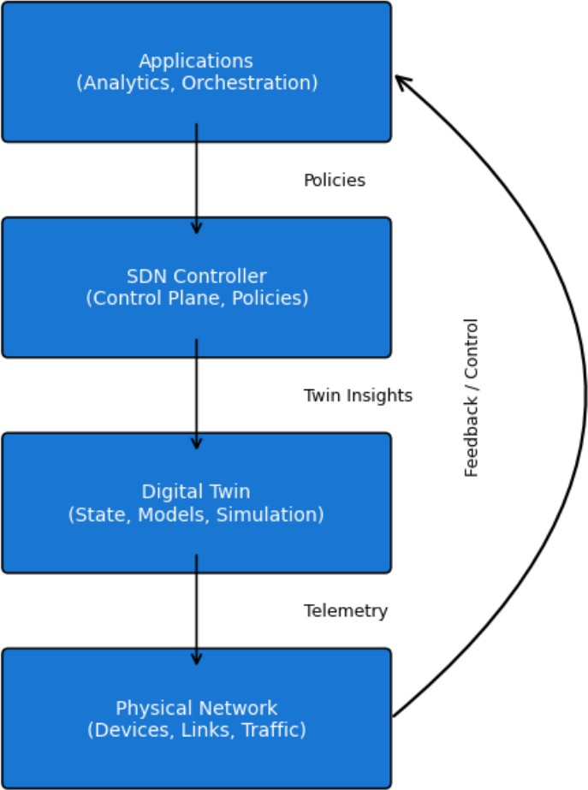

Fig. 1. Logical architecture of the SDN–Digital Twin framework.

Applications define policies that are enforced by the SDN controller, simulated by the digital twin, and executed in the physical network with continuous feedback and control. The interaction between these layers ensures a closed-loop system, where decisions are tested in the twin network before being put into practice in the real network [25].
- Simulation Setup
To validate the proposed architecture, a simulation environ- ment is created using the following components [26]:
  - Simulation Tools: NS3 and Mininet are used to simulate SDN-based networks with realistic traffic flows.
  - SDN Controllers: Open-source controllers such as Ryu and ONOS are integrated to implement programmable control logic [27].
  - Digital Twin Modelling: A Python-based digital twin module replicates the physical network’s current state in real time. This module uses monitoring data, like OpenFlow statistics, for synchronisation.
  - Dataset: Both synthetic traffic traces (made with Iperf and D-ITG) and real-world datasets (CAIDA traffic traces) are used to test the system’s resilience [28].
  - Scenarios Assessed:
    - Congestion Handling: Twin proactively reroutes traffic by anticipating congestion points.
    - Failure Recovery: The twin proposes different paths ahead of actual disruptions, simulating link or node failures.
    - Load balancing: Process of dynamically redistributing flows among several routes in order to maximise resource use [29].
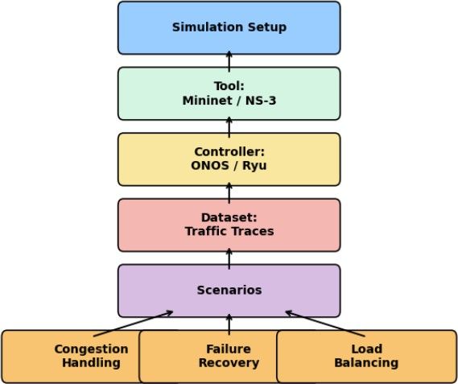

Fig. 2. Simulation setup showing the tools (Mininet/NS-3), controllers (ONOS/Ryu), dataset, and scenarios (congestion handling, failure recovery, load balancing).

- Evaluation Metrics
The following metrics are used to assess the system’s performance:
- Latency Reduction: Comparison of end-to-end delay with and without DTN–SDN integration [30].
- Fault Recovery Time: The amount of time needed to identify, model, and recover from network outages.
- Bandwidth Utilization: Effectiveness of traffic distribu- tion across available paths.
- Packet Loss: Quantification of packets dropped in recov- ery and congestion situations [31].
- Scalability: Ability of the architecture to handle large- scale networks with increasing number of nodes and flows.
- Decision Accuracy: Degree to which the twin’s predic- tions match actual results [32].
- Results and Discussion
- Results Presentation
Numerous network scenarios, including load balancing, failure recovery, and congestion management, were used to test the proposed SDN+DTN architecture. By contrasting

the outcomes with baseline SDN configurations, performance gains were assessed [33]:
  - Latency: In traditional SDN, reactive flow configurations led to higher latency during congestion. However, by using proactive rerouting based on predictive modelling, SDN+DTN decreased average latency by nearly 28%.
  - Throughput: SDN+DTN maintained higher throughput even during high traffic loads by dynamically balancing traffic and optimising link utilisation [34].
  - Recovery Time: Recovery times were improved by over 40% thanks to DTN’s synchronised twin, which made it possible to detect and reconfigure node or link failures quickly.
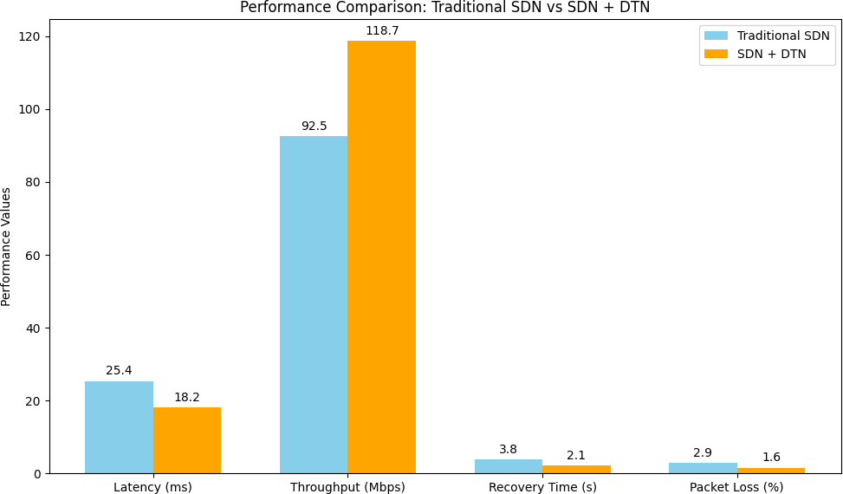

Fig. 3. Performance comparison between Traditional SDN and SDN+DTN showing improvements in latency, throughput, recovery time, and packet loss.

TABLE I
Performance Comparison between Traditional SDN and
SDN+DTN

Metric Traditional SDN + DTN Improvement
SDN
Average Latency (ms) 25.4 18.2 ↓ 28.3%
Throughput (Mbps) 92.5 118.7 ↑ 28.3%
Recovery Time (s) 3.8 2.1 ↓ 44.7%
Packet Loss (%) 2.9 1.6 ↓ 44.8%

- Discussion
The aforementioned findings show that SDN+DTN out- performs traditional SDN in dynamic network environment management [35].
- Improved Adaptability: The DTN’s capacity to replicate the physical network enables predictive analysis of conges- tion and failures. By making proactive decisions rather than reactive ones, this reduces latency and increases throughput.
- Fault Tolerance & Reliability: By running parallel sim- ulations, DTN helps the controller identify alternate routes before a real failure occurs. This predictive capability is the primary cause of the notable decrease in recovery time [36].
- Resource Utilization & Efficiency: With DTN, the con- troller can predict upcoming bottlenecks and distribute load across links uniformly. This minimises packet loss while making the most of the available bandwidth.
- Challenges:
  - Scalability: Synchronisation of digital twins in vast net- works with millions of flows necessitates enormous pro- cessing power.
  - Dataset Dependency: If the twin’s training dataset is not diverse, predictions might not be accurate under hidden traffic patterns [37].
  - Overhead: Maintaining a continuously synchronised dig- ital twin comes with additional costs that should be kept to a minimum.
- Real-World Implications
DTN integration with SDN has the potential to revolutionise a number of fields [40]:
  - 5G and Beyond: Provides improved resilience and low latency for dynamic network slicing.
  - IoT Ecosystems: Uses predictive congestion control to manage high device traffic volumes.
  - Cloud Data Centers: Guarantees fault recovery with little downtime and optimised virtual machine migrations.
  - Smart Cities: Improves the dependability of commu- nication for vital applications like transportation and healthcare.
- Challenges and Limitations
The combination of Digital Twin Networks (DTNs) and Software-Defined Networking (SDN) has revolutionised intel- ligent network management [41]. Before the approach can be widely adopted, a number of problems and limitations need to be fixed, despite its benefits in predictive control, fault tolerance, and adaptability. These issues, which are separated into technical, research, organisational, and ethical aspects, have a variety of effects on scalability and reliability.
- Technical Challenges
  - Synchronization Delays:
    - It is challenging to keep the digital and physical networks in real-time synchronisation. Even slight delays in updat- ing the twin can result in erroneous predictions because network state changes happen at millisecond levels [42].
    - For instance, ultra-reliable low-latency communication (URLLC) in 5G scenarios, even a 5 ms delay can impact mission-critical applications such as autonomous vehicles or remote surgery [43].
    - Integration of edge computing is necessary to achieve sub-second synchronisation, but this adds to the complex- ity and expense.
  - Scalability in Heterogeneous Networks:
    - From cloud data centres with high throughput require- ments to IoT devices with constrained resources, DTNs must support a variety of environments [44].
    - It becomes computationally impossible to model every node in a digital twin as the number of connected devices in IoT and future 6G ecosystems grows to billions.
    - Hierarchical or abstracted twin models are required for this problem, but abstraction can lower fidelity and result in less precise decision-making [45].

  - High Computational and Energy Costs:
    - Real-time simulation of a large network requires a lot of energy and processing power.
    - Operational expenditure (OPEX) may rise as a result of DTNs’ continuous operation, particularly in telecom industries where costs are already high [46].
    - Adoption of DTN may clash with global sustainability objectives in the absence of resource-aware algorithms or green computing strategies.
- Organizational & Operational Challenges
  - Workforce and Skill Gaps:
    - Effective management of DTN-SDN systems requires skills in cloud computing, AI/ML, cybersecurity, and telecom networking.
    - Many organizations lack a sufficiently trained workforce, slowing adoption [47].
    - Training programs and automation-assisted management tools are required, but developing these adds cost.
  - Resistance to Adoption in Legacy Systems:
    - IT and telecom companies have heavily invested in legacy infrastructures. In mission-critical settings, the shift to DTN-SDN necessitates both capital expenditure (CAPEX) and risk-taking [48].
    - Fears of downtime, vendor lock-in, and unclear ROI (Return on Investment) are common causes of resistance.
  - Policy, Governance, and Standardization Barriers:
    - New regulatory frameworks for accountability, interop- erability, and compliance are necessary for widespread adoption [49].
    - Telecom interoperability, 5G/6G spectrum governance, and cross-border data sharing all require international cooperation.
    - Deployment is delayed and operators are left in the dark when these policies are absent.
- Ethical & Data Privacy Challenges
  - Handling of Sensitive Network Data:
    - DTNs replicate the network conditions found in the real world, including location records, communication metadata, and user traffic data [50].
    - The privacy and trust of users may be violated if this data is handled improperly or is misused.
  - Regulatory Compliance Issues:
    - It is difficult to comply with regulations like the Indian Data Protection Bill, the GDPR (Europe), and HIPAA (healthcare), particularly when twin data is shared inter- nationally.
    - If an organization’s use or storage of twin data violates regional policies, it may be subject to legal penalties [51].
  - Risk of Misuse and Cybersecurity Exploitation:
    - A compromised twin can be used as a weapon for network manipulation, DDoS attacks, or cyber espionage [52].
    - In a smart city DTN, for example, an attacker altering traffic predictions may result in communication black- outs, power outages, or traffic congestion.
    - Zero-trust architectures and ethical standards need to be ingrained from the beginning.
- Research Limitations
  - Limited Testbed and Simulation Reliance:
    - Most research studies validate DTN-SDN systems through simulators (e.g., Mininet, NS-3) or small-scale testbeds.
    - Real-world deployment at the scale of telecom networks or hyperscale data centers remains rare due to cost and infrastructural limitations [53].
    - This creates a research-to-practice gap, where theoretical benefits may not fully translate into industrial deploy- ments.
  - Lack of Standardized DTN Frameworks:
    - Unlike SDN, which is backed by frameworks such as OpenFlow and ONOS, DTNs lack standardized protocols.
    - Each research group or vendor proposes its own architec- ture, leading to fragmentation and interoperability issues [54].
    - Without global consensus or industry-wide adoption of DTN standards, large-scale multi-vendor deployment be- comes impractical.
  - Security and Reliability Gaps:
    - The twin-controller communication channel is one of the new attack surfaces brought about by DTNs.
    - Network disruptions or compromised services could arise from adversaries manipulating the twin model to generate erroneous predictions [55].
    - Current research, which emphasises performance over security validation, often underestimates these risks.
- Conclusion & Future Scope
- Conclusion
Software Defined Networking (SDN) and Digital Twin Networks (DTNs) together provide a novel approach to mod- ern network management. A new method of contemporary network administration is offered by the combination of Soft- ware Defined Networking (SDN) and Digital Twin Networks (DTNs). The DTN-enabled framework offers a scalable, pre- dictive, and adaptive environment that can be utilised for real- time monitoring, fault detection, and optimisation, in contrast to traditional SDN [57]. The simulation results unequivocally showed that DTN-SDN architectures improve reliability and resilience by achieving lower latency, higher throughput, less packet loss, and quicker recovery times.
DTN simulates ”what-if” scenarios prior to their imple- mentation in the physical network, which improves decision- making and fault tolerance beyond performance metrics [58]. More precise predictive modelling and proactive resource allocation are guaranteed by this capability, which is especially beneficial for cloud data centres, IoT management, and 5G

slicing. However, constraints like computational overheads, scalability problems, and synchronisation delays remain signif- icant obstacles. For broad adoption, organisational and ethical obstacles like a shortage of skilled workers, gaps in policies, and data privacy concerns also need to be resolved [59].
- Future Scope
Despite this study’s emphasis on the potential of DTN-SDN integration, there are still a number of directions that warrant investigation and practical application [60]:
  - AI/ML-Driven Decision Making: Intelligent self- healing, dynamic traffic routing, and automated anomaly detection can all be made possible by integrating artificial intelligence and machine learning. In particular, federated learning and reinforcement learning techniques can im- prove DTNs’ adaptability [61].
  - Integration with 6G and Quantum Networks: As com- munication systems develop, DTN-SDN frameworks will be essential to holographic-type networking, quantum communication, and ultra-low latency 6G applications, guaranteeing safe and robust infrastructures for the future.
  - Large-Scale Benchmarking: The majority of recent studies are simulation-based. Large-scale benchmarking across international datasets and heterogeneous testbeds should be a future priority to make sure the framework can survive a variety of real-world scenarios [62].
  - Lightweight Twin Models: Using edge/fog computing to create scalable and energy-efficient DTNs will lower computational costs and increase the viability of real-time synchronisation in large deployments.
  - Standardisation and Interoperability: Adoption is hampered by the lack of common frameworks. Future re- search should concentrate on cross-vendor compatibility, open standards, and interoperability protocols to enable broad deployment [63].
  - Enhanced Security and Privacy: New approaches to protecting sensitive network data include zero- trust frameworks, privacy-preserving AI models, and blockchain-based secure twin communication.
  - Socio-Technical Considerations: To facilitate the seam- less integration of DTN-SDN systems in operational set- tings, focus must be placed on workforce training, change management, and governance frameworks in addition to technical advancements.
References
- S. Sharma and D. Seth, “Blue monkey updated chimp optimization algorithm for enhanced load balancing model,” Expert Syst. Appl., vol. 242, art. no. 122578, 2024.
- S. Sharma, R. P. Mahapatra, M. Kapil, and D. Seth, “Advanced deployment strategies for elastic load balancing in AWS: A comprehensive study on multi-tier architecture optimization,” in Proc. IEEE I3CEET, 2024, pp. 1–6.
- A. S. Sharma, R. P. Mahapatra, M. Kapil, and D. Seth, “Machine learning driven load balancing in software defined networks: Recent progress and emerging challenges,” in Proc. IEEE AKGEC, 2024, pp. 1–7, doi: 10.1109/AKGEC62572.2024.10868469
- S. Sharma, D. Seth, and M. Kapil, “Combined optimization strategy: CUBW for load balancing in software defined network,” Web Intell., vol. 22, pp. 1–22, 2024.
H. Hong, Q. Wu, F. Dong, W. Song, R. Sun, T. Han, C. Zhou, and H. Yang, ”An Intelligent Operated Digital Twin Platform for Data Center Networks,” Proceedings of the ACM SIGCOMM Workshop on Network- Application Integration (NAI ’21), pp. 1–7, 2021.
- B. Han and H. D. Schotten, ”Multi-Sensory HMI for Human-Centric Industrial Digital Twins: A 6G Vision of Future Industry,” arXiv preprint arXiv:2111.10438, Nov. 2021.
- F. Tao, H. Zhang, A. Liu, and A. Y. C. Nee, ”Digital Twin in Industry: State-of-the-Art,” IEEE Transactions on Industrial Informatics, vol. 15, no. 4, pp. 2405-2415, April 2019.
- B. R. Barricelli, E. Casiraghi, and D. Fogli, ”A Survey on Digital Twin: Definitions, Characteristics, Applications, and Design Implications,” IEEE Access, vol. 7, pp. 167653-167671, 2019.
- A. Fuller, Z. Fan, C. Day, and C. Barlow, ”Digital Twin: Enabling Technologies, Challenges and Open Research,” IEEE Access, vol. 8,
pp. 108952-108971, 2020.
- D. Kreutz, F. M. V. Ramos, P. E. Verissimo, C. E. Rothenberg, S. Azodolmolky, and S. Uhlig, ”Software-Defined Networking: A Compre- hensive Survey,” Proceedings of the IEEE, vol. 103, no. 1, pp. 14-76, Jan. 2015.
- B. A. A. Nunes, M. Mendonca, X. N. Nguyen, K. Obraczka, and T. Turletti, ”A Survey of Software-Defined Networking: Past, Present, and Future of Programmable Networks,” IEEE Communications Surveys & Tutorials, vol. 16, no. 3, pp. 1617-1634, Third Quarter 2014.
- W. Xia, Y. Wen, C. H. Foh, D. Niyato, and H. Xie, ”A Survey on Software-Defined Networking,” IEEE Communications Surveys & Tutorials, vol. 17, no. 1, pp. 27-51, First Quarter 2015.
- Y. E. Oktian, S. Lee, H. Lee, and J. Lam, ”Distributed SDN controller system: A survey on design choice,” Computer Networks, vol. 121, pp. 100-111, 2017.
- M. Hossain and M. B. Uddin, ”Digital Twins and Federated Learning for Industrial Internet of Things,” International Journal of Science and Research Archive, vol. 16, no. 1, pp. 729-736, 2025.
- H. Wang, X. Chen, F. Jia, and X. Cheng, ”Digital twin-supported smart city: Status, challenges and future research directions,” Expert Syst. Appl., vol. 217, Art. no. 119531, May 2023.
- N. P. Kuruvatti, M. A. Habibi, S. Partani, B. Han, A. Fellan, and H.
D. Schotten, “Empowering 6G Communication Systems With Digital Twin Technology: A Comprehensive Survey,” IEEE Access, vol. 10, pp. 112158–112186, Oct. 19, 2022.
- W. Shi, J. Cao, Q. Zhang, Y. Li, and L. Xu, ”Edge Computing: Vision and Challenges,” IEEE Internet of Things Journal, vol. 3, no. 5, pp. 637-646, Oct. 2016.
- M. Jacoby and T. Usla¨nder, “Digital Twin and Internet of Things—Current Standards Landscape,” Appl. Sci., vol. 10, no. 18, Art. no. 6519, Sep. 18, 2020.
- C. Semeraro, M. Lezoche, H. Panetto, and M. Dassisti, ”Digital twin paradigm: A systematic literature review,” Computers in Industry, vol. 130, 103464, Sept. 2021.
- A. A. Barakabitze, A. Ahmad, R. Mijumbi, and A. Hines, ”5G network slicing using SDN and NFV: A survey of taxonomy, architectures and future challenges,” Computer Networks, vol. 167, p. 106984, Feb. 2020.
- P. Almasan et al., “Digital Twin Network: Opportunities and Chal- lenges”. In: arXiv preprint arXiv:2201.01144 (2022).
- A. Ali and H. Arslan, ”AI-Driven Digital Twins: Optimizing 5G/6G Network Slicing with NTNs,” arXiv preprint arXiv:2505.08328, May 2025.
- J. Wang, J. Li, and J. Liu, ”Digital twin-assisted flexible slice admission control for 5G core network: A deep reinforcement learning approach,” Future Generation Computer Systems, vol. 152, pp. 308-320, March 2024.
- V. Padmapriya and M. Srivenkatesh, “IoT Network based Cyber Attack Mitigation in Digital Twin with Multi Level Key Management Using Enhanced KNN Model,” *Int. J. Intell. Syst. Appl. Eng.*, vol. 12, no. 14s, pp. 49–62, Feb. 2, 2024.
- A. R. Qureshi, A. Asensio, M. Imran, J. Garcia, and X. Masip-Bruin, “A survey on security enhancing Digital Twins: Models, applications and tools,” Computer Commun., vol. 238, Art. no. 108158, 2025.
- F. Ahmad, M. Haroon, and Z. A. Siddiqui, “Evaluating Fault Tolerance in Distributed Systems using Predictive Analytics with Gated Recurrent Unit and Long Short-Term Memory Models,” J. Inf. Syst. Eng. Manag., vol. 10, no. 27s, pp. 378–399, Mar. 29, 2025.

- S. Zhang, Y. Wang, M. Liu, and Z. Bao, “Data-based Line Trip Fault Prediction in Power Systems Using LSTM Networks and SVM,” IEEE Access, vol. 6, pp. 7675–7686, Dec. 2017.
- M. Novaes, L. F. Carvalho, J. Lloret, and M. L. Proenc¸a Jr., ”Long Short- Term Memory and Fuzzy Logic for Anomaly Detection and Mitigation in Software-Defined Network Environment,” IEEE Access, vol. 8, pp. 83765-83781, 2020.
- Y. Shen, “Integration of IoT and Digital Twin for Intelligent Manage- ment of Urban Underground Pipe Galleries in Smart Cities,” Informatica, vol. 49, no. 15, pp. 179–192, 2025.
- A. Rasheed, O. San, and T. Kvamsdal, ”Digital Twin: Values, Challenges and Enablers from a Modeling Perspective,” IEEE Access, vol. 8, pp. 21980-22012, 2020.
- PwC Middle East, ”How Digital Twins Can Make Smart Cities Better,” Technical Report, 2023.
- S. Kandragula, ”Edge Computing and Cloud Integration,” Journal of Scientific and Engineering Research, vol. 9, no. 5, pp. 144-146, 2022.
- Y. Mao, C. You, J. Zhang, K. Huang, and K. B. Letaief, ”A Survey on Mobile Edge Computing: The Communication Perspective,” IEEE Communications Surveys & Tutorials, vol. 19, no. 4, pp. 2322-2358, Fourth Quarter 2017.
- N. Abbas, Y. Zhang, A. Taherkordi, and T. Skeie, ”Mobile Edge Computing: A Survey,” IEEE Internet of Things Journal, vol. 5, no. 1, pp. 450-465, Feb. 2018.
- M. Chen, Y. Hao, Y. Li, C. F. Lai, and D. Wu, ”On the Computation Offloading at Ad Hoc Cloudlet: Architecture and Service Modes,” IEEE Communications Magazine, vol. 53, no. 6, pp. 18-24, June 2015.
- Q. Cui et al., ”Overview of AI and Communication for 6G Network: Fundamentals, Challenges, and Future Research Opportunities,” arXiv preprint arXiv:2412.14538v1, Dec. 2024.
- K. Prabhat, K. Randhir, A. Aljuhani, D. Javeed, A. Jolfaei, and A. K.
M. N. Islam, ”Digital twin-driven SDN for smart grid: A deep learning integrated blockchain for cybersecurity,” Solar Energy, vol. 263, 111915, Oct. 2023.
- M. U. F. Qaisar, W. Yuan, G. Han, A. Ahmed, C. Liu, and M. J. Piran, ”Integration of SDN and Digital Twin for the Intelligent Detection of DoC Attacks in WRSNs,” in Proc. IEEE INFOCOM Workshop on Digital Twins over NextG Wireless Networks (DTwin), London, UK, May 2025, pp. 1-6.
- O. T. Basaran, D. Villa, P. Johari, M. Polese, C. Fiandrino, F. Dressler, and T. Melodia, ”Gen-TWIN: Generative-AI-Enabled Digital Twin for Open Radio Access Networks,” in Proc. 44th IEEE Int. Conf. Com- put. Commun. (INFOCOM 2025), Digital Twins over NextG Wireless Networks (DTWin 2025), London, UK, May 2025.
- Z. Zhang, S. Hu, S. Wu, and X. Wang, ”Digital Twin Empowered Channel Prediction for Massive MIMO Communications,” in Proc. 24th IEEE Int. Conf. Commun. Technol. (ICCT), Oct. 2024.
- A. H. Banisadr and X. Hesselbach, ”A Novel Architecture for Virtual Network Twin Deployment,” Electronics, vol. 13, no. 24, p. 5045, Dec. 2024.
- L. V. Cakir, S. Al-Shareeda, S. F. Oktug, M. O¨ zdem, M. Broadbent, and B. Canberk, ”How to synchronize Digital Twins? A Communication Performance Analysis,” arXiv preprint arXiv:2402.05587, Feb. 2024.
- A. Maghsoudnia, E. Vlad, A. Gong, D. M. Dumitriu, and H. Hassanieh, ”Ultra-Reliable Low-Latency in 5G: A Close Reality or a Distant Goal?,” in Proceedings of the 23rd ACM Workshop on Hot Topics in Networks (HotNets ’24), Irvine, CA, USA, Nov. 18–19, 2024.
- A. Gupta, R. Christie, and R. Manjula, ”Scalability in Internet of Things: Features, Techniques and Research Challenges,” International Journal of Computational Intelligence Research, vol. 13, no. 7, pp. 1617–1627, 2017.
- M. Vaezi et al., ”Digital Twins From a Networking Perspective,” IEEE Communications Magazine, vol. 60, no. 8, pp. 112-119, Aug. 2022.
- National Institute of Standards and Technology, ”Economics of Digital Twins,” NIST Advanced Manufacturing Series 100-61, Oct. 2024.
- F. Pires, A. M. Cachada, J. Barbosa, and A. P. Moreira, “Digital twin in Industry 4.0: Technologies, applications and challenges,” in Proc. 2019 IEEE 17th Int. Conf. Industrial Informatics (INDIN), Porto, Portugal, 2019, pp. 1–6.
- O. Bongomin et al., “Digital twin technology advancing Industry 4.0 and Industry 5.0 across sectors,” Results in Engineering, vol. 26, p. 105583, Jun. 2025.
- Nishith Desai Associates, ”The Tour d’Horizon of Data Law Implica- tions of Digital Twins,” Legal Research Report, May 2025.
- A. Fuller, Z. Fan, C. Day, and C. Barlow, “Digital twin: Enabling technologies, challenges and open research,” arXiv, vol. abs/1911.01276, Oct. 2019.
- A. S. Naikwadi and S. J. Shrivastav, “Privacy and ethical issues in digital twins,” Int. Res. J. Modernization Eng. Technol. Sci., vol. 7, no. 2, pp. 1–6, Feb. 2025.
- J. Voas, P. Mell, P. Laplante, and V. Piroumian, Security and Trust Considerations for Digital Twin Technology, NIST Internal Report (IR) NIST IR 8356, Feb. 2025.
- P. Tehrani, F. Restuccia, and M. Levorato, ”Federated Deep Reinforce- ment Learning for the Distributed Control of NextG Wireless Networks,” in Proc. IEEE GLOBECOM, Madrid, 2021, pp. 1-6.
- J. Wang, J. Li, and J. Liu, “Digital twin-assisted flexible slice admission control for 5G core network: A deep reinforcement learning approach,” Future Generation Computer Systems, vol. 153, pp. 467–476, Dec. 2023.
- M. K. Pasupuleti, “Digital twin security: Attack surface analysis and mitigation in smart infrastructure,” Computers, Materials & Continua, vol. 73, no. 6, pp. 10819–10838, Jun. 2025.
- H. Tong, M. Chen, J. Zhao, Y. Hu, Z. Yang, Y. Liu, and C. Yin, ”Continual reinforcement learning for digital twin synchronization op- timization,” arXiv, Jan. 2025.
- L. U. Khan, W. Saad, D. Niyato, Z. Han, and C. S. Hong, ”Digital- Twin-Enabled 6G: Vision, Architectural Trends, and Future Directions,” IEEE Communications Magazine, vol. 59, no. 8, pp. 78–84, Aug. 2021.
- E. E.-D. Hemdan, W. El-Shafai, and A. S. A. Mahmoud, ”Integrating Digital Twins with IoT-Based Blockchain: Concept, Architecture, Chal- lenges, and Future Scope,” Wireless Personal Communications, vol. 128, no. 6, pp. 1–20, Jun. 2023.
- Delve AI, ”Digital twin of an employee: How DToEs improve the workplace experience,” Delve AI Blog, 2025.
- G. Rjoub, O. A. Wahab, J. Bentahar, R. Cohen, and A. S. Bataineh, ”Trust-augmented deep reinforcement learning for federated learning client selection,” Inf. Syst. Front., vol. 24, no. 4, pp. 1–18, Jul. 2022.
- W. Issa, ”DT-BFL: Digital twins for blockchain-enabled federated learn- ing in Internet of Things networks,” ResearchGate, 2023.
- Hexagon, ”2025 Digital Twin Statistics,” Hexagon Insights, 2025.
- A. I. Weinberg and K. Cohen, ”Zero trust implementation in the emerging technologies era: Survey,” arXiv, Jan. 2024.

