Deploying and testing the contract using Ethereum Wallet using a private blockchain

These are the existing accounts we are going to test with.

|  |  |  |
| --- | --- | --- |
| **Account name** | **Account address** | **Account Balance** |
| Account 5 | 0x1332D1E8221F7bf5acB16f188E837555f6CbbD55 | 100 Ethers |
| Account 6 | 0x2A7f775Fa7C670acB9b3fF1c57d2275216111C3b | 100 Ethers |
| Account 7 | 0x163AbF9B35bB845Be25509410638CdCc8ebbeB41 | 100 Ethers |
| Account 8 | 0x44E9C1616c621D298aB98000De474450E2843114 | 100 Ethers |

**Note :**

We are going to deploy our FundingHub and Project contract from Account 8

**Screen shot of accounts**

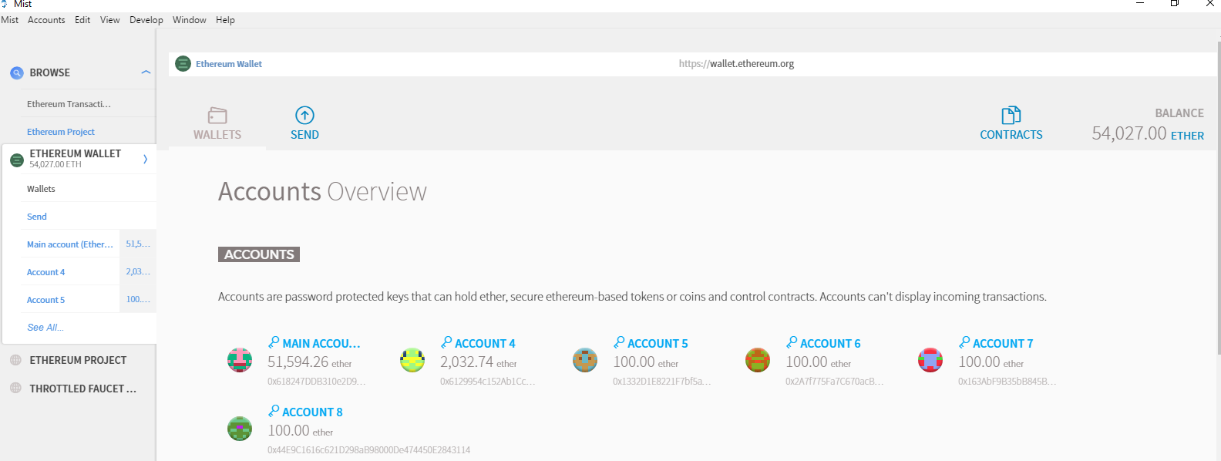

**Step 1:**

Deploy our FundingHub.sol and Project.sol

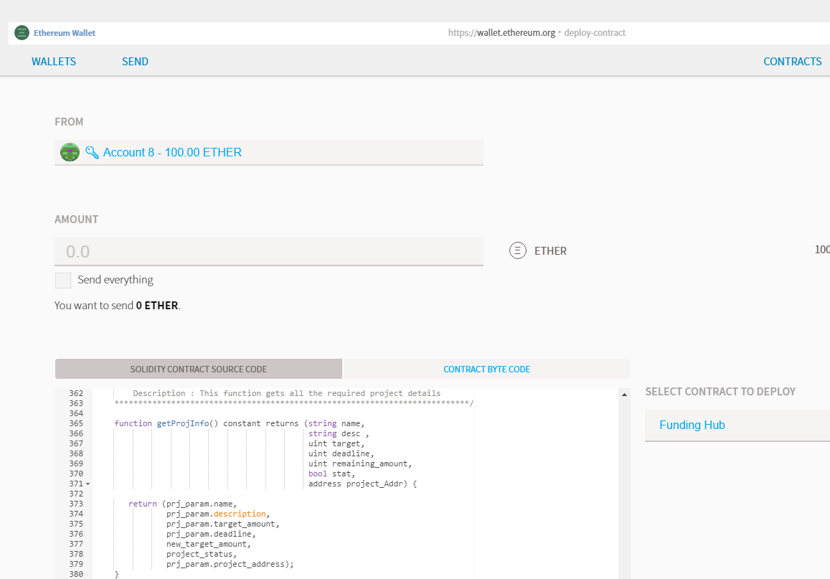

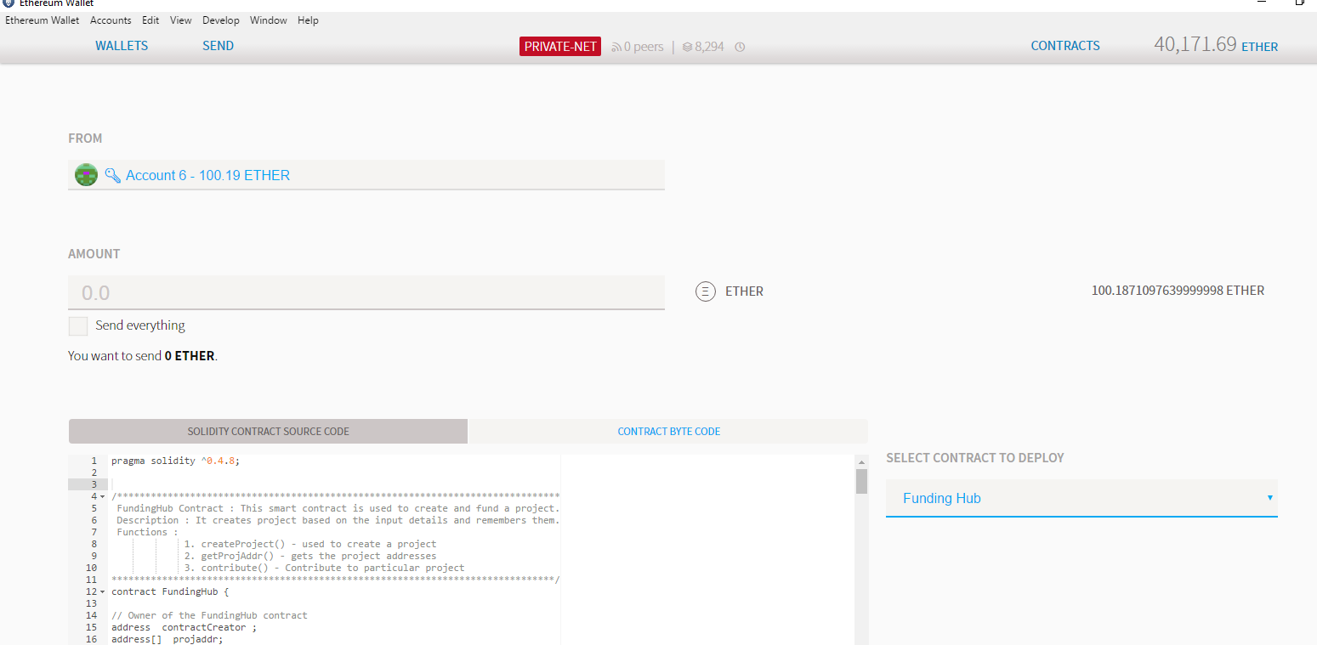

Wait for few seconds to mine

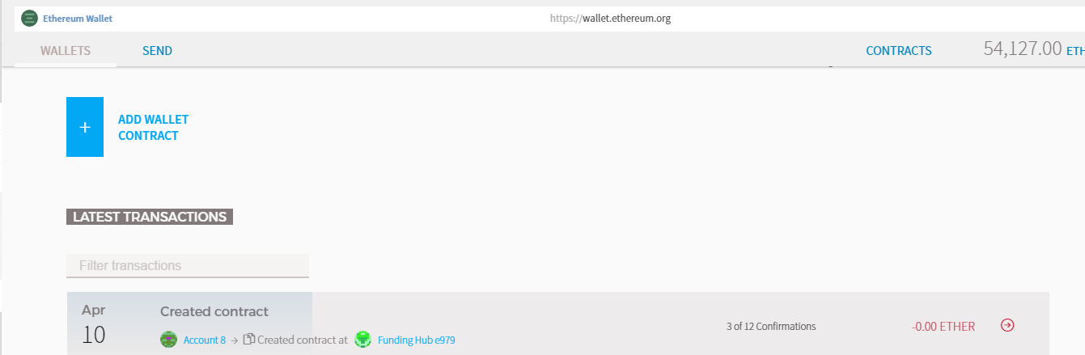

Now the contract is successfully created and deployed in Private blockchain.

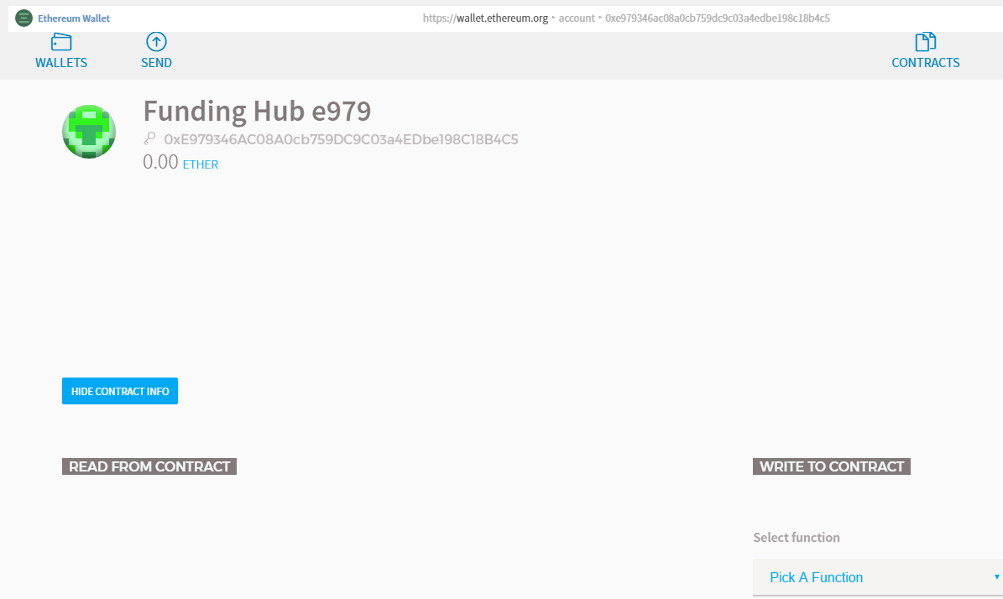

**Step 2 :**

Let us create a project with the following values

Project Name: Project 1

Project Description: Testing Project

Funding goal: 100 ethers

Deadline : 1791798765

Execute from Account 8

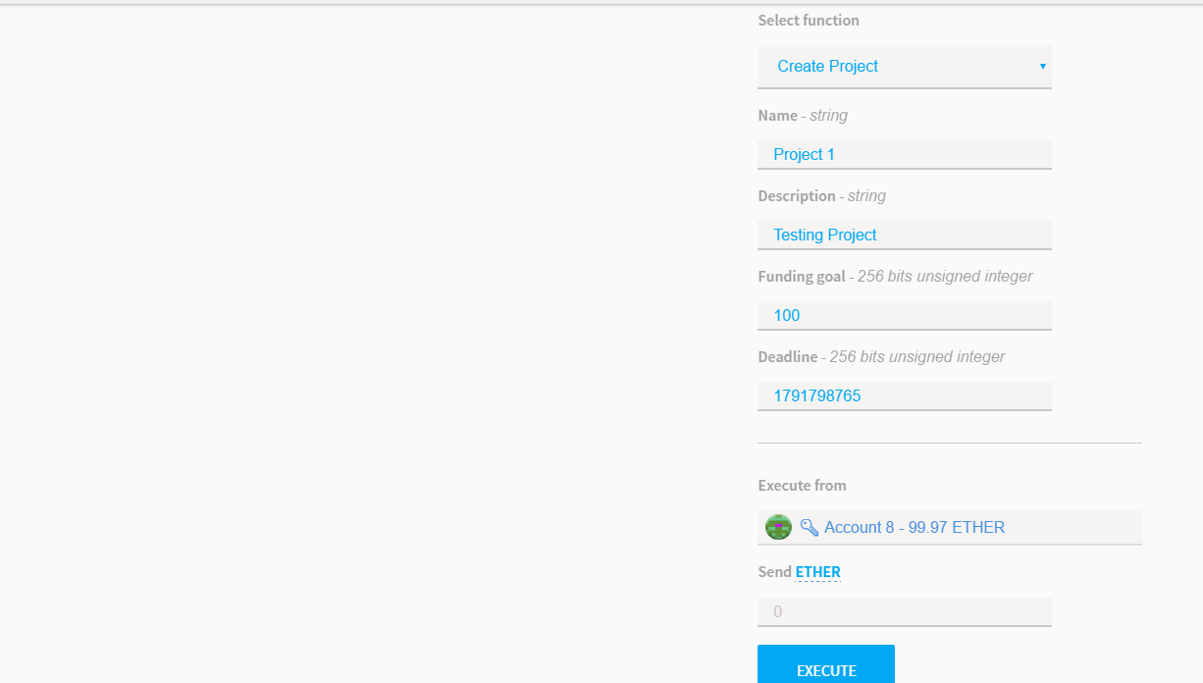

Wait for it to mine

**Step 3:**

From Filter events get the project address

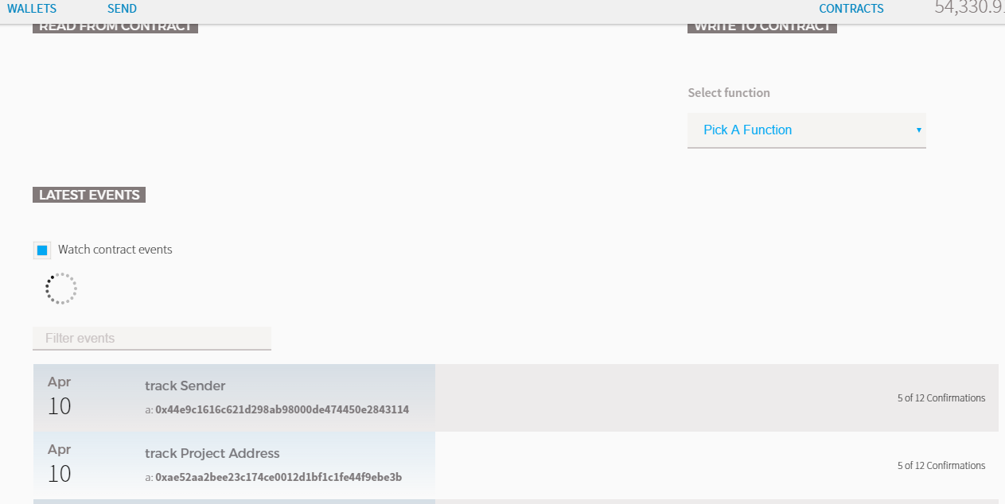

**Step 4:**

Using the project address, contribute to the project.

As part of testing, we are going to do the following

Account 5 🡪 will transfer 30 Ethers

Account 6 🡪 will transfer 30 Ethers

Account 7 🡪 will transfer 60 ethers

**Expected Result**

Account 8 will receive 100 Ethers. This is the funding goal 🡪 Original Balance (99 Ethers) + 100 received Ethers. Result would sump to 199 Ethers

Account 5 🡪 Original Balance (100 Ethers) – 30 funded Ethers. Result would sum up to 70 Ethers

Account 6 🡪 Original Balance (100 Ethers) – 30 funded Ethers. Result would sum up to 70 Ethers

Account 7 🡪 Original Balance (100 Ethers) – 60 funded Ethers. Now only 40 ethers are remaining but 20 was transferred more. This has to be refunded. Result would sum up to 60 Ethers

Let us start funding using Ethereum Wallet

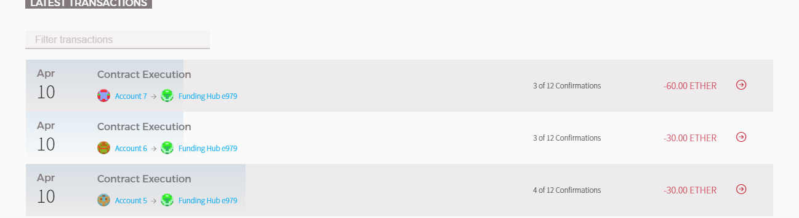

**Actual Result**

You can notice both the expected and actual result matches.

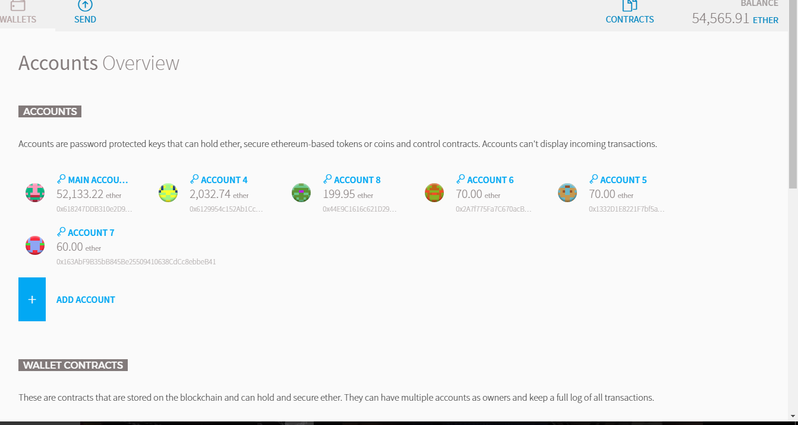

Testing is also completed using Ethereum Wallet