This docment explains the step by step process of downloading my B9Lab project and executing the same in Ubuntu environment.

Step 1 :

Download the scource code from the following link

https://github.com/sunils2020/mytest

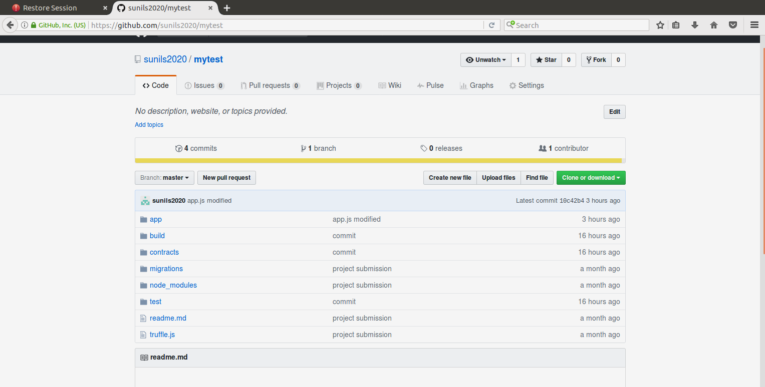

Step 2:

Storing the project inside /home/sunil/final-exam and extract the contents of the zip file

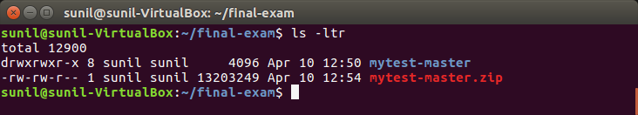

Step 3:

Open a terminal window and type testrpc and hit enter

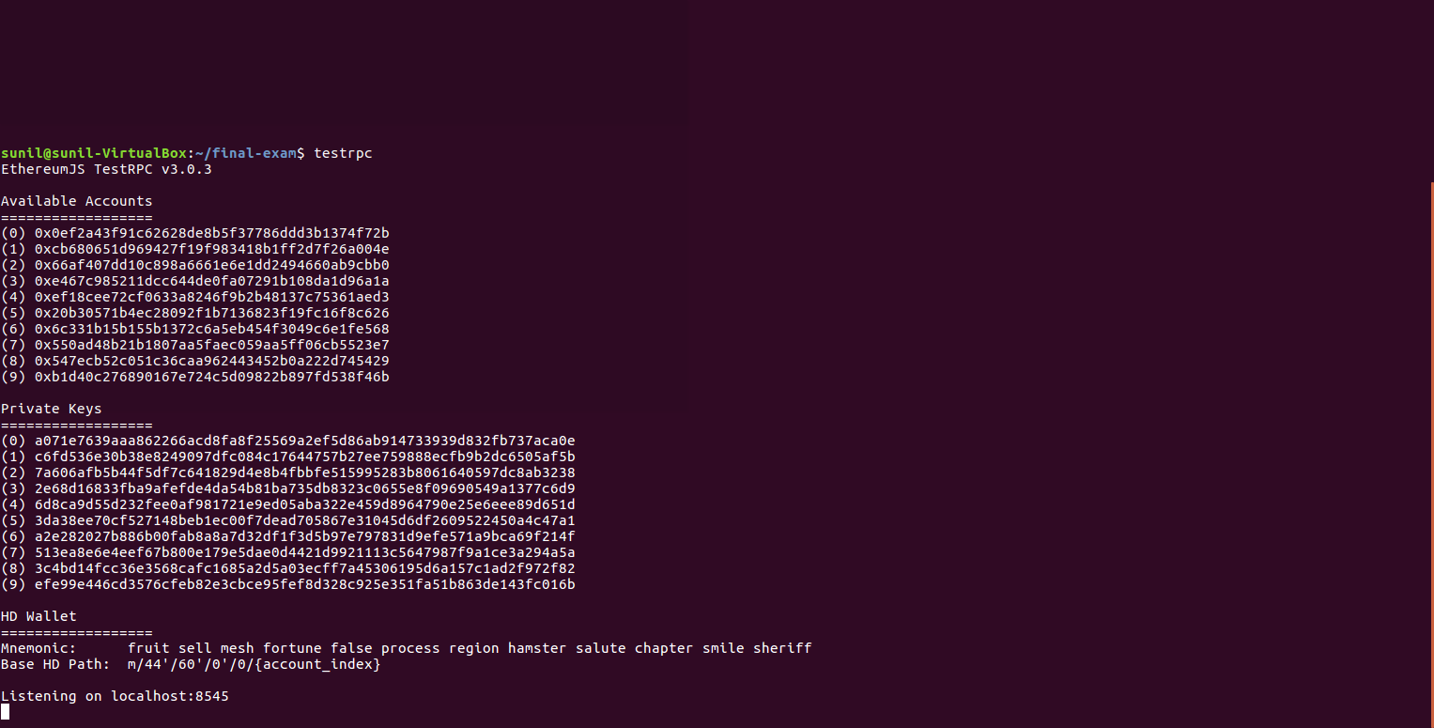

Step 4:

- Open another terminal and cd to the following path
  - cd /home/sunil/final-exam/mytest-master
- Execute the following commands in order
  - truffle compile
  - truffle migrate – reset
  - truffle build
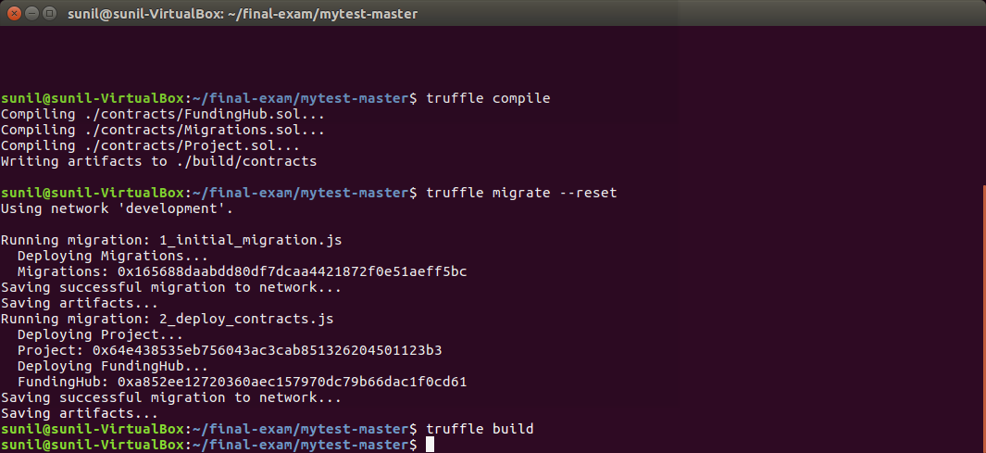
Step 5 :

Execute truffle test command which will test the refund functionality as per the project requirements.

Note:
When you run the test for the first time , “coinbase balance before” and “coinbase balance after” seems to reduce more but this is because it is displayed in whole number (ethers) rather than wei.

However for the next successive runs it shouldn’t be a problem

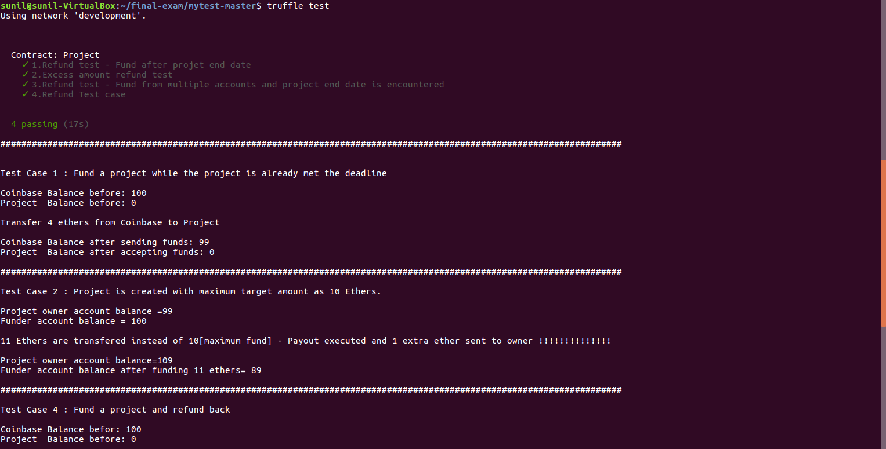
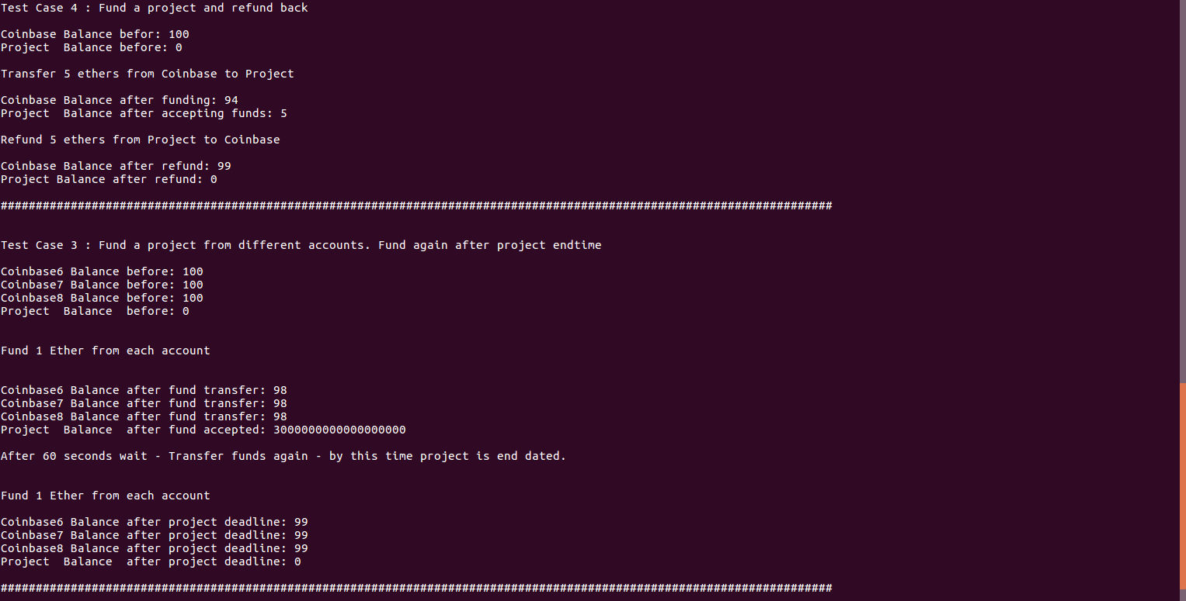

Let us run again (Iteration 2 )

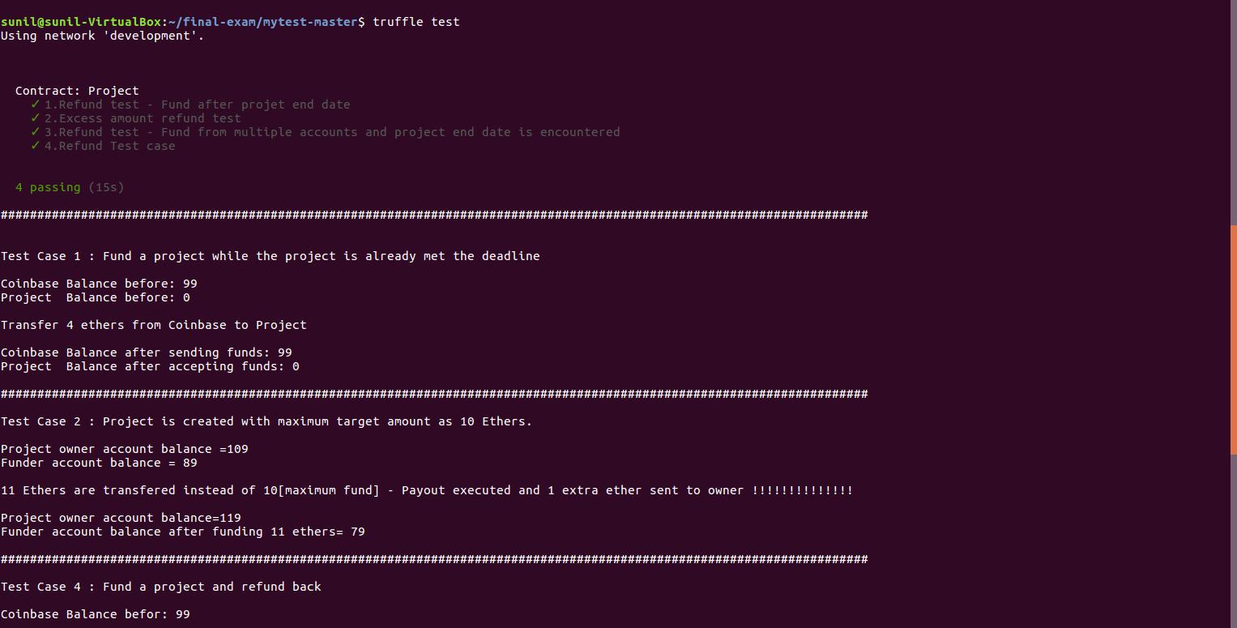

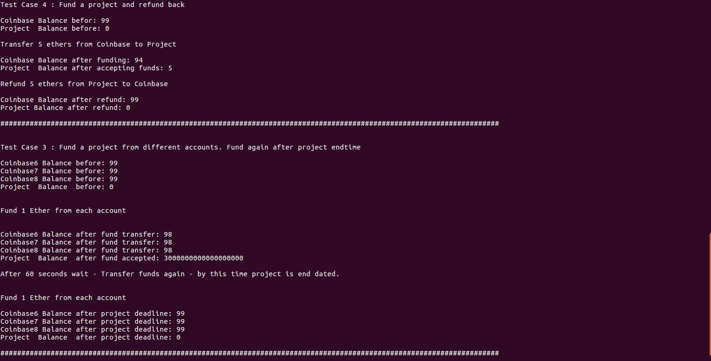

Step 6 :

Let us now test using the UI

Open the index.html present in the location

/home/sunil/final-exam/mytest-master/build

- Create a project using UI and click “Create Project” button
- Hover over the mouse in “Project end date” field and a calendar would pop up

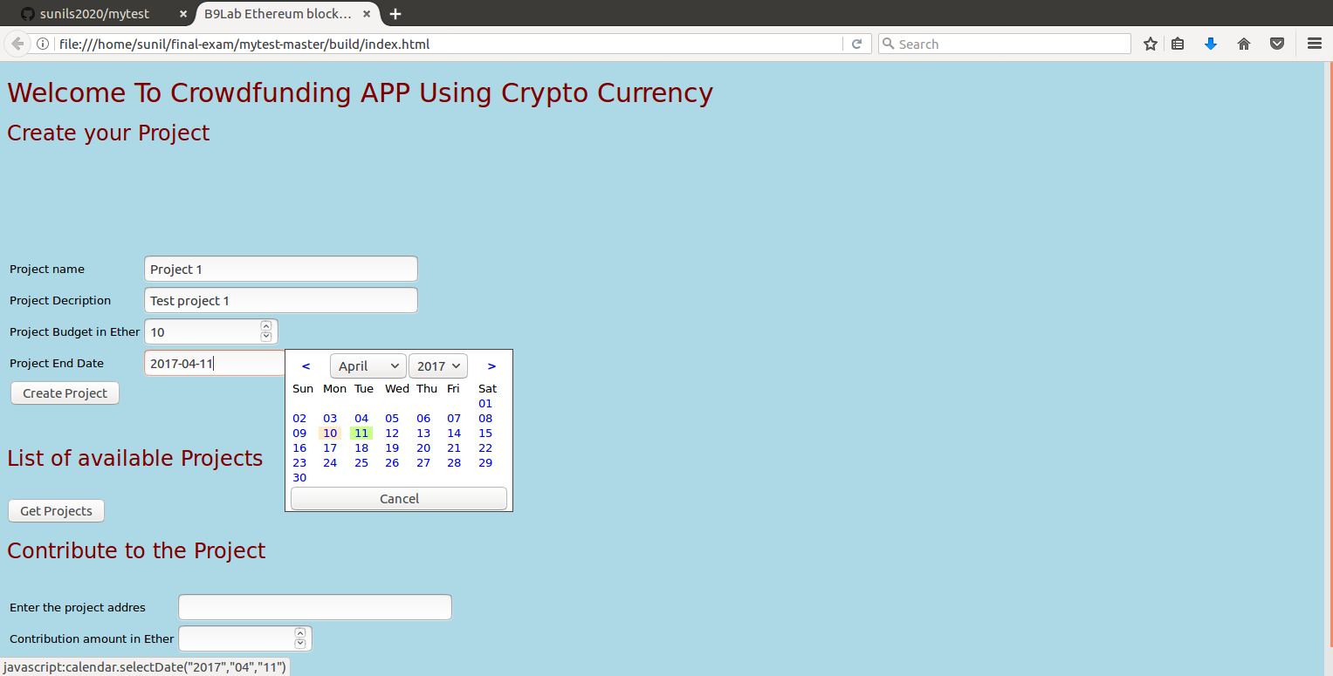

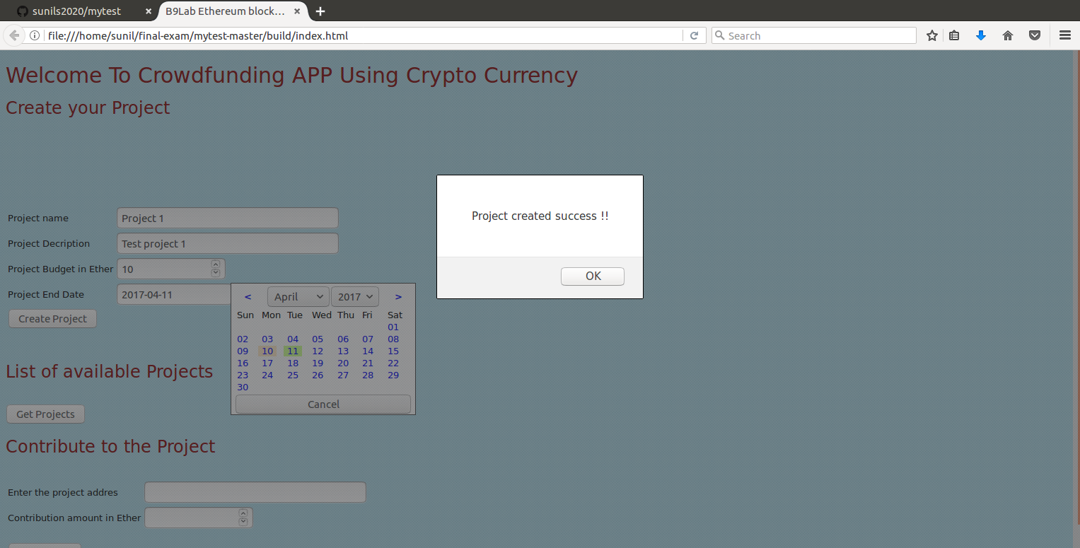

3. Let us create two more projects
Project 3 alone is created with old end date.

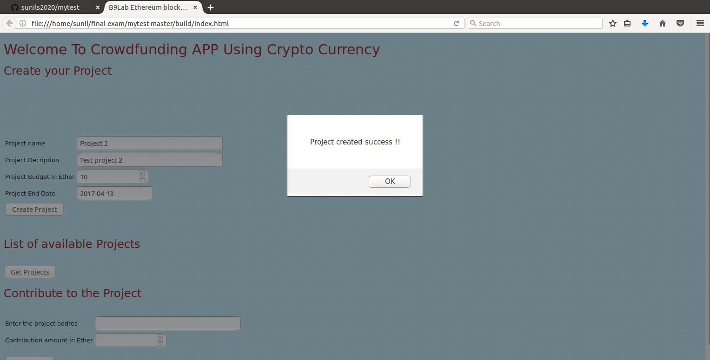

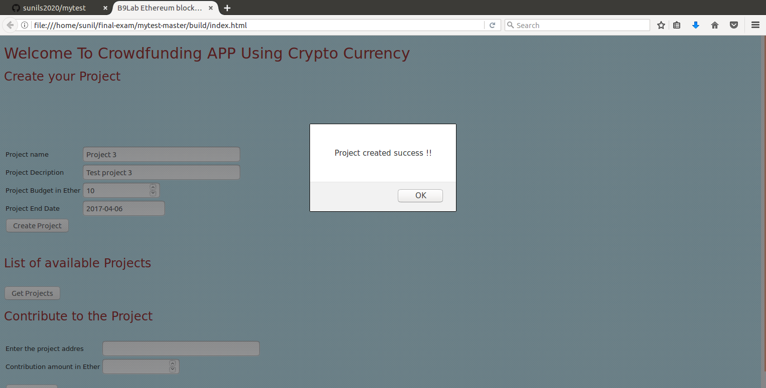
Step 7 :

- Let us retrieve all the projects by clicking “Get Projects” button
- Notice Project 3 status is “Ended” because the project has old end date

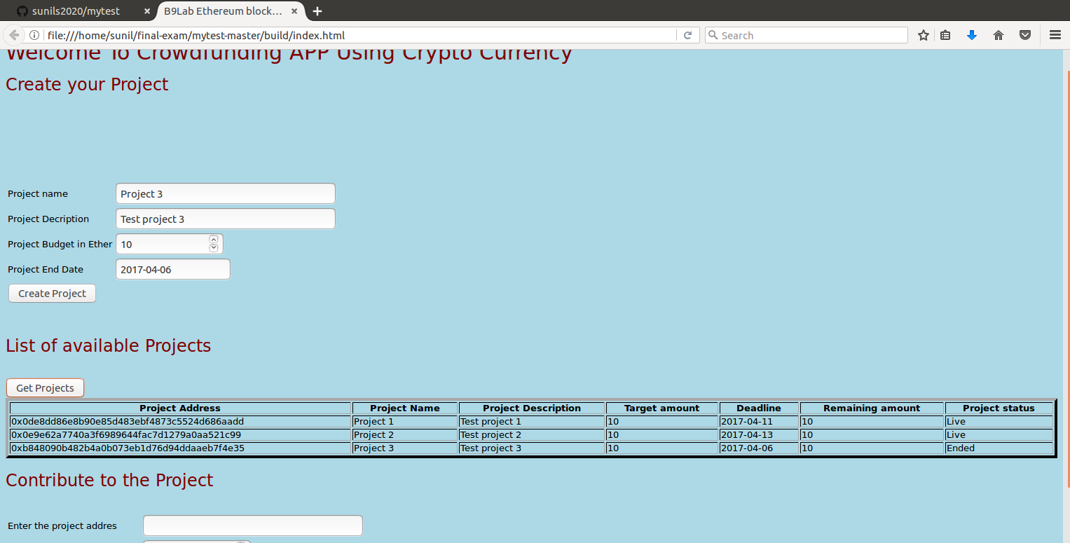

Step 8 :

- Contribute 10 ethers to project 1
- Contribute 9 ethers to project 2
- Look at the balance amount and the project status

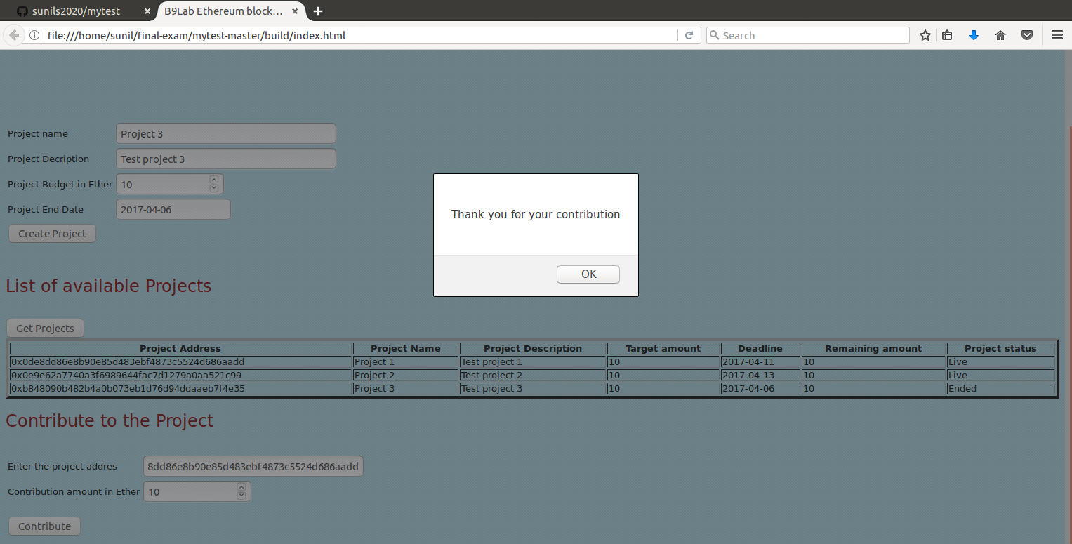

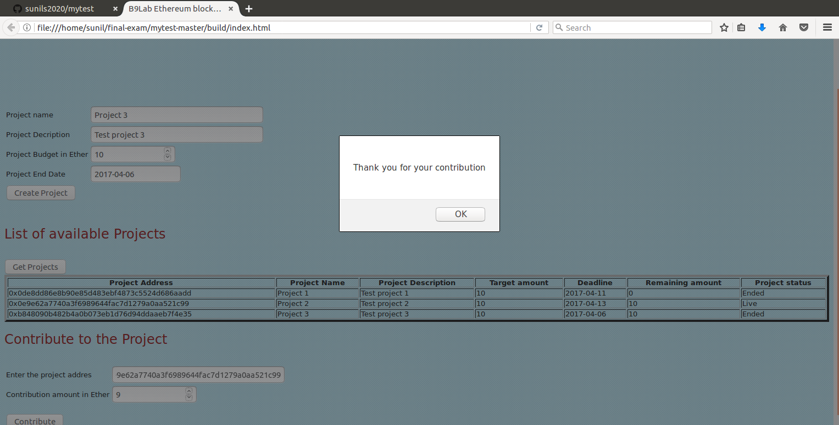

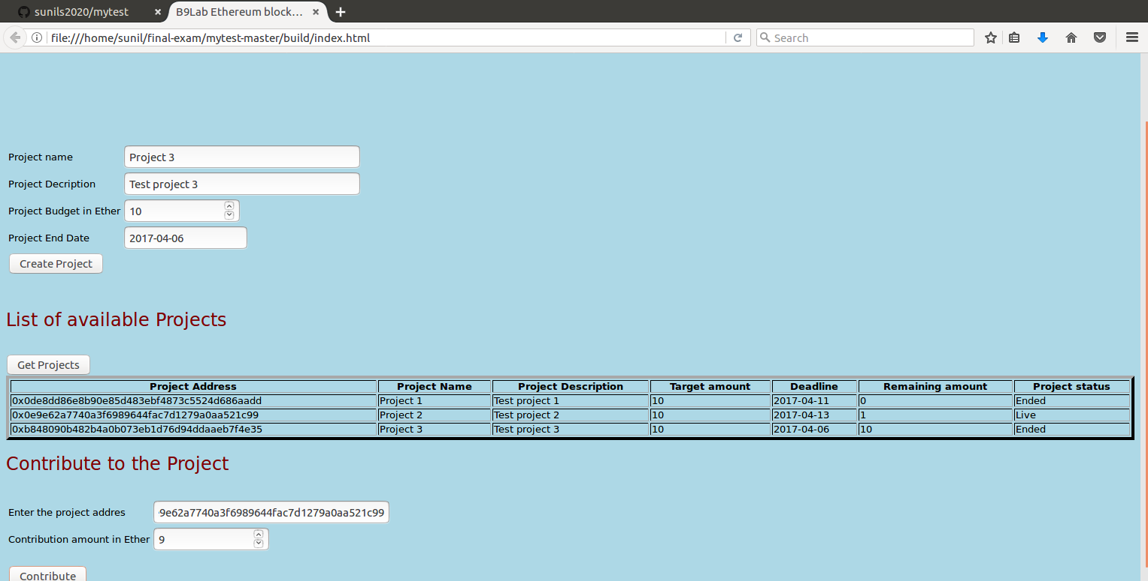

Testing using UI is completed.

Step 8 :
Let us now test with Ethereum wallet

