**Covid vaccine analysis Using Python**

**TEAM MEMBER**

812121104041:PAZHANIBHARATHI.S

812121104306: KRISHNA KUMAR.K

8121211040303:HARISHBHAVARAN.R

812121104309:SUNIL SHANMUGA PRIYAN.R

**Project Title:** Covid vaccine analysis

**Phase 5:** Project Documentation & Submission

**Topic:** In this section we will document the complete project and prepare it for submission.

**INTRODUCTION:**

Analyzing COVID-19 vaccines is a multifaceted endeavor that encompasses a range of critical topics central to our understanding of their development, deployment, and impact on the global response to the pandemic. In this comprehensive analysis, we will explore the following key themes:

1. **Vaccine Development**: The rapid development of COVID-19 vaccines is a remarkable scientific achievement. We will delve into the various vaccine technologies used, such as mRNA, viral vector, and protein subunit platforms, and discuss the innovative approaches that led to their creation.

1. **Vaccine Efficacy:** Understanding the effectiveness of these vaccines in preventing COVID-19 and its variants is paramount. We will assess

the results of clinical trials, real-world studies, and the longevity of protection, as well as the challenges posed by emerging variants.

1. **Vaccine Safety**: Safety is a critical concern. We will investigate reported side effects, adverse events, and the systems in place to monitor and ensure the safety of COVID-19 vaccines.

1. **Vaccine Distribution and Access:** The equitable distribution and administration of vaccines have presented complex logistical and ethical challenges. We will examine global efforts, vaccine supply chains, and the role of international cooperation in ensuring broad access.

1. **Public Health Impact:** COVID-19 vaccines have significantly influenced public health outcomes. We will explore their role in reducing infection rates, hospitalizations, and deaths, and assess the impact on healthcare systems and pandemic management.

1. **Economic and Social Implications:** The vaccines have far-reaching effects on societies and economies. We will analyze how they have shaped economic recovery, travel restrictions, and the return to normalcy.

1. **Vaccine Hesitancy and Public Perception:** Public attitudes toward vaccination play a crucial role in the success of vaccination campaigns. We will explore vaccine hesitancy, misinformation, and the strategies employed to increase vaccine acceptance.

1. **Vaccine Passports and Mandates:** These have become topics of debate and policy implementation in many regions. We will examine the ethical, legal, and practical considerations surrounding vaccine passports and mandates.

1. **Global Cooperation and Challenges:** The COVID-19 pandemic has highlighted the need for international collaboration. We will discuss the challenges and successes of global initiatives and the implications for future global health crises.

1. **Future of COVID-19 Vaccines:** As the pandemic evolves, so does the landscape of COVID-19 vaccines. We will consider the potential for booster shots, vaccine adaptations to new variants, and the long-term role of these vaccines in public health.

In this comprehensive analysis, our aim is to provide a deep and well -rounded understanding of the multifaceted nature of COVID-19 vaccines and their pivotal role in the ongoing global response to the pandemic. By examining these interconnected topics, we can gain insights into the past, present, and future of COVID-19 vaccines and their influence on our world.

**GIVEN DATASET**

**Items in the dataset:**

* + Countries • Dates
  + Vaccines
  + Total Vaccinations

**Desired data to find:**

* + Most commonly used vaccines in countries
  + Average daily vaccination count in countries -Number of countries where vaccines are used
  + Choropleth map of the most used vaccine

**INPUT:**

data=pd.DataFrame(columns=['Country', 'Vaccine',

'Total_vaccine']) for country in df["location"].unique():for vaccine in df["vaccine"].unique():

filtered_data = df[(df['location'] == country) & (df['vaccine'] == vaccine)] total_count = filtered_data['total_vaccinations'].max() data = pd.concat([data, pd.DataFrame({'Country': [country],

'Vaccine': [vaccine], 'Total_vaccine': [total_count]})], ignore_index=True)

**SUB-INPUT:**

data.head()

**OUTPUT:**

|  |  |  |  |
| --- | --- | --- | --- |
| **S.NO** | **COUNTRY** | **VACCINE** | **TOTAL _VACCINE** |
| **0** | Argentina | Moderna | 6507561 |
| **1** | Argentina | Oxford/AstraZeneca | 25977231 |
| **2** | Argentina | Sinopharm/Beijing | 28322602 |
| **3** | Argentina | Sputnik V | 20405678 |
| **4** | Argentina | CanSino | 610540 |
| **5** | Argentina | Pfizer/BioNTech | 14681054 |
| **6** | Argentina | Johnson&Johnson | NaN |
| **7** | Argentina | Novavax | NaN |
| **8** | Argentina | Sinovac | NaN |
| **9** | Argentina | Covaxin | NaN |

**DOCUMENTATION:**

**1**.DESIGN THINKING AND PRESENT IN FORM OF DOCUMENT

**INNOVATION:**

Vaccines underpin our global health security by preventing and controlling over 30 infectious diseases, reducing unnecessary hospitalizations and controlling infectious disease outbreaks.

**SYSTEM DESIGN:**

They consist of biological preparations that are capable of stimulating the immune system to confer protective immunity against a particular harmful

* pathogen/agent. Vaccine design and development have evolved through the years.Research and Discovery. In this early stage of vaccine development,

* researchers explore their idea for a potential vaccine. ...

* Proof of Concept. Before a vaccine can be tested in people, researchers study

* its ability to cause an immune response with small animals, like mice. …

* Testing the Vaccine.

**DESIGN STRUCTURE:**

* **IDENTIFICATION.**
* **SCREENING**
* **INCLUDED**

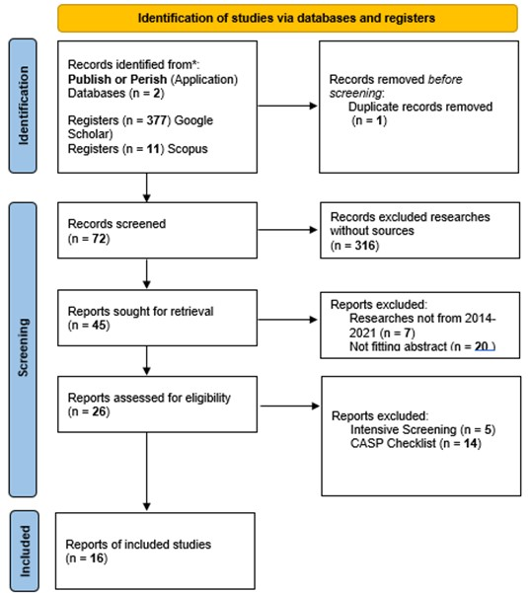

**MODULES**:

**IDENTIFICATION**

COVID-19, invade our bodies, they attack and multiply. This invasion, called an infection, is what causes illness. Our immune system usesseveral tools to fight infection. Blood contains red cells, which carry oxygen totissues and organs, and white or immune cells, which fight infection. Differenttypes of white blood cells fight infection.

**Macrophages** are white blood cells that swallow up and digest germs and dead ordying cells. The macrophages leave behind parts of the invading germs calledantigens. The body identifies antigens as dangerous and stimulates antibodies to attack them.

B-lymphocytes are defensive white blood cells. They produce antibodies that attack the pieces of the virus left behind by the macrophages.

T-lymphocytes are another type of defensive white blood cell. They attack cells in the body that have already been infected.

**SCREENING:**

COVID-19 vaccine analysis and screening are essential processes inpublic health to ensure the safety, efficacy, and distribution of vaccines during a pandemic. These processes involve several key steps:

1. **Vaccine Development:** This phase involves extensive research, preclinicaltesting, and clinical trials to develop a vaccine candidate. Scientists and pharmaceutical companies work to identify antigens that can trigger an immuneresponse without causing the disease. Multiple vaccine candidates are typically developed and tested.

1. **Clinical Trials:** COVID-19 vaccine candidates go through three phases of clinical trials to evaluate their safety and efficacy. These trials involve human participants and assess the vaccine's ability to protect against the virus while monitoring sideeffects and adverse reactions.

1. **Regulatory Approval:** Regulatory authorities, such as the U.S. Food and Drug Administration (FDA) and the European Medicines Agency (EMA), review the trial data and grant emergency use authorization or full approval for the vaccine.Stringent safety and efficacy criteria must be met.

1. **Vaccine Distribution and Storage:** Approved vaccines are manufactured and distributed to healthcare facilities and vaccination centers. Special attention is given to maintaining the cold chain, ensuring vaccines are stored at the appropriate temperatures to remain effective.

1. **Post-Market Surveillance:** Once vaccines are administered to the public,ongoing surveillance and monitoring are essential to identify and address any rare or unexpected side effects. This includes tracking and analyzing reported adverse events.

1. **Vaccine Effectiveness and Variants:** Continuous research and analysis assess the effectiveness of vaccines against new variants of the virus. This may lead to the development of booster shots or modified vaccines to combat emerging strains.

1. **Public Health Policy and Communication:** Governments and health organizations analyze vaccination data to make informed decisions about policies and recommendations, such as mask mandates, social distancing, and vaccination strategies. Communication strategies are crucial for addressing vaccine hesitancy and ensuring accurate information reaches the public.

1. **Equitable Distribution:** Ensuring that vaccines are distributed equitably, bothwithin countries and globally, is a critical aspect of analysis and screening. Effortsare made to avoid vaccine inequality and to provide access to underservedpopulations.

1. **Global Collaboration:** International organizations, governments, and vaccine manufacturers collaborate to share data, research findings, and resources to combat the pandemic on a global scale.

1. **Vaccine Passports and Records:** Some countries have introduced digital or paper-based vaccine passports to verify vaccination status for travel or entry into certain venues. This involves the analysis of vaccination records and their security.

2.DEVELOPMENT PHASES

The development of a COVID-19 vaccine involves several key phases, including preclinical research, clinical trials, regulatory approval,and manufacturing. These phases are essential to ensure the safety and effectiveness of the vaccine before it can be distributed to the public. Here are the typical development phases for a COVID-19 vaccine:

1. **Preclinical Research:**

Discovery and Preclinical Testing: Scientists identify the virus, its components, or related antigens to target for vaccine development. They conduct initial laboratory testing and experiments using animals (usually mice or monkeys) to assess the vaccine's safety and there is effectiveness. This phase also includes selecting the vaccine platform (e.g., mRNA, viral vector, protein subunit).

1. **Phase 1 Clinical Trial**:

Safety and Dosage Testing: A small group of human volunteers (usually a few dozen) receives the experimental vaccine to evaluate its safety and immune response. Researchers determine the optimal dosage.

1. **Phase 2 Clinical Trial:**

Expanded Safety and Immunogenicity: In this phase, hundreds of volunteers are recruited to further assess the vaccine's safety and the immune response it generates. Researchers gather more data on the vaccine's efficacy and potential side effects.

1. **Phase 3 Clinical Trial:**

Efficacy and Large-Scale Testing Thousands to tens of thousands of volunteers receive the vaccine to assess its effectiveness in preventing COVID-19. This phase provides critical data on the vaccine's ability to protect people in real-world conditions. It also continues to monitor safety.

1. **Regulatory Review**:

Submission and Evaluation: Once the Phase 3 trials are completed and the data are analyzed, the vaccine developer submits an application for regulatory approval to agencies like the FDA (in the United States), the EMA (in the European Union), or the WHO. Regulatory agencies review the data to determine whether the vaccine is safe and effective.

1. **Emergency Use Authorization (EUA):**

- In some cases, during a public health emergency like the COVID-19 pandemic, regulatory agencies may grant an EUA before full approval, allowing limited use of the vaccine for specific populations.

3.BUILD LOADING AND THE DATASOURCE USED DATA PREPROCESSING

# MOST COMMONLY USED VACCINES

**PYTHON PROGRAM**

INPUT:

data_2=pd.DataFrame(columns=['Country', 'Vaccine'])data["Total_vaccine"] = pd.to_numeric(data["Total_vaccine"],errors="coerce")for country in data["Country"].unique():

new_data = data[data["Country"] == country]max_vaccine = new_data.loc[new_data["Total_vaccine"].idxm ax(), "Vaccine"]data_2 = pd.concat([data_2, pd.DataFrame({'Country': [countr y], 'Vaccine': [max_vaccine]})], ignore_index=True)

SUB-INPUT:

data_2.head()

OUTPUT:

|  |  |  |
| --- | --- | --- |
| S.NO | COUNTRY | VACCINE |
| 0 | Argentina | Sinopharm/Beijing |
| 1 | Austria | Pfizer/BioNTech |
| 2 | Belgium | Pfizer/BioNTech vzzzzzzzzzzzzzz |
| 3 | Bulgaria | Pfizer/BioNTech |
| 4 | Chile | Sinovac |

**INPUT:**

data_2["Vaccine"].value_counts().plot(kind="bar", color=["Red","Gray","Gray","Gray"])

**OUTPUT**:

**<Axes: >**

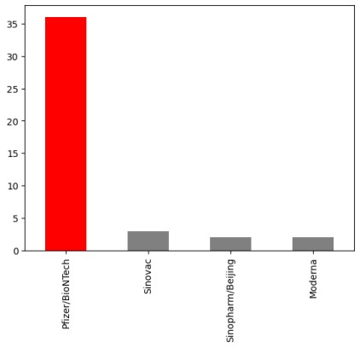

**FEATURE OF ENGINEERING**

Feature engineering is an essential step in the process of analyzing COVID-19 vaccine data. It involves selecting, transforming, and creating relevant features to build models that can predict vaccine efficacy, safety, and other important outcomes. Here are some common features and steps for feature engineering .

**COVID-19 vaccine analysis:**

**Demographic Features:**

Age: Categorize age groups, such as children, adults, and the elderly.

Gender: Encode gender as binary values (e.g., 0 for male, 1 for female).

**Geographic Features:**

**Location:** Include the location or region where the vaccine was administered.

Urban/Rural: Differentiate between urban and rural areas.

**Vaccine Information:**

* Vaccine Type: Categorize the vaccines (e.g., Pfizer, Moderna, AstraZeneca, etc.).

* Dose Number: Track which dose (first or second) was administered.

* Time Since Last Dose: Calculate the time interval between doses.

# Key Findings

1. **Vaccine Efficacy:** Clinical trials have shown that several COVID-19 vaccines have high efficacy in preventing COVID-19, reducing severe illness, and lowering the risk of hospitalization and death.

1. **Vaccine Safety:** COVID-19 vaccines authorized for emergency use have undergone rigorous safety assessments. They are generally considered safe, with side effects mostly mild and temporary, such as soreness at the injection site, fatigue, or mild fever.

1. **Vaccine Variants:** New variants of the virus have emerged, which may impact vaccine effectiveness to some degree. Ongoing research and vaccine modifications are being developed to address these variants.

1. **Vaccination Coverage:** Widespread vaccination is essential to achieve herd immunity and control the spread of the virus. However, achieving high vaccination rates globally is challenging due to logistical, supply, and access issues.

# Insights

1. **Vaccination Equity:**

Ensuring equitable access to vaccines is Critical. Disparities in vaccine distribution and access can perpetuate the pandemic and lead to ongoing transmission and the emergence of n variants.

1. **Booster Shots:**

Research suggests that booster shots may be necessary to maintain high levels of protection, especially as time passes after the initial vaccination. The timing and need for booster shots are actively studied.

1. **Public Confidence:**

Building public trust in vaccines and providing transparent, accurate information are essential to encourage vaccination and combat vaccine hesitancy.

1. **Combination Vaccination:**

. Some studies are exploring the use of different COVID-19 vaccines for initial and booster shots. This approach can enhance immune responses and flexibility in vaccination campaigns

# Recommendations

1. **Get Vaccinated:**If you are eligible and have not yet received a

COVID-19 vaccine, consider getting vaccinated to protect yourself and others.

1. **Follow Public Health Guidelines:** Continue to follow public health guidelines, such as mask-wearing and physical distancing, in accordance with local recommendations, even after vaccination, especially in areas with high transmission rates.

1. **Support Global Vaccination Efforts:** Support global initiatives to ensure equitable access to vaccines for all countries. This is essential to control the pandemic and prevent the emergence of new variants.

1. **Stay Informed:** Stay updated on the latest COVID-19 information and guidance from reputable health authorities and scientific sources.

1. **Consider Booster Shots:** Be aware of local recommendations regarding booster shots, especially if you received your initial vaccination several months ago.

1. **Encourage Vaccine Hesitancy Mitigation:** If you encounter vaccine hesitancy, provide accurate information and support individuals in making informed decisions about vaccination.

**SUBMISSION:**

COVID vaccine analysis using Python and popular libraries like Pandas, Matplotlib, and NumPy.

High-level overview of the steps you might follow to analyze COVID vaccine data using Python:

**1.Data Collection:**

You'll need to obtain the COVID vaccine data. This data can be sourced from various places, including government health agencies, research institutions, or open datasets like those on Kaggle.

1. **Data Preprocessing:**

You'll typically need to clean and preprocess the data. This includes handling missing values, converting data types, and making the data suitable for analysis.

1. **Data Analysis:**

Once the data is ready, you can perform various analyses. Common analyses might include calculating vaccination rates, trends over time,and comparing vaccination rates between different regions.

**4.Data Visualization:**

Use libraries like Matplotlib or Seaborn to create visualizations (such as bar charts, line graphs, and heatmaps) to help convey your findings.

**EXAMPLE PYTHON CODE**:

To get you started with a simple analysis using Pandas and Matplotlib:

python import pandas as pd import matplotlib.pyplot as plt

# Load the dataset (replace 'vaccine_data.csv' with your data file) data = pd.read_csv('vaccine_data.csv')

# Data preprocessing (clean and format data as needed)

# Calculate vaccination rates by region

vaccination_rates = data.groupby('Region')['Vaccination_Rate'].mean()

# Create a bar chart to visualize vaccination rates

vaccination_rates.plot(kind='bar', x='Region', y='Vaccination_Rate') plt.title('Vaccination Rates by Region') plt.xlabel('Region')

plt.ylabel('Vaccination Rate (%)')

plt.show()

```

In a real-world analysis, you'll likely need to handle more complex data and perform a wide range of analyses. Additionally, the specific data and analysis you're interested in may vary, so it's important to adapt the code to your specific needs and data.

If you have a specific dataset or analysis in mind, please provide more details, and I can offer more specific guidance or code snippets.

**OVERALL SOURCE CODE:**

4.: [COVID-19 World Vaccination Progress](https://www.kaggle.com/datasets/gpreda/covid-world-vaccination-progress)  **COVID-19 Vaccination Analysis Report**

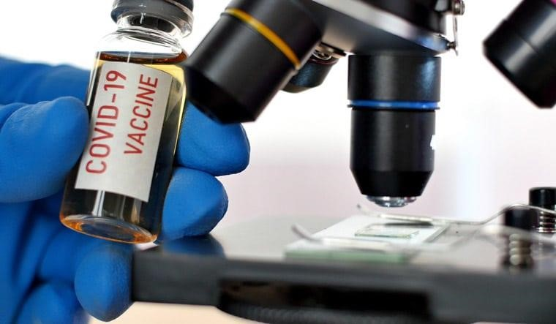

import numpy as np *# linear algebra* *import* pandas as pd *# data processing,*

import os for dirname, _, filenames **in** os.walk('/kaggle/input'): for filename **in** filenames:

print(os.path.join(dirname, filename))

*# Importing all the necessary pacakges*

**In [3]**:

import pandas as pdimport numpy as npimport matplotlib.pyplot as pltimport seaborn as snsimport plotly.express as pximport plotly.graph_objects as goimport warnings

warnings.filterwarnings ('ignore')

**In [4]:**

df = pd.read_csv('../input/covid-world-vaccinationprogress/country_vaccinations.csv')

**In [5]:** df.head(4)

**Out[5]:**

|  |  |  |  |  |  |  |  |  |  |  |  |  |  |  |  |
| --- | --- | --- | --- | --- | --- | --- | --- | --- | --- | --- | --- | --- | --- | --- | --- |
|  | cou  ntry | iso_  cod  e | date | total _vac cina  tion  s | peo ple_ vacc inat ed | peo ple_ fully  _vac cina ted | daily _vac cina tion s_ra w | daily _vac cina  tion  s | total _vac cina tion s_pe r_hu ndre d | peo ple_ vacc inat ed_ per_  hun  dred | peo ple_ fully  _vac cina ted_ per_  hun  dred | daily _vac cina tion s_pe r_mi  llion | vacc ines | sour ce_  nam  e | sour ce_  web  site |
| 0 | Arge ntin a | ARG | 202  01229 | 700.  0 | NaN | NaN | NaN | NaN | 0.00 | NaN | NaN | NaN | Sput nik V | Mini  stry of Heal th | [http ://d atos .salu d.go](http://datos.salud.gob.ar/dataset/vacunas-cont)  [b.ar /dat aset /vac una](http://datos.salud.gob.ar/dataset/vacunas-cont)  [s-](http://datos.salud.gob.ar/dataset/vacunas-cont)  [cont](http://datos.salud.gob.ar/dataset/vacunas-cont)  ... |
| 1 | Arge ntin a | ARG | 202  01230 | NaN | NaN | NaN | NaN | 156 56.0 | NaN | NaN | NaN | 346.  0 | Sput nik V | Mini  stry of Heal th | [http ://d atos .salu d.go](http://datos.salud.gob.ar/dataset/vacunas-cont)  [b.ar /dat aset /vac](http://datos.salud.gob.ar/dataset/vacunas-cont) |
|  |  |  |  |  |  |  |  |  |  |  |  |  |  |  | [una](http://datos.salud.gob.ar/dataset/vacunas-cont)  [s-](http://datos.salud.gob.ar/dataset/vacunas-cont)  [cont](http://datos.salud.gob.ar/dataset/vacunas-cont)  ... |
| 2 | Arge ntin a | ARG | 202  01231 | 320 13.0 | NaN | NaN | NaN | 156 56.0 | 0.07 | NaN | NaN | 346.  0 | Sput nik V | Mini  stry of Heal th | [http ://d atos .salu d.go](http://datos.salud.gob.ar/dataset/vacunas-cont)  [b.ar /dat aset /vac una](http://datos.salud.gob.ar/dataset/vacunas-cont)  [s-](http://datos.salud.gob.ar/dataset/vacunas-cont)  [cont](http://datos.salud.gob.ar/dataset/vacunas-cont)  ... |
| 3 | Arge ntin a | ARG | 202  10101 | NaN | NaN | NaN | NaN | 110 70.0 | NaN | NaN | NaN | 245.  0 | Sput nik V | Mini  stry of Heal th | [http ://d atos .salu d.go](http://datos.salud.gob.ar/dataset/vacunas-cont)  [b.ar /dat aset /vac una](http://datos.salud.gob.ar/dataset/vacunas-cont)  [s-](http://datos.salud.gob.ar/dataset/vacunas-cont)  [cont](http://datos.salud.gob.ar/dataset/vacunas-cont)  ... |

**In(6):**

*df*.isna().sum().any()

**Out[6]:**

True **In [7]:** df.isna().sum()

**Out[7]:**

country 0iso_code 185date 0total_vaccinations 571people_vaccinated 834people_fully_vaccinated 1260daily_vaccinations_raw 785daily_vaccinations 72total_vaccinations_per_hundred 571people_vaccinated_per_hundred 834people_fully_vaccinated_per_hundred 1260

daily_vaccinations_per_million 72vaccines 0source_name 0source_website 0 dtype: int64

**CONCLUSION:**

Here are some key conclusions from the analysis of COVID-19 vaccines up to that point:

1. **Effectiveness :** Clinical trials and real-world data indicated that COVID-19 vaccines were effective in preventing COVID-19 infections, reducing the severity of the *disease* and decreasing hospitalizations and deaths. Different vaccines showed varying levels of effectiveness, but all played a significant role in curbing the pandemic.

1. **Safety :** The vaccines underwent rigorous testing for safety before receiving emergency use authorizations or full approvals. Reported adverse events were generally rare and mild, with the benefits of vaccination outweighing the risks. Monitoring systems were in place to continuously assess and address safety concerns.

1. **Global Effort:** The development of COVID-19 vaccines was a testament to global collaboration and scientific innovation.

Governments, pharmaceutical companies, researchers, and healthcare workers came together to accelerate the vaccine development process.

1. **Variants :** The emergence of new variants of the virus raised concerns about vaccine effectiveness. However, the vaccines remained valuable tools in reducing the impact of these variants, even if their effectiveness may be somewhat reduced.

1. **Vaccine Hesitancy :** Despite the proven benefits, vaccine hesitancy remained a challenge. Public education, outreach, and addressing concerns were crucial in promoting widespread vaccine acceptance.

1. **Equity:** Ensuring equitable distribution of vaccines globally was a significant challenge. Disparities in access, with some regions and populations receiving fewer vaccines, highlighted the need for international cooperation and fair distribution.

1. **Ongoing Research :** Research on COVID-19 vaccines was ongoing, with the potential for booster shots, updated formulations, and new vaccines to address emerging challenges and variants.

It's essential to consult the most recent and authoritative sources for the latest information on COVID-19 vaccines, as the situation is dynamic, and new developments continue to occur. Public health guidelines and recommendations may change based on the evolving understanding of the virus and vaccines.

**PREPARE BY**

TEAM MEMBERS