**Create Firefox profile to handle the downloads and SSL certificates.**

1. Close all instances of firefox
2. Start > firefox.exe –p > enter
3. Click **Create Profile**
4. Click **Next**
5. Enter profile name as “**KYC-AFT**”
6. Click **Finish**
7. Select the profile **“KYC-AFT”** and click **“Start Firefox”**
8. Open the UBO webpage (<https://internal-uboqa-web-1999720210.us-east-1.elb.amazonaws.com/kyc-webapp/#/login>)
9. Add the exception as shown below screenshots

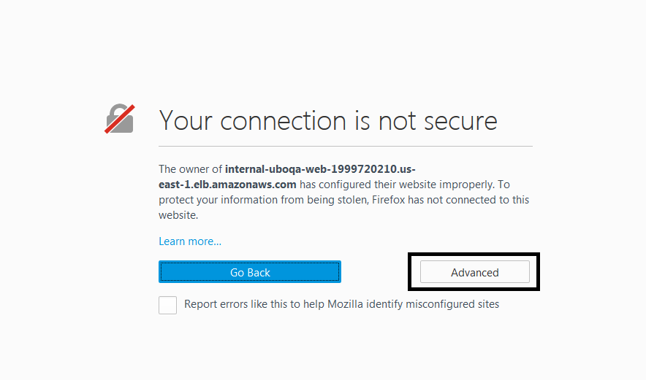

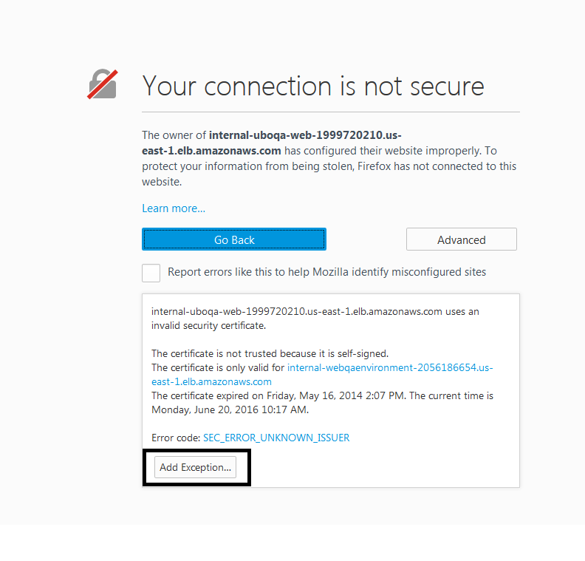

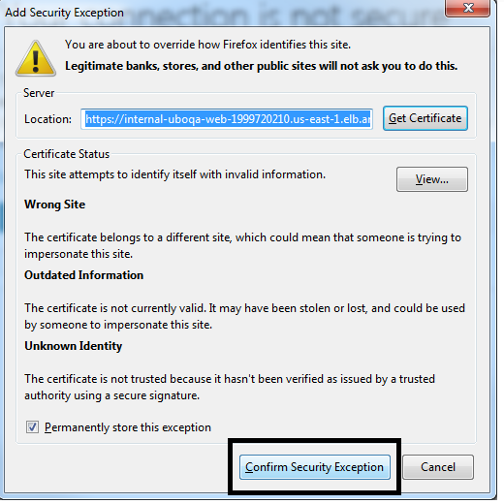

1. Open Firefox **Tools > Options**

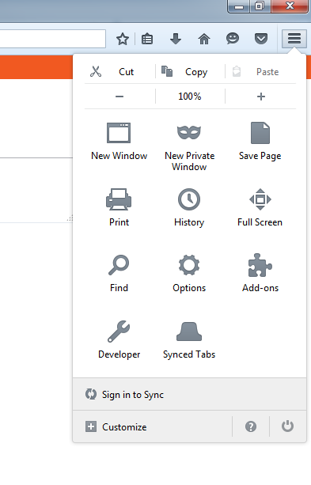

1. Change the download folder to the folder **F:\workspace\kyc-automated-functional-test\src\test\resources\pdfs\actual** *(depends where your AFT is located)*

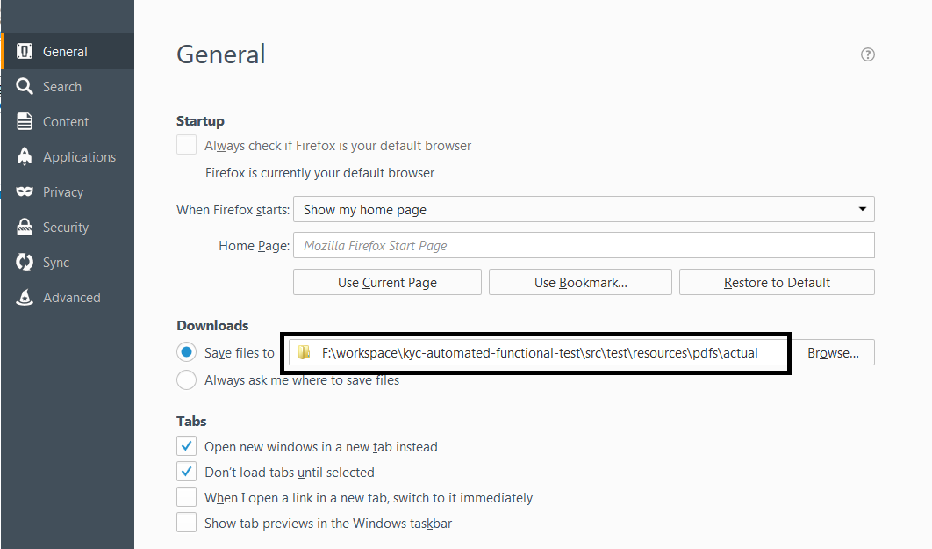

1. Click on **Applications** and select **PDF option.** Select the option **“Save file”**

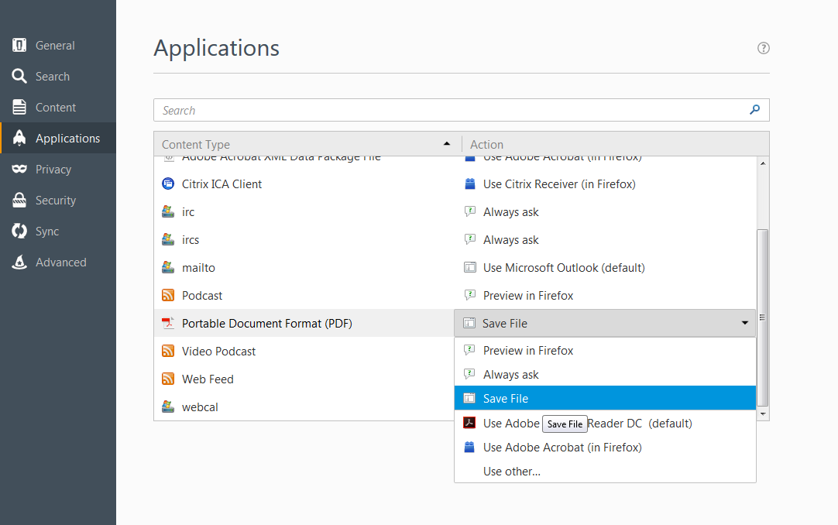

1. Go to any of the page in UBO and click on the **Save as PDF** icon. You should not see the save dialog open and the file should be downloaded in the folder provided in the step 11.