React

>>Advantages of react
Component-Based Architecture : Reusable component
Virtual DOM
Unidirectional Data Flow
- Data flows in one direction, making debugging and state management easier.
Fast Rendering
JSX Syntax
Hooks

• Angular: Best for large enterprise apps with strict structure and built-in features.
• Vue: Great for small to medium projects, easier to learn, and very elegant.
⚠️ Limitations of React
Just the View Layer
Boilerplate and Setup
Performance Issues in Large Apps
Frequent Updates
>>Use state () and useeffect()
>>Keys
>>Jsx
>>Function component and class component
>>Life cycle
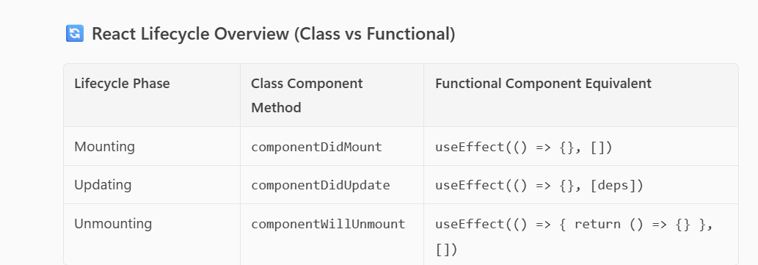

[] → only on mount
[value] → on mount and when value changes
no array → on every render

>> Virtual DOM

Controlled Components
- React controls the form data via state.
- The value of the input is set by React using useState or similar.
- Every change updates the state, and the UI reflects that state.

Uncontrolled Components
- DOM controls the form data, not React.
- You access the value using a ref (useRef) instead of state.
- React doesn’t track changes directly.
- Example
- const App = () => {
- const refvalue = useRef()
- const handle =()=>{
- alert(refvalue.current.value)
- }
- return (
- <div>
- <input type="text" ref={refvalue} />
- <button onClick={handle}> clcik</button>
- </div>
- )
- }

>> state vs props
>> prop drilling how to handle it
>>> error boundery (compontdid catch)
Error Boundaries are components that catch errors anywhere in their child component tree, log those errors, and display a fallback UI instead of crashing the whole app.
Check for the code
>>>React hook
"useReducer is like a mini Redux inside a component. It helps manage complex state transitions using a reducer function and actions. It's cleaner than useState when the state logic grows."
>> useReducer is same like redux
>have more boiler-plates for action , reducer etc
>more complex
>useState is fast enough.

Use state () , use effect () , use ref(),

useMemo – Memoize a value
- Prevents expensive calculations from running on every render.
- Returns a memoized value.
- “useMemo is used to cache the result of a computation so it doesn’t re-run unless its dependencies change.”

- import React, { useMemo, useState } from 'react';

- function App() {
- const [names, setNames] = useState("");
- const [num, setNum] = useState(0);

- const addClick = () => {
- setNum(count => count + 1);
- };
- // experience cal
- const exp = useMemo(() => {
- let result = [];
- for (let i = 0; i < 100; i++) {
- result.push(num);
- }
- return result.join(", ");
- }, [num]);

- return (
- <div>
- <div>{exp}</div>
- <input
- type="text"
- value={names}
- onChange={(e) => setNames(e.target.value)}
- />
- <button onClick={addClick}>Click</button>
- </div>
- );
- }

- export default App;

useCallback – Memoize a function
- Prevents a function from being re-created on every render.
- Useful when passing functions to child components to avoid unnecessary re-renders.
“useCallback is used to memoize functions so they don’t get re-created unless dependencies change, which helps optimize child component rendering.”

import React, { useCallback, useMemo, useState } from 'react';
import Child from './Child';

function App() {
const [names, setNames] = useState("");
const [num, setNum] = useState(0);

const addClick = () => {
setNum(count => count + 1);
};

const exp = useCallback(() => {
let result = [];
for (let i = 0; i < 100; i++) {
result.push(num);
}
alert( result.join(", "))
}, [num]);
hoc
return (
<div>
<div> {num}</div>
<input
type="text"
value={names}
onChange={(e) => setNames(e.target.value)}
/>
<button onClick={addClick}>Click</button>
<Child onClick={exp}/>
</div>
);
}

export default App;

/////////////////////////////child

import React from 'react'

function Child({onClick}) {
return (
<div>
<button onClick={onClick}>button</button>
</div>
)}
export default Child

>>>Rules for hook
Used in functional component only
Used in only top leval
Cant be used in the any loop , function

Step-by-Step: Share Data Between Siblings
1. Lift the state up to the parent component.
2. Pass data and functions as props to each sibling.
“To share data between sibling components, I lift the shared state up to their common parent. One sibling updates the state, and the other reads it via props. This keeps data flow unidirectional and predictable.”

>> Conditional rendering in
Conditional rendering in React lets us control what gets displayed based on state or props. We can use if, ternary operators, or logical && to render components dynamically.”

>>> useContext vs Redux
useContext is great for simple global state like themes or user info. But for complex state logic, especially with async actions or multiple reducers, Redux is more powerful and scalable. Redux also offers better debugging and middleware support."

>> Hook can’t achicve this method so we use this in error boundery
Component did catch()
“componentDidCatch is used to catch and log errors that occur during rendering or lifecycle methods of child components.”
Get derived state from error()
“getDerivedStateFromError lets us update the component’s state when an error is detected, so we can show a fallback UI.”
Get snapshot before update()
getSnapshotBeforeUpdate() is a rarely used lifecycle method in class components. It allows you to capture information from the DOM right before it changes due to an update.
>> Different phase of lifecycle >> mount , update , unmount
>> data passing from child to parent
>> optimazting app
Usememo()
Lazyloading()
Pure compontent
“A Pure Component automatically avoids re-rendering if props and state haven’t changed. It uses shallow comparison to improve performance, especially in components with stable props.”

>> Lazy loading
“Lazy loading in React helps optimize performance by loading components only when needed. I use React.lazy() to import components dynamically and wrap them in Suspense to show a loading indicator.”

import React, { Suspense } from "react";
// Lazy load the component
const LazyComponent = React.lazy(() => import('./MyComponent'));
function App() {
return (
<Suspense fallback={<div>Loading...</div>}>
<LazyComponent />
</Suspense>
);}
React Node
Anything that can be rendered (JSX, string, number, fragment, etc.)
React Element
A plain object describing what to render (like <div />)
React Component
A function or class that returns JSX and can be reused across the app
>> proptype

>> stateless component in React is a component that does not manage or hold its own state. It simply receives data via props and renders UI based on those props.

>> A stateful component in React is a component that manages its own internal state

>> mutating state
means directly changing the state object instead of using the proper method like setState

React relies on immutability to detect changes and re-render components. If you mutate state directly:
- React may not re-render because it compares references, not deep values.
- It can cause unexpected bugs and break the component lifecycle.

>> What is Reconciliation? (meant virtual dom )
Instead of re-rendering the entire DOM, React compares the new virtual DOM with the previous one, finds the differences (called diffing), and updates only the parts that changed.

What is SSR in React?
Yes, React does support SSR (Server-Side Rendering)
Server-Side Rendering means rendering your React components on the server, and sending the fully rendered HTML to the browser. This helps:
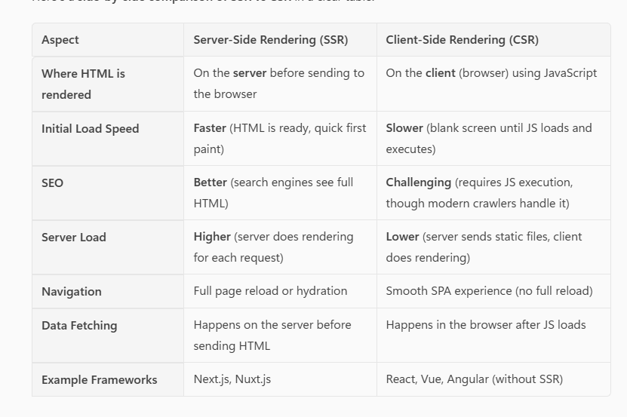
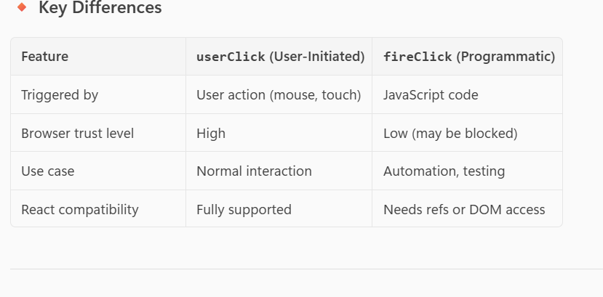
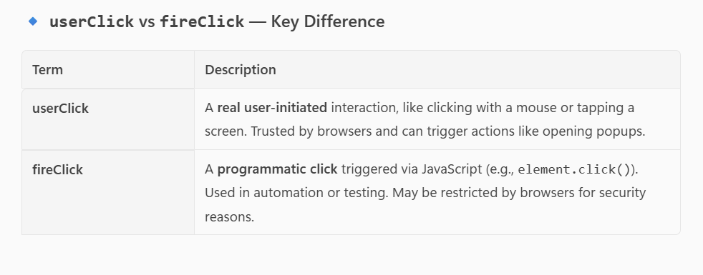
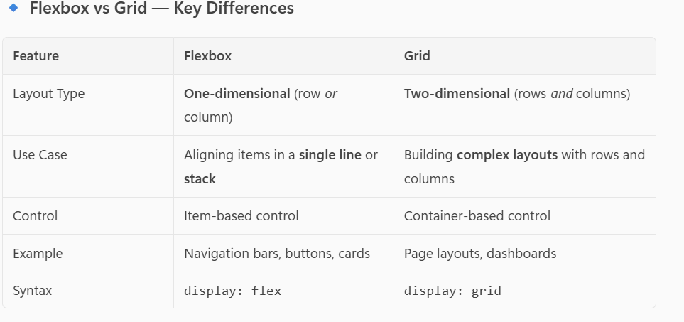
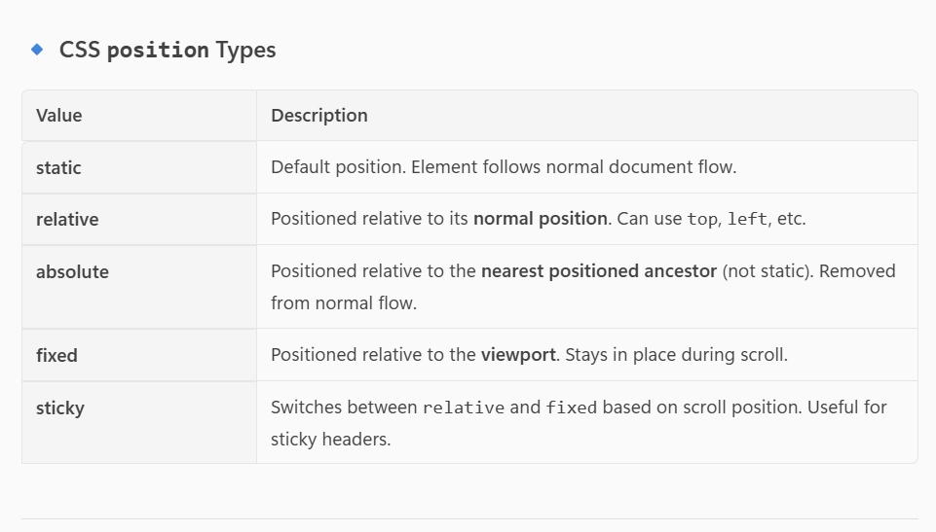
Media quere
@media screen and (max-width:750px){
}
• screen – for devices with screens (default)
• print – for printed documents
>>forwardRef?
forwardRef is used when you want to pass a ref from a parent to a child component, especially when the child is a custom component.

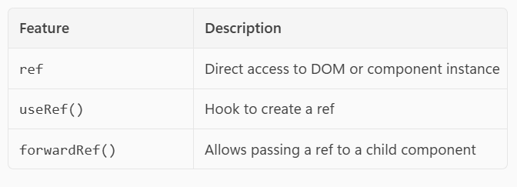

Callback hell
(also known as the "Pyramid of Doom") is a situation in JavaScript where you have many nested callbacks, making the code:complex

How to handel callback hell
>Use Promises
> Use async/await
> Use Named Functions

How to Memoize a Component
React provides a built-in function called React.memo() for this purpose.
When to Use React.memo?
Use it when:
- The component is pure (output only depends on props).
- The component is rendered frequently.
- You want to avoid unnecessary re-renders.

What is Accessibility?
Accessibility (often abbreviated as a11y) in web development means designing and building websites, apps, and digital content so that everyone, including people with disabilities, can use them effectively.

How to improve accessibility
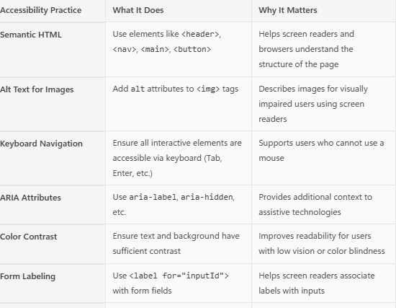
🛑 Why e.preventDefault() is important in a form's onSubmit handler:
When you submit a form in HTML (even in React), the browser by default tries to:
- Reload the page
- Send the form data to the server (if an action is specified

Real-World Use Cases for e.preventDefault()
1. Form Submission
- Prevents page reload.
- Lets you validate and process form data using React or send it to an API.
2. Anchor Tags (<a>)
JSX
# e.preventDefault()}>
Click me
</a>
Show more lines
- Prevents navigation to # or any URL.
- Useful when you want to handle navigation manually (e.g., with React Router).
3. Drag and Drop
JavaScript
element.addEventListener("dragover", (e) => {
e.preventDefault(); // Allows drop
});
Show more lines
- Prevents the browser from blocking the drop event.
- Used in custom file upload or drag-and-drop interfaces.
4. Keyboard Events
JavaScript
document.addEventListener("keydown", (e) => {
if (e.key === "Enter") {
e.preventDefault(); // Prevents form submission or default behavior
}
});
Show more lines
- Useful in custom input handling or game controls.
5. Touch Events (Mobile)
JavaScript
element.addEventListener("touchmove", (e) => {
e.preventDefault(); // Prevents scrolling
});

Show more lines
- Used in mobile apps or games to control gestures.

✅ Summary
Use e.preventDefault() when:
- You want full control over what happens.
- The default browser behavior is not what you want.
- You’re building interactive UIs that go beyond basic HTML behavior.

==============================================================
✅ Common Use Cases for Lazy Loading
1. Images and Media
- Why: Images are often large and numerous, especially in e-commerce, blogs, or social media apps.
- How: Use loading="lazy" or libraries like react-lazyload.
- Example: Product images on Amazon, thumbnails on YouTube.

- <img
- src={item.image}
- alt={item.title}
- loading="lazy"
- style={{ width: "200px", height: "200px", margin: "20px" }}
- />

✅ What loading="lazy" Does
It tells the browser to defer loading the image until it's about to enter the viewport — meaning the user is about to scroll to it.

🔍 Why It's Useful
- Improves performance: Only loads images when needed.
- Reduces initial page load time: Especially helpful when you have many images.
- Saves bandwidth: Useful for users on slow or limited connections.
- Enhances user experience: Faster rendering of visible content.

🧠 How It Works Behind the Scenes
When the browser sees loading="lazy":
- It waits until the image is close to being visible (usually within a few hundred pixels).
- Then it starts downloading and rendering the image.
This is native lazy loading, supported in most modern browsers without needing extra libraries.

✅ When to Use It
Use loading="lazy" for:
- Product images
- Blog post thumbnails
- Gallery photos
- Any image not immediately visible on page load

2. Components
- Why: Some components (e.g., modals, charts, dashboards) are not needed immediately.
- How: Use React.lazy() and Suspense to load them only when needed.
- Example: A chart component that loads only when the user clicks "View Analytics".
We use React.lazy() in real-world React projects to lazy load components, which means loading them only when they are needed — not during the initial page load.

✅ When to Use React.lazy()
Here are the most common scenarios:
1. Lazy Loading Pages or Routes
- In apps with multiple pages (e.g., using React Router), you can lazy load each page.
- This reduces the initial bundle size and speeds up the first load.
Example:
const AboutPage = React.lazy(() => import('./AboutPage'));
2. Lazy Loading Heavy Components
- If a component is large or uses heavy libraries (charts, maps, editors), load it only when needed.
- const Chart = React.lazy(() => import('./Chart'));

3. Conditional Rendering
- If a component is shown only after a user action (e.g., clicking a button), lazy load it.
Example:
const Modal = React.lazy(() => import('./Modal'));

{showModal && (
<Suspense fallback={<div>Loading modal...</div>}>
<Modal />
</Suspense>
)}

3. Routes (Pages)
- Why: Not all pages are needed at once.
- How: Use React.lazy() with React Router to load pages on demand.
- Example: Lazy load the "Settings" page only when the user navigates to it.

4. Third-party Libraries
- Why: Some libraries are heavy and used conditionally.
- How: Dynamically import them when needed.
- Example: Load a PDF viewer only when the user opens a document.
5. Infinite Scroll Lists
- Why: Loading hundreds of items at once is inefficient.
- How: Load more items as the user scrolls, and lazy load each item.
- Example: Facebook or Instagram feed, product listings on Flipkart.

🧠 Benefits in Real Projects
Benefit | Impact
🚀 Faster initial load | Improves first paint and time-to-interactive
📉 Reduced bandwidth | Saves data for users on slow networks
🧠 Better UX | Smooth scrolling and transitions
🧩 Modular architecture | Easier to maintain and scale

✅ Summary of Dependencies
Use Case | Dependency | Required?
Image lazy loading | None (loading="lazy") | Native Lazy Loading (No Dependency Needed)
Component lazy loading | React.lazy + Suspense | Built-in React feature, no extra dependency needed.
Scroll-based lazy loading Scroll (Infinite Scroll) | @react-intersection-observer or react-lazyload | Option A: react-intersection-observer  - Detects when an element enters the viewport.  - Great for infinite scroll or triggering animations.  Option B: react-lazyload  - Lazy loads components or images based on scroll position.
Route lazy loading | React.lazy + react-router-dom | No extra dependency beyond react-router-dom

>> connect
connect is a higher-order function provided by react-redux that links your React component to the Redux store. It allows the component to:
- Access state from the store.
- Dispatch actions to update the store.

>> ✅ mapStateToProps
This function tells connect which parts of the Redux state your component needs.
It takes the entire Redux state as an argument and returns an object that maps state values to component props.

>> mapDispatchToProps
This function tells connect which actions your component can dispatch.
It returns an object where keys become props and values are functions that dispatch actions.
• Hooks (useSelector, useDispatch) → modern, simpler, flexible.
• connect → legacy but still relevant for class components and performance optimizations.

>> usefectch hook
// parent
import { useEffect, useState } from "react"

const usefetch = (url)=>{
const [data , setData] = useState([])

useEffect(()=>{
fetch (url)
.then(res =>res.json())
.then(json => setData(json))
})

return {data}
}

export default usefetch

//////////////////parent

import React from 'react'
import usefetch from './Child'

const App = () => {
const {data} =usefetch("https://jsonplaceholder.typicode.com/todos")

console.log(data)
return (
<div>
{data.map((item)=>(<div key={item.id}>{item.title}</div>))}
</div>
)
}

export default App

What useTransition Does
- Marks some state updates as non-urgent.
- Lets React keep the UI responsive by prioritizing urgent updates first.
- Returns:
  - isPending → Boolean indicating if the transition is ongoing.
  - startTransition → Function to wrap non-urgent updates.
- import React, { useState, useTransition } from "react";

- const biglist = []
- for (let i = 0; i < 5000; i++) {
- biglist.push(`item ${i}`)
- }

- function App() {
- const [query, setQuery] = useState("");
- const [filteredList, setFilteredList] = useState(bigList);
- const [isPending, startTransition] = useTransition();

- const handleChange = (e) => {
- const value = e.target.value;
- setQuery(value); // urgent update (typing)
- startTransition(() => {
- // non-urgent update (filtering)
- const newList = bigList.filter((item) =>
- item.toLowerCase().includes(value.toLowerCase())
- );
- setFilteredList(newList);
- });
- };

- return (
- <div>
- <input value={query} onChange={handleChange} placeholder="Search..." />
- {isPending && <p>Loading...</p>}
- <ul>
- {filteredList.map((item) => (
- <li key={item}>{item}</li>
- ))}
- </ul>
- </div>
- );
- }

- export default App;

What is useDeferredValue?
- It defers a value update so React can prioritize urgent updates (like typing).
- Useful when rendering based on that value is expensive (e.g., filtering a big list).
- Unlike useTransition, it works on values, not state updates.

import React, { useState, useDeferredValue } from "react";

const bigList = Array.from({ length: 5000 }, (_, i) => `Item ${i}`);

function App() {
const [query, setQuery] = useState("");
const deferredQuery = useDeferredValue(query); // defer heavy updates

const filteredList = bigList.filter((item) =>
item.toLowerCase().includes(deferredQuery.toLowerCase())
);

return (
<div>
<input
value={query}
onChange={(e) => setQuery(e.target.value)}
placeholder="Search..."
/>
<p>Typing: {query}</p>
<p>Deferred: {deferredQuery}</p>
<ul>
{filteredList.map((item) => (
<li key={item}>{item}</li>
))}
</ul>
</div>
);
}

export default App;

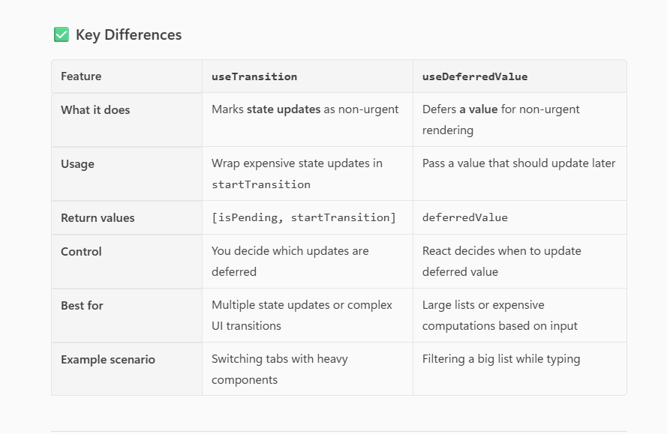

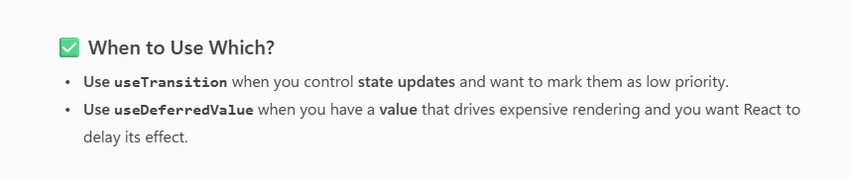
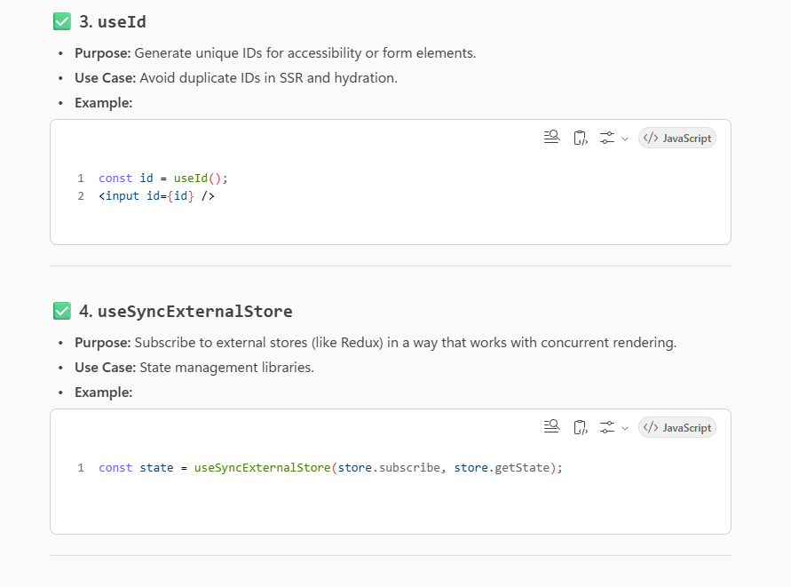
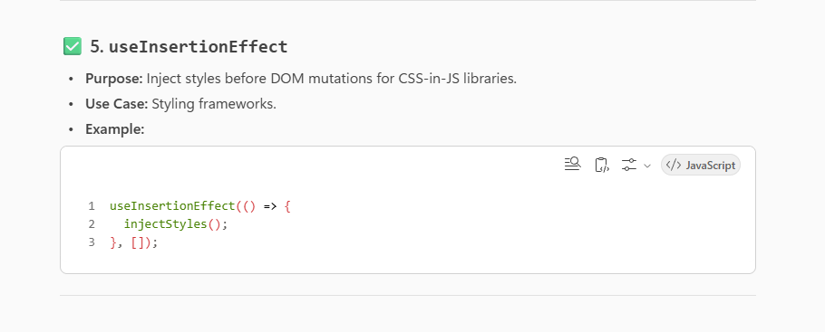
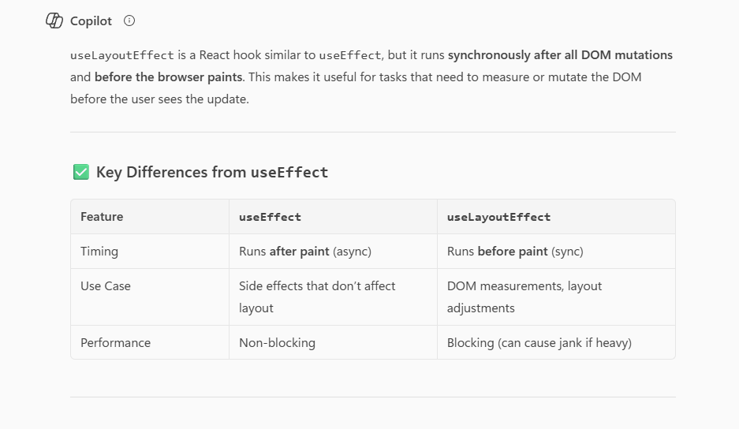
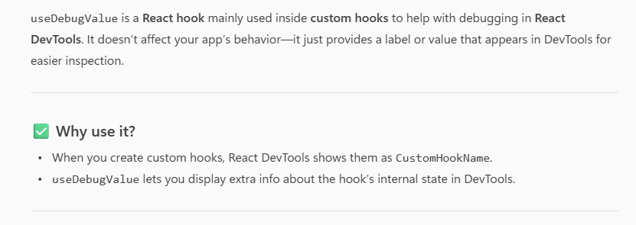

• Redux (with Redux Toolkit): Best for large/enterprise apps, strict patterns, and great DevTools. Predictable, testable, and team-friendly. Have reducerand , action
Have good dependence like thunk , immer etc
• Zustand: Best for small/medium apps. Minimal boilerplate, fast, simple API based on hooks. Don’t have action
• MobX: Best for reactive, computed-heavy UIs. Very ergonomic, but can feel “magical” and less predictable in big teams. Don’t have action

