Agentic AI Code Review and Quality Engineering Platform Project Documentation
Technical architecture, workflow, operations, security, quality checks, and demonstration guide
Purpose. This document explains the working TypeScript, NestJS, and React demonstration project. It is written for technical architects, senior engineers, and engineering leaders who need to understand how the platform combines agentic AI review with deterministic quality engineering.
Item | Details
Project type | Working local demonstration platform
Primary stack | TypeScript, NestJS, React, Vite, Node.js
AI provider | Gemini API with local structured fallback
Quality tools | ESLint, TypeScript compiler, Jest coverage, npm audit
Current policy outcome for sample project | BLOCKED because deterministic gates fail

Document Control
Item | Value
Document owner | Engineering architecture demo
Audience | Technical architects, senior engineers, engineering leaders, reviewers
Repository | agentic-review-demo
Primary deliverables | React UI, NestJS API, agents package, shared schemas, sample project, docs
Review status | Platform build, tests, lint, and end-to-end API flow verified

Executive Summary
The platform reviews a local repository through a NestJS orchestrator. It gathers Git context, runs an AI Code Review Agent, runs a deterministic Quality Agent, aggregates findings, evaluates an explicit policy, and displays the outcome in a React dashboard.
The core architectural decision is separation of authority. Deterministic tools remain authoritative for compiler, lint, test, coverage, and dependency facts. AI contributes contextual findings with evidence, confidence, file references, and suggested fixes. AI findings require human validation and do not directly block production.
Objective | How the project demonstrates it
Agentic AI | The Code Review Agent uses controlled repository tools and emits structured findings.
Quality engineering | The Quality Agent executes real deterministic checks through a command allowlist.
Enterprise guardrails | Path validation, schema validation, environment-only secrets, and read-only AI access are implemented.
Human control | Reviewers can accept, dismiss, or resolve findings from the dashboard.
Observability | Operational agent and tool events are captured as a trace without exposing hidden model reasoning.

Architecture Overview
The repository is organized as a compact monorepo. Application code is separated from reusable agent and schema packages, while the intentionally defective sample project remains isolated from platform quality checks.
Area | Path | Responsibility
Frontend | apps/web | React dashboard for review execution, findings, quality checks, and trace.
Backend | apps/api | NestJS API, review lifecycle, orchestration, and finding updates.
Agents | packages/agents | Code Review Agent, Quality Agent, repository tools, policy engine, aggregator, trace recorder.
Shared schemas | packages/shared | Zod schemas and TypeScript types shared by API, agents, and UI.
Sample app | sample-project | Small NestJS Orders domain with intentional defects for demonstration.
Documentation | docs/project-documentation | Project document, screenshots, and Word deliverable.

Logical Flow
- Developer opens the dashboard and starts a review.
- NestJS validates the repository path and collects Git context.
- The Quality Agent runs deterministic tools through an allowlist.
- The Code Review Agent gathers bounded repository evidence and creates structured AI findings.
- The aggregator deduplicates findings from AI and deterministic sources.
- The policy engine produces PASS, WARNING, HUMAN REVIEW REQUIRED, or BLOCKED.
- The dashboard shows the decision, quality checks, findings, and trace.
- A human reviewer accepts, dismisses, or resolves findings.

Review Workflow
The runtime workflow is intentionally visible in the dashboard so a reviewer can see what the system is doing and why a decision was made.
Step | Runtime activity | Source of truth
1 | Initialize review and create trace recorder | NestJS orchestrator
2 | Validate repository and collect Git context | Repository tools
3 | Run TypeScript, ESLint, Jest, coverage, and npm audit | Quality Agent
4 | Analyze changed code and related files | Code Review Agent
5 | Normalize and deduplicate findings | Review Aggregator
6 | Apply deterministic and AI policy rules | Policy Engine
7 | Show findings, quality checks, and trace | React dashboard
8 | Accept, dismiss, or resolve findings | Human reviewer

Running Project Screenshots
These screenshots were captured from the running application and show the current demo state.

Dashboard before review
The initial dashboard shows repository context and the primary review action.
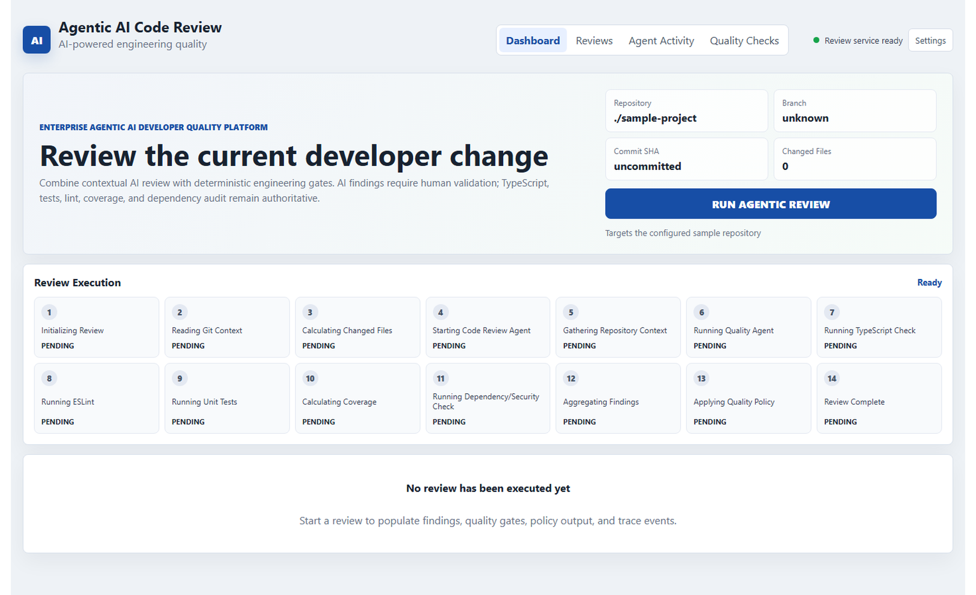

Dashboard after completed review
The completed review shows the BLOCKED policy decision and live review summary.
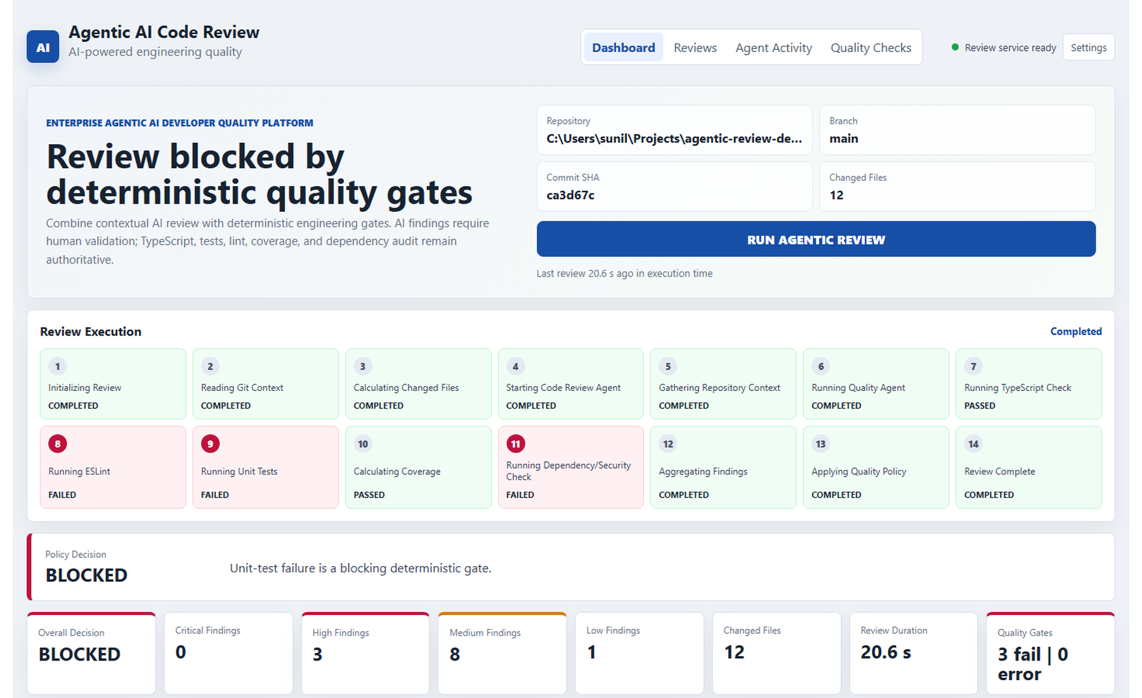

Quality checks panel
Deterministic quality outputs are displayed with real status, duration, metrics, and summaries.
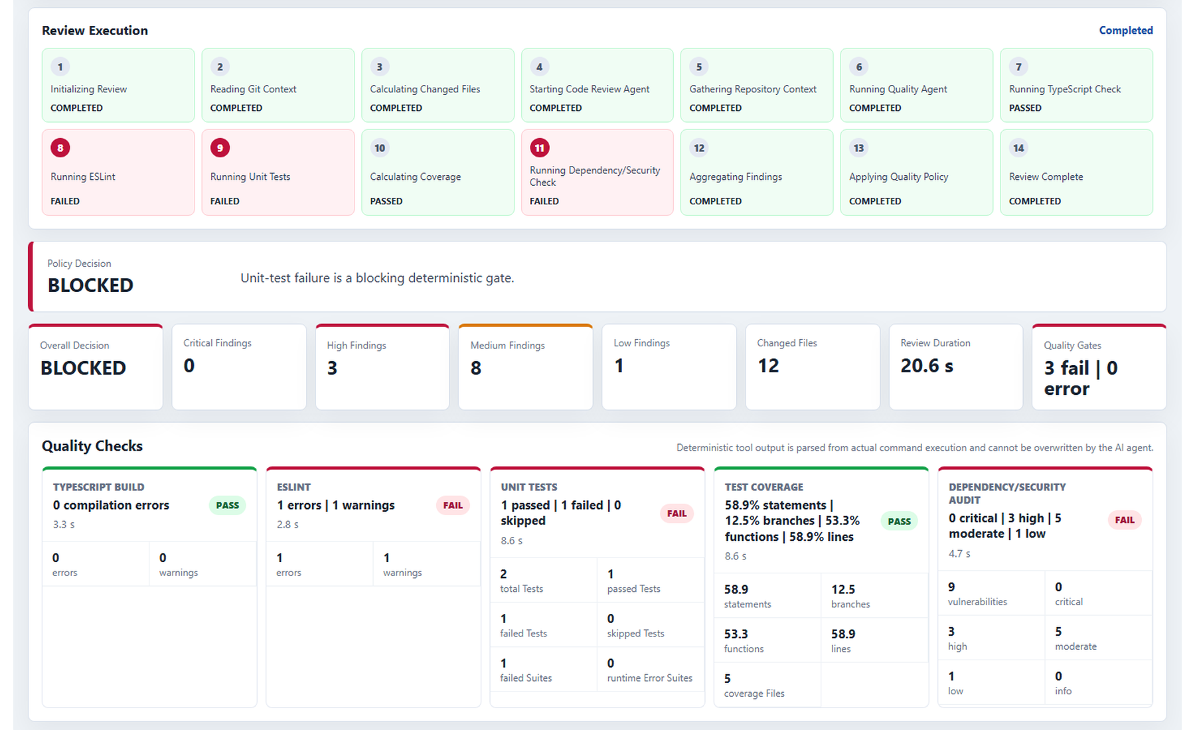

Findings and human review
AI and deterministic findings are shown with severity, source, evidence, and human actions.
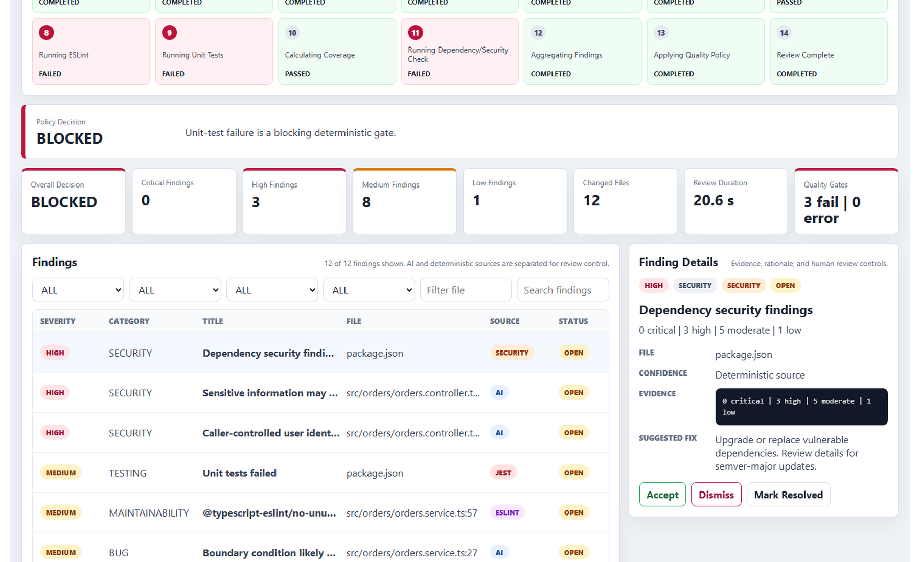

Agent activity trace
Operational trace events show agent and tool activity without exposing hidden model reasoning.
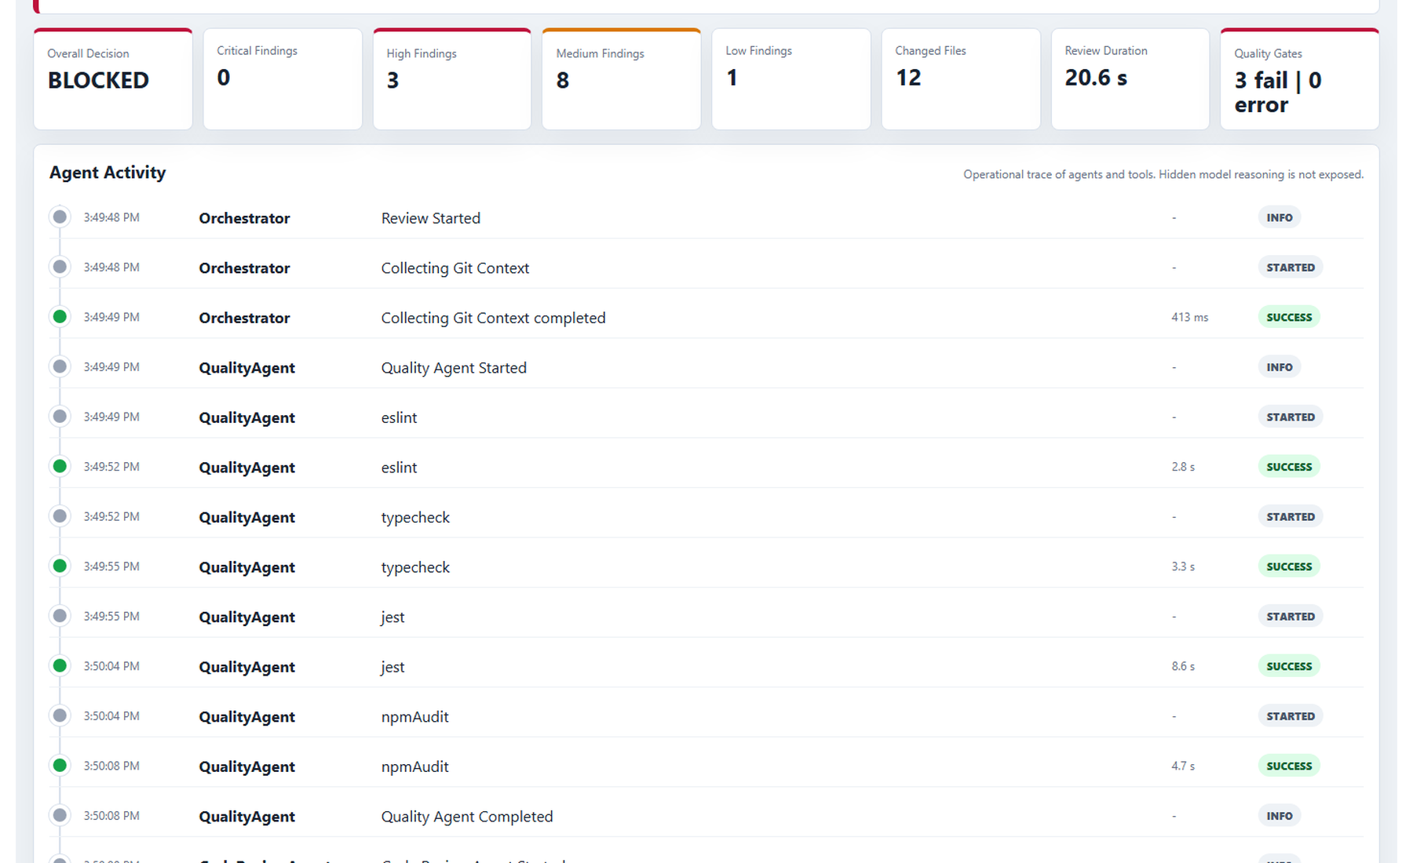

Agent Components

Code Review Agent
The Code Review Agent performs contextual analysis over bounded repository evidence. It can inspect Git diff, read constrained files, search the repository, inspect package metadata, find related tests, read coding standards, and consume deterministic quality results. It cannot execute arbitrary shell commands.
Tool | Purpose
getGitDiff | Review changed code rather than the entire repository.
readFile | Read bounded files under the configured repository root.
searchRepository | Find related code by query without path traversal.
getPackageInfo | Understand scripts and dependencies.
getRelatedTests | Locate likely tests for a changed file.
getCodingStandards | Provide local review rules and expected practices.
getQualityResults | Use deterministic outputs as context without changing them.

Quality Agent
The Quality Agent runs allowed deterministic commands and normalizes their outputs. It never invents results and treats tool infrastructure errors separately from quality failures.
Tool | Command | Normalized output
ESLint | npm run lint -- --format json | Errors, warnings, file, line, rule, message
TypeScript | npm run typecheck | Compilation status and compiler errors
Jest and coverage | npm run test:coverage -- --json | Passed, failed, skipped tests and coverage percentages
npm audit | npm audit --json --audit-level=moderate | Critical, high, moderate, low, and total vulnerabilities

API and Data Model
Endpoint | Method | Purpose
/api/health | GET | Health check
/api/reviews | POST | Start a new review
/api/reviews/:id | GET | Fetch complete review result
/api/reviews/:id/findings | GET | Fetch review findings
/api/reviews/:id/quality | GET | Fetch deterministic quality results
/api/reviews/:id/trace | GET | Fetch operational trace
/api/reviews/:reviewId/findings/:findingId | PATCH | Update finding status

Quality Check Model
Each deterministic check is normalized with a consistent shape.
Field | Meaning
tool | Machine-readable tool id such as eslint, typecheck, jest, coverage, or npmAudit.
status | PASS, FAIL, WARNING, ERROR, or SKIPPED.
durationMs | Tool execution duration.
summary | Human-readable result summary.
metrics | Structured counts such as errors, warnings, failedTests, and vulnerabilities.
details | Parsed per-file, per-test, or per-package details.

Policy Decisions
Condition | Decision
TypeScript/build failure | BLOCKED
Unit-test failure | BLOCKED
Critical or high deterministic security finding | BLOCKED
Configured deterministic quality gate failure | BLOCKED
AI critical or high finding | HUMAN REVIEW REQUIRED
AI medium finding | WARNING
All gates pass and no open high-risk AI findings remain | PASS

Security and Observability

Security Guardrails
- API keys are loaded from environment variables and .env is ignored by Git.
- Repository root validation prevents path traversal outside the workspace.
- Repository access for the AI agent is read-only.
- The LLM is not given arbitrary shell execution.
- Quality commands are selected from a fixed allowlist.
- AI output is validated with shared Zod schemas.
- Deterministic tool results remain authoritative.
- AI findings require human validation before release decisions.

Trace Events
The trace captures operational activity such as Review Started, Collecting Git Context, eslint, typecheck, jest, npmAudit, readFile, getRelatedTests, Policy Evaluation, and Review Completed. It intentionally excludes hidden model reasoning.

Setup and Operations
Command | Purpose
npm install | Install workspace dependencies
Copy-Item .env.example .env | Create local environment file on Windows PowerShell
npm run dev | Run API and frontend together
npm run build | Build shared, agents, API, and web packages
npm run test | Run platform tests
npm run lint | Run platform linting
npm run demo:quality | Run deterministic quality checks against sample-project

Environment Variables
Variable | Purpose | Example
PORT | API port | 3001
WEB_ORIGIN | CORS origin | http://localhost:5173
REPOSITORY_ROOT | Repository to review | ./sample-project
GEMINI_API_KEY | Gemini API key | your_key_here
GEMINI_MODEL | Gemini model | gemini-3.5-flash-lite
ENABLE_LLM_REVIEW | Enable live LLM calls | true
MAX_REVIEW_FILES | Changed file cap | 30
MAX_FILE_BYTES | File read cap | 12000

Sample Project Ground Truth
The sample project intentionally contains defects that demonstrate the value of combining deterministic tools with contextual AI review.
ID | Intentional defect | Expected detector
GT-01 | userId trusted from request body instead of authenticated principal | Code Review Agent
GT-02 | DTO missing validation decorators and validation pipe | Code Review Agent
GT-03 | Zero quantity allowed | Code Review Agent
GT-04 | Restricted product authorization missing | Code Review Agent
GT-05 | Sensitive-looking context logged with console.log | ESLint and Code Review Agent
GT-06 | Exceptions swallowed in findOrdersForUser | Code Review Agent and ESLint
GT-07 | Sequential awaits in summary logic | Code Review Agent
GT-08 | Coupon logic returns zero for no-discount orders | Jest and Code Review Agent
GT-09 | Missing edge-case tests | Code Review Agent
GT-10 | Old demo dependency tree with real audit findings | npm audit

Testing and Acceptance
The platform verification pass ran build, test, lint, deterministic quality demo, and end-to-end API review execution.
Verification | Result
npm run build | Passed
npm run test | Passed
npm run lint | Passed
npm run demo:quality | Executed real sample-project quality checks
End-to-end API review | Completed with BLOCKED decision and real quality results
Human finding update | PATCH endpoint verified and policy recalculated

Acceptance Criteria Summary
Capability | Status
React UI runs | Complete
NestJS backend runs | Complete
User can start review | Complete
Code Review Agent executes | Complete
Quality Agent executes | Complete
Real ESLint, TypeScript, Jest, coverage, and audit results collected | Complete
Policy engine produces final decision | Complete
UI displays findings, quality checks, and trace | Complete
Human can accept and dismiss findings | Complete
Secrets excluded from Git | Complete

Limitations and Roadmap
Current limitation | Recommended future improvement
Review state is in-memory | Persist reviews and audit events in MongoDB or Postgres
Endpoint is synchronous | Move review execution to queue-backed workers
No GitHub PR integration | Add GitHub Actions, webhook, PR comments, and status checks
No authentication | Add SSO and role-based reviewer permissions
Single-language demo focus | Add language-specific quality runners and policy profiles
No auto-fix flow | Generate patches only after explicit human approval
Basic cost controls | Add model routing, token budgets, caching, and review summaries

