What is ngrok?

Ngrok is a tool that creates a secure tunnel between a public internet endpoint and a locally running server on your computer. In simpler terms, it allows you to expose a web server on your local machine to the internet. This can be incredibly useful for tasks like testing webhooks, sharing work-in-progress web projects, or accessing local services remotely.

1. **Webhook Testing**: Run ngrok on your local machine to get a URL to receive webhooks directly in the app you're developing. Inspect and replay requests for fast development.
2. **Local Previews:** Demo a website running on your local machine to a client or stakeholder without deploying to a staging site.
3. **Mobile Backend Testing:** Test your mobile apps against a backend that you're developing on your local machine.

A **tunnel** is basically a bridge between your local server and the ngrok provided endpoint which is publicly available.

# How to use ngrok for tunneling?

Step 1: **Create an account**

* Create an account in ngrok first, by going to this [link](https://ngrok.com/).

Step 2: **Install**

* D[ownload the ngrok agent from ngrok’s Download page](https://ngrok.com/download).
* You’d see an executable file named `ngrok.exe`, store it in a specified folder where you usually store your important executables and add the path of that directory into your environmental PATH. `

This would allow you to access the ngrok executable throughout all your terminals.

Step 3: **Setup your AUTH-TOKEN**

* Now setup your auth-token so that ngrok can verify you and could create a tunnel for you.
* Copy your auth-token from ngrok’s dashboard > Your Authtoken.
* Open cmd and type `ngrok config add-authtoken <TOKEN>`. Replace <TOKEN> with your Authtoken.

Step 4: **Put your app online**

* Let’s assume that you have a working web application listening on http://localhost:8080. To Create a tunnel for your app run in cmd `ngrok http <http://localhost:8080>`.
* You will see something similar to this, which means any request coming from https://8834-117-254-139-5.ngrok-free.app will get forwarded to your app.

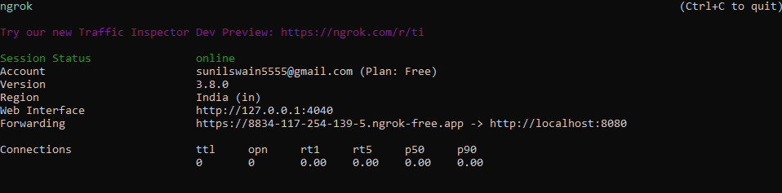

* If your app is listening on a different URL, change the above command to match.

Step 5: **Always use the same domain**

With time you might get frustrated since every time you run the tunnel this way it generates an unique url. To tackle that we can use a static domain provided by ngrok, each free account can have only one static active at any given point of time.

* If you want to keep the same URL each time you use ngrok, create a static domain on your dashboard and then use the **--domain** flag to ask the ngrok agent to use it. Run the ngrok tunnel again with the command `ngrok http 8080 --domain jumpy-red-mollusk.ngrok-free.app`.

## Conclusion

In conclusion ngrok lets you easily share local websites or services over the internet with others, making it simple to test and collaborate on projects without dealing with complex network setups.