BUSINESS SALES ANALYTICS DASHBOARD
Internship Project Report
Name: Sunil Kumar
Domain: Data Science
Duration: 2-Month Internship

1. Introduction
This project analyzes the Superstore Sales dataset using Python, Pandas, and Matplotlib to identify business trends, high-performing products, regional performance, and sales distribution.

2. Objectives
- Analyze sales performance
- Identify top products and states
- Visualize business trends
- Support data-driven decision making

3. Dataset Description
Dataset: Superstore Sales
Rows: 9800
Columns: 18
Tools: Google Colab, Python, Pandas, Matplotlib

Figure 1: Category Wise Sales
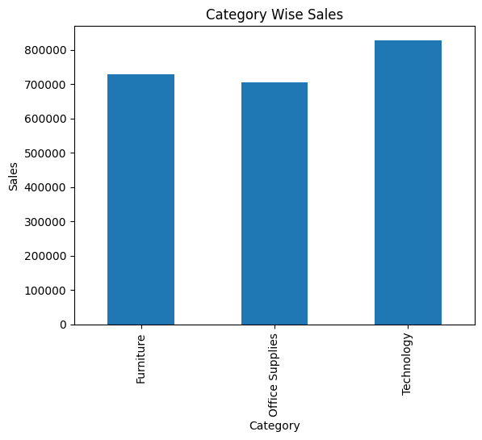
Figure 1: Category Wise Sales

Figure 2: Top 10 States by Sales
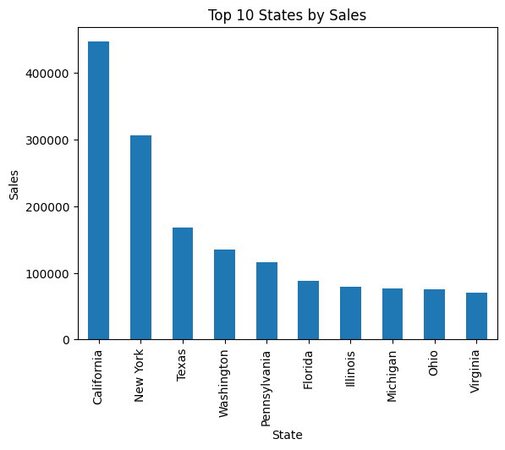
Figure 2: Top 10 States by Sales

Figure 3: Top 10 Products by Sales
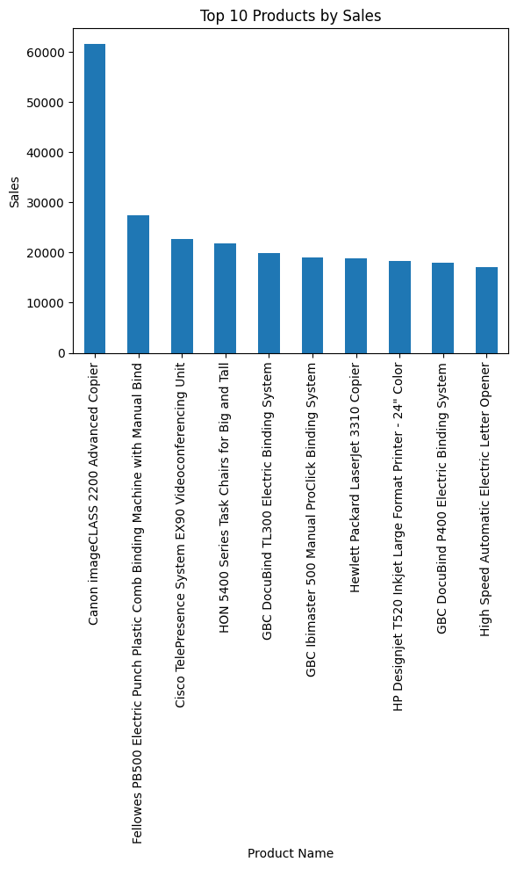
Figure 3: Top 10 Products by Sales

Figure 4: Region Wise Sales
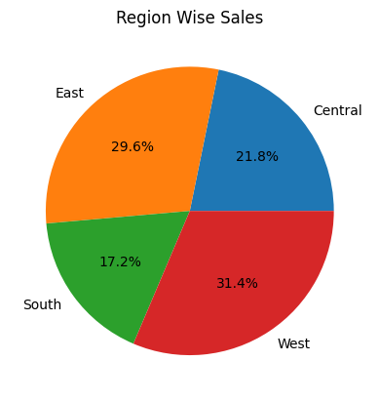
Figure 4: Region Wise Sales

4. Key Findings
- Technology category generated the highest sales.
- California achieved the highest sales among all states.
- Canon imageCLASS 2200 Advanced Copier was the top-selling product.
- West region contributed the highest share of sales (31.4%).
- Visual analysis helps management improve sales strategy and inventory planning.

5. Conclusion
The project successfully demonstrates how exploratory data analysis and visualization can reveal valuable business insights from retail sales data. The generated dashboard can assist organizations in monitoring performance and making informed business decisions.

