Introduction to GNU/Linux file system.
Objective
Introduce the students to file system structure.
Explanation
When you install GNU/Linux system on a partition, a file system is created. The system can be visualised as a tree. The start of the tree is designated as root ( /) There are several standard sub direcories under / . Each of them have specific purpose. In this session, we explain the purpose of each folder.
When you install a new system a system administrator account is also created by default. The name of this account is root. The administrator has a separate home folder named root under / . Please note that when you say root it can imply three things.
a) root of the tree desiganted as /
b) The administrator account root
c) The root folder under / which is again home directory of root, the admin.
Students should explore each folder on the system from command line as well as gui.
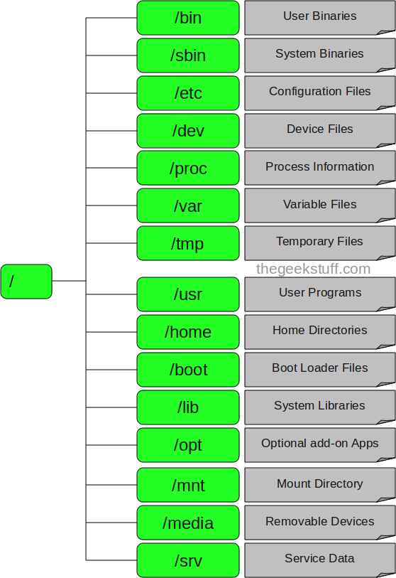

1. / – Root
- Every single file and directory starts from the root directory.
- Only root user has write privilege under this directory.
- Please note that /root is root user’s home directory, which is not same as /.

2. /bin – User Binaries
- Contains binary executables.
- Common linux commands you need to use in single-user modes are located under this directory.
- Commands used by all the users of the system are located here.
- For example: ps, ls, ping, grep, cp.

3. /sbin – System Binaries
- Just like /bin, /sbin also contains binary executables.
- But, the linux commands located under this directory are used typically by system aministrator, for system maintenance purpose.
- For example: iptables, reboot, fdisk, ifconfig, swapon

4. /etc – Configuration Files
- Contains configuration files required by all programs.
- This also contains startup and shutdown shell scripts used to start/stop individual programs.
- For example: /etc/resolv.conf, /etc/logrotate.conf

5. /dev – Device Files
- Contains device files.
- These include terminal devices, usb, or any device attached to the system.
- For example: /dev/tty1, /dev/usbmon0

6. /proc – Process Information
- Contains information about system process.
- This is a pseudo filesystem contains information about running process. For example: /proc/{pid} directory contains information about the process with that particular pid.
- This is a virtual filesystem with text information about system resources. For example: /proc/uptime

7. /var – Variable Files
- var stands for variable files.
- Content of the files that are expected to grow can be found under this directory.
- This includes — system log files (/var/log); packages and database files (/var/lib); emails (/var/mail); print queues (/var/spool); lock files (/var/lock); temp files needed across reboots (/var/tmp);

8. /tmp – Temporary Files
- Directory that contains temporary files created by system and users.
- Files under this directory are deleted when system is rebooted.

9. /usr – User Programs
- Contains binaries, libraries, documentation, and source-code for second level programs.
- /usr/bin contains binary files for user programs. If you can’t find a user binary under /bin, look under /usr/bin. For example: at, awk, cc, less, scp
- /usr/sbin contains binary files for system administrators. If you can’t find a system binary under /sbin, look under /usr/sbin. For example: atd, cron, sshd, useradd, userdel
- /usr/lib contains libraries for /usr/bin and /usr/sbin
- /usr/local contains users programs that you install from source. For example, when you install apache from source, it goes under /usr/local/apache2

10. /home – Home Directories
- Home directories for all users to store their personal files.
- For example: /home/john, /home/nikita

11. /boot – Boot Loader Files
- Contains boot loader related files.
- Kernel initrd, vmlinux, grub files are located under /boot
- For example: initrd.img-2.6.32-24-generic, vmlinuz-2.6.32-24-generic

12. /lib – System Libraries
- Contains library files that supports the binaries located under /bin and /sbin
- Library filenames are either ld* or lib*.so.*
- For example: ld-2.11.1.so, libncurses.so.5.7

13. /opt – Optional add-on Applications
- opt stands for optional.
- Contains add-on applications from individual vendors.
- add-on applications should be installed under either /opt/ or /opt/ sub-directory.

14. /mnt – Mount Directory
- Temporary mount directory where sysadmins can mount filesystems.

15. /media – Removable Media Devices
- Temporary mount directory for removable devices.
- For examples, /media/cdrom for CD-ROM; /media/floppy for floppy drives; /media/cdrecorder for CD writer

16. /srv – Service Data
- srv stands for service.
- Contains server specific services related data.
- For example, /srv/cvs contains CVS related data.
Exercises.
Find out location of following programs
1) bash
2) man
3) ps
4) ifconfig
5) passwd

Look at /etc/folder
Try opening /etc/passwd. What do you observe.
Find out how your password is stored. ( search google and find out)

