Readme

* The given json files are invalid, since they have numbers with leading zeros, which is not supported by json. Here is a part of file v1.0 as an example:  
    
  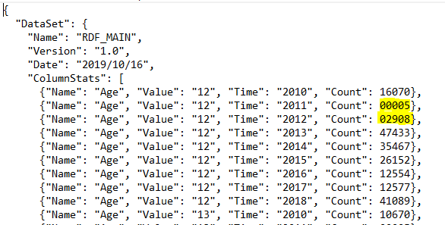  
    
  Most common JSON parsers for .NET cannot parse these files (tried Newtonsoft.Json and System.Text.Json), and it appears like the only way to get this to work is to write my own Json parser which strips out the leading zeros before parsing (which I think is beyond the scope of this assessment). As a workaround, I had manually remove the leading zeros from the given files to make them valid Json, and these are included as part of my submission.
* The assumption for input files is that the filename contains ‘v1.0’ for dataset 1 and ‘v1.1’ for dataset 2, and they have .json extension.
* The program was written using Visual Studio 2022 Community Edition on Windows 10, with .NET 5.0. It is tested and working. Here is a screenshot of the output for the given json files (after validating the them by removing leading zeros):  
    
  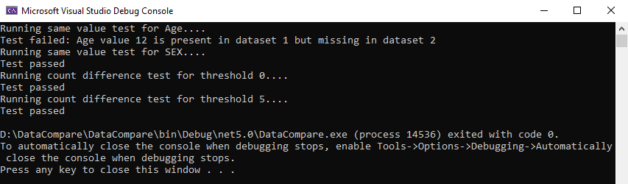
* The additional requirements (points 4 and 5) of the count difference test have been implemented.