Week 1 – 0:

--Overview of C, Constant, Variable and Data Types

ROLL NO.:241501223

Name: Sunil Varma S

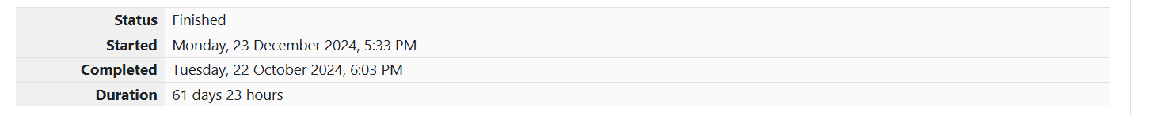

**Q1)** Given below is a simple program written in C language.

Change the text in the code given below to make the program print "**Hello C**" instead of "**Hello B**"

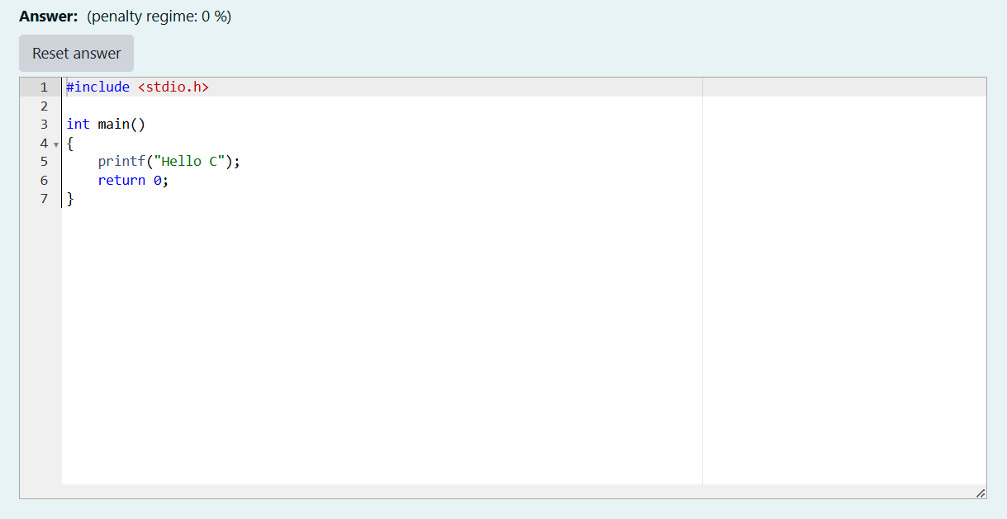

OUTPUT:

**Q2)** The code given below contains instructions to print the text "**I love Apples**" to the console.

The \n in the text "I love Apples\n" ensures that the line breaks after printing the text "I love Apples" (which means that nothing else is printed on the same line).

Follow the steps given below to change the text, execute **compile** command and finally **execute** the file:

1. In the code given below, change the text to print "**I love Mangoes**" instead of "**I love Apples**".

Answer:(penalty regime: 0 %)

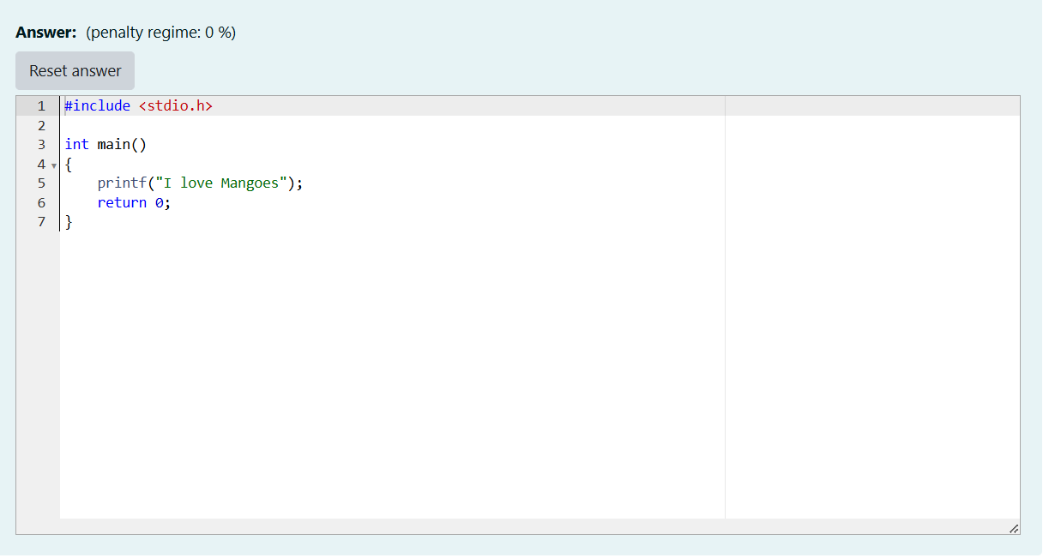

OUTPUT:

