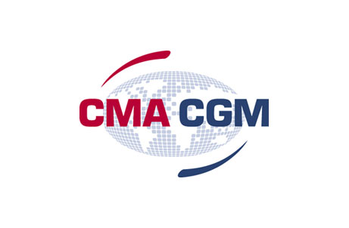
CMA CGM Shared Service Centre (India) Pvt.Ltd.

{Project Name}
Version {#}

Change Management Plan

Version History
Version | Date | Author | Description

Note:
Standardized version numbering convention:
Drafts – (Before approval signature)
0.#
0.#+1
0.#+2

Published – (Once there is an approval on the document)
1.0
1.#
1.#+1

Approval List
Name | Role | Organization | Approval Status

Distribution List
Name | Title | Company | To | Cc
All Reviewers/Approvers | - | CMA CGM / CCS | X | X

Contents

1 Introduction 3
1.1 Purpose 3
1.2 Scope 3
1.3 Definitions & Acronyms 3
1.4 Involved Stakeholders 3
1.5 References 3
2 Change Management Process 3
2.1 Change Request Process Flow Requirements 3
2.2 Change Request Form and Change Management Log 3
2.3 Evaluating and Authorizing Change Requests 3
2.4 Change Control Board 3
3 Responsibilities 3
3.1 Organization Structure 3
3.2 Roles & Responsibilities 3
4 Appendix 3
4.1 Appendix C - Change Request Form Example 3
4.2 Appendix C - Change Request Tracker 3

Introduction

Purpose
<In this subsection, specify the purpose of the document and the intended audience>

Scope
<In this section the describe the scope of the project for e.g. Development of new application/system, Maintenance of existing system, Enhancement to the existing system, Production support of existing system, Bug fixing of system/application, Testing of system/application, Data Migration, >
<In this subsection, describe the domain to be covered and brief description of the domain. Also specify exclusions, if any. >

Definitions & Acronyms
<In this subsection, provide all the terms used in this document. Also list in the same subsection acronyms and abbreviations required to properly interpreting the document. >

Acronym | Definition

Involved Stakeholders
<In this subsection, provide all the stakeholders involved in the project. >

Name | Business Group | Key Activities

References

Document Title | Document Location | Document Description
Doc Name:<insert Document Name>  Doc Version: <insert Document version> | <Location of the document where it is stored> | <insert the need to refer attached document>
Doc Name:<insert Document Name>

Doc Version: <insert Document version>
Doc Name:<insert Document Name>

Doc Version: <insert Document version>

Change Management Process

Change Request Process Flow Requirements

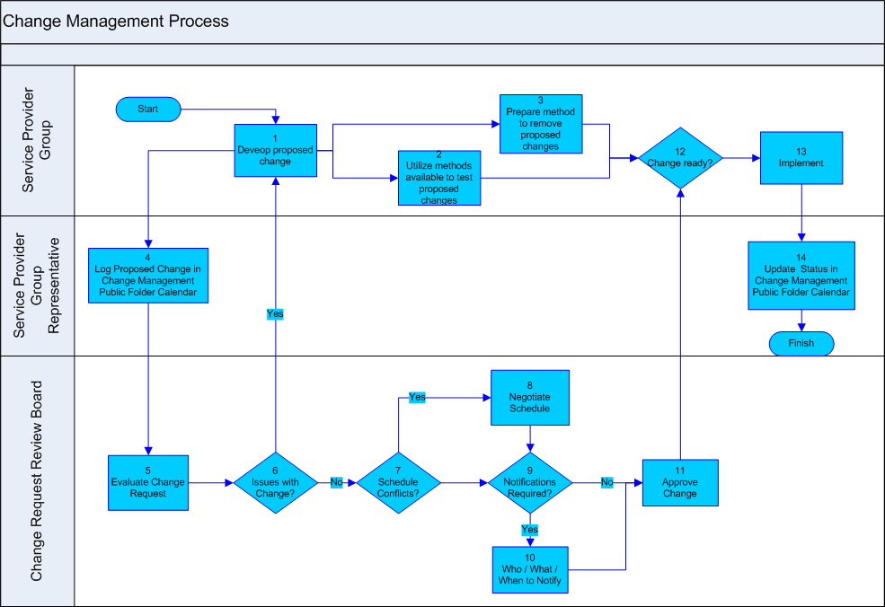

<Outline the project team’s agreed upon change request (CR) process flow. The following outlines a generic change request process flow >

Step | Description
Generate CR | A submitter completes a CR Form and sends the completed form to the Change Manager
Log CR Status | The Change Manager enters the CR into the CR Log. The CR’s status is updated throughout the CR process as needed.
Evaluate CR | Project personnel review the CR and provide an estimated level of effort to process, and develop a proposed solution for the suggested change
Authorize | Approval to move forward with incorporating the suggested change into the project/product
Implement | If approved, make the necessary adjustments to carry out the requested change and communicate CR status to the submitter and other stakeholders

Change Request Form and Change Management Log
< List and define the data elements the project team needs to include on the Change Request Form and in the Change Management Log. Examples of these are provided in Appendix D and Appendix E. At a minimum, the following data should be included on the project’s Change Request Form and Change Management Log>

Element | Description
Date | The date the CR was created
CR# | Assigned by the Change Manager
Title | A brief description of the change request
Description | Description of the desired change, the impact, or benefits of a change should also be described
Submitter | Name of the person completing the CR Form and who can answer questions regarding the suggested change
Phone | Phone number of the submitter
E-Mail | Email of the submitter
Product | The product that the suggested change is for
Version | The product version that the suggested change is for
Priority | A code that provides a recommended categorization of the urgency of the requested change (High, Medium, Low)

Evaluating and Authorizing Change Requests
<In order to evaluate and prioritize a change request, the “priority” and “type” of the change are taken into consideration. Use the first and second tables below to list and define the “priority” and “type” data elements that are applicable for the project. The third table provides examples of commonly used project status types. The list of elements is at the discretion of the project manager>

Priority | Description
High | <Insert the definition the project assigns to a high priority CR>
Medium | <Insert the definition the project assigns to a medium priority CR>
Low | <Insert the definition the project assigns to a low priority CR>

Change Control Board
<A Change Control Board (CCB) is a formally constituted group of stakeholders responsible for approving or rejecting changes to the project baselines. This group may meet on a predefined schedule or on an as needed basis. The table below provides a brief description of personnel acting as the Change Control Board (CCB) and their role/level of authority within that group

Role | Name | Contact | Description
<Insert Role> | <Insert Name> | <Insert Contact> | <Insert Role Description>

Responsibilities

Organization Structure
< In this section describe the organizational structure of the project and the relation between the project and any other organizations & support functions the project interacts with (for e.g. HR, IT Learning & Development Team, Training, Admin, Legal Team etc.). Use organization charts, matrix diagrams, or other appropriate notations to describe the lines of authority.

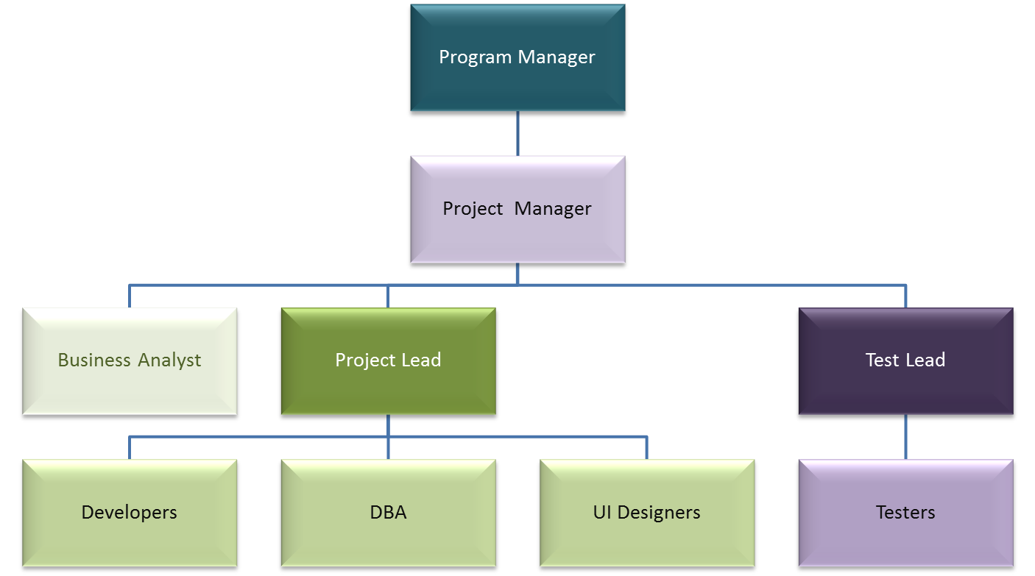

Roles & Responsibilities
< Provide a brief description of persons responsible for each step of the change management process for the project >

Role | Name | Contact | Description
Project Manager
Change Manager
<Insert Role> | <Insert Name> | <Insert Contac#> | <Insert Role Description>

Appendix

Appendix C - Change Request Form Example
<The example Change Request From attached below can be used to submit changes during the life of the project.>

Appendix C - Change Request Tracker
<The detailed Change Management Log template attached below can be used to track and manage requested changes during the life of the project >

