**JADA SUNIL**

***Market Segmentation And Analysis Of E – Learning Website***

**1] INTRODUCTION:**

E-learning platforms have revolutionized the way we acquire knowledge and skills, providing a flexible and accessible alternative to traditional educational models. In an era where information and technology drive societal progress, e-learning offers a pathway to education for a diverse global audience. These platforms deliver a broad range of courses, from academic subjects to professional skills and personal development, catering to learners of all ages and backgrounds.

The core advantage of e-learning platforms lies in their flexibility and adaptability. Learners can access educational content from anywhere with an internet connection, allowing them to learn at their own pace and on their own schedule. This flexibility is particularly valuable for working professionals, parents, or those with other commitments that make traditional classroom-based learning impractical.

Moreover, e-learning platforms often incorporate innovative technologies to enhance the learning experience. Features like interactive quizzes, video lectures, gamification, and adaptive learning paths are designed to engage users and improve knowledge retention. Artificial intelligence (AI) and machine learning are increasingly being used to personalize learning, providing customized content based on individual progress and learning styles.

In this context, the success of an e-learning platform depends on its ability to create engaging, personalized, and high-quality learning experiences while maintaining a sustainable business model. Platforms that effectively balance these factors are poised to make a significant impact on education, providing learners with the tools they need to thrive in a rapidly changing world.

**2] PROBLEM STATEMENT:**

In the digital age, access to quality education and skill development is essential, yet many people face barriers due to geographical location, cost, or inflexible learning schedules. Traditional educational models often struggle to adapt to diverse learning needs and fail to leverage technology to improve the learning experience. This leads to a lack of personalized learning paths, limited access to expert instructors, and inadequate support for lifelong learning. E-learning platforms must overcome these challenges by providing accessible, affordable, and flexible education while ensuring high-quality content, personalized learning experiences, and robust user engagement. Additionally, platforms must address technology and compliance issues, maintain data security, and create a sustainable business model to support continuous growth and innovation.

**3] DATA SOURCE:**

Dataset related to E-learning Platform information related to various online courses of E-learning Platform has been collected from KAGGLE

Below is the link of the dataset and the source from where it is collected

<https://www.kaggle.com/datasets/khaledatef1/online-courses>

Data Pre-processing Libraries Used

: ● Pandas ● Numpy ● Seaborn ● Matplotlib ● Scikit Learn

**4] TARGET SEGMENT**

**Target Segments for E-Learning Platforms**

1. Students (K-12):

This segment includes school-aged children and teenagers. E-learning platforms targeting this group often focus on supplementing school curriculum, offering tutoring, or providing exam preparation resources.

2. Higher Education Students:

This segment encompasses college and university students. E-learning platforms serving this group might offer college-level courses, academic support, or resources for standardized tests like SAT, GRE, or GMAT.

3. Working Professionals:

This segment targets individuals seeking career development, upskilling, or reskilling. Platforms serving this group often offer professional certifications, technical training, and business skills.

4. Lifelong Learners:

These are individuals interested in learning new skills or pursuing personal interests, regardless of age or career stage. E-learning platforms for this segment may offer courses in arts, hobbies, languages, or general knowledge.

5. Corporate Clients:

This segment includes businesses that use e-learning platforms for employee training and development. Platforms targeting corporate clients often focus on compliance training, leadership development, and industry-specific skills.

6. Educational Institutions:

This segment targets schools, colleges, and universities that use e-learning platforms to deliver or supplement education. These platforms might provide learning management systems (LMS), virtual classrooms, or curriculum-aligned content.

7. Government and Non-Profits:

This segment includes government agencies and non-profit organizations that use e-learning platforms for public education, community outreach, or workforce development. Platforms serving this segment might focus on compliance, public safety, or social programs.

**5] RESULTS:**

# * **Analyzing Popular Courses**

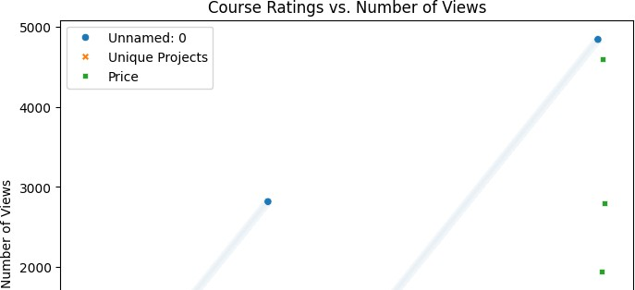 





# **Analyze further based on the data**

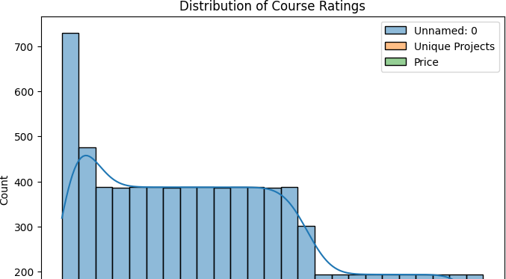 

**6] CONCLUSION:**

E-learning platforms offer vast opportunities in a rapidly growing market. Effective market segmentation and analysis provide a pathway to success by addressing the unique needs of different user groups. Platforms that combine tailored content, technology innovation, and strong partnerships are well-positioned to thrive in this competitive landscape. By continuously adapting to market trends and user feedback, e-learning platforms can create lasting value and impact in the education sector

**Strategic Focus :**

**To succeed in this dynamic environment, e-learning platforms should focus on**:

* Tailored Content: Create content that meets the specific needs of each segment, including industry-specific courses, professional development, and academic programs.
* Localized Content: Invest in localization to reach global audiences, ensuring content is accessible and relevant across different regions.
* Technology-Driven Solutions: Embrace technology to enhance user experiences, utilizing AI, VR/AR, and data analytics to create personalized and engaging learning pathways.
* Collaborative Partnerships: Build relationships with educational institutions, industry leaders, and corporate clients to expand the platform's reach and credibility.
* Strong Compliance and Security: Maintain strict compliance with regulations and ensure data security to foster user trust.

By embracing these strategic focus areas, e-learning platforms can achieve sustainable growth and make a significant impact on the education landscape. As the market continues to evolve, platforms that remain adaptable and innovative will be best positioned for long-term success.

**7] GITHUB LINK – of the project code implementation:**

**https://github.com/sunilyadav2713/Final-project-**