**PRACTICAL NO – 29**

**Question:** Create a Django based web application to parse GET request and display a web page with some content of your choice.

**Solution:**

Step 1: Go to virtual environment folder and activate the virtual environment.

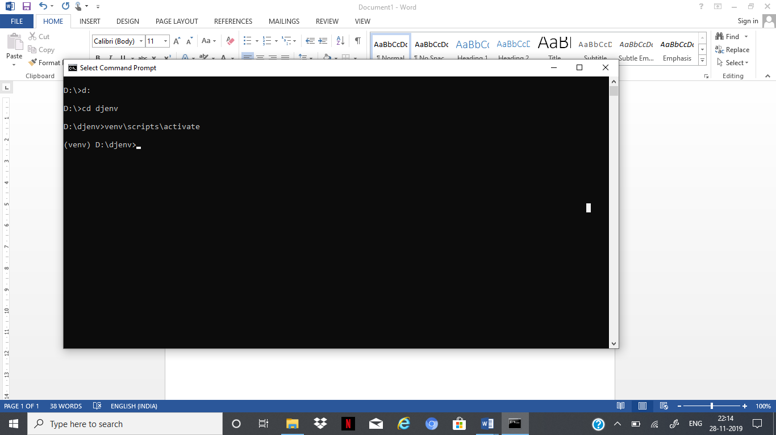

Step 2: Create a project named RFSKK and app inside project with name student.

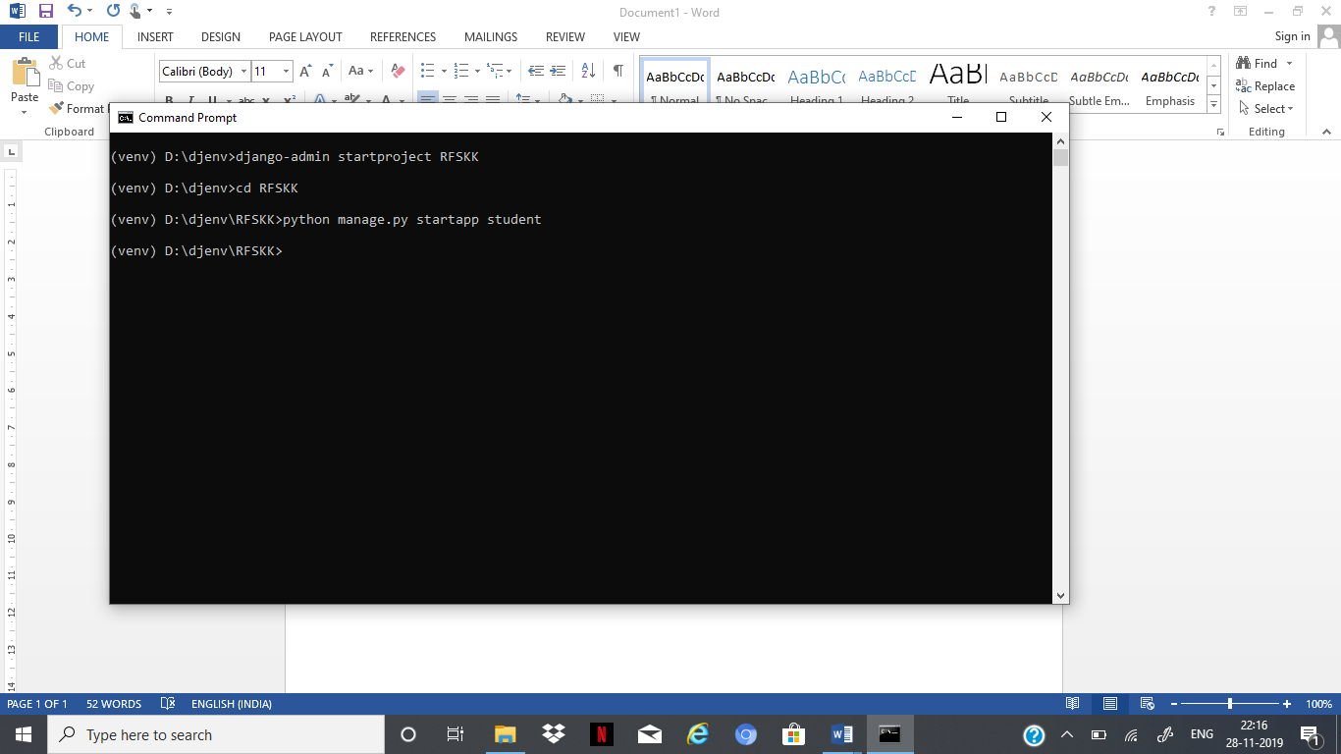

Step 3: Registering the app (student) in project (RFSKK)- To register the app (student) in the project (RFSKK), we need to make changes in settings.py from inner RFSKK folder.

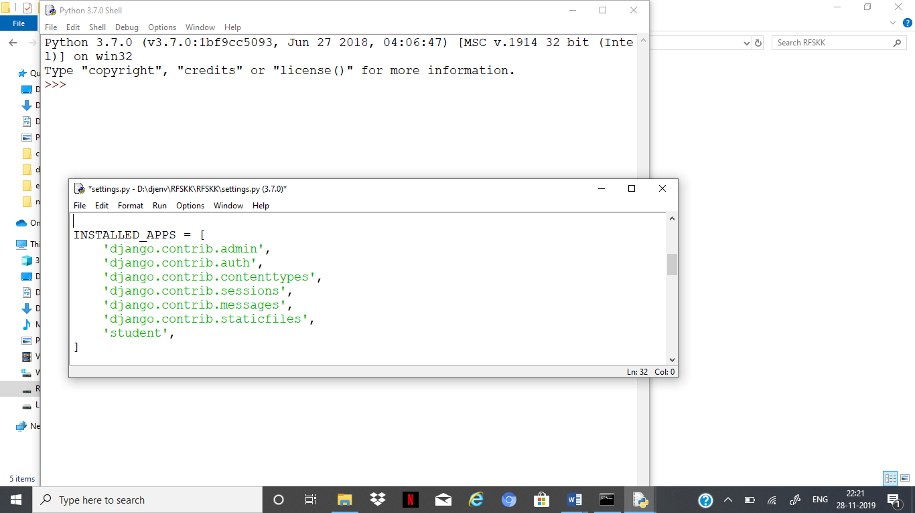

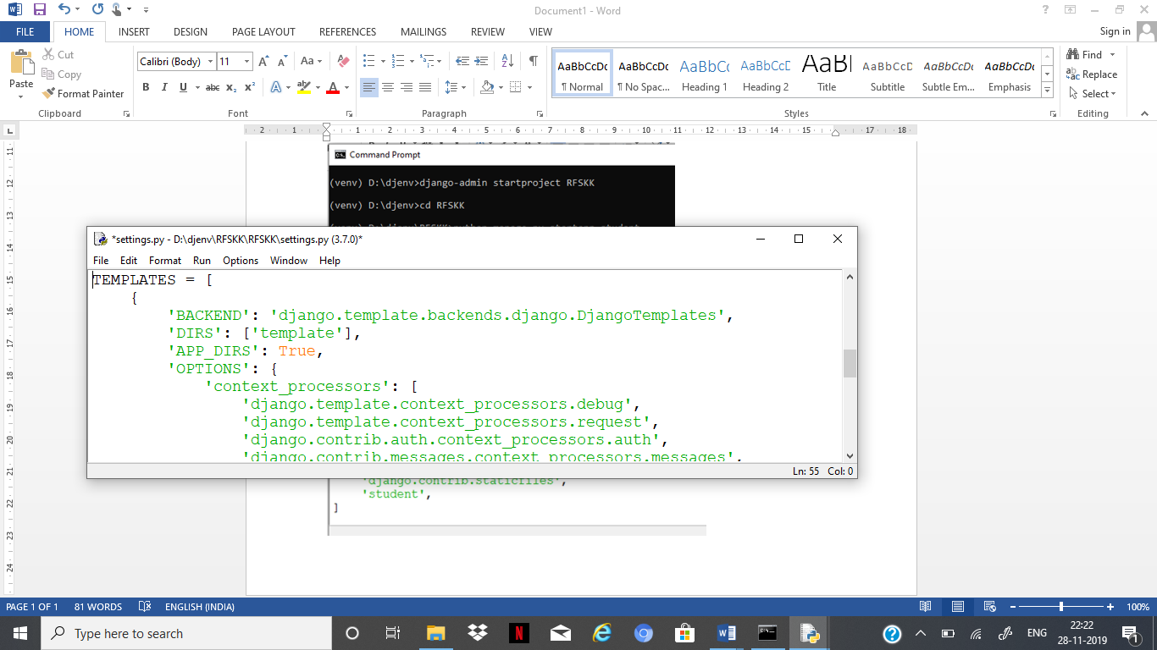

Step 4: Creating and saving web page in template folder. Create the template folder in outer project location with name as template. In template folder create an HTML file with name firstpage.html

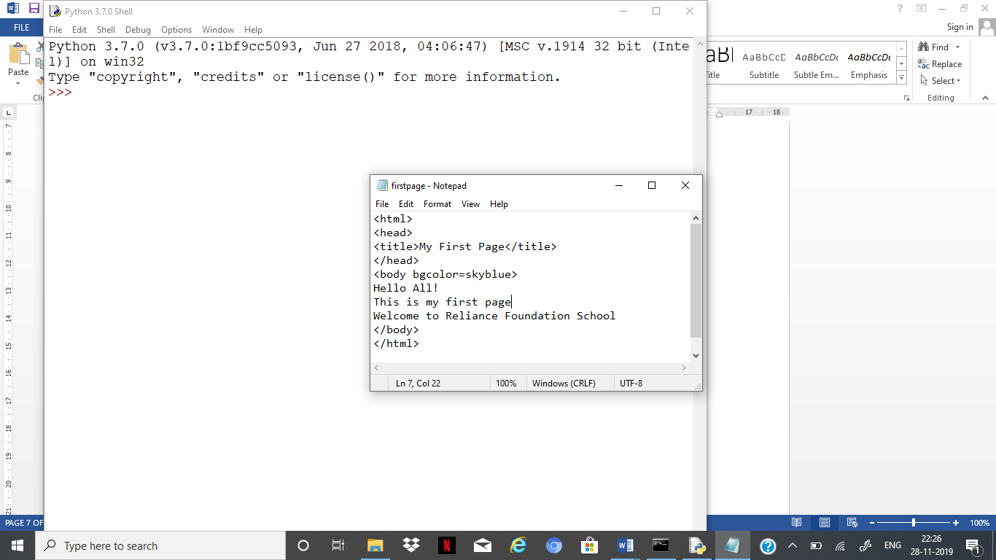

Step 5: Writing functions in views.py (writing logic).

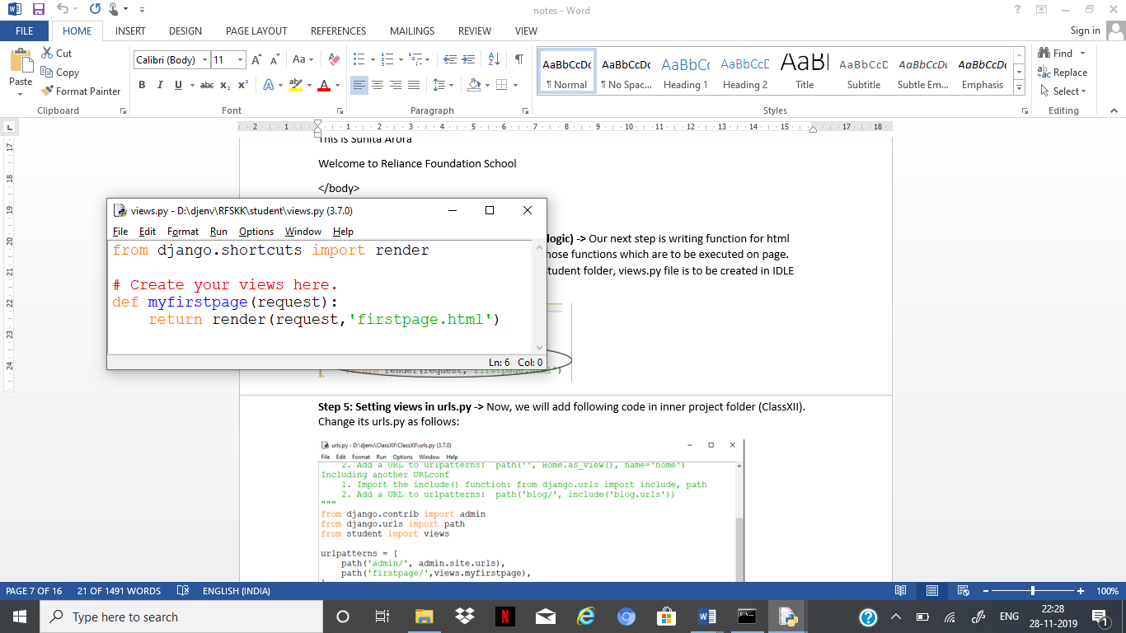

Step 6: Setting views in urls.py.

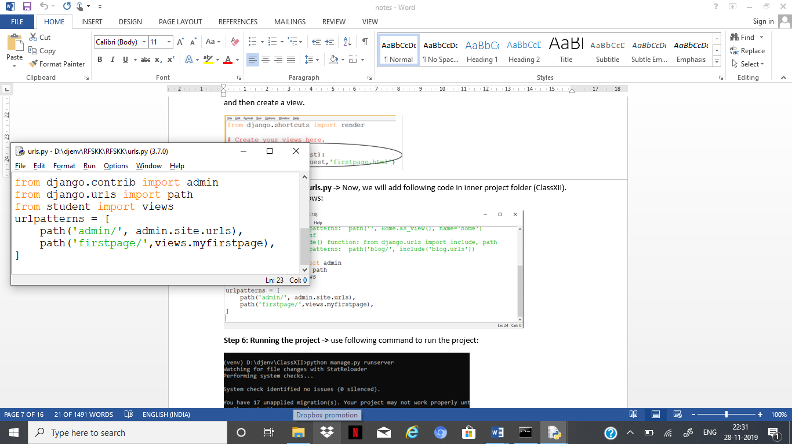

Step 7: Running the project

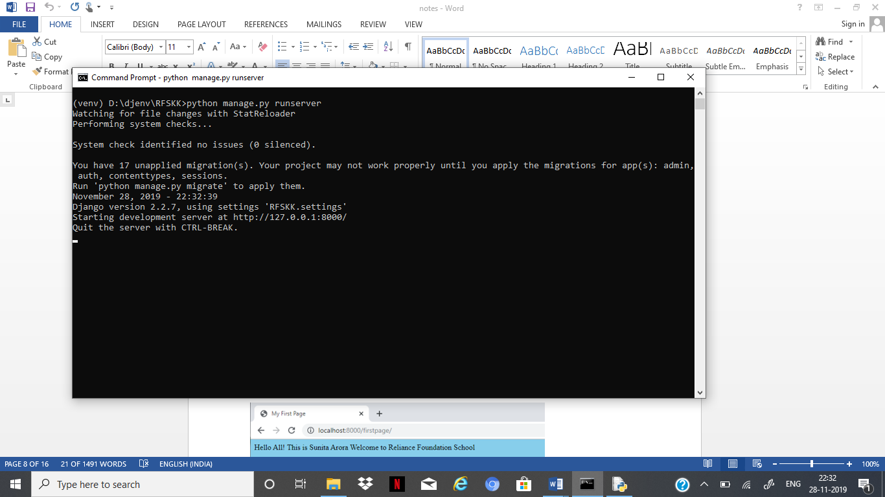

Step 8: Displaying the web page

