Full Name: Sunita Jangra

Contact :7217646153

E-Mail ID: sunitahsharma2021@gmail.com

World Wide Covid Data Analysis

Tableau Project



Objectives
The Covid-19 pandemic has had a profound impact across the globe, with countries experiencing varying levels of cases, recoveries, and fatalities. This project analyzes worldwide Covid data to uncover meaningful insights into the spread and management of the virus. By examining country-wise statistics, the study aims to highlight global trends, compare national responses, and provide a clear picture of how different regions were affected. The analysis is supported by visual dashboards and comparative metrics to make the findings accessible and actionable.
Some of the Sheets created to make the Dashboard, attached are the screenshot for the same

1) Total Number of Countries

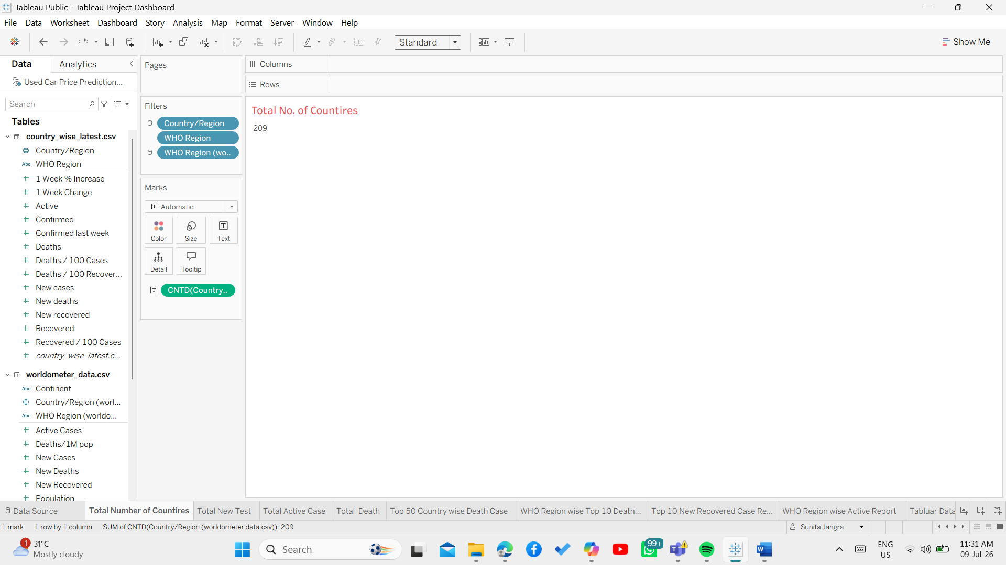

2) Total Number of Case
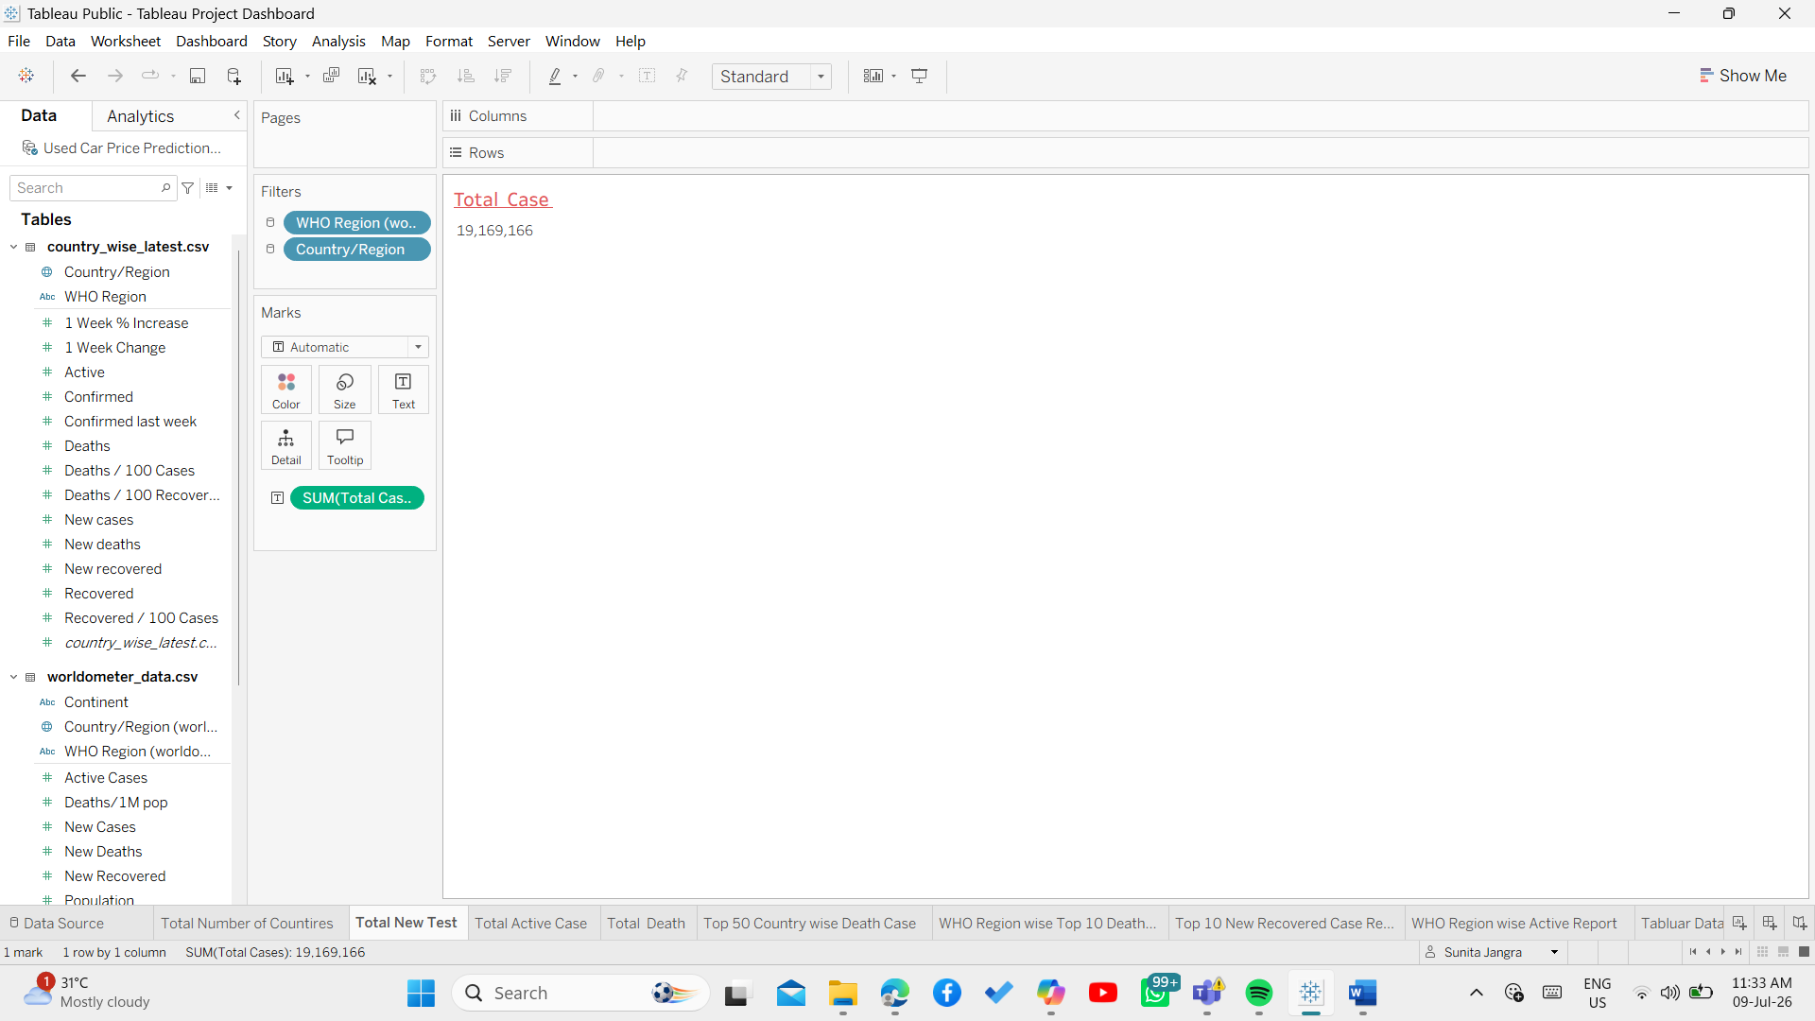

3) Total Active Case
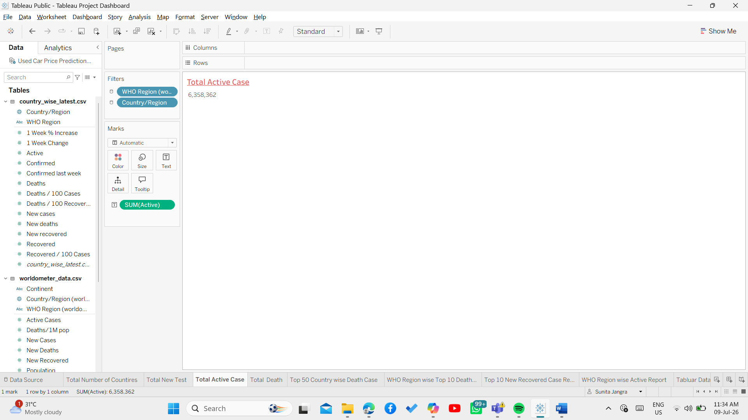

4) Total Number of Death
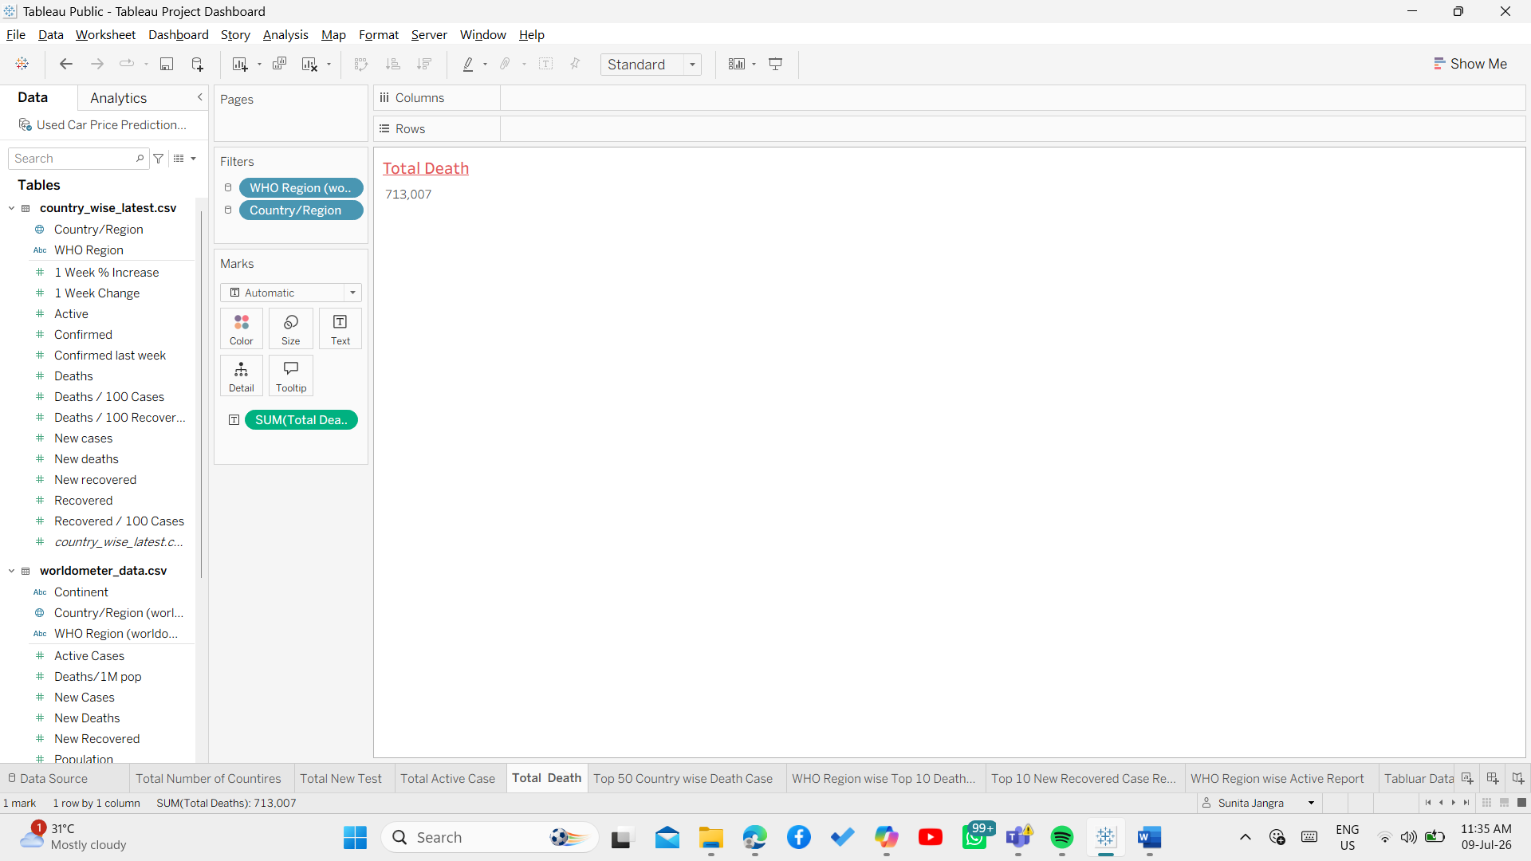

5) Top 50 Country Wise Death Case
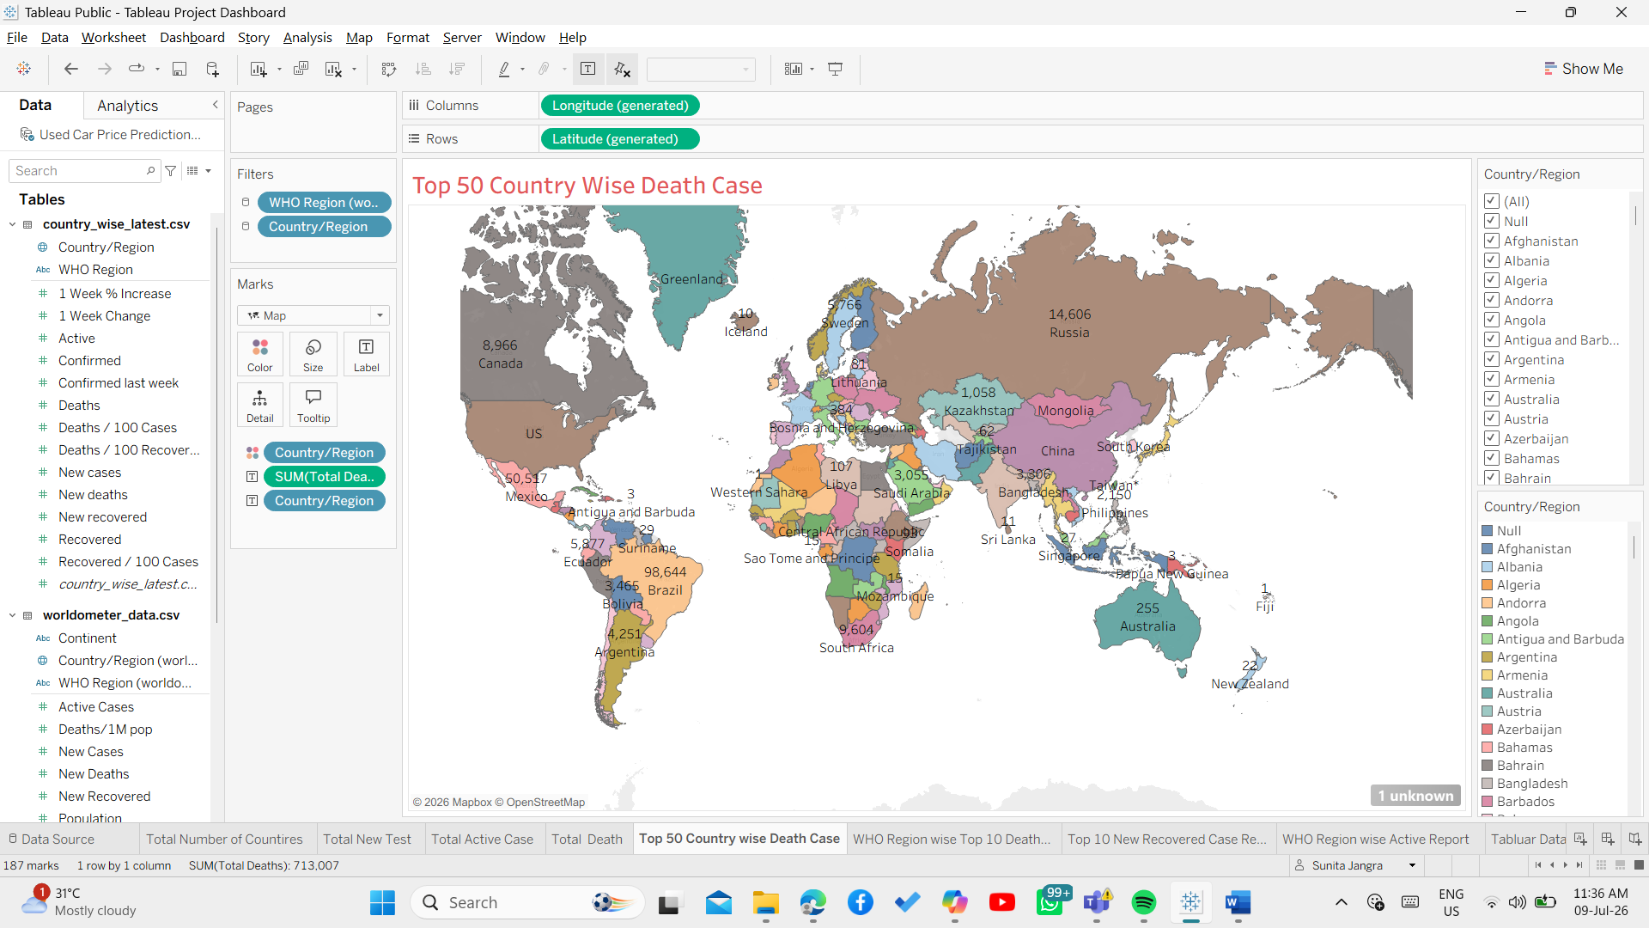

6) Top 50 Country Wise Death Case
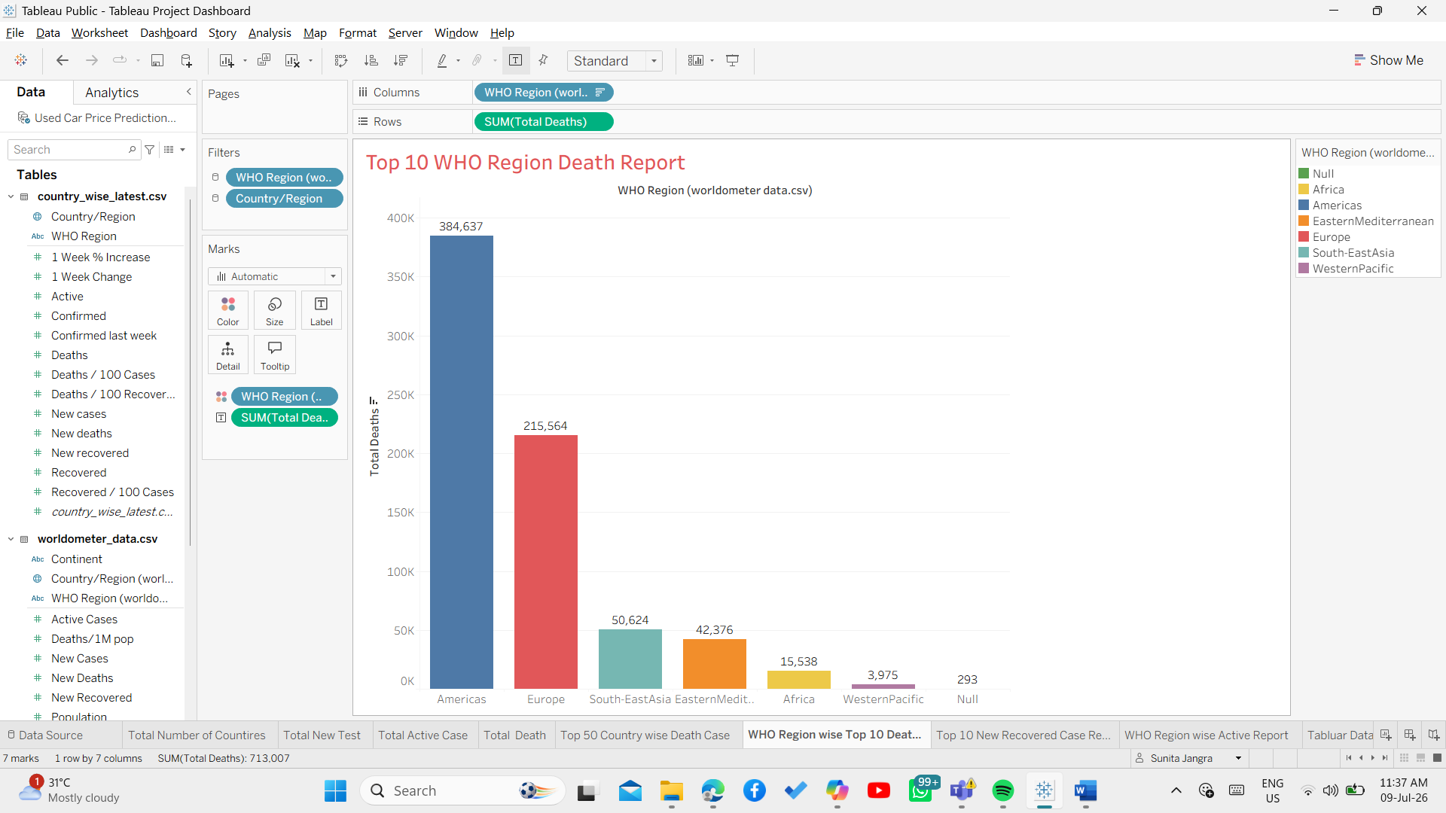

7) Top 50 Country Wise Death Case
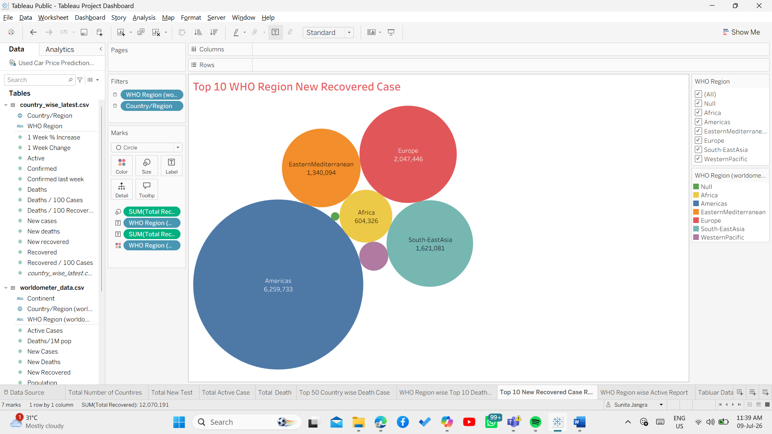

8) WHO Region wise Active Case
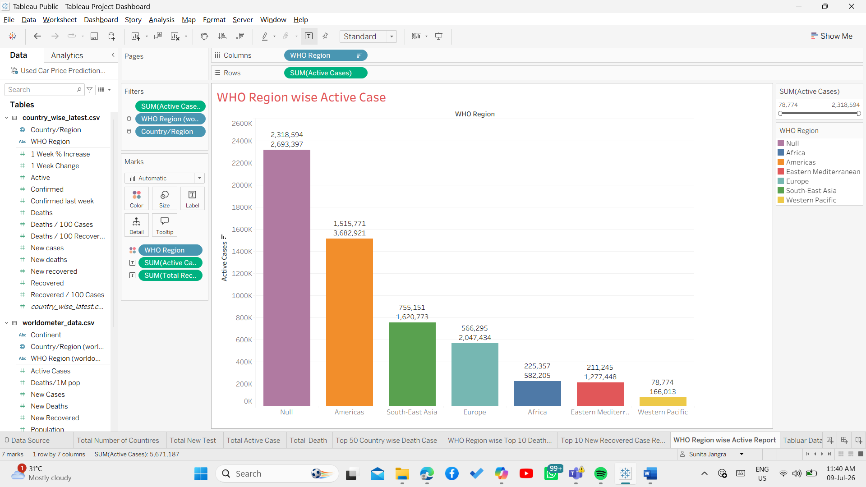

9) Covid Data
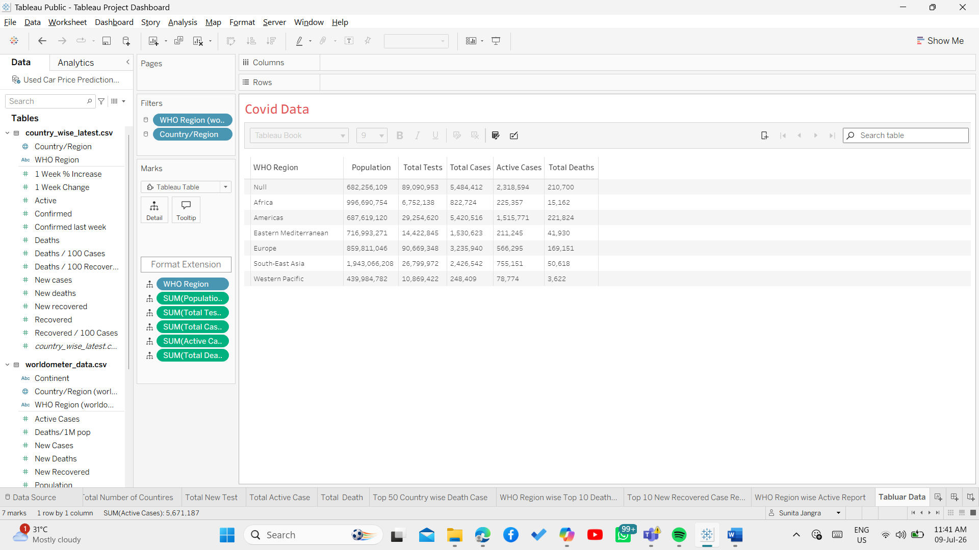

Dashboard

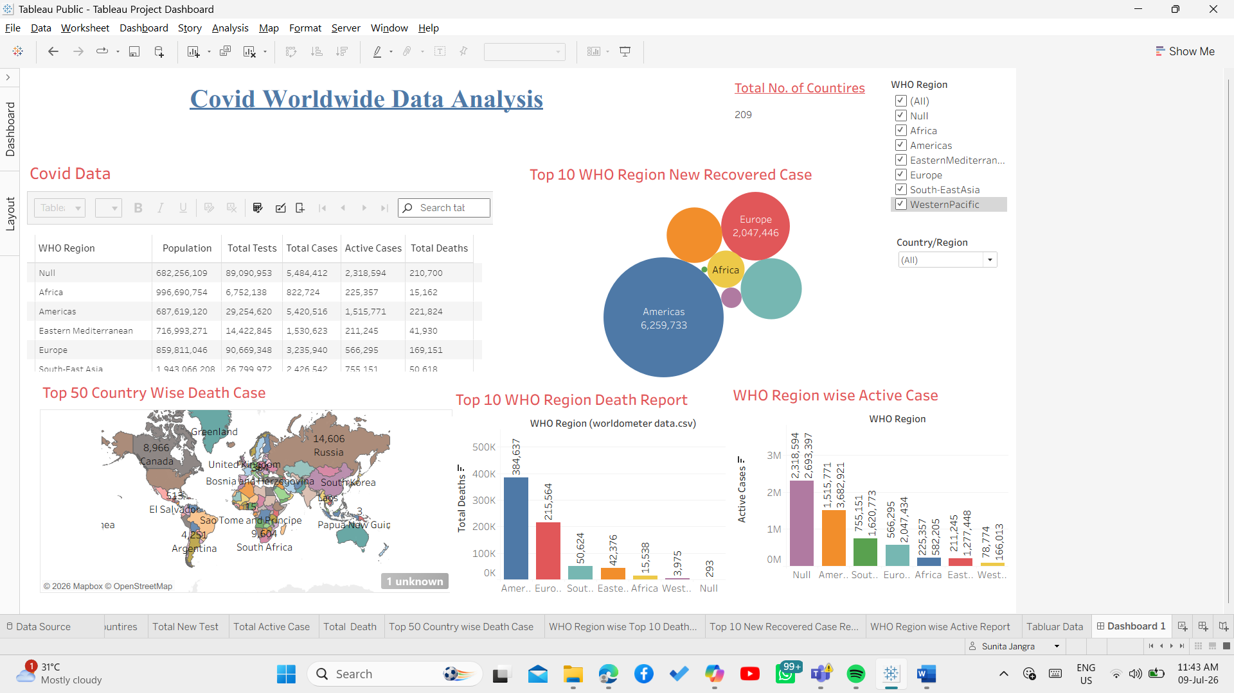

Thank You

