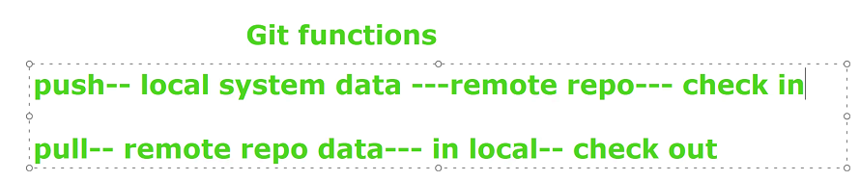

Requirement :Git intalled

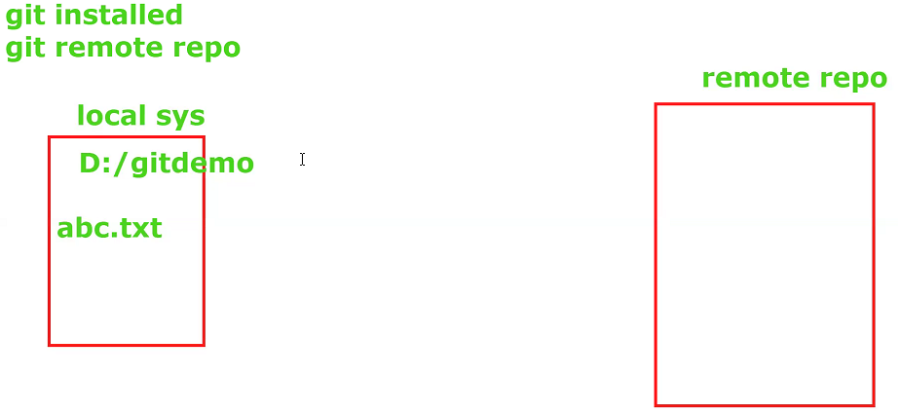

Commands:

1. git init: Local folder - 🡪 Local repository
2. To add a file: git add abc.txt

Staging area: file is ready for staging

1. git commit –m “add a file”

means abc.txt is added to staging area (reach to courier office)

1. git remote add <var> url

origin : any var (url is assigned to var for further uses)

url-- path repo url (adding destination addr)

1. git push <var> < branch>

file--- remote repo

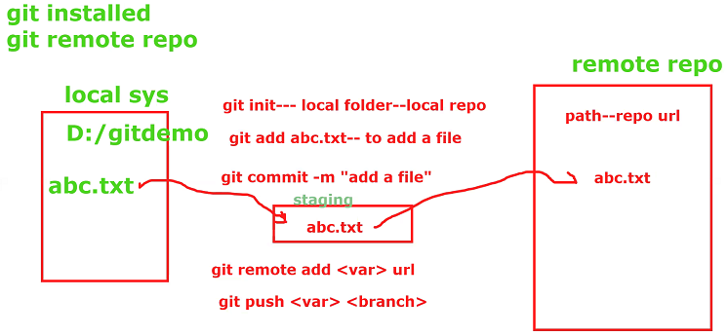

Git status

Git difference commands

Input: D: gitDemo folder--- files abc.txt

To send to remte repo

Right click -Git bash here

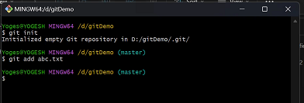

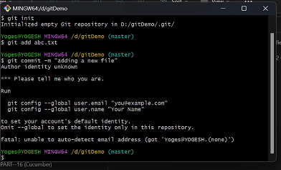

Git commit –m “adding a new file”

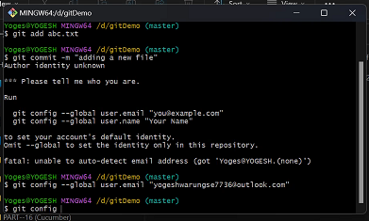

git config --global user.email "sunitavani2022@gmail.com"

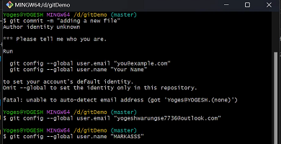

$ git config --global user.name "sunitavani142"

Commit cmd

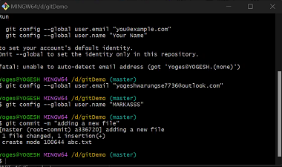

Github login

Create Repository: eg. Gitdemo

After creating repository: we will get url---copy url

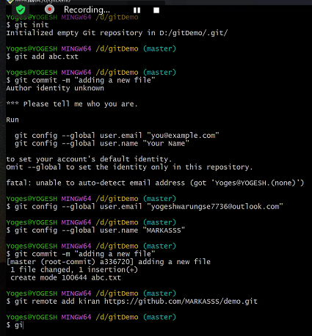

Git remote add sunita *paste path*

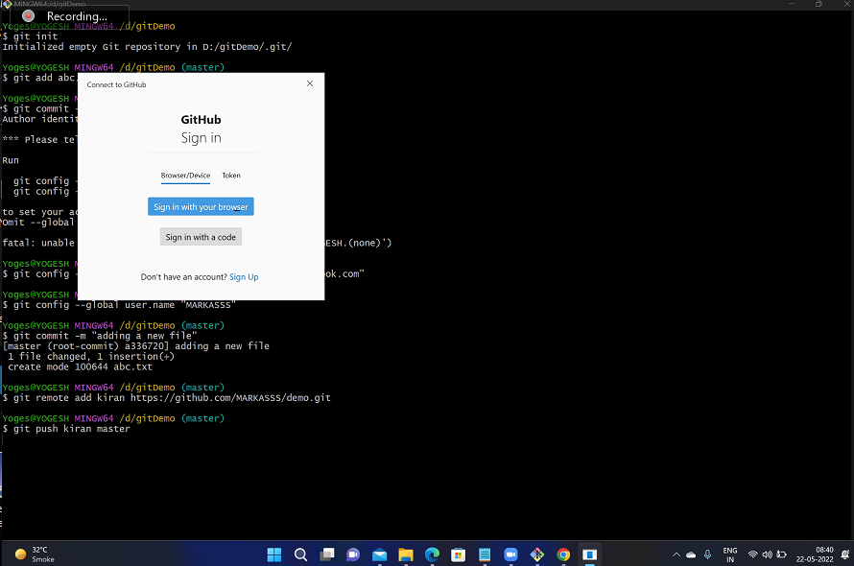

git push sunita master

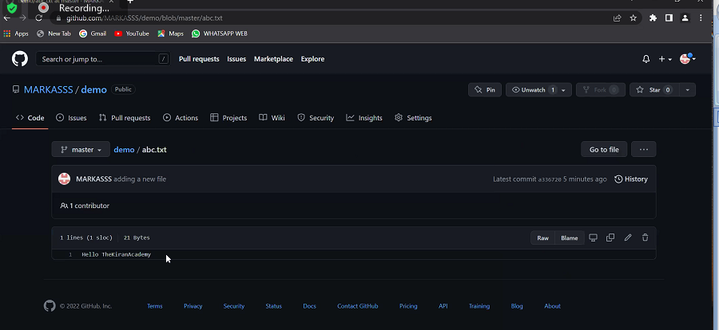

File uploaded to git

All cmd

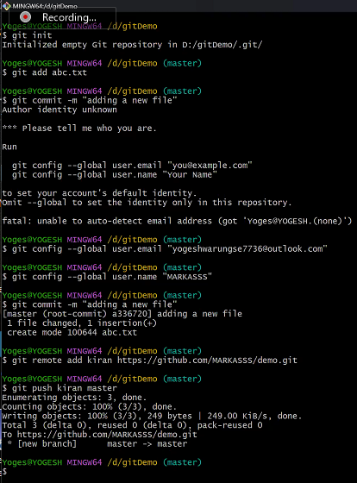

Remote to local

To get addr

Type url

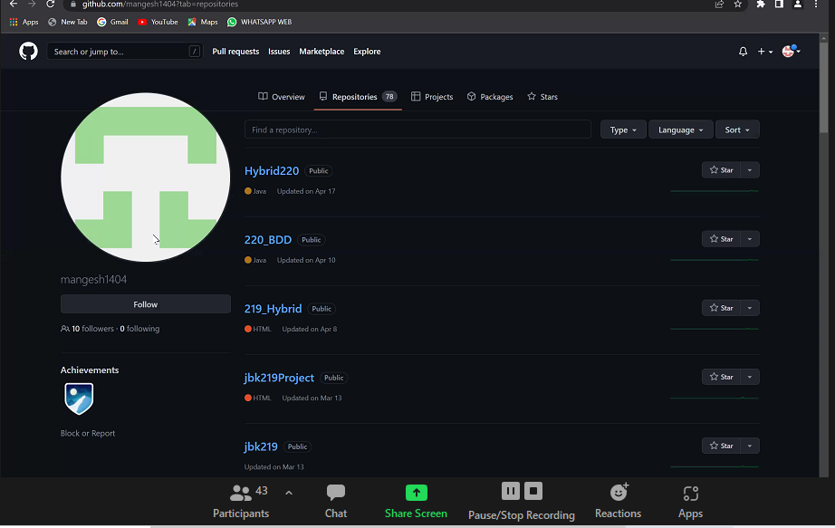

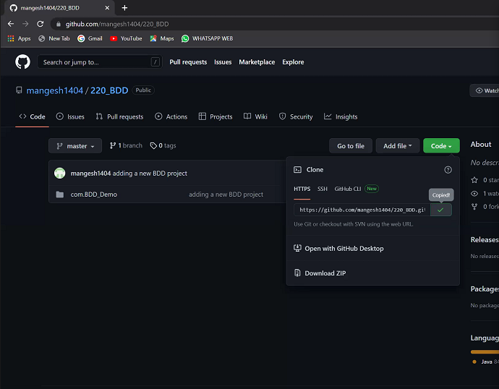

Eclipse: Next process import

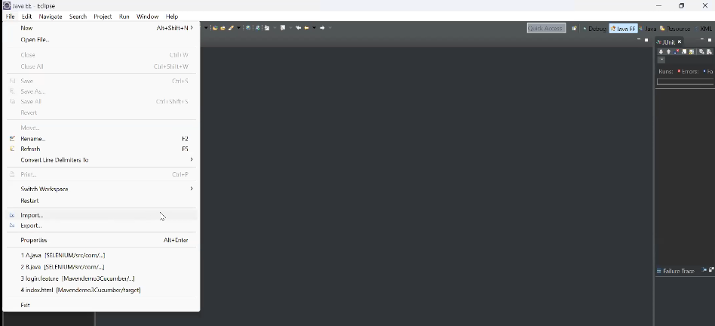

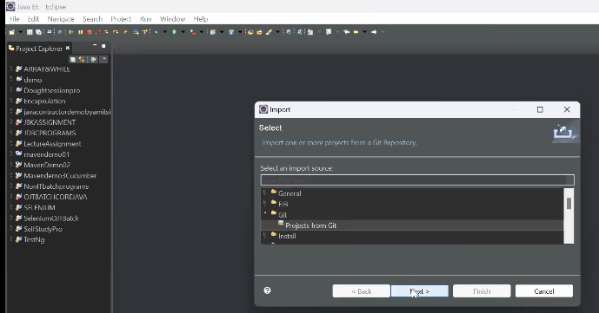

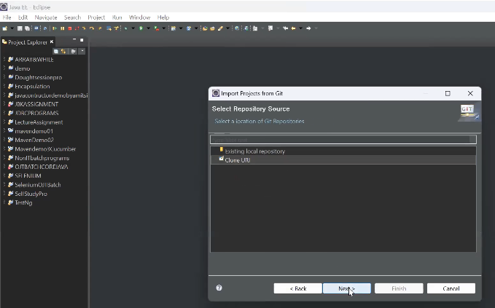

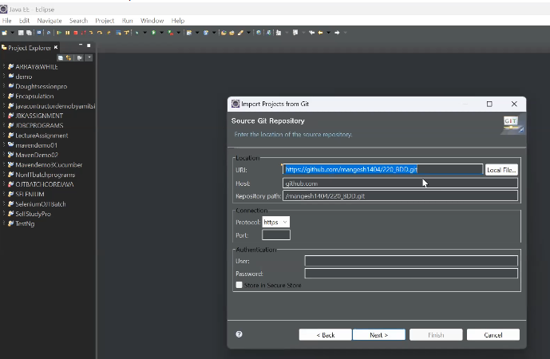

Already url comes, no need to write

Repository(which is to pull) is public so User and password not required

Click Next

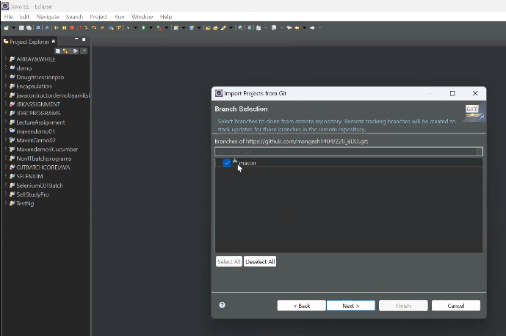

Select Branch(Brach is one here) Next

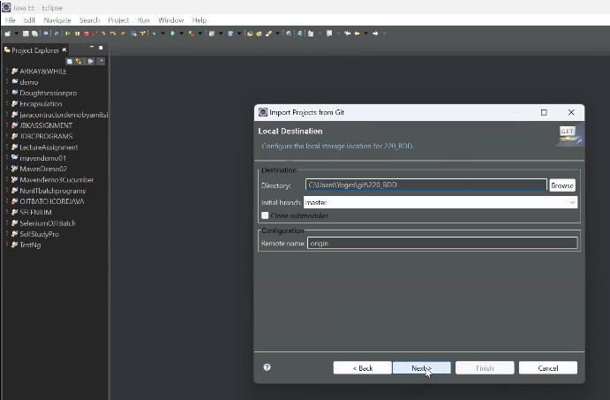

Next Next Next Finish…Project is pulled in Eclipse

Folder ---- Pull

Getbash here

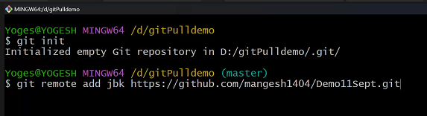

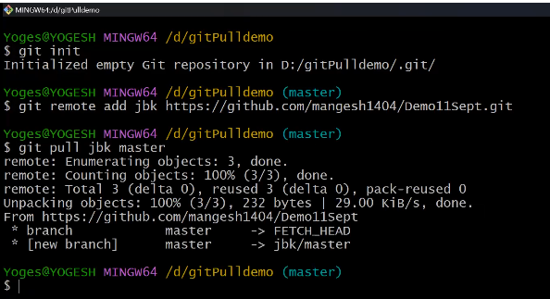

Project/ file is pulled to folder

