Document title
  - Subtitle
Body text - Lorem ipsum dolor sit amet, consectetur adipiscing elit, sed do eiusmod tempor incididunt ut labore et dolore magna aliqua. Ut enim ad minim veniam, quis nostrud exercitation ullamco laboris nisi ut aliquip ex ea commodo consequat. Duis aute irure dolor in reprehenderit in voluptate velit esse cillum dolore eu fugiat nulla pariatur. Excepteur sint occaecat cupidatat non proident, sunt in culpa qui officia deserunt mollit anim id est laboum.

Document title
  - Subtitle
Body text - Lorem ipsum dolor sit amet, consectetur adipiscing elit, sed do eiusmod tempor incididunt ut labore et dolore magna aliqua. Ut enim ad minim veniam, quis nostrud exercitation ullamco laboris nisi ut aliquip ex ea commodo consequat. Duis aute irure dolor in reprehenderit in voluptate velit esse cillum dolore eu fugiat nulla pariatur. Excepteur sint occaecat cupidatat non proident, sunt in culpa qui officia deserunt mollit anim id est laboum.

Document title
  - Subtitle
Body text - Lorem ipsum dolor sit amet, consectetur adipiscing elit, sed do eiusmod tempor incididunt ut labore et dolore magna aliqua. Ut enim ad minim veniam, quis nostrud exercitation ullamco laboris nisi ut aliquip ex ea commodo consequat. Duis aute irure dolor in reprehenderit in voluptate velit esse cillum dolore eu fugiat nulla pariatur. Excepteur sint occaecat cupidatat non proident, sunt in culpa qui officia deserunt mollit anim id est laboum.

Document title
  - Subtitle
Body text - Lorem ipsum dolor sit amet, consectetur adipiscing elit, sed do eiusmod tempor incididunt ut labore et dolore magna aliqua. Ut enim ad minim veniam, quis nostrud exercitation ullamco laboris nisi ut aliquip ex ea commodo consequat. Duis aute irure dolor in reprehenderit in voluptate velit esse cillum dolore eu fugiat nulla pariatur. Excepteur sint occaecat cupidatat non proident, sunt in culpa qui officia deserunt mollit anim id est laboum.

TOC Title (optional)
Table of Contents
Heading 1 2
Heading 2 2
Heading 3 2
Heading 3 - Top Border Bold 2
Heading 3 - Top Border 2
Top subheadings 4
Left subheadings 4
Top and left subheadings 5
Top and left subheadings 2 5
Top and left subheadings with sales line highlight 6
Top and left subheadings with sales line highlight 2 7

Heading 1

Heading 2

Heading 3

Heading 3 - Top Border Bold

Heading 3 - Top Border

Heading 4

Heading 5

Heading 6
Body text - Lorem ipsum dolor sit amet, consectetur adipiscing elit, sed do eiusmod tempor incididunt ut labore et dolore magna aliqua. Ut enim ad minim veniam, quis nostrud exercitation ullamco laboris nisi ut aliquip ex ea commodo consequat. Duis aute irure dolor in reprehenderit in voluptate velit esse cillum dolore eu fugiat nulla pariatur. Excepteur sint occaecat cupidatat non proident, sunt in culpa qui officia deserunt mollit anim id est laborum.
Body Text Bold - Lorem ipsum dolor sit amet, consectetur adipiscing elit, sed do eiusmod tempor incididunt ut labore et dolore magna aliqua. Ut enim ad minim veniam, quis nostrud exercitation ullamco laboris nisi ut aliquip ex ea commodo consequat. Duis aute irure dolor in reprehenderit in voluptate velit esse cillum dolore eu fugiat nulla pariatur. Excepteur sint occaecat cupidatat non proident, sunt in culpa qui officia deserunt mollit anim id est laborum.
Body Text - Bottom Border - Lorem ipsum dolor sit amet, consectetur adipiscing elit, sed do eiusmod tempor incididunt ut labore et dolore magna aliqua.
Body Text - Bottom Border Bold - Lorem ipsum dolor sit amet, consectetur adipiscing elit, sed do eiusmod tempor incididunt ut labore et dolore magna aliqua.
Body Text - Top Border - Lorem ipsum dolor sit amet, consectetur adipiscing elit, sed do eiusmod tempor incididunt ut labore et dolore magna aliqua.
Body Text - Top Border Bold - Lorem ipsum dolor sit amet, consectetur adipiscing elit, sed do eiusmod tempor incididunt ut labore et dolore magna aliqua.
Placeholder text - Lorem ipsum dolor sit amet, consectetur adipiscing elit, sed do eiusmod tempor incididunt ut labore et dolore magna aliqua. Ut enim ad minim veniam, quis nostrud exercitation ullamco laboris nisi ut aliquip ex ea commodo consequat. Duis aute irure dolor in reprehenderit in voluptate velit esse cillum dolore eu fugiat nulla pariatur. Excepteur sint occaecat cupidatat non proident, sunt in culpa qui officia deserunt mollit anim id est laborum.
Markup - Lorem ipsum dolor sit amet, consectetur adipiscing elit, sed do eiusmod tempor incididunt ut labore et dolore magna aliqua. Ut enim ad minim veniam, quis nostrud exercitation ullamco laboris nisi ut aliquip ex ea commodo consequat. Duis aute irure dolor in reprehenderit in voluptate velit esse cillum dolore eu fugiat nulla pariatur. Excepteur sint occaecat cupidatat non proident, sunt in culpa qui officia deserunt mollit anim id est laborum.
- List Bullet
  - List Bullet 2
    - List Bullet 3
      - List Bullet 4

- List Number
  - List Number 2
    - List Number 3
      - List Number 4


Figure 1: Caption lorem ipsum dolor sit amet, nonumes molestie placerat duo ea, vis eu elitr dicunt.

Recipient Name Bold
Address
Date (NOTE: Type the date out instead of using fields, which break on Mac and Linux.
Salutation
Closing
Quote
“[Name] gave our team the clarity we were missing. What used to take hours of manual coordination now happens in minutes, with far fewer errors.”
John Doe, Director of Operations, Northstar Utilities

Code example
// Initialize API client
const client = initClient({
apiKey: "YOUR_API_KEY",
environment: "production"
});
// Fetch user data
async function getUser(userId) {
try {
const response = await client.get(`/users/${userId}`);
return response.data;
} catch (error) {
console.error("Error fetching user:", error);
}
}

Tables

Top subheadings
TITLE OF TABLE
Subheading | Subheading | Subheading | Subheading color
Lorem ipsum dolor sit amet, consectetur adipiscing elit, sed do eiusmod tempor incididunt ut labore et dolore magna aliqua. Ut enim ad minim veniam, quis nostrud exercitation ullamco laboris nisi ut aliquip ex ea commodo | Lorem ipsum dolor sit amet, consectetur adipiscing elit, sed do eiusmod tempor incididunt ut labore et dolore magna aliqua. Ut enim ad minim veniam, quis nostrud exercitation ullamco laboris nisi ut aliquip ex ea commodo | Lorem ipsum dolor sit amet, consectetur adipiscing elit, sed do eiusmod tempor incididunt ut labore et dolore magna aliqua. Ut enim ad minim veniam, quis nostrud exercitation ullamco laboris nisi ut aliquip ex ea commodo | Lorem ipsum dolor sit amet, consectetur adipiscing elit, sed do eiusmod tempor incididunt ut labore et dolore magna aliqua. Ut enim ad minim veniam, quis nostrud exercitation ullamco laboris nisi ut aliquip ex ea

Left subheadings
TITLE OF TABLE
Subheading | Lorem ipsum dolor sit amet, consectetur adipiscing elit, sed do | Lorem ipsum dolor sit amet, consectetur adipiscing elit, sed do | Lorem ipsum dolor sit amet, consectetur adipiscing elit, sed do
Subheading | Lorem ipsum dolor sit amet, consectetur adipiscing elit, sed do | Lorem ipsum dolor sit amet, consectetur adipiscing elit, sed do | Lorem ipsum dolor sit amet, consectetur adipiscing elit, sed do
Subheading | Lorem ipsum dolor sit amet, consectetur adipiscing elit, sed do | Lorem ipsum dolor sit amet, consectetur adipiscing elit, sed do | Lorem ipsum dolor sit amet, consectetur adipiscing elit, sed do
Subheading | Lorem ipsum dolor sit amet, consectetur adipiscing elit, sed | Lorem ipsum dolor sit amet, consectetur adipiscing elit, sed do | Lorem ipsum dolor sit amet, consectetur adipiscing elit, sed do
Subheading | Lorem ipsum dolor sit amet, consectetur adipiscing elit, sed | Lorem ipsum dolor sit amet, consectetur adipiscing elit, sed do | Lorem ipsum dolor sit amet, consectetur adipiscing elit, sed do
Subheading | Lorem ipsum dolor sit amet, consectetur adipiscing elit, sed | Lorem ipsum dolor sit amet, consectetur adipiscing elit, sed do | Lorem ipsum dolor sit amet, consectetur adipiscing elit, sed do
Subheading color | Lorem ipsum dolor sit amet, consectetur adipiscing elit, sed | Lorem ipsum dolor sit amet, consectetur adipiscing elit, sed | Lorem ipsum dolor sit amet, consectetur adipiscing elit, sed

Top and left subheadings
TABLE TITLE
 | Subheading | Subheading | Subheading
Subheading | Lorem ipsum dolor sit amet, consectetur adipiscing elit, sed do | Lorem ipsum dolor sit amet, consectetur adipiscing elit, sed do | Lorem ipsum dolor sit amet, consectetur adipiscing elit, sed do
Subheading | Lorem ipsum dolor sit amet, consectetur adipiscing elit, sed do | Lorem ipsum dolor sit amet, consectetur adipiscing elit, sed do | Lorem ipsum dolor sit amet, consectetur adipiscing elit, sed do
Subheading | Lorem ipsum dolor sit amet, consectetur adipiscing elit, sed | Lorem ipsum dolor sit amet, consectetur adipiscing elit, sed do | Lorem ipsum dolor sit amet, consectetur adipiscing elit, sed do
Subheading | Lorem ipsum dolor sit amet, consectetur adipiscing elit, sed | Lorem ipsum dolor sit amet, consectetur adipiscing elit, sed do | Lorem ipsum dolor sit amet, consectetur adipiscing elit, sed do
Subheading color | Lorem ipsum dolor sit amet, consectetur adipiscing elit, sed | Lorem ipsum dolor sit amet, consectetur adipiscing elit, sed | Lorem ipsum dolor sit amet, consectetur adipiscing elit, sed

Top and left subheadings 2
TABLE TITLE
 | Subheading | Subheading | Subheading
Subheading | Lorem ipsum dolor sit amet, consectetur adipiscing elit, sed do | Lorem ipsum dolor sit amet, consectetur adipiscing elit, sed do | Lorem ipsum dolor sit amet, consectetur adipiscing elit, sed do
Subheading | Lorem ipsum dolor sit amet, consectetur adipiscing elit, sed do | Lorem ipsum dolor sit amet, consectetur adipiscing elit, sed do | Lorem ipsum dolor sit amet, consectetur adipiscing elit, sed do
Subheading | Lorem ipsum dolor sit amet, consectetur adipiscing elit, sed | Lorem ipsum dolor sit amet, consectetur adipiscing elit, sed do | Lorem ipsum dolor sit amet, consectetur adipiscing elit, sed do
Subheading | Lorem ipsum dolor sit amet, consectetur adipiscing elit, sed | Lorem ipsum dolor sit amet, consectetur adipiscing elit, sed do | Lorem ipsum dolor sit amet, consectetur adipiscing elit, sed do
Subheading | Lorem ipsum dolor sit amet, consectetur adipiscing elit, sed do | Lorem ipsum dolor sit amet, consectetur adipiscing elit, sed do | Lorem ipsum dolor sit amet, consectetur adipiscing elit, sed do
Subheading color | Lorem ipsum dolor sit amet, consectetur adipiscing elit, sed | Lorem ipsum dolor sit amet, consectetur adipiscing elit, sed | Lorem ipsum dolor sit amet, consectetur adipiscing elit, sed

Top and left subheadings with sales line highlight
TABLE TITLE
 | Subheading | Subheading | Subheading
Subheading | Lorem ipsum dolor sit amet, consectetur adipiscing elit, sed do | Lorem ipsum dolor sit amet, consectetur adipiscing elit, sed do | Lorem ipsum dolor sit amet, consectetur adipiscing elit, sed do
Subheading | Lorem ipsum dolor sit amet, consectetur adipiscing elit, sed do | Lorem ipsum dolor sit amet, consectetur adipiscing elit, sed do | Lorem ipsum dolor sit amet, consectetur adipiscing elit, sed do
Subheading | Lorem ipsum dolor sit amet, consectetur adipiscing elit, sed | Lorem ipsum dolor sit amet, consectetur adipiscing elit, sed do | Lorem ipsum dolor sit amet, consectetur adipiscing elit, sed do
Subheading | Lorem ipsum dolor sit amet, consectetur adipiscing elit, sed | Lorem ipsum dolor sit amet, consectetur adipiscing elit, sed do | Lorem ipsum dolor sit amet, consectetur adipiscing elit, sed do
Color block | Lorem ipsum dolor sit amet, consectetur | Lorem ipsum dolor sit amet, consectetur | Lorem ipsum dolor sit amet, consectetur

Top and left subheadings with sales line highlight 2
TITLE OF TABLE
 | Subheading | Subheading | Subheading
Subheading | Lorem ipsum dolor sit amet, consectetur adipiscing elit, sed do | Lorem ipsum dolor sit amet, consectetur adipiscing elit, sed do | Lorem ipsum dolor sit amet, consectetur adipiscing elit, sed do
Subheading | Lorem ipsum dolor sit amet, consectetur adipiscing elit, sed do | Lorem ipsum dolor sit amet, consectetur adipiscing elit, sed do | Lorem ipsum dolor sit amet, consectetur adipiscing elit, sed do
Subheading | Lorem ipsum dolor sit amet, consectetur adipiscing elit, sed | Lorem ipsum dolor sit amet, consectetur adipiscing elit, sed do | Lorem ipsum dolor sit amet, consectetur adipiscing elit, sed do
Subheading | Lorem ipsum dolor sit amet, consectetur adipiscing elit, sed | Lorem ipsum dolor sit amet, consectetur adipiscing elit, sed do | Lorem ipsum dolor sit amet, consectetur adipiscing elit, sed do
Bright color block | Lorem ipsum dolor sit amet, consectetur | Lorem ipsum dolor sit amet, consectetur | $xxxx

Color pillars (DBOP)
Our solutions and products each fall within a designated pillar – DESIGN, BUILD, OPERATE, PROTECT – and each has an assigned Octave key color. Keep the key color prominent, however, you can use other Octave colors as subtle accents.
For more information, visit the product accent colors guide.

About Octave
Octave is a leader in enterprise software, turning data into decisive action and intelligence into your edge. Our software solves for and simplifies complexity, from the design and build to operations and protection of people, property, and assets– for any scope, at any scale. For decades, we’ve partnered with customers to sharpen performance, elevate efficiency, and amplify results. From factory floors to entire cities, our solutions are tuned to scale up what’s possible from day one onward.
©2026 Intergraph Corporation and/or its affiliates. All rights reserved.

Word document preferred margins

US Letter (8.5”x11”)
- Top 0.75”
- Left 0.75”
- Right 1.25”
- Bottom 1.0”
- Header 0.5”
- Footer 0.5”

Footer table settings
- Columns: 3
- Width: 100% of text area
- US Letter: 6.5"
- Alignment: Left
- Indent from left: 0"
- AutoFit: Fixed Column Width
- Borders: None

A4 (210 × 297 mm)
- Top: 19 mm (≈ 0.75")
- Left: 19 mm (≈ 0.75")
- Right: 32 mm (≈ 1.25")
- Bottom: 25 mm (≈ 1.0")
- Header: 12.7 mm (≈ 0.5")
- Footer: 12.7 mm (≈ 0.5")

Footer table settings
- Columns: 3
- Width: 100% of text area
- A4 width: 159 mm (≈ 6.25")
- Alignment: Left
- Indent from left: 0 mm
- AutoFit: Fixed Column Width
- Borders: None

Bullet styles
- Select your bulleted list copy
- Open your Styles Pane
- Clear Formatting if needed
- Select Octave List Spacing
- This adds 3 pt after-item spacing to your list
  - Unchecks “Don’t add spacing…” so that the items can have proper spacing
  - 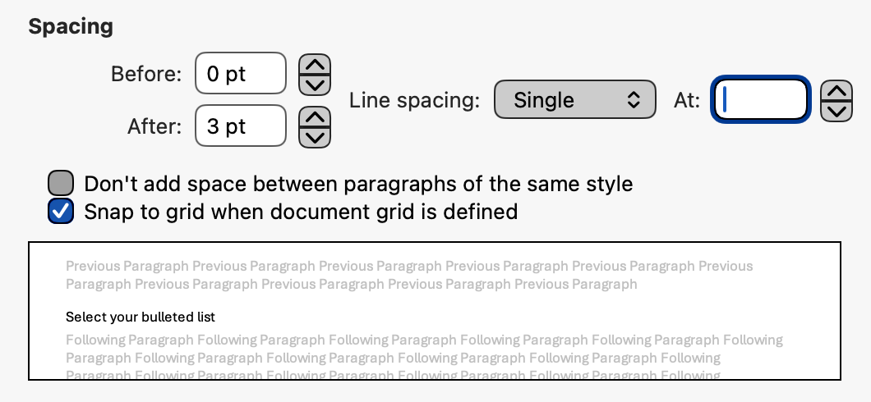
  - This can also be reached in your toolbar using the “Line and Paragraph” spacing
  - 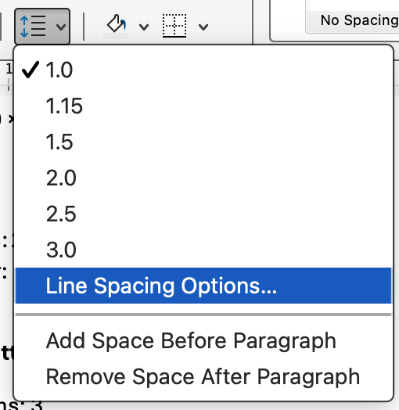
- Apply bullet or number styles
  - If this is broken, you can adjust your list, then click Definite New Multilevel List…
    - You may need to do this if Word has brough over corrupted styles from a previous document

Octave is a leader in enterprise software, turning data into decisive action and intelligence into your edge. Our software solves for and simplifies complexity, from the design and build to operations and protection of people, property, and assets– for any scope, at any scale. For decades, we’ve partnered with customers to sharpen performance, elevate efficiency, and amplify results. From factory floors to entire cities, our solutions are tuned to scale up what’s possible from day one onward.
©2026 Intergraph Corporation and/or its affiliates. All rights reserved.

Octave is a leader in enterprise software, turning data into decisive action and intelligence into your edge. Our software solves for and simplifies complexity, from the design and build to operations and protection of people, property, and assets– for any scope, at any scale. For decades, we’ve partnered with customers to sharpen performance, elevate efficiency, and amplify results. From factory floors to entire cities, our solutions are tuned to scale up what’s possible from day one onward.

About Octave
Octave is a leader in enterprise software, turning data into decisive action and intelligence into your edge. Our software solves for and simplifies complexity, from the design and build to operations and protection of people, property, and assets– for any scope, at any scale. For decades, we’ve partnered with customers to sharpen performance, elevate efficiency, and amplify results. From factory floors to entire cities, our solutions are tuned to scale up what’s possible from day one onward.
©2026 Intergraph Corporation and/or its affiliates. All rights reserved.

About Octave
Octave is a leader in enterprise software, turning data into decisive action and intelligence into your edge. Our software solves for and simplifies complexity, from the design and build to operations and protection of people, property, and assets– for any scope, at any scale. For decades, we’ve partnered with customers to sharpen performance, elevate efficiency, and amplify results. From factory floors to entire cities, our solutions are tuned to scale up what’s possible from day one onward.
©2026 Intergraph Corporation and/or its affiliates. All rights reserved.

