DSL Spec Workshop — Executable Specs for Agentic Coding

Purpose
Agentic coding tools are good at producing code that looks right. The open problem is proving it is right — and most teams still answer that by having a person read the diff. This workshop builds a small, real example of the alternative: a Given/When/Then spec, written before the code, that a machine runs and answers pass/fail. You’ll watch an AI agent build a feature against that spec inside a canon sprint, then deliberately break the implementation live and watch the spec — not a person, not the agent’s own say-so — catch it.
Teaching question this answers: when an agent tells you its work is done, what actually checked that, and could it be wrong?

Suggested app behavior
A single function, apply_discount(cart_total, code) -> dict, that decides whether a discount code applies to a cart:
- "SAVE10" — 10% off, only if cart_total >= 50
- "SAVE20" — 20% off, only if cart_total >= 100
- any other code — not applied, reason: "invalid code"
- a valid code below its minimum — not applied, reason: "minimum not met"
Deliberately small. The point of this workshop is the spec/verification loop, not the business logic.

Before you start
- Install canon’s sprint skill if you haven’t: ~/.canon/tools/skills.sh add sprint (see docs/setup.md for the full install guide).
- Start the board so you can watch ticket state as you go: sprint-check (or sprint-check-win on Windows), then open the URL it prints (defaults to http://127.0.0.1:8423, auto-increments if busy).
- Have your agent (Claude Code, Codex, or another canon-compatible agent) open in a terminal at the project folder you create in step 1 below.
Git terms used below, if you’re new to them: main is the default branch; a commit is a saved snapshot; HEAD is “the commit you’re currently on.”

Beginner-friendly workflow
- Create a project folder somewhere outside this canon repo, e.g. ~/DiscountSpecDemo, and cd into it. Copy this example’s .gitignore into your new project root.
- Copy the spec and the runner from this example into your new project:
  - specs/discount.feature → your project’s specs/discount.feature
  - dsl_runner.py → your project’s dsl_runner.py
- Read specs/discount.feature before moving on — it’s short. This is the contract the agent is about to build against; you should be able to read every line and know exactly what “correct” means here, without running anything.
- Create an AGENTS.md in your new project with:
- ## Workshop Guidelines
- Implement `discount.py` with a single function `apply_discount(cart_total: float, code: str) -> dict`,
returning `{"applied": bool, "final_total": float, "reason": str}`.
- The exact rules are defined in `specs/discount.feature` — read it, don't guess the behavior.
- `python dsl_runner.py specs/discount.feature` must exit 0 before this is considered done.
- Do not modify `specs/discount.feature` or `dsl_runner.py` to make the check pass — if the spec
seems wrong, say so and ask, don't quietly edit the test.
- Do not start implementation or run `sprint complete` without explicit approval.
- That second-to-last line matters more than it looks — it’s the guard against the exact failure mode this workshop is about: an agent “passing” a check by editing the check, not the code.
- Start the sprint. Give your agent this prompt:
- Read specs/discount.feature. Start a sprint to implement discount.py so that python dsl_runner.py specs/discount.feature exits 0. Put the spec’s three scenarios directly into acceptance.md’s criteria — don’t paraphrase them into prose — and make the exact runner command the ## Test Plan line.
- Review the plan before approving. Check specifically that:
  - acceptance.md’s criteria reference the real scenario names from the .feature file, not a vague restatement like “discount logic works correctly.”
  - ## Test Plan contains the literal command python dsl_runner.py specs/discount.feature, not “manually verify the discount logic” or similar prose.
- This is the moment the workshop is really about: an acceptance criterion that names an exact, runnable check is fundamentally different from one a reviewer has to interpret.
- Approve the plan. Let the agent implement discount.py.
- Run the check yourself before letting the agent call it done:
- python dsl_runner.py specs/discount.feature
- You should see three [PASS] lines and exit code 0. If anything fails, that’s real signal — don’t let the agent talk you out of it by re-explaining the code; the spec’s answer is the answer.
- Run sprint complete. Watch what the evaluator actually does for this criterion — it should run the Test Plan command and grade on the exit code, not just read discount.py and judge whether it looks reasonable. That’s the difference this whole workshop is trying to make visible.
- The live moment. Open discount.py and comment out (or delete) the minimum-cart-total check — make every valid code apply regardless of cart size. Save it, then re-run:
- python dsl_runner.py specs/discount.feature
- You should see [FAIL] Valid code below minimum is rejected -- applied True != expected False; ... — an exact, specific mismatch, not a vague “something’s wrong.” Revert your edit and re-run to confirm it goes back to three [PASS] lines.
- Nobody had to notice that regression by reading the diff. The spec did.
- Reflect before moving on. The check that just caught your break was written in step 4, before any implementation existed — that ordering is what made it a real check instead of a description of whatever the code happened to do.

Seeing — and authoring — the spec on the board
sprint-check renders a Given/When/Then block written in an acceptance criterion as a highlighted scenario panel, so the spec you’re grading against is readable at a glance instead of buried in a text file. When step 4’s agent puts the three scenarios into acceptance.md, the ticket’s Acceptance tab shows them like this:
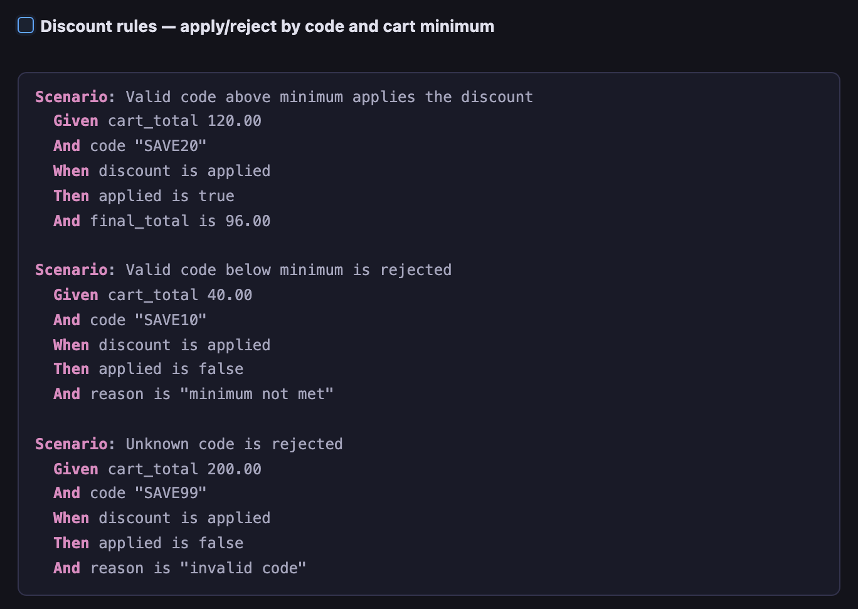
The Acceptance tab rendering the three discount scenarios as a highlighted Gherkin panel under a checkbox criterion
You (or the agent) don’t have to hand-type the fences — the Acceptance editor’s toolbar has two scenario buttons:
The Acceptance editor toolbar; the Scenario button inserts an inline Given/When/Then block and the Scenario-from-file button references a .feature file
- Scenario (the lines-and-arrow button) inserts an inline ```gherkin block skeleton to fill in.
- Scenario from file (the document button) inserts a ```gherkin-file reference to a .feature kept under the ticket (.tickets/<id>/features/<name>.feature); the board fetches and renders that file inline. This is for display — the workshop’s checker still runs the project copy, python dsl_runner.py specs/discount.feature.
The criterion is a real checkbox, so leaving it unchecked blocks sprint complete like any other unmet criterion. The panel above keeps all three scenarios under one criterion (mirroring discount.feature); if you’d rather each scenario be graded and checked off on its own, split them into one criterion per scenario — the panel renders the same either way.
Why this matters for step 8’s grading: because the criterion carries a real Given/When/Then block and names its runner command in ## Test Plan, canon’s evaluator grades it by running that command and reading the exit code — not by reading discount.py and judging whether it looks right. That “run it, report the boolean” behavior is canon’s defined rule for scenario-backed criteria, and it’s exactly what makes the live break in step 9 impossible for the gate to miss.

Hands-on: create the ticket on the board and grade it with the evaluator
The Beginner-friendly workflow above drives everything through sprint start. Here’s the same idea board-first — create the ticket in the UI, author the spec as a scenario in the Acceptance form, let the agent build against it, and watch the fresh evaluator run your scenario and grade it. Run it on the cheaper, faster Haiku model.
- New Ticket. On the board (sprint-check), click + New, title it DSL Discount, Type Task, Priority P2, then Create →.
- 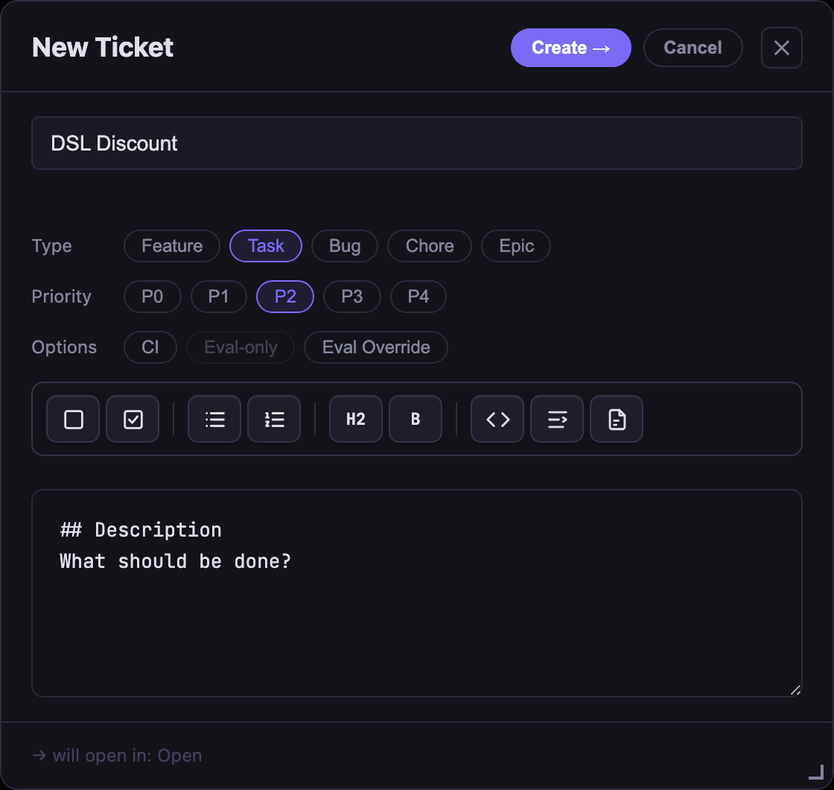
- New Ticket modal — DSL Discount, Task, P2
- Author the spec as an Acceptance scenario. Open the card → + New doc → Acceptance. In the editor, click the Scenario toolbar button and paste the three discount scenarios as one criterion, then name the runner in the Test Plan:
- ## Criteria
- [ ] **Discount rules — apply/reject by code and cart minimum**
```gherkin
Scenario: Valid code above minimum applies the discount
Given cart_total 120.00
And code "SAVE20"
When discount is applied
Then applied is true
And final_total is 96.00
Scenario: Valid code below minimum is rejected
Given cart_total 40.00
And code "SAVE10"
When discount is applied
Then applied is false
And reason is "minimum not met"
Scenario: Unknown code is rejected
Given cart_total 200.00
And code "SAVE99"
When discount is applied
Then applied is false
And reason is "invalid code"
```
## Test Plan
- [ ] `python dsl_runner.py specs/discount.feature` exits 0
- Save — the board renders your scenario as a highlighted panel under its checkbox:
- 
- Acceptance tab rendering the three discount scenarios as a highlighted Gherkin panel
- Let the agent plan and build against it. Ask your agent (use the ticket id from step 1):
- Start a sprint on ticket <id> (sprint start <id>) to implement discount.py against the Gherkin scenario in its Acceptance. Write the plan; after I approve it, implement — keeping python dsl_runner.py specs/discount.feature as the check. Don’t edit the spec or the runner.
- sprint start <id> adopts the ticket you created on the board and seeds a plan.md (approach + sign-off) — which the close gate in step 4 requires; your Acceptance scenario is left as-is. Review and approve the plan, then let the agent implement.
- Grade it with the evaluator — on Haiku. Set the gate model to Haiku (the ticket’s Plan tab → Model dropdown → haiku, or add | Gate model: haiku to plan.md’s ## Sign-off line), then run sprint complete. The fresh evaluator runs your Test Plan command and grades on the exit code — it doesn’t just read discount.py. Against a not-yet-correct implementation it fails, naming the exact mismatch (real output from a Haiku evaluator run):
- [FAIL] Valid code above minimum applies the discount -- applied False != expected True; final_total 120.0 != expected 96.0
[FAIL] Valid code below minimum is rejected -- reason 'invalid code' != expected 'minimum not met'
[PASS] Unknown code is rejected
fail: runner exited 1 — "Valid code above minimum" and "Valid code below minimum is rejected" mismatched.
- Fix discount.py and re-run; the same evaluator now passes:
- [PASS] Valid code above minimum applies the discount
[PASS] Valid code below minimum is rejected
[PASS] Unknown code is rejected
pass: the runner exited 0 with all three scenarios reporting [PASS].
- Nobody read the diff to catch the wrong implementation — the evaluator ran the spec and the boolean did. That’s the whole point, and on Haiku it’s cheap enough to do on every close.
Why the interactive close here, not the headless gate? canon’s headless gate (sprint-headless-eval, the one CI uses) deliberately runs the evaluator with a narrow tool allowlist because it grades untrusted PR diffs — so it can’t execute an arbitrary scenario runner and would mark the “runner exits 0” item not-run. The interactive sprint complete evaluator has the tools to run it, so scenario execution works there today. Letting the headless path run scenario runners safely is tracked as a separate improvement.

The spec, annotated
Scenario: Valid code below minimum is rejected
Given cart_total 40.00
And code "SAVE10"
When discount is applied
Then applied is false
And reason is "minimum not met"
Every line here is both readable (a non-engineer can confirm this rule is what they meant) and executable (dsl_runner.py runs it against the real function and gets a real answer). That dual requirement is the whole pattern — a spec that’s precise but unreadable is just code with extra steps; a spec that’s readable but unrun is just a comment.

The runner, annotated
dsl_runner.py is intentionally small (~50 lines) and intentionally not a general Gherkin engine — it recognizes only the five step shapes this spec file uses. That’s a deliberate constraint, not a shortcut: a parser this size can be read end to end and trusted; a general natural-language step interpreter can’t, and pointing one at live-edited text (in a workshop, or in production) is asking for silent misparses. If you outgrow this pattern, the fix is adding more recognized step shapes, not switching to free-text parsing.

Test cases
Scenario | cart_total | code | Expected applied | Expected result
Valid code, above minimum | 120.00 | SAVE20 | true | final_total: 96.00
Valid code, below minimum | 40.00 | SAVE10 | false | reason: "minimum not met"
Unknown code | 200.00 | SAVE99 | false | reason: "invalid code"

What each case means in the business
The table above is the machine-facing contract. This companion table keeps the same cases legible to the person who owns the pricing policy and explains what each result protects.
Case | What to run or change | Expected result | Why it matters
Valid code above minimum | Run the saved spec with cart 120.00 and code SAVE20. | [PASS]; applied: true; final total 96.00. | Confirms an approved promotion is applied at the correct threshold and amount.
Valid code below minimum | Run the saved spec with cart 40.00 and code SAVE10. | [PASS]; applied: false; reason minimum not met. | Prevents discounts from leaking below the commercial minimum and protects margin.
Unknown code | Run the saved spec with cart 200.00 and code SAVE99. | [PASS]; applied: false; reason invalid code. | Prevents an unapproved or mistyped code from changing the order total.
Deliberate implementation break | Remove the minimum-total check from discount.py, then rerun the same spec. | The below-minimum scenario returns [FAIL] with the actual/expected mismatch. | Demonstrates that the written policy catches a regression without someone having to inspect the diff.
Restore the implementation | Put the minimum-total check back and rerun the spec. | Three [PASS] lines; exit code 0. | Confirms the production behavior is back in agreement with the policy contract.

Where this pattern fits — and where it doesn’t
Say this part out loud if you’re running this as a group workshop; it’s what keeps the exercise honest instead of a sales pitch for DSLs:
- Fits well: anything with a checkable ground truth — this discount function, data validation, routing decisions, structured extraction, query generation. If you can write a Then, use one.
- Doesn’t fit: open-ended output with no single right answer — “write a better error message,” “summarize this concisely.” Forcing a spec there either flattens the task into a checklist that misses the point, or you end up building an LLM judge — which just moves “who verifies this” one level up, onto something that itself needs verifying.
- The honest limit of this exercise specifically: dsl_runner.py proves the code matches the spec. It doesn’t prove the spec matches what you actually meant — if the same person (or the same agent) writes both the implementation and the spec by watching the code run, you get a regression lock on today’s behavior, not a correctness check against intent. The spec in this workshop was handed to you already written, in step 2, before any code existed — that’s what makes it a real check. In your own work, that means: write the spec first, or have someone other than the implementer sign off on it, before trusting it as proof of anything.

“Isn’t this just a unit test?”
Say yes first — for this exact bug, a pytest equivalent would catch it too:
def test_below_minimum_rejected():
result = apply_discount(40.00, "SAVE10")
assert result["applied"] is False
assert result["reason"] == "minimum not met"
Same detection power, same mechanism. The DSL isn’t a stronger test — the difference is who could have written it. The .feature version only requires knowing the discount rule; the pytest version requires knowing the rule and Python (assert, dict indexing, how to run the suite). Whoever owns the pricing policy can write and sign off on the scenario directly, with zero code literacy — the unit test needs a translation step from rule to assert syntax, done by whoever implements it, which is exactly where intent quietly drifts.
One counter to have ready: “isn’t ‘write the check before the code’ just TDD?” Yes — concede it. TDD gets you the ordering. It doesn’t get you the readership: a test-first pytest file is still unreadable to whoever actually owns the rule. That gap matters more, not less, as rules move further from engineering — pricing policy, compliance, CFIHOS conformance — cases where the person who knows what “correct” means was never going to write the assert.

Suggested demonstration sequence (for instructors)
Condensed recap of the steps above, for running this live in front of a group:
- Show specs/discount.feature on screen — read it aloud, confirm the room agrees on what “correct” means before any code exists.
- Prompt the agent to build against it (step 4 above); narrate what you’re checking for in the plan (step 5) before approving.
- Let the build finish, run the checker, show green.
- sprint complete — pause on the evaluator’s output specifically calling out that it ran the command rather than reading the code.
- Break discount.py live (step 9), re-run, show the exact failure message, revert, show green again. This is the moment to slow down — it’s the entire point of the workshop in about fifteen seconds.
- Close on the honest-limit section above — name what this does and doesn’t prove before anyone in the room asks.

Related material
- The real-world version of this pattern: a CFIHOS-style conformance engine for plant equipment data, with the same spec/runner/live-break structure, in overtone_demo/scenarios.py (separate repo).
- posts/dsl-for-agentic-coding-session.md in this repo — the talk this workshop is built from, including a longer treatment of the “where it doesn’t fit” section above.

