LAB EXPERIMENTS
CSA1012 -SOFTWARE ENGINEERING

GITHUB LINK : https://github.com/sunitha3114/CSA1012-Software-Engineering-.git

Experiment 1: Create a Kanban Board to Visualize Tasks
OUTPUT:
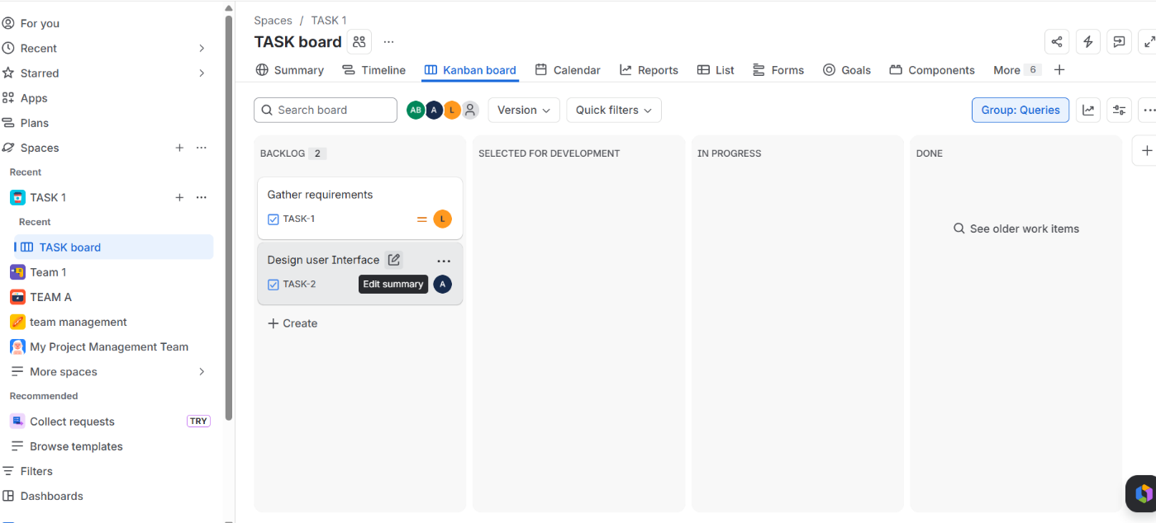

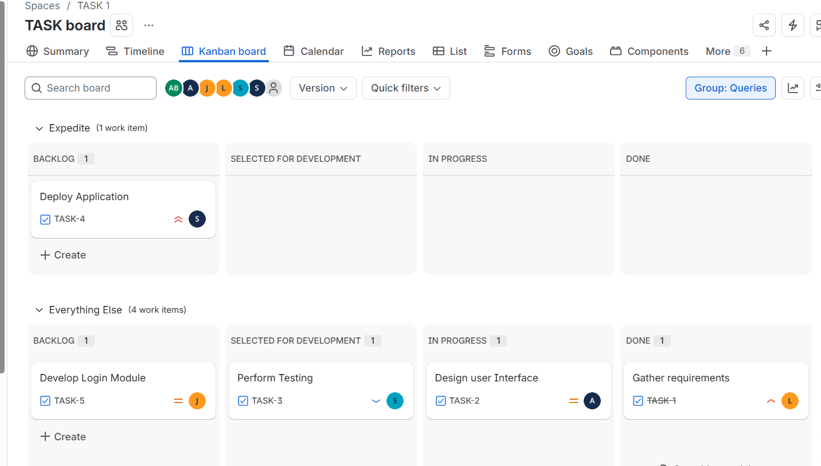

Experiment 2: Design a Bus Ticket Booking System Prototype
OUTPUT:
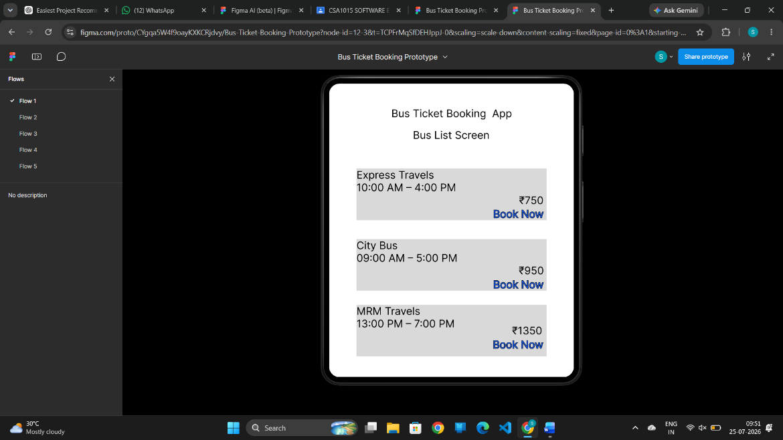

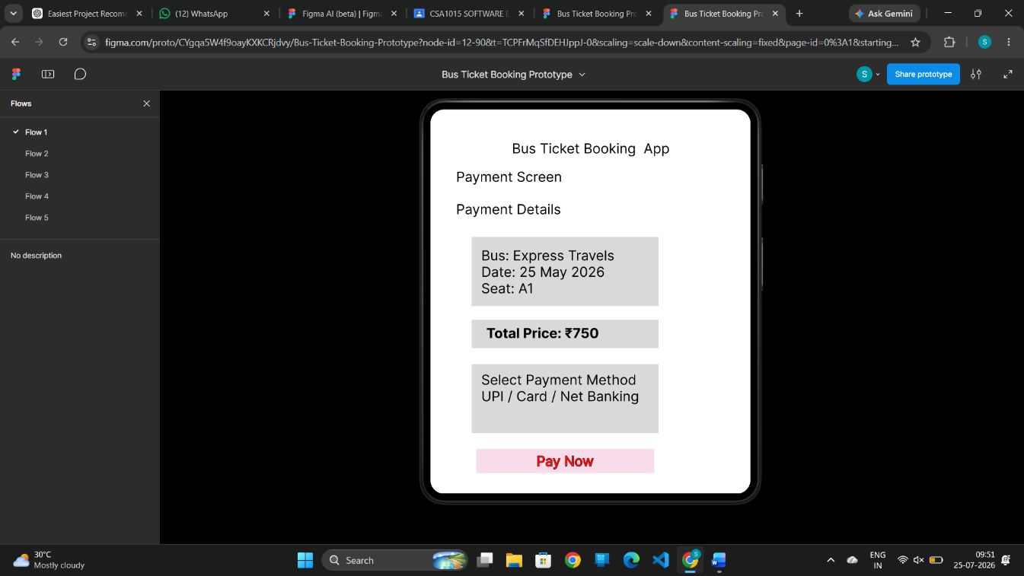

Experiment 3: Prototype an E-Commerce Mobile Application
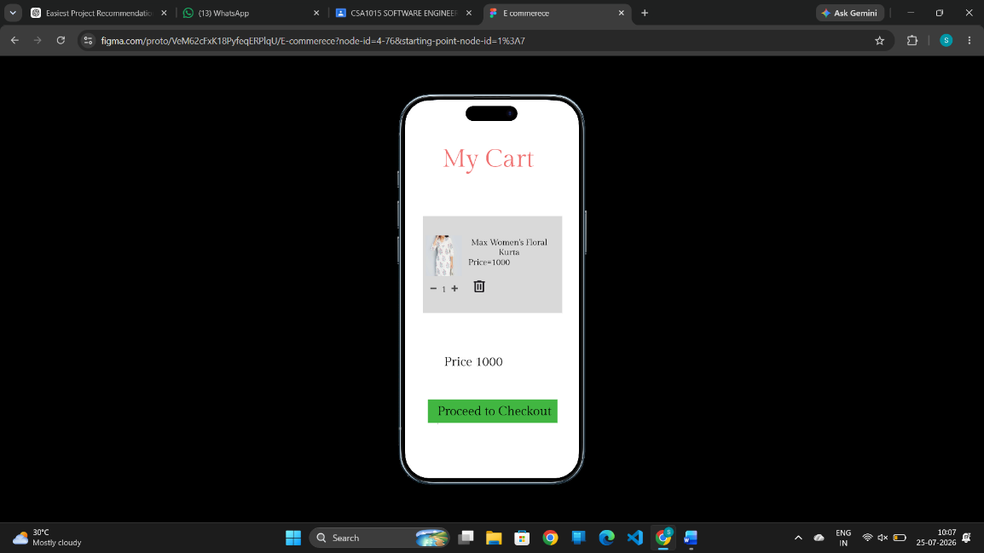
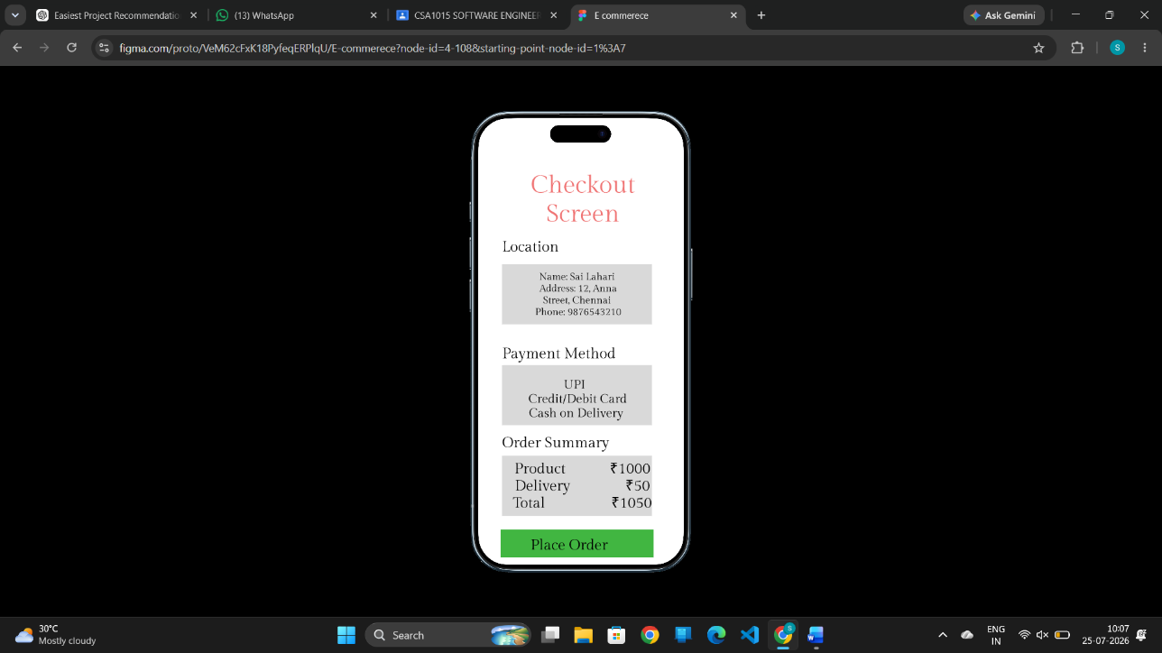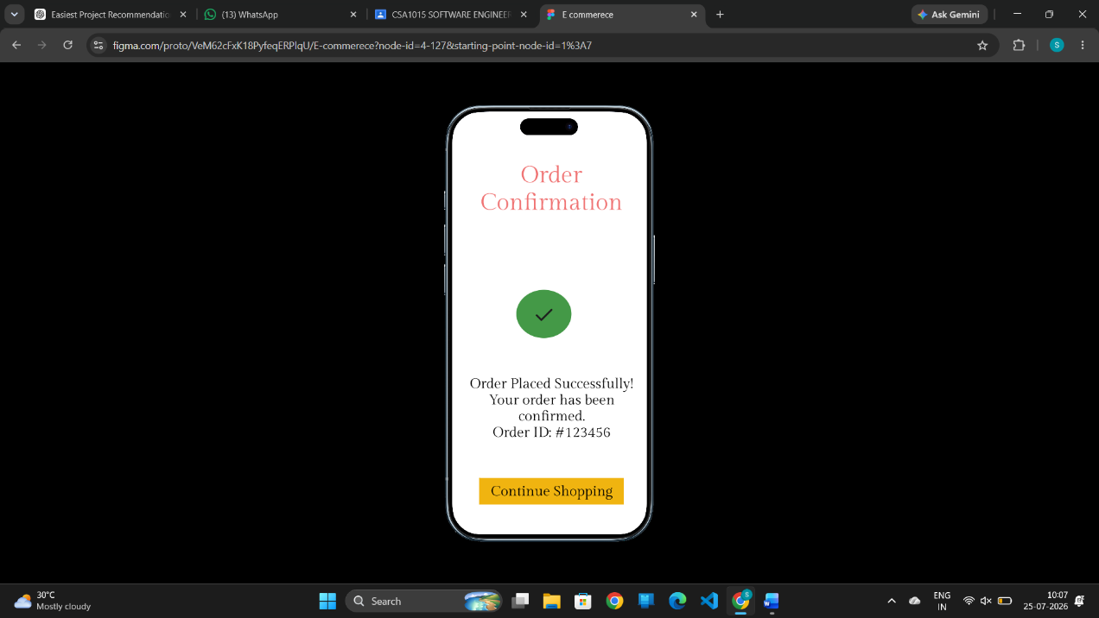
Experiment 4: Create a Scrum Project in Jira
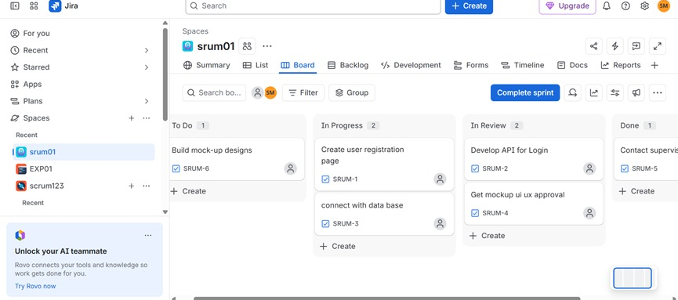

Experiment 5: Prioritize Library Management System Requirements Using the MoSCoW Method

