SBA-8

211505-SUNITHA VN

1. program to take input of two integer arrays from the user and to find the sum of both the arrays.

Sort the elements of the resultant array in ascending order using selection sort.

package training_java;

import java.io.*;

import java.util.*;

public class Assgnmnt10three {

public static void main(String[] args)

{

System.out.println("Enter the array size:");

Scanner sc=new Scanner(System.in);

int size=sc.nextInt();

System.out.println("Enter the array 1 elements:");

int[] arr1=new int[size];

for(int i=0;i<size;i++)

{

arr1[i]=sc.nextInt();

}

System.out.println("Enter the array 2 elements:");

int[] arr2=new int[size];

for(int i=0;i<size;i++)

{

arr2[i]=sc.nextInt();

}

System.out.println("Sum of the araay elements :");

int[] arr3=new int[size];

int sum=0;

for(int i=0;i<size;i++)

{

arr3[i]=(arr1[i]+arr2[i]);

}

System.out.print("[");

for(int i=0;i<size;i++)

{

System.out.print(arr3[i]+",");

}

System.out.println("]");

System.out.println("");

for(int l=0;l<size-1;l++)

{

int min_idx=l;

for(int j=l+1;j<size;j++)

{

if(arr3[min_idx]>arr3[j])

min_idx=j;

}

int temp=arr3[min_idx];

arr3[min_idx]=arr3[l];

arr3[l]=temp;

}

System.out.println("Sum of the array after selection sort is:");

System.out.print("[");

for(int k=0;k<size;k++)

{

System.out.print(arr3[k]+",");

}

System.out.print("]");

}

}

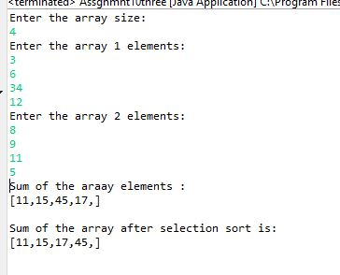

2.program to take input of Two arrays and store the similar elements into the resultant array.

sort the resultant array in ascending order using bubble sort.

NOTE: there must at least be 6 similar elements.

similar elements= the elements occurring in both the arrays.

package training_java;

import java.util.Scanner;

import java.util.ArrayList;

public class Assgnmnt10four {

public static void main(String[] args)

{

System.out.println("Enter the array size:");

Scanner sc=new Scanner(System.in);

int size=sc.nextInt();

System.out.println("Enter the array 1 elements:");

int[] arr1=new int[size];

for(int i=0;i<size;i++)

{

arr1[i]=sc.nextInt();

}

System.out.println("Enter the array 2 elements:");

int[] arr2=new int[size];

for(int i=0;i<size;i++)

{

arr2[i]=sc.nextInt();

}

System.out.println("Similar elements :");

ArrayList<Integer> arr3=new ArrayList<Integer>();

for(int i=0;i<size;i++)

{

for(int j=0;j<size;j++)

{

if(arr1[i]==arr2[j])

arr3.add(arr1[i]);

}

}

System.out.println(arr3);

int len=arr3.size();

Integer[] arr4=new Integer[len];

arr4=arr3.toArray(arr4);

for(int i=0;i<len;i++)

{

for(int j=0;j<len-1-i;j++)

{

if(arr4[j+1]<arr4[j])

{

int temp=arr4[j+1];

arr4[j+1]=arr4[j];

arr4[j]=temp;

}

}

}

System.out.println("after bubble sort is:");

System.out.print("[");

for(int i=0;i<len;i++)

{

System.out.print(arr4[i]);

System.out.print(" ");

}

System.out.println("]");

}

}

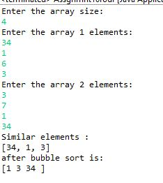

3.program to take input two arrays and store the dissimilar elements into a resultant array.

sort the resultant array in a descending order using bubble sort.

dissimilar elements= the elements not occurring in both the arrays.(unique elements)

package training_java;

import java.util.*;

import java.util.Arrays;

public class Assgnmnt10five {

public static void main(String[] args)

{

System.out.println("Enter the array size:");

Scanner sc=new Scanner(System.in);

int size=sc.nextInt();

System.out.println("Enter the array 1 elements:");

int[] arr1=new int[size];

for(int i=0;i<size;i++)

{

arr1[i]=sc.nextInt();

}

System.out.println("Enter the array 2 elements:");

int[] arr2=new int[size];

for(int i=0;i<size;i++)

{

arr2[i]=sc.nextInt();

}

System.out.println("Disimilar elements :");

ArrayList<Integer> arr3=new ArrayList<Integer>();

int flag=0;

for(int i=0;i<size;i++)

{

for(int j=0;j<size;j++)

{

if(arr1[i]==arr2[j])

flag=1;

}

if(flag==0)

{

arr3.add(arr1[i]);

}

flag=0;

}

for(int i=0;i<size;i++)

{

for(int j=0;j<size;j++)

{

if(arr2[i]==arr1[j])

flag=1;

}

if(flag==0)

{

arr3.add(arr2[i]);

}

flag=0;

}

System.out.println(arr3);

int len=arr3.size();

Integer[] arr4=new Integer[len];

arr4=arr3.toArray(arr4);

for(int i=0;i<len;i++)

{

for(int j=0;j<len-1-i;j++)

{

if(arr4[j+1]>arr4[j])

{

int temp=arr4[j+1];

arr4[j+1]=arr4[j];

arr4[j]=temp;

}

}

}

System.out.println("after bubble sort is:");

for(int i=0;i<len;i++)

{

System.out.println(arr4[i]);

}

}

}

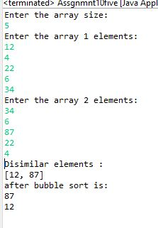

4. Implement Array List and add, remove, elements in the Array List and perform sorting of the elements using the iterator.

**package** training_java;

**import** java.util.ArrayList;

**import** java.util.Collections;

**import** java.util.Iterator;

**public** **class** Sba8_4 {

**public** **static** **void** main(String[] args)

{

ArrayList<String>list=**new** ArrayList<String>();

list.add("Apple");

list.add("Orange");

list.add("Grape");

list.add("Mango");

list.add("Banana");

list.add("Watermelon");

System.***out***.println("The elements in ArrayLists are: "+list);

list.remove(5);

System.***out***.println("The contents of list after removing the element at 5th position is: "+list);

Iterator<String>iter=list.iterator();

System.***out***.println("\nThe iterator values" + " of list are: ");

**while** (iter.hasNext()) {

System.***out***.print(iter.next() + " ");

}

}

}

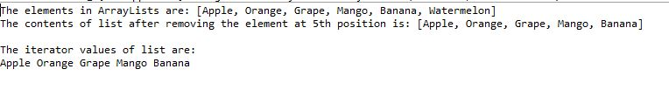

5. Implement LinkedList and add, remove, elements in the LinkedList and perform sorting of the elements using the iterator.

**package** training_java;

**import** java.util.*;

**public** **class** Sba8_5 {

**public** **static** **void** main(String[] args)

{

LinkedList<String>list=**new** LinkedList<String>();

list.add("Red");

list.add("Italy");

list.add("Blue");

list.add("London");

list.add("Paris");

list.add("Purple");

System.***out***.println("Linkedlist: "+list);

list.remove(5);

System.***out***.println("Updated linked list: "+list);

ListIterator list_iter=list.listIterator(2);

System.***out***.println("The list is as follows: ");

**while**(list_iter.hasNext()) {

System.***out***.println(list_iter.next());

}

}

}

