211505-Sunitha V N

1. Create an array of 10 elements and print them using the for each loop.

**public** **class** Sba1_1 {

**public** **static** **void** main(String[] args) {

**int** arr[]= {23,1,56,12,33,78,56,45,32,90};

System.***out***.print("Array is:");

System.***out***.print("[");

**for**(**int** i:arr)

{

System.***out***.print(i+",");

}

System.***out***.print("]");

}

}

Output

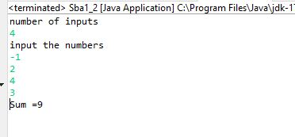

1. Take the number input from the console and add all the positive numbers. (not to consider the negative number if entered)

**import** java.util.*;

**public** **class** Sba1_2 {

**public** **static** **void** main(String[] args) {

Scanner sc=**new** Scanner(System.***in***);

System.***out***.println("number of inputs");

**int** n=sc.nextInt();

**int** num,sum=0;

System.***out***.println("input the numbers");

**for**(**int** i=0;i<n;i++)

{

num=sc.nextInt();

**if**(num>0)

sum=sum+num;

}

System.***out***.println("Sum ="+sum);

}

}

Output



1. Create a labeled break and write a simple logic and execute the program.

**public** **class** Sba1_3 {

**public** **static** **void** main(String[] args) {

aa:

**for**(**int** i=0;i<10;i++)

{

bb:

**for**(**int** j=1;j<=i;j++)

{

**if**(i==8)

**break** bb;

System.***out***.print(i+",");

}

System.***out***.println();

}

}

}

Output

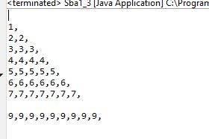

1. Do the addition of around 10 even numbers, but use the continue statement in the logic.

**public** **class** Sba1_4 {

**public** **static** **void** main(String[] args) {

**int** sum=0;

**for**(**int** i=2;i<50;i++)

{

**if**(i%2!=0)

**continue**;

**else**

sum=sum+i;

}

System.***out***.print("sum of even numbers :");

System.***out***.println(sum);

}

}

