211505 - Sunitha V N

1. Write a program to reverse the String (use char[] or String built in method)

**import** java.util.*;

**import** java.lang.*;

**public** **class** Sba2_1 {

**public** **static** **void** main(String[] args) {

System.***out***.println("input the string to be reversed");

String str=**new** String();

Scanner sc=**new** Scanner(System.***in***);

str=sc.nextLine();

System.***out***.println("Reversed string is: ");

**char** ch[]=str.toCharArray();

**for**(**int** i=ch.length-1;i>=0;i--)

{

System.***out***.print(ch[i]);

}

}

}

Output

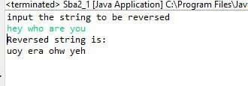

1. Write programs to depict the usage of contains(), length(), replace(), concat(), equals()

**public** **class** Sba2_2 {

**public** **static** **void** main(String[] args) {

String str1="psychology";

String str2="psycho";

**if**(str1.contains(str2))

{

System.***out***.println("str1 contains str2");

}

**else**

System.***out***.println("str1 does not contains str2");

System.***out***.println("length of the string str1 is "+str1.length());

String str3="class";

System.***out***.println("str1+str3 :"+str1.concat(str3));

System.***out***.println("replace str1 "+str1.replace("ology", "atrist"));

**if**(str2.equals(str1))

{

System.***out***.println("Both are equal");

}

**else**

System.***out***.println("Both are different");

}

}

Output

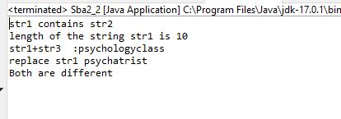

1. Write a customized Exception class for a Banking project

**public** **class** Sba2_3 {

**public** **static** **void** main(String[] args)

{

**try**

{

**int** Initial=200;

**int** Balance=0;

System.***out***.println(" "+(Initial/Balance));

}

**catch**(ArithmeticException e)

{

System.***out***.println("Arithmetic Exception:Balance is zero");

}

**finally**

{

System.***out***.println("Try again later");

}

}

}

output

