**SBA-3**

Sunitha VN-211505

1. Create Database project_movie_data and deploy table data according to ER diagram.

create database project_movie_data;

use project_movie_data;

db.JPG

2. Create 9 tables which are presented in ER model and load the data with their foreign key and primary key values.

create table actor(act_id int not null,act_fname varchar(20),act_lname varchar(20),act_gender char(1),primary key(act_id));

INSERT INTO actor (act_id, act_fname, act_lname, act_gender) VALUES

(101, 'James', 'Stewart', 'M'),

(102, 'Deborah', 'Kerr', 'F'),

(103, 'Peter', 'OToole', 'M'),

(104, 'Robert', 'De Niro', 'M'),

(105, 'F. Murray', ' Abraham', 'M'),

(106, 'Harrison', 'Ford', 'M'),

(107, 'Nicole', ' Kidman', 'F'),

(108, 'Stephen', 'Baldwin', 'M'),

(109, 'Jack', 'Nicholson', 'M'),

(110, 'Mark', 'Wahlberg', 'M'),

(111, 'Woody', 'Allen', 'M'),

(112, 'Claire', 'Danes', 'F'),

(113, 'Tim', 'Robbins', 'M'),

(114, 'Kevin', 'Spacey', 'M'),

(115, 'Kate', 'Winslet', 'F'),

(116, 'Robin', 'Williams', 'M'),

(117, 'Jon', 'Voight', 'M'),

(118, 'Ewan', 'McGregor', 'M'),

(119, 'Christian', 'Bale', 'M'),

(120, 'Maggie', 'Gyllenhaa', 'F'),

(121, 'Dev', 'Patel', 'M'),

(122, 'Sigourney', 'Weaver', 'F'),

(123, 'David', 'Aston', 'M'),

(124, 'Ali', 'Astin', 'F');

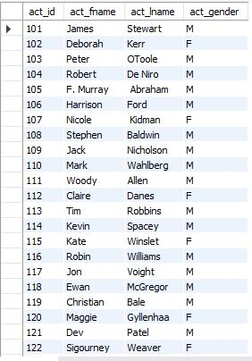

create table director(dir_id int not null,dir_fname varchar(20),dir_iname varchar(20),primary key(dir_id));

insert into director (dir_id, dir_fname, dir_iname)values

(201, ' Alfred ', ' Hitchcock'),

(202, ' Jack ', ' Clayton'),

(203, ' David ', ' Lean'),

(204, ' Michael ', ' Cimino'),

(205, ' Milos ', ' Forman'),

(206, ' Ridley ', ' Scott'),

(207, ' Stanley ', ' Kubrick'),

(208, ' Bryan ', ' Singer'),

(209, ' Roman ', ' Polanski'),

(210, ' Paul ', ' Thomas An'),

(211, ' Woody ', ' Allen'),

(212, ' Hayao ', ' Miyazaki'),

(213, ' Frank ', ' Darabont'),

(214, ' Sam ', ' Mendes'),

(215, ' James ', ' Cameron'),

(216, ' Gus ', ' Van Sant'),

(217, ' John ', ' Boorman'),

(218, ' Danny ', ' Boyle'),

(219, ' Christoph', ' Nolan'),

(220, ' Richard ', ' Kelly'),

(221, ' Kevin ', ' Spacey'),

(222, ' Andrei ', ' Tarkovsky'),

(223, ' Peter ', ' Jackson');

select *from director;

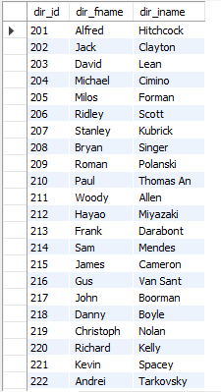

create table if not exists movie(mov_id int not null,mov_title varchar(50),mov_year int,mov_time int,mov_lan varchar(50),mov_dt_rel date,mov_rel_country varchar(5),primary key(mov_id));

INSERT INTO movie (mov_id, mov_title, mov_year, mov_time, mov_lan, mov_dt_rel, mov_rel_country) VALUES

(901, 'Vertigo', 1958, 128, 'English', '1958-08-24', 'UK'),

(902, 'The Innocents', 1961, 100, 'English', '1962-02-19', 'SW'),

(903, 'Lawrence of Arabia', 1962, 216, 'English', '1962-12-11', 'UK'),

(904, 'The Deer Hunter', 1978, 183, 'English', '1979-03-08', 'UK'),

(905, 'Amadeus', 1984, 160, 'English', '1985-01-07', 'UK'),

(906, 'Blade Runner', 1982, 117, 'English', '1982-09-09', 'UK'),

(907, 'Eyes Wide Shut', 1999, 159, 'English', '0000-00-00', 'UK'),

(908, 'The Usual Suspects', 1995, 106, 'English ', '1995-08-25', 'UK'),

(909, 'Chinatown', 1974, 130, 'English', '1974-08-09', 'UK'),

(910, 'Boogie Nights', 1997, 155, 'English', '1998-02-16', 'UK'),

(911, 'Annie Hall', 1977, 93, 'English', '1977-04-20', 'USA'),

(912, 'Princess Mononoke', 1997, 134, 'Japanese', '2001-10-19', 'UK'),

(913, 'The Shawshank Redem', 1994, 142, 'English', '1995-02-17', 'UK'),

(914, 'American Beauty', 1999, 122, 'English', '0000-00-00', 'UK'),

(915, 'Titanic', 1997, 194, 'English', '1998-01-23', 'UK'),

(916, 'Good Will Hunting', 1997, 126, 'English', '1998-06-03', 'UK'),

(917, 'Deliverance', 1972, 109, 'English', '1982-10-05', 'UK'),

(918, 'Trainspotting', 1996, 94, 'English', '1996-02-23', 'UK'),

(919, 'The Prestige', 2006, 130, 'English', '2006-11-10', 'UK'),

(920, 'Donnie Darko', 2001, 113, 'English', '0000-00-00', 'UK'),

(921, 'Slumdog Millionaire', 2008, 120, 'English', '2009-01-09', 'UK'),

(922, 'Aliens', 1986, 137, 'English', '1986-08-29', 'UK'),

(923, 'Beyond the Sea', 2004, 118, 'English', '2004-11-26', 'UK'),

(924, 'Avatar', 2009, 162, 'English', '2009-12-17', 'UK'),

(925, 'Braveheart', 1995, 178, 'English', '1995-09-08', 'UK'),

(926, 'Seven Samurai', 1954, 207, 'Japanese', '1954-04-26', 'JP'),

(927, 'Spirited Away', 2001, 125, 'Japanese', '2003-09-12', 'UK'),

(928, 'Back to the Future', 1985, 116, 'English ', '1985-12-04', 'UK');

select *from movie;

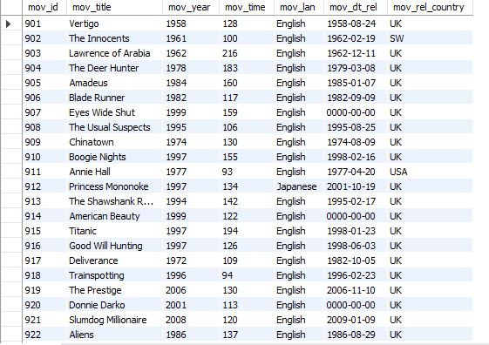

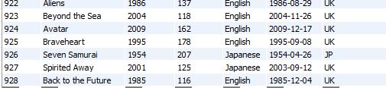

create table if not exists movie_cast(act_id int not null,mov_id int not null,role varchar(30),foreign key(act_id)references actor(act_id),foreign key(mov_id)references movie(mov_id));  
INSERT INTO movie_cast (act_id, mov_id, role) VALUES  
(101, 901, ' John Scottie Fergus'),  
(102, 902, ' Miss Giddens'),  
(103, 903, ' T.E. Lawrence'),  
(104, 904, ' Michael'),  
(105, 905, ' Antonio Salieri'),  
(106, 906, ' Rick Deckard'),  
(107, 907, ' Alice Harford'),  
(108, 908, ' McManus'),  
(110, 910, ' Eddie Adams'),  
(111, 911, ' Alvy Singer'),  
(112, 912, ' San'),  
(113, 913, ' Andy Dufresne'),  
(114, 914, ' Lester Burnham'),  
(115, 915, ' Rose DeWitt Bukater'),  
(116, 916, ' Sean Maguire'),  
(117, 917, ' Ed'),  
(118, 918, ' Renton'),  
(120, 920, ' Elizabeth Darko'),  
(121, 921, ' Older Jamal'),  
(122, 922, ' Ripley'),  
(114, 923, ' Bobby Darin'),  
(109, 909, ' J.J. Gittes'),  
(119, 919, ' Alfred Borden');

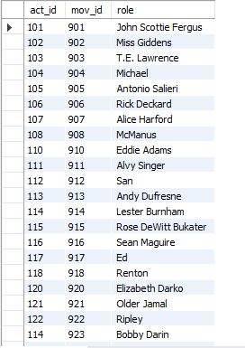

tb4.2.JPG

create table if not exists movie_direction(dir_id int not null,mov_id int not null,foreign key(dir_id)references director(dir_id),foreign key(mov_id)references movie(mov_id));  
INSERT INTO movie_direction (dir_id, mov_id) VALUES  
(201, 901),  
(202, 902),  
(203, 903),  
(204, 904),  
(205, 905),  
(206, 906),  
(207, 907),  
(208, 908),  
(209, 909),  
(210, 910),  
(211, 911),  
(212, 912),  
(213, 913),  
(214, 914),  
(215, 915),  
(216, 916),  
(217, 917),  
(218, 918),  
(219, 919),  
(220, 920),  
(218, 921),  
(215, 922),  
(221, 923);  
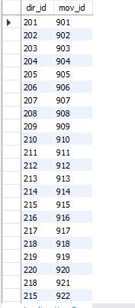

create table reviewer(rev_id int not null,rev_name varchar(30),primary key(rev_id));  
insert into reviewer(rev_id,rev_name)values(9001,'Righty Sock'),(9002,'Jack Malvern'),(9003,'Flagrant Baronessa'),(9004,'Alec Show'),(9005,null),(9006,'Victor Woeltjen'),  
(9007,'Simon Wright'),(9008,'Neal Wruck'),(9009,'Paul Monks'),(9010,'Mike Salvati'),(9011,null),(9012,'Wesley S.Walker'),(9013,'Sasha Goldshtein'),(9014,'Josh Cates'),(9015,'Krug Stllo'),  
(9016,'Scott LeBrun'),(9017,'Hannah Steele'),(9018,'Vincent Cadena'),(9019,'Brandt Sponseller'),(9020,'Richard Adams');

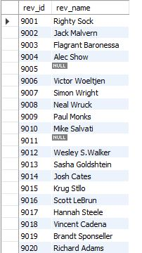  
create table if not exists genres(gen_id int not null,gen_title varchar(20),primary key(gen_id));  
INSERT INTO genres (gen_id, gen_title) VALUES  
(1001, ' Action'),  
(1002, ' Adventure'),  
(1003, ' Animation'),  
(1004, ' Biography'),  
(1005, ' Comedy'),  
(1006, ' Crime'),  
(1007, ' Drama'),  
(1008, ' Horror'),  
(1009, ' Music'),  
(1010, ' Mystery'),  
(1011, ' Romance'),  
(1012, ' Thriller'),  
(1013, ' War');  
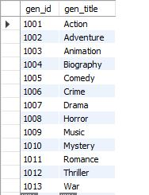

create table if not exists movie_genres(mov_id int not null,gen_id int not null,foreign key(mov_id)references movie(mov_id) ,foreign key(gen_id)references genres(gen_id));  
INSERT INTO movie_genres (mov_id, gen_id) VALUES  
(922, 1001),  
(917, 1002),  
(903, 1002),  
(912, 1003),  
(911, 1005),  
(908, 1006),  
(913, 1006),  
(926, 1007),  
(928, 1007),  
(918, 1007),  
(921, 1007),  
(902, 1008),  
(923, 1009),  
(907, 1010),  
(927, 1010),  
(901, 1010),  
(914, 1010),  
(906, 1012),  
(904, 1013);  
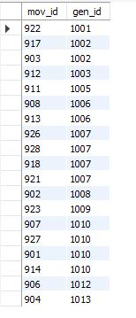

create table if not exists rating(mov_id int not null,rev_id int not null,rev_stars int,num_o_ratings int,foreign key(mov_id)references movie(mov_id),foreign key(rev_id) references reviewer(rev_id));

INSERT INTO rating (mov_id, rev_id, rev_stars, num_o_ratings) VALUES

(901, 9001, '8.4', 263575),

(902, 9002, '7.9', 20207),

(903, 9003, '8.3', 202778),

(906, 9005, '8.2', 484746),

(924, 9006, '7.3', null),

(908, 9007, '8.6', 779489),

(909, 9008, null, 227235),

(910, 9009, '3', 195961),

(911, 9010, '8.1', 203875),

(912, 9011, '8.4', 0),

(914, 9013, '7', 862618),

(915,9001,'7.7',830095),

(916, 9014, '4', 642132),

(925, 9015, '7.7', 81328),

(918, 9016, null, 580301),

(920, 9017, '8.1', 609451),

(921, 9018, '8', 667758),

(922, 9019, '8.4', 511613),

(923, 9020, '6.7', 13091);

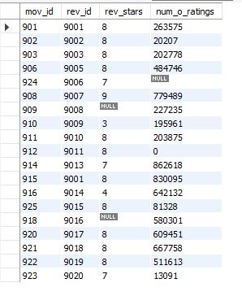

3. Write a query in SQL to list the Horror movies?

select movie.mov_title

from movie,movie_genres,genres

where movie.mov_id=movie_genres.mov_id

and  genres.gen_id=movie_genres.gen_id

and genres.gen_title="Horror";

out3.JPG

4.Write a query in SQL to find the name of all reviewers who have rated 8 or more stars?

select rev_name from reviewer rv INNER JOIN rating rt on rv.rev_id=rt.rev_id

where rt.rev_stars>=8.00;

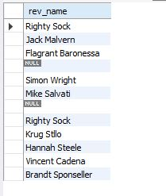

5.Write a query in SQL to list all the information of the actors who played a role in the movie ‘Deliverance’

SELECT *

FROM actor

WHERE act_id IN(

SELECT act_id

FROM movie_cast

WHERE mov_id IN (

SELECT mov_id

FROM movie

WHERE mov_title='Deliverance'

));

5.JPG

6.Write a query in SQL to find the name of the director (first and last names) who directed a movie that casted a role for ‘Eyes Wide Shut’. (using subquery)

SELECT dir_fname, dir_iname

FROM director

WHERE dir_id in (

SELECT dir_id

FROM movie_direction

WHERE mov_id in(

SELECT mov_id

FROM movie_cast WHERE role = ANY (

SELECT role

FROM movie_cast

WHERE mov_id IN (

SELECT mov_id

FROM movie

WHERE mov_title='Eyes Wide Shut'))));

6.JPG

7.Write a query in SQL to find the movie title, year, date of release, director and actor for those movies which reviewer is ‘Neal Wruck’

SELECT mov_title, mov_year, mov_dt_rel, dir_fname, dir_iname, act_fname,

act_lname FROM movie a, movie_direction b, director c, rating d, reviewer e, actor f,

movie_cast g WHERE a.mov_id=b.mov_id AND b.dir_id=c.dir_id AND a.mov_id=d.mov_id AND d.rev_id=e.rev_id

AND a.mov_id=g.mov_id AND g.act_id=f.act_id AND e.rev_name ="Neal Wruck";

