Agentic URL Shortener: Project Setup Guide
This document provides the complete source code and directory structure for the Agentic URL Shortener service. Follow the structure below to recreate the project locally and import it into IntelliJ IDEA.

1. Project Structure
agentic-url-shortener/
├── pom.xml
└── src/main/
├── java/com/example/shortener/
│ ├── ShortenerApplication.java
│ ├── UrlController.java
│ ├── UrlService.java
│ └── orchestration/
│ ├── OrchestrationController.java
│ └── WorkflowService.java
└── resources/
└── application.properties

2. Maven Configuration (pom.xml)
Create pom.xml in the project root folder.
<project xmlns="http://maven.apache.org/POM/4.0.0"
xmlns:xsi="http://www.w3.org/2001/XMLSchema-instance"
xsi:schemaLocation="http://maven.apache.org/POM/4.0.0
https://maven.apache.org/xsd/maven-4.0.0.xsd">
<modelVersion>4.0.0</modelVersion>
<groupId>com.example</groupId>
<artifactId>agentic-url-shortener</artifactId>
<version>0.0.1-SNAPSHOT</version>
<parent>
<groupId>org.springframework.boot</groupId>
<artifactId>spring-boot-starter-parent</artifactId>
<version>3.5.0</version>
<relativePath/>
</parent>
<properties>
<java.version>21</java.version>
</properties>
<dependencies>
<dependency>
<groupId>org.springframework.boot</groupId>
<artifactId>spring-boot-starter-web</artifactId>
</dependency>
<dependency>
<groupId>org.springframework.boot</groupId>
<artifactId>spring-boot-starter-validation</artifactId>
</dependency>
<dependency>
<groupId>org.springframework.boot</groupId>
<artifactId>spring-boot-starter-test</artifactId>
<scope>test</scope>
</dependency>
</dependencies>
<build>
<plugins>
<plugin>
<groupId>org.springframework.boot</groupId>
<artifactId>spring-boot-maven-plugin</artifactId>
</plugin>
</plugins>
</build>
</project>

3. Core Implementation

ShortenerApplication.java
package com.example.shortener;
import org.springframework.boot.SpringApplication;
import org.springframework.boot.autoconfigure.SpringBootApplication;
@SpringBootApplication
public class ShortenerApplication {
public static void main(String[] args) {
SpringApplication.run(ShortenerApplication.class, args);
}
}

UrlService.java
package com.example.shortener;
import org.springframework.stereotype.Service;
import java.net.URI;
import java.security.SecureRandom;
import java.util.concurrent.ConcurrentHashMap;
import java.util.concurrent.atomic.LongAdder;
@Service
public class UrlService {
private static final String ALPHABET = "0123456789abcdefghijklmnopqrstuvwxyzABCDEFGHIJKLMNOPQRSTUVWXYZ";
private static final SecureRandom RANDOM = new SecureRandom();
private final ConcurrentHashMap<String, Link> links = new ConcurrentHashMap<>();
public Link create(String rawUrl) {
URI uri = URI.create(rawUrl);
String scheme = uri.getScheme();
if (scheme == null || !(scheme.equalsIgnoreCase("http") || scheme.equalsIgnoreCase("https")) || uri.getHost() == null) {
throw new IllegalArgumentException("URL must be a valid HTTP or HTTPS URL");
}
String code;
do { code = randomCode(7); } while (links.containsKey(code));
Link link = new Link(code, uri.toString());
links.put(code, link);
return link;
}
public Link find(String code) {
Link link = links.get(code);
if (link == null) throw new LinkNotFoundException();
return link;
}
private String randomCode(int length) {
StringBuilder result = new StringBuilder(length);
for (int i = 0; i < length; i++) {
result.append(ALPHABET.charAt(RANDOM.nextInt(ALPHABET.length())));
}
return result.toString();
}
public static final class Link {
private final String code;
private final String originalUrl;
private final LongAdder clicks = new LongAdder();
Link(String code, String originalUrl) { this.code = code; this.originalUrl = originalUrl; }
public String code() { return code; }
public String originalUrl() { return originalUrl; }
public long clicks() { return clicks.sum(); }
public void recordClick() { clicks.increment(); }
}
public static final class LinkNotFoundException extends RuntimeException {}
}

UrlController.java
package com.example.shortener;
import jakarta.validation.Valid;
import jakarta.validation.constraints.NotBlank;
import org.springframework.http.HttpStatus;
import org.springframework.http.ResponseEntity;
import org.springframework.web.bind.annotation.*;
import org.springframework.web.servlet.view.RedirectView;
@RestController
public class UrlController {
private final UrlService service;
public UrlController(UrlService service) { this.service = service; }
@PostMapping("/api/links")
public LinkResponse create(@Valid @RequestBody CreateLinkRequest request) {
UrlService.Link link = service.create(request.url());
return new LinkResponse(link.code(), link.originalUrl(), "http://localhost:8080/" + link.code());
}
@GetMapping("/{code}")
public RedirectView redirect(@PathVariable String code) {
UrlService.Link link = service.find(code);
link.recordClick();
return new RedirectView(link.originalUrl());
}
@GetMapping("/api/links/{code}")
public LinkResponse details(@PathVariable String code) {
UrlService.Link link = service.find(code);
return new LinkResponse(link.code(), link.originalUrl(), link.clicks());
}
@ExceptionHandler(UrlService.LinkNotFoundException.class)
public ResponseEntity<String> notFound() { return ResponseEntity.status(HttpStatus.NOT_FOUND).body("Short link not found"); }
@ExceptionHandler(IllegalArgumentException.class)
public ResponseEntity<String> badRequest(IllegalArgumentException e) { return ResponseEntity.badRequest().body(e.getMessage()); }
public record CreateLinkRequest(@NotBlank String url) {}
public record LinkResponse(String code, String originalUrl, Object shortUrlOrClicks) {}
}

4. Orchestration Implementation

orchestration/WorkflowService.java
package com.example.shortener.orchestration;
import org.springframework.stereotype.Service;
import java.time.Instant;
import java.util.*;
import java.util.concurrent.*;
@Service
public class WorkflowService {
private final ExecutorService executor = Executors.newFixedThreadPool(4);
private final ConcurrentHashMap<String, Run> runs = new ConcurrentHashMap<>();
public Run start() {
String id = UUID.randomUUID().toString();
Run run = new Run(id, defaultStages());
runs.put(id, run);
executor.submit(() -> execute(run));
return run;
}
public Run get(String id) {
Run run = runs.get(id);
if (run == null) throw new NoSuchElementException("Run not found");
return run;
}
public Run approve(String id, String stageId) {
Run run = get(id);
synchronized (run) {
Stage stage = requireStage(run, stageId);
if (stage.status != Status.WAITING_FOR_APPROVAL) throw new IllegalStateException("Stage not awaiting approval");
stage.status = Status.PENDING;
event(run, "Approval granted for " + stageId);
}
executor.submit(() -> execute(run));
return run;
}
private void execute(Run run) {
while (true) {
List<Stage> ready;
synchronized (run) {
if (run.stages.stream().anyMatch(s -> s.status == Status.FAILED)) { run.status = "FAILED"; return; }
ready = run.stages.stream()
.filter(s -> s.status == Status.PENDING)
.filter(s -> run.stages.stream()
.filter(d -> s.dependsOn.contains(d.id))
.allMatch(d -> d.status == Status.SUCCEEDED))
.toList();
if (ready.isEmpty()) {
if (run.stages.stream().allMatch(s -> s.status == Status.SUCCEEDED)) run.status = "SUCCEEDED";
else if (run.stages.stream().anyMatch(s -> s.status == Status.WAITING_FOR_APPROVAL)) run.status = "WAITING_FOR_APPROVAL";
return;
}
ready.forEach(s -> s.status = Status.RUNNING);
}
ready.stream().map(s -> CompletableFuture.runAsync(() -> runStage(run, s), executor)).toList().forEach(CompletableFuture::join);
}
}
private void runStage(Run run, Stage stage) {
synchronized (run) {
event(run, "Started " + stage.id);
if (stage.requiresApproval) { stage.status = Status.WAITING_FOR_APPROVAL; event(run, "Waiting for approval: " + stage.id); return; }
}
for (int attempt = 1; attempt <= stage.maxAttempts; attempt++) {
try {
Thread.sleep(500);
synchronized (run) { stage.status = Status.SUCCEEDED; event(run, "Completed " + stage.id); }
return;
} catch (Exception e) {
synchronized (run) { event(run, "Attempt " + attempt + " failed for " + stage.id); }
}
}
synchronized (run) { stage.status = Status.FAILED; event(run, "Retries exhausted for " + stage.id); }
}
private List<Stage> defaultStages() {
return new ArrayList<>(List.of(
new Stage("requirements", Set.of(), false),
new Stage("design", Set.of("requirements"), false),
new Stage("implementation", Set.of("design"), false),
new Stage("human-review", Set.of("implementation"), true),
new Stage("validation", Set.of("human-review"), false)
));
}
private Stage requireStage(Run run, String id) {
return run.stages.stream().filter(s -> s.id.equals(id)).findFirst().orElseThrow();
}
private void event(Run run, String message) { run.audit.add(new AuditEvent(Instant.now(), message)); }
public enum Status { PENDING, RUNNING, WAITING_FOR_APPROVAL, SUCCEEDED, FAILED }
public static final class Stage {
public final String id; public final Set<String> dependsOn; public final boolean requiresApproval;
public final int maxAttempts = 3; public volatile Status status = Status.PENDING;
Stage(String id, Set<String> dependsOn, boolean requiresApproval) { this.id = id; this.dependsOn = dependsOn; this.requiresApproval = requiresApproval; }
}
public static final class Run {
public final String id; public volatile String status = "RUNNING";
public final List<Stage> stages; public final List<AuditEvent> audit = new CopyOnWriteArrayList<>();
Run(String id, List<Stage> stages) { this.id = id; this.stages = stages; }
}
public record AuditEvent(Instant timestamp, String message) {}
}

orchestration/OrchestrationController.java
package com.example.shortener.orchestration;
import org.springframework.web.bind.annotation.*;
@RestController
@RequestMapping("/api/workflows")
public class OrchestrationController {
private final WorkflowService service;
public OrchestrationController(WorkflowService service) { this.service = service; }
@PostMapping
public WorkflowService.Run start() { return service.start(); }
@GetMapping("/{id}")
public WorkflowService.Run get(@PathVariable String id) { return service.get(id); }
@PostMapping("/{id}/approve/{stageId}")
public WorkflowService.Run approve(@PathVariable String id, @PathVariable String stageId) {
return service.approve(id, stageId);
}
}

5. Resources

application.properties
server.port=8080
spring.application.name=agentic-url-shortener

With DB :

$body = @{ url = "https://www.google.com" } | ConvertTo-Json
$result = Invoke-RestMethod -Uri "http://localhost:8080/api/shorten" -Method Post -ContentType "application/json" -Body $body
$result | Format-List
$result | Format-List
shortCode : 0GIsFY7
originalUrl : https://www.google.com
shortUrl : http://localhost:8080/0GIsFY7

Invoke-RestMethod -Uri "http://localhost:8080/api/links/0GIsFY7" -Method Get | ConvertTo-Json

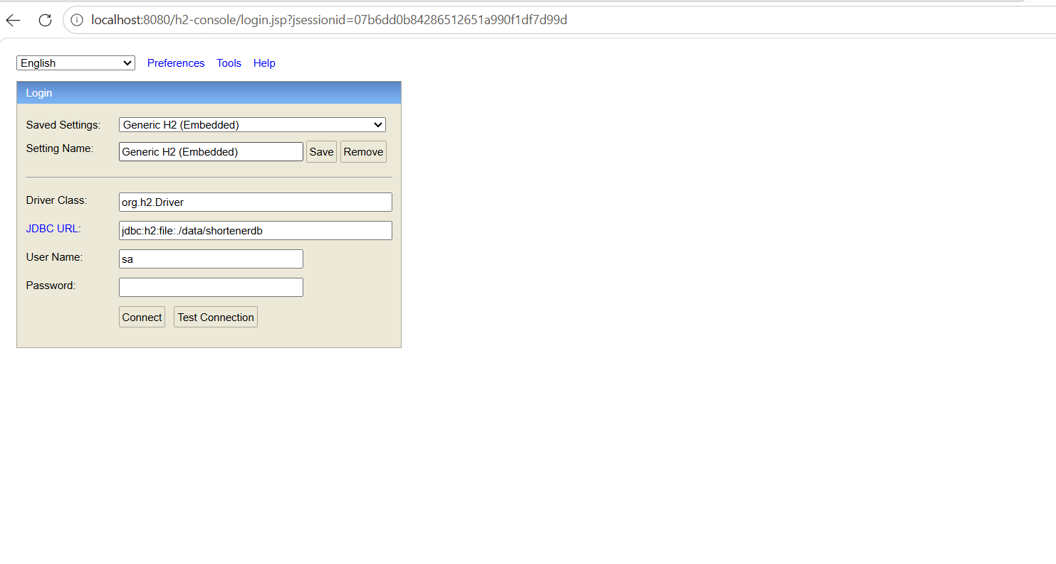

• Add H2 and Spring Data JPA dependencies to pom.xml.
• Configure the database in application.properties.
• Create a Url entity and a UrlRepository.
• Update UrlService to save and retrieve links from the database.
• Test that short links and click counts survive an application restart.

Database version: 2.3.232
Autocommit mode: undefined/unknown
Isolation level: undefined/unknown
Minimum pool size: undefined/unknown
Maximum pool size: undefined/unknown
2026-10-16T21:36:54.291+05:30 INFO 32720 --- [agentic-url-shortener] [ main] o.h.e.t.j.p.i.JtaPlatformInitiator : HHH000489: No JTA platform available (set 'hibernate.transaction.jta.platform' to enable JTA platform integration)
2026-10-16T21:36:54.295+05:30 INFO 32720 --- [agentic-url-shortener] [ main] j.LocalContainerEntityManagerFactoryBean : Initialized JPA EntityManagerFactory for persistence unit 'default'
2026-10-16T21:36:54.350+05:30 WARN 32720 --- [agentic-url-shortener] [ main] JpaBaseConfiguration$JpaWebConfiguration : spring.jpa.open-in-view is enabled by default. Therefore, database queries may be performed during view rendering. Explicitly configure spring.jpa.open-in-view to disable this warning
2026-10-16T21:36:54.690+05:30 INFO 32720 --- [agentic-url-shortener] [ main] o.s.b.a.h2.H2ConsoleAutoConfiguration : H2 console available at '/h2-console'. Database available at 'jdbc:h2:file:./data/shortenerdb'
2026-10-16T21:36:54.772+05:30 INFO 32720 --- [agentic-url-shortener] [ main] o.s.b.w.embedded.tomcat.TomcatWebServer : Tomcat started on port 8080 (http) with context path '/'
2026-10-16T21:36:54.782+05:30 INFO 32720 --- [agentic-url-shortener] [ main] c.e.shortener.ShortenerApplication : Started ShortenerApplication in 3.511 seconds (process running for 3.896)

