2503b05115

Set 5
- Q1. Generate Python code for the Fibonacci sequence with Cursor AI. Refine your prompts to handle only positive integers and record the changes and outcomes.
(Each question carries 5 marks)

Write an iterative Python function named fibonacci that returns the first n Fibonacci numbers.
Prompt:
Code: 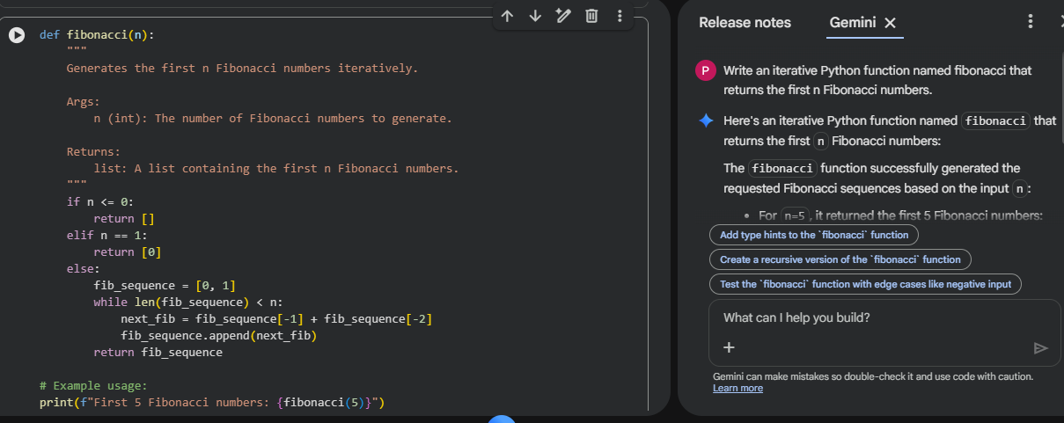
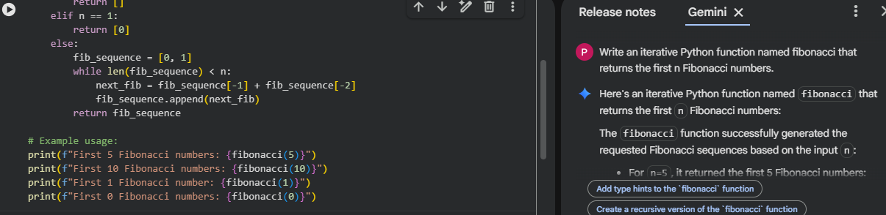
Output:
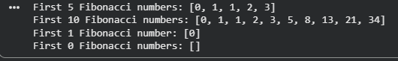

- Q2. Write a Python queue class (`enqueue`, `dequeue`, `peek`). Use an AI assistant and test the class with multiple scenarios. Describe how AI-generated code manages edge cases and how you improved it.
(Each question carries 5 marks)
Prompt: Write a Python Queue class using a list internally. Include the following methods
Code:
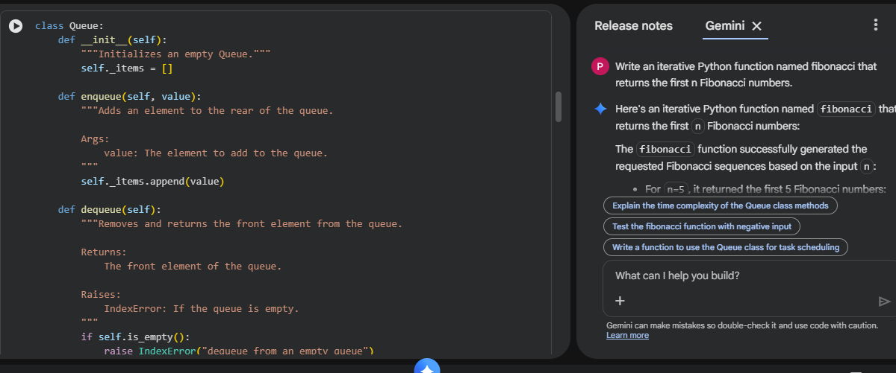
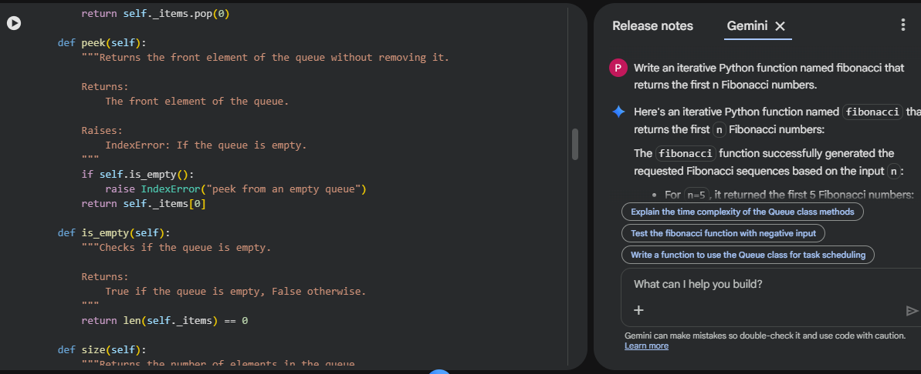
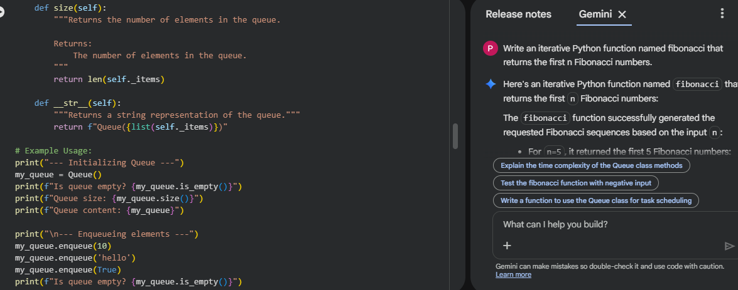
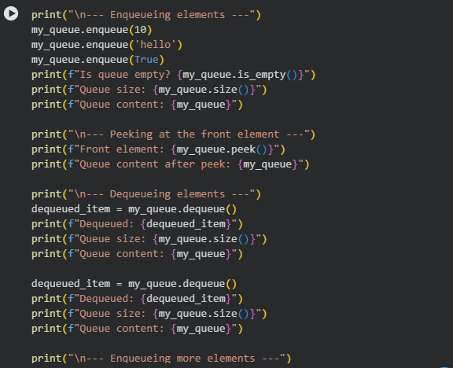
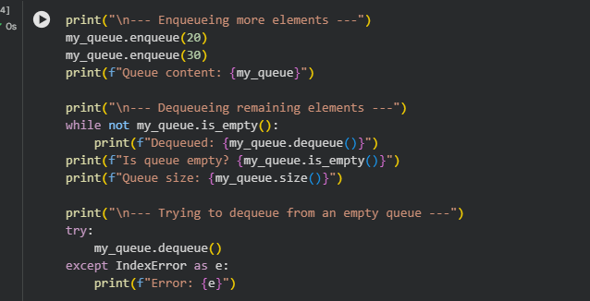

Output:
