|  |  |  |  |  |  |  |  |  |  |  |  |  |
| --- | --- | --- | --- | --- | --- | --- | --- | --- | --- | --- | --- | --- |
| **Fire Incident / Accident Investigation Report.** | | | | | | | | | | | | |
| Name of the Project : **Aparna Sarovar** | | | | | | | | | | | | |
| **Location: L- Block 602 Flat** | | | | | | | | | | | | |
| **Type of Fire Accident** | | | Exposition : | | | | Major Fire **🗸** | | | | Gas : | |
| Ele.ShortCircuit:**🗸** | | | | Combatable Oil | | | | Others | |
| **Date & time: 29-05-2019,20:30 Hrs Around** | | | | | | | | | | | | |
| **Exact Location: Hall** | | | | | | | | | | | | |
| **Name and title of person reporting fire: Ratnakar ( Tenant )** | | | | | | | | | | | | |
| **Alarm/Signal device used:** | | | Fire Alarm | | **🗸** | Detector | | |  | Phone**🗸** | | Yes |
| **Was evacuation of facility necessary:** Yes If yes how may were Evacuated. | | | |  | No | **🗸** | |  |  |  | |  |
| **Were there any deaths?** | | | Yes |  | No **🗸** | | |  |  |  | |  |
| **Were there any injuries?** | | | Yes |  | No | **🗸** | |  |  |  | |  |
| **If yes,how many and describe:** | | | **NA** |  |  |  | |  |  |  | |  |
| **Type of firefighting equipment used to extinguish fire: CO2 & ABC** | | | | | | | | | | | | |
| **Water:** | **Co2 *:*** | | **🗸** |  |  |  | | **ABC/ MDP: 🗸** | | | | |
| **Foam:** | **Water from Hydrant** | | | | | | | **Water from Hose reel drum** | | | | |
| **Class of fire : E** | | | | | | | | | | | | |
| **Class A : Combustible Material** | |  | | **ClassB:Oil&GreaseFires** | | | | | | |  | |
| **Class C : Flammable Gases** | |  | | **Class D : Metal Fires** | | | | | | |  | |
| **Class E : Electrical Fires** | | **🗸** | | **ClassF:CookingOils&fats** | | | | | | |  | |
| **Known or probable cause: Fire incident took place due to Electrical short circuit in AC blower.** | | | | | | | | | | | | |

|  |  |
| --- | --- |
| **Description of the incident:**  Yesterday (29-05-2019) the fire incident has occurred in the AC blower in Hall area at L-602 flat. It happened around 20:30 Hrs, Mrs.Vasantha 65 years old lady Found Some sparks inside the AC unit and she operate the remote and switch of the AC,with in the few seconds she observed fire in the AC unit and she immediately informed to his husband by mobile.  Mr.Suresh L-604 flat resident identified the fire and he informed to main gate security,  Security team received the fire call around 20:35Hrs and Mr.Somesh informed to fire safety staff and they rushed to the location along with his team and started firefighting by using CO2 and ABC fire extinguishers.  Before the fire team attended, security person Mr.ramesh breaks the Floor MCP manual call point and he alert every one regarding incident.  Fire team put off the LPG supply of the flat and electrical person Mr.Kaveen manually put off the 4pole MCB which is in electrical shaft. After that electrical and fire safety staff thoroughly checked the condition of total flat and declared that everything is in under control.  **Fire Safety Team Investigation**  As per our fire safety team investigation the fire incident occurred at L-block 602 flat.  On 03-05-2019 Friday we have receive a complaint from L-602 flat regarding AC,APMS Senior electrician Mr.Babru visited the flat and they observed wrong cable connections and poor cable quality on AC unit given by outside vendor. Immediately he informed to residents regarding wrong connections of AC unit. with the permission of residents and AC technician electrical supervisor correct that connection, but not cables.  In this case the fire incident was happened due to electrical short circuit, the main reason of short circuit is poor quality of cable and overheating of AC unit.  And we suspected the small sparks converted in to big fire, due to copper pipe covering tube and cotton karten near AC unit also one of the major reason in this case.  After controlled the fire with Fire extinguishers fire sprinkler was activated automatically and sprinkle the water.  It was noticed that flat ELCB and incoming and outgoing 20Amps MCB also tripped due to electrical short circuit at the time of the fire and if it was isolated fire may spread to the entire flat by electrical internal cabling.  **Suspected Reasons for incident and key observations**   1. We observed no stabilizer was installed for AC unit 2. No maintenance of AC since last few years 3. Used Poor Quality of Cable and joints. 4. Based on residents complaints we suspected that was Faulty AC unit 5. On 01-05-2019 to till residents raised 04 no of complaints for AC in his flat. 6. On 26-05-2019 resident raised a complaint on his AC unit frequently tripped for every 01:30Mnts 7. AC Installed by Incompetent technician   **Used Fire System :**   1. Manual Call Point (MCP) 2. Fire Extinguisher CO2 =03 nos 3. Fire Extinguisher ABC =01 nos   **Sequence of incident**  Fire observed around 20:30Hrs  First information given to Main gate around 20:35 Hrs  Main Gate to L-Block Maintenance office around 20:37 Hrs  MCP activated around 20:38 Hrs  Fire Controlled time around 20:45 Hrs  Sprinkler activated inside the flat around 20:45Hrs. | |
| **Cause of fire :**upon initial examination fire incident took place due to Electrical short circuit | |
| What steps have been taken by the facility to prevent reoccurrence:   1. Periodical inspections of all AC Blower and outdoor units and electrical appliances to be carried by authorized personnel. 2. More residents need to be participated in fire/evacuation drills to know what to do in case of fire and short circuit, how to activate the fire alarm, how to deal with fire accident and how to evacuate. | |
| Describe the local fire department participation:  Local Fire Services were not alerted because the APMS Security team has controlled the fire. | |
| **Conclusion:**   1. By citing this incident as a case study we may motivate more residents to participate in the fire drills in large number | |
| **Name K.Prabhakar** | **Signature : K.Prabhakar** |
| **Title :Sr.Fire Safety Officer** | **Date of the report: 30-05-2019** |

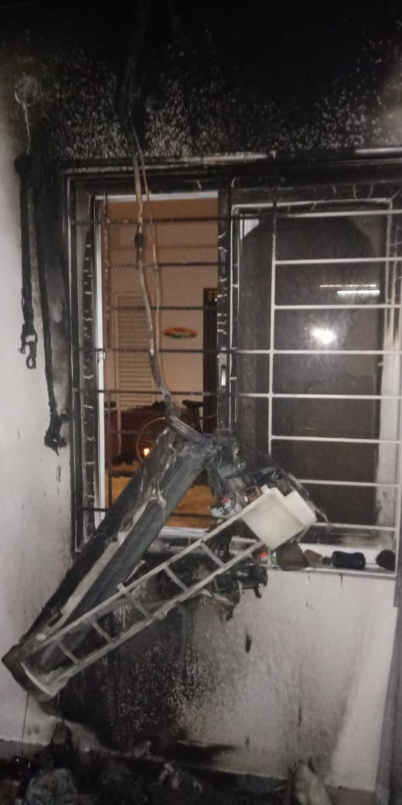 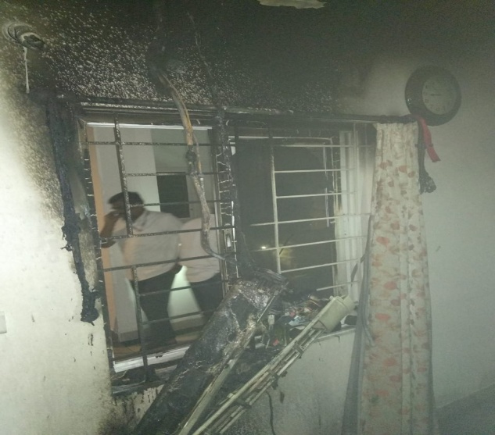

Complaint Log Details

|  |  |  |  |  |  |  |  |
| --- | --- | --- | --- | --- | --- | --- | --- |
| **Son** | **Date** | **Given By** | **Description** | **login time** | **attended Time** | **Attended By** | **Remarks** |
| 1 | 01.05.2019 | Resident | AC routing explanation | 12:30 | 13:00 | Amith | 1. Complaint recorded in log book not in APNA complex due to Helpdesk person week off 2. Complaint not resolved 3. Electrical supervisor (Babru) & Electrician(Amith) visited the flat again at 13:10 for AC routing purpose 4. After that AC installation was completed by outside vendor |
| 2 | 02.05.2019 | Resident | AC complaint | 10:00 | - | - | 1. Resident only Preferring electrical supervisor(Babru) but same day his taken PH 2. Complaint recorded in log book not in APNA complex |
| 3 | 03.05.2019 | Resident | AC complaint | 11:25 | 11:40 | 1. Babru 2. Ravi | 1.In front of AC technician Electrical superviosr identified AC power supply connection wrongly given by vendor 2.In front of AC technician connections are correctly given by electrical supervisor,at that time supervisor suggested to resident regarding cable quality(Cable quality is not good, it will be not standble for long time) 3. Complaint recorded in log book not in APNA complex |
| 4 | 26.05.2019 | Resident | AC complaint | 14:50 | 16:00 | Ravi | 1. Attended by Ravi, at that time resident said every 1:30 hrs AC was tripping frequently and resident turned on multiple times.Electrican suggested to contact AC techniian immediately |