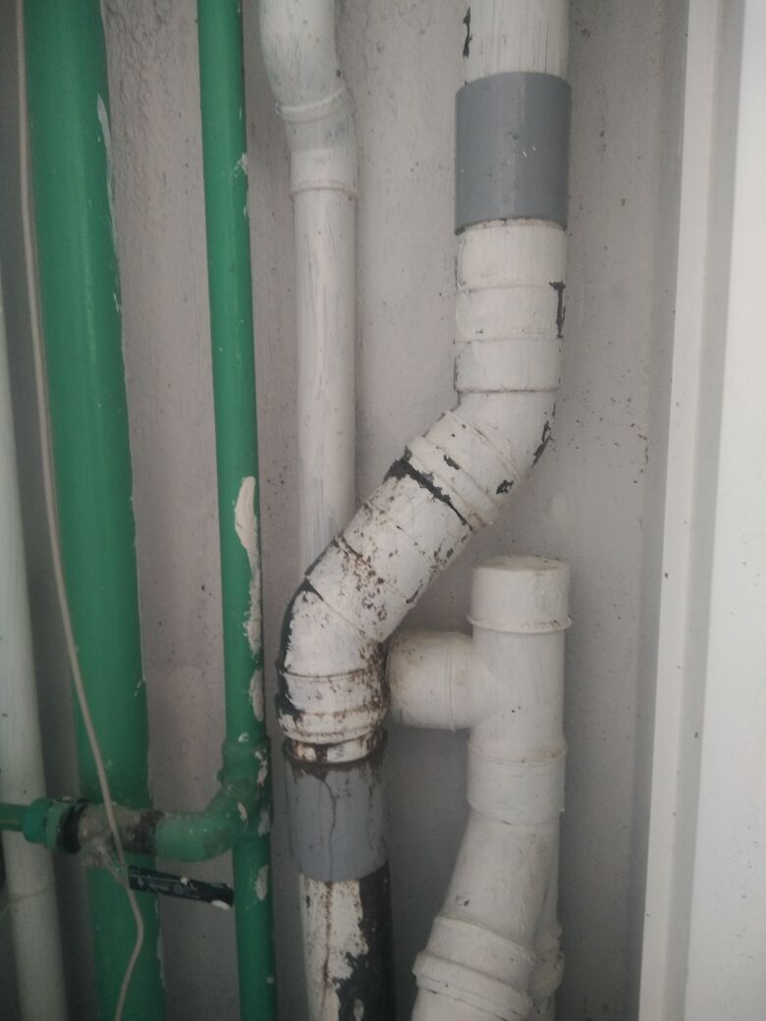

**45˚PVC bend**

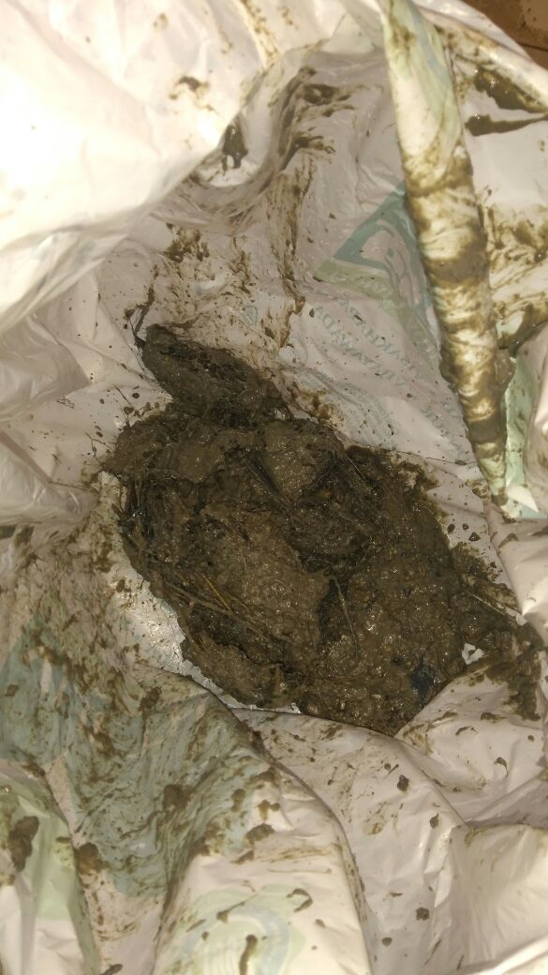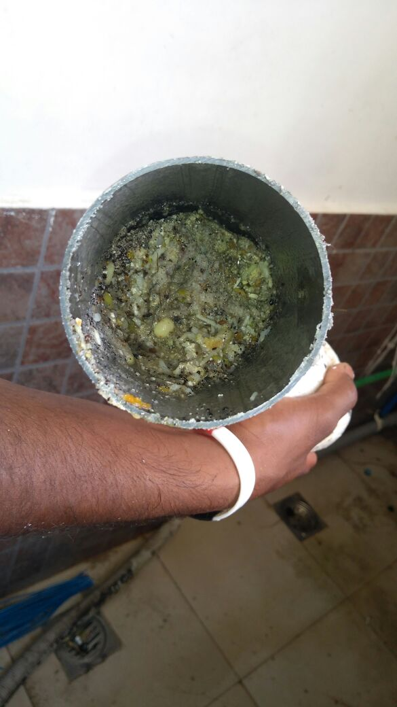

*Incident Report*

**Site Name:** Sarovar Grande

**Date & Time:** 13.04.2018; 1030 Hrs.

**Block & Flat No**: B-403

**Location/Area:** kitchen Utility / Floor Trap

**Subject:** Reverse flow of Waste water thru Kitchen Utility Floor Trap

**Report:** The tenant of the flat had reported about water flooding inside the flat and logging about 2inch in 2 bed rooms, kitchen, living, dinning.

**Action Taken:** Immediately inform above flats occupants over phone not to use the kitchen utility and team rushed to the shaft and cellar areas to check the blockage in the pipe line. APMS housekeeping team cleaned / sanitised entire flat with chemicals. Upon requesting HK team cleaned the flat for next three days to glee the resident.

**Damages claimed by the Resident / Owner**: Wooden scatting of TV rack and cupboard and dish washer, AC indoor unit which were not operated for long time.

**Customer Care Support:** Mr.Narsingh visited the flat immediately and discussed with tenant and owner and appraised the unfortunate situation once again and assured to extend support thru projects and APMS to fix wooden flooring and few petty expectations by the tenant.

**Findings:** No blockage found in the horizontal line where 75mm dia vertical waste line joins to 100 and further into 160mm dia. Finally blockage was found in 75mm dia vertical line between 45 degrees bend near Flat-303 shaft.

**Root Cause:** Blockage of wood waste blended with human hair in the 75mm dia vertical line where direction altered to accommodate 3rd, 2nd, 1st floor waste lines.

**Preventive Action Plan:** Considering the root cause, cleaning of vertical lines between the bends as shown in below image to be included in PPM schedule. Clean out trap to be provided. Also indenting a portable pressure jet machine and spring rope equipment.