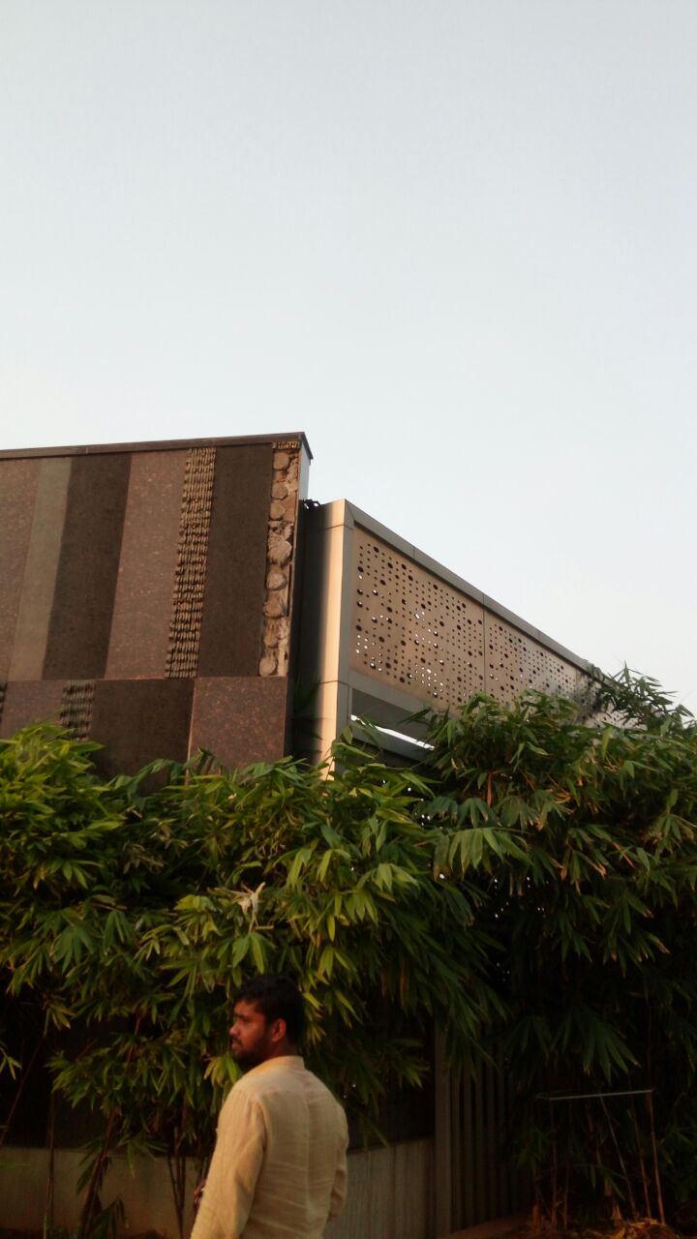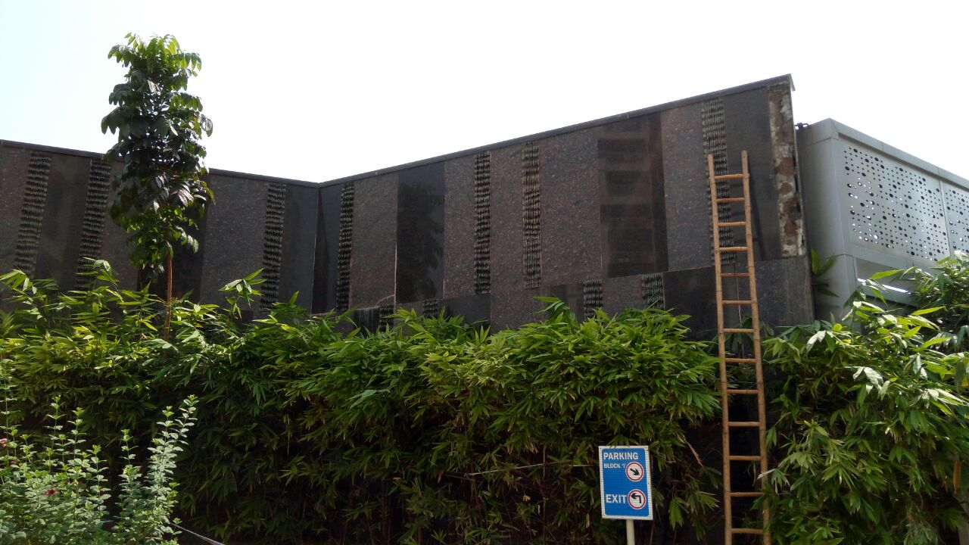

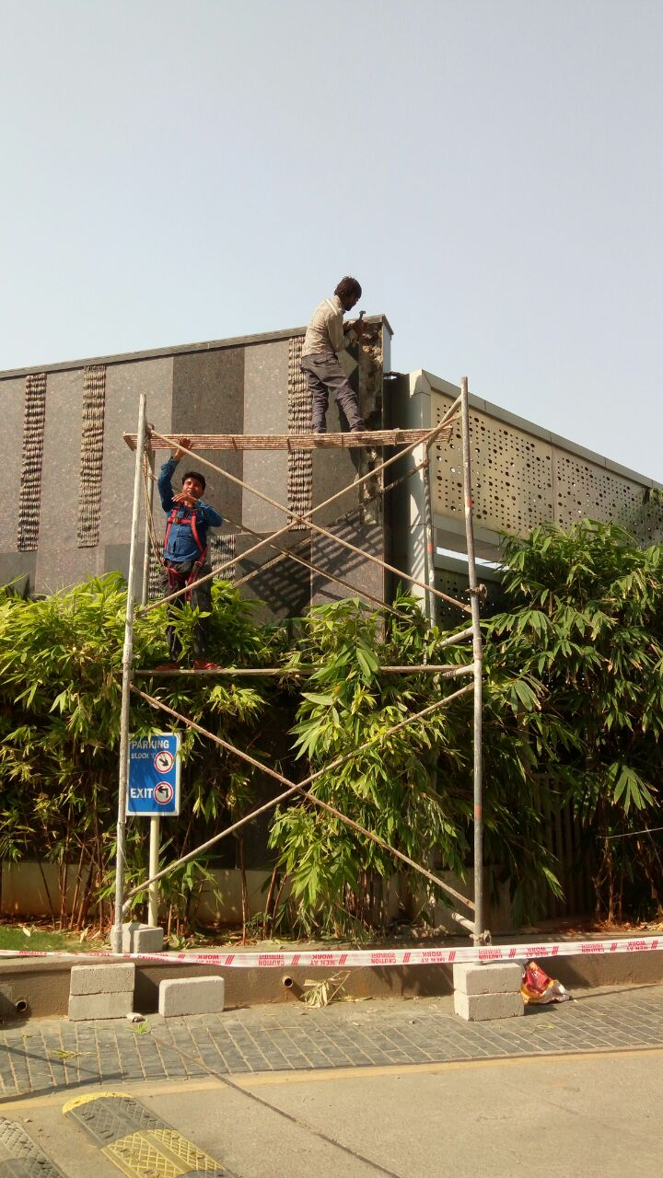

*Near miss Incident Report*

**Site Name:** Sarovar Grande

**Date & Time:** 25.05.2018; 1800 Hrs.

**Location/Area:** Main gate exit

**Subject:** Wall cladding granite fell down

**Report:** Wall cladding granite suddenly fell down at 6:00 pm at that time residents walking. One of the boy cycling just near miss the incident.

**Action Taken:** Immediately we informed the project in charge Mr Praveen Kumar garu, sir responding immediately and attended grande next day with contractor.

**Customer Care Support:** Not required

**Findings:** Cladding granite air gaps.

**Root Cause:** Cladding granite air gaps. Due heavy heat and rains some cracks formed in granite.

**Preventive Action Plan:** Considering the root cause, and instruct to contractor for checking of all cladding granites and remove top sheets and filled properly with cement slurry.