 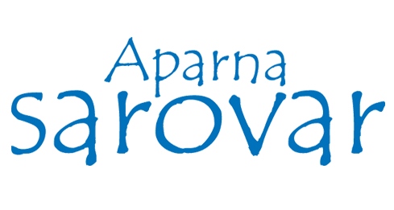

**VESSEL/CONFINED SPACE ENTRY WORK PERMIT**

Sl.No: _____________ Date:

Equipment name & Code No: Exact location

Description of work to be done:

Permit issued at ________Hrs permit valid up to: Hrs

|  |  |  |  |  |  |
| --- | --- | --- | --- | --- | --- |
| **Sl .No** | **Precautions** | **Yes / NA** | **Sl. No** | **Precautions** | **Yes / NA** |
| 1    2      3  4 | Sump is examined for oxygen percentage(% O2:__________)  Sump properly ventilated, adequately illuminated and temperature checked.  sump is examined for toxic vapors and poisonous gases  Post the rescue man |  | 5    6  7 | Area is barricaded and danger board display.  Ensure good house keeping  Ensure tools and PPE condition such as air mask, gloves, ladder, belt etc… are good. |  |

We have personally checked and satisfied ourselves that, the above particulars are correct and it is safe to do the work.

.

Date: Time: Hrs. Name & Signature of the Site In charge: ________________

Date: Time: Hrs. Name & Signature of the Mechanical Engineer: _____________

Date: Time: Hrs. Name & Signature of the Safety In charge: ______________