**Apartment Management Monsoon Maintenance – How to Clean the Swimming Pool**

It goes without saying that a beautiful property with a well maintained swimming pool is always a delight to witness. However, proper thought and care should be put in when it comes to maintaining a swimming pool, especially during the monsoon.

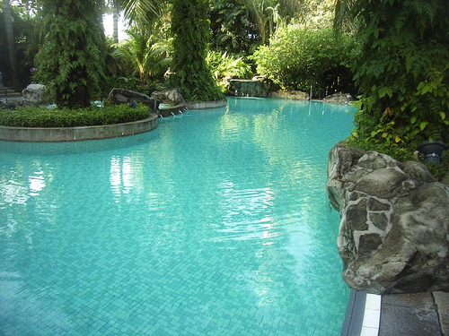

**Why Monsoon Maintenance is Essential**

A swimming pool in a housing society needs to be maintained throughout the year and this can be done changing the water regularly and adding the right sanitizers that are eco-friendly.

This is truer during the monsoon season as there’s a greater chance of moss growing on the slabs around the pool during this time. This can be mainly attributed to the moist weather and the ever damp surface around the pool.

During the monsoon, the pH levels of the water in the pool need to be maintained as the rains can play havoc and affect the pH value by introducing dirty and contaminated water. An imbalance in the chemical composition of the pool water may rise during the rains.

Acid rains can especially be quite dangerous as harmful and toxic substances from the atmosphere may get mixed with the pool water due to such rain. The rains will also bring along a lot of organic materials and pollen that will get accumulated in the pool. Within hours of the first shower of the monsoon, a significant variation in the pool water’s pH level will be easily noticeable.

**Maintaining the Pool During the Monsoon**

The swimming pool can be maintained well if the right filtration systems or chemical treatment programs are adopted and implemented.

* **Brushing the Pool Walls**

Brushing the floor and walls of the pool helps in eliminating the wild shrubs that grow within. Metal rakes can be used in order to remove any fungal or mossy growth on the tiles that surround the swimming pool. You should hose down the mossy spot once you remove the plants using the rake.

* **Regular Chlorination**

Adding chlorine to the pool water through specially designed chlorine tablets will help in preventing the growth of algae. Routine chlorination should be done as it helps in preventing health hazards like ear infections, Legionnaires Disease, gastroenteritis and athlete’s foot, which are quite prevalent among people who frequent unclean water bodies.

* **Using Algaecides**

An algaecide will also be effective in clearing algae from the pool. You can try using both ammonia as well as metal based algaecides. Ammonia based varieties are more effective and can be used to clean the pool in a stain-free way.

During the rains, the water in the pool tends to get discoloured; so it is important to treat it with ammonia based algaecides to prevent further discoloration. Generally, balancers, stabilisers and shocks are used for pool cleaning.

* **Using Pool Filters**

A filter should be attached to the pool and the water should be cleaned on a daily basis during the rains so that the debris and dirt can be completely cleared. Also, it helps in circulating the fresh water well. The filter also needs to be cleaned regularly by the maintenance personnel and dead algae should be removed, as it will solve no purpose otherwise.

An unclean pool can be dangerous to swimmers and the filtering system as well. It can cause eye irritation or skin problems in swimmers. You can help the apartment maintenance crew with cleaning the pool or simply carry out the steps yourself with other residents.

**Housing Society Knowhow – Rain Water Harvesting Guidelines in Hyderabad**

Infrastructure management in any two cities is never the same, and Rain Water Harvesting (RWH) is one such measure that has different guidelines in every city. The RWH guidelines in Hyderabad are understandably entirely different from those in Bangalore.

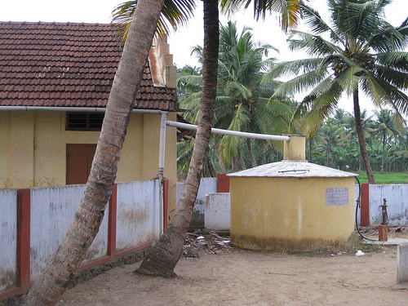

To understand the guidelines better, you’ll need to grow familiar the concept of rain water harvesting and the reasons behind the same.

**Why Rain Water Harvesting?**

Rain water is one of the purest forms of water that is majorly deemed fit for human consumption and use worldwide. Gathering rain water and using the same can help in tackling the demand for fresh water and the practice can also help in preventing floods. Some advantages of rain water harvesting include:

This process will help in recharging water aquifers

* The quality of ground water can be significantly improved
* Soil erosion can be reduced when excess rain water is tapped and stored
* Water logging can be prevented and this will help in negating mosquito related problems
* Water shortage issues that crop up in cities like Hyderabad during the summer can be tackled
* Power consumption can be reduced as the process of pumping water can be made rare

**RWH Guidelines in Hyderabad City**

Guidelines for rain water harvesting were enforced in Hyderabad in the year 2001.

* The owner or occupier of a particular building, which stands on an area of more than 300 square meters, should install a rainwater investing system.
* It is mandatory to install RWH systems in commercial complexes and housing societies.
* Trenches and percolation pits should be installed around every building in Hyderabad these can have a dimension of 1.2 x 1.2 x 2.5 meters. The trenches can have a depth of 2 meters, a width of 0.6 meters and a length of around 2 to 6 meters.
* Terrace water can be sent directly to these trenches and pits, and they need to mandatorily have filter materials. A brick wall should be constructed near these trenches and pits, with an ideal depth so that loose soil does not mix with the rain water that’s collected.
* Concrete slabs that are well perforated should be provided over these trenches and pits. Fine sand and coarse sand should be used in two layers in these trenches and pits.
* PVC pipes can be used to connect the terrace to the sump so that the rain water that’s collected can be channeled down to the sump.
* Rain water harvesting experts should be consulted to build a value system, which will directly discharge the first batch of rain water that’s collected (as it is bound to be dirty due to its interaction with dust on the terrace floor). The secondary batches will them be stored in the sump.
* Filtering tanks need to be constructed near the sumps in order to purify the water, and these should have two layers – one layer of coarse sand and another layer of fine sand. This filtering tank should have a dimension of 1 x 1 x 1 meters. The tank should have a sloping base so that water doesn’t get accumulated by any chance.

You can check if the rain water harvesting system in your housing society follows these guidelines and bring up any missing features during resident meetings.

**Apartment Association Security Tips – What to expect from an Apartment Security Agency?**

Every Apartment Owners Association has a permanent headache: The Right Apartment Security Agency.

Finding the  right apartment security agency for your community is very important, as proper security is one of the primary concerns that people look into, when moving into an apartment complex. Apartments are relatively safe to live in, as people reside well within accessible distances from each other, but adequate security measures should always be taken in order to avoid any slip ups or mishaps.

There are many facets involved in filtering out the best apartment security agency, and these are quite easy to follow and implement. Once you properly list out and analyze your expectations from an apartment security agency, you will well be on your way to finding the right one.

**Looking for a security agency to gaurd your apartment complex?**  
Check out [supplier database](http://www.apnacomplex.com/suppliers/) from ApnaComplex and request for quotations from multiple security agencies at the click of a button.

#1- Proper Background Check

Every Apartment Association must think of the security guard as an extended member of the apartment community. Wouldn’t you like to trust your security with someone who is well qualified, with all the necessary credentials?

This is why an apartment owner’s association needs to do a routine and comprehensive background check on every applicant. While contracting security guards, make sure you keep an eye out for off duty policemen, because they’ll have a lot of experience in the field. It is important to have security guards on the rolls, who have prior experience doing night duty, patrolling and log maintenance.

Go through their profiles; see the amount of experience they have garnered over the years, see how adept they are at tackling tricky situations and hire them based on all these points. You can ask the security agency to do this for you, but you’ll need to follow up with them regularly. If the agency does not have these profiles or make them available to the Apartment Association, then it is definitely advisable to move to the next agency.

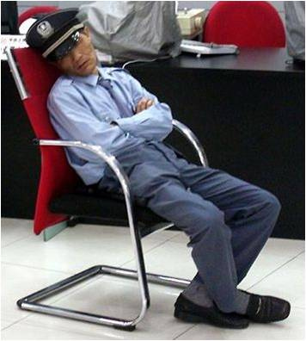

Who you should not hire!

#2 – The Importance Of Effective Equipment

An apartment security agency will provide all guards with a pager, but this will hardly be effective in helping the guard take immediate action.

You’ll need to include a section in the contract demanding that all guards from the agency should be properly equipped with radios, cell phones, flashlights, notebooks, pens (tactical or combat ones) and vehicles. Providing the security guard with a list of emergency contacts and a phone line will also prove useful. Dress code and attire/uniform is also extremely important. Security guards need to have an aura of confidence and authority, and shabby people do not exude that, however big their moustaches may be.

This will make things a lot easier for the guard supervisor in an emergency situation, but increase confidence and bring relief to the welfare association and the residential community as well.



Ex-policemen make great apartment guards!

#3 – Maintaining A Log

Asking your guard to maintain a log of his activities is a very good way of keeping track of your guard’s productivity. This should be properly and clearly mentioned in the contract as mandatory.

Anyone can maintain a log in a generic way, writing abrupt entries like:

“10 PM to 11 PM – Roads are clean. No sign of trouble.”

This should be avoided as far as possible. Entries like these will hardly help you keep track of what your guard’s been up to. Mention in the contract that the entries in a log should be more detailed. A sample would be:

10 PM: Checked the south-side gate, generator room, swimming pool entrance and toilets. All locks intact.

10.10 PM: A black Maruti, Number plate: XYZ has been allowed into the complex, heading up towards Block C. Signed an entry to meet Mr. Kishore, apartment no. 392. Sent two security personnel to escort him to Mr. Kishore’s apartment. Awaiting response and confirmation from guards via walkie talkie from Apartment 392, C Block.

Entries likes these will help during a post mortem analysis too, if there’s been a problem and all instances and clues need to be brought onboard.

#4 – Contract Issues

Apart from the above mentioned clauses in the contract, you will need to make sure that through the contract, the guard or the agency should be held responsible for any losses that occur due to negligence on his/their part. This will provide you with indemnity, and will make the guard take his role even more seriously. This will also increase the commitment of the agency involved.

Certain contracts may also have an indemnity clause that works in the favour of the security agency, so every apartment association keep an eye out for such lines.

Good security guards are a necessity for any apartment complex that touts of being a safe haven for its residents. Get the insights of every person from your apartment association while framing certain clauses of your contract, and once an agency has been selected, open all channels of communication between the residents and the guards in order to make things smoother and easier for both parties.

**How to calculate Maintenance Charges for your Apartment Association? OR How to share Common Expenses in a Housing Society?**

A seemingly simple but complex issue in every apartment association is on how to arrive at the maintenance charges to be levied on the members. The issue is complex enough that it is impossible to please all the members with a single way of calculating the maintenance charges.

As discussed in the “[Popular methods of calculating Maintenance charges](http://blog.apnacomplex.com/2010/07/20/popular-methods-of-calculating-maintenance-charges-in-apartment-complexes/)” – societies have option of charging Per Square Feet (PSF) or Per Flat (PF) basis. While the regulations in most states is not very clear (or not enforced with necessary rigor), the model bye-laws of Maharashtra state provide a relatively clear answer to this debate. The answer at a high level is simple – follow a combination of per sft and per flat for various heads.

The same can be adopted by societies of all states (as most model bye-laws are derived works of the model bye-laws from Maharashtra State).

Types of Charges

There are quite a few types of charges that can be levied on members. The periodicity of levying these charges can be decided by the General Body of the Association. Usually charges like ‘Sinking Fund’ will be levied once in an year – and Maintenance Dues will be charged once in a month. Brief explanation of various charges is given below.

Service Charges (a.k.a Maintenance Charges in most societies)

This charge needs to be levied on per flat basis. This charge needs to be levied based on the expenses incurred by the society towards procurement of services. This includes all Staff Salaries (including society office staff, maintenance staff, security staff, housekeeping staff, technical staff etc.), Administration Expenses (internet, telephone, printing, stationary etc.), Auditor Expenses, Common Area Electricity Bill (excluding bill for Lift operations), Conveyance / Travel Expenses, Legal Expenses, Membership to local federations / bodies etc.

Expenses on repairs and maintenance of building of Society

These charges may be decided by General Body subject to minimum 0.75 percent (0.75%) of the cost of construction of flat/shop per annum. For example, if the construction cost is Rs. 1200/- per sft, this charge will be Rs. 9,000/- per annum for a 1000 sft flat. This is calculated on per sft basis and can be levied once in a year. This excludes Lift related repair & maintenance.

Expenses for lift repair, maintenance and for running the lift

This charge should be based on expenses incurred for Lift Repair, Lift Maintenance and Running of Lift, including Electricity Charges for Lift oeprations. This needs to be charged equally on all Members of the building where in lift is provided.

Sinking Fund (a.k.a Corpus Fund)

The exact amount may be decided by General Body subject to minimum of 0.25% of the cost of construction of flat per annum. This is calculated on per sft basis and can be levied once in a year. This is to be collected if the builder has not collected this amount at the time of selling the flats and handed over the corpus to the association.

Parking Charges

This charge is to be levied based on number of parking lots in a flat. The fee per parking lot may be as decided by General Body of the Society.

Property Tax

This is applicable only in states where societies are authorized to collect property tax on behalf of Govt. The tax to be collected is determined by the state.

Water charges

This charge is to be levied based on number of water inlets into a flat. The fee per water inlet may be as decided by General Body of the Society. In modern apartments / layouts, this charge can be calculated based on the reading from the water meters that measure consumption of the water by a flat.

Interest on defaulted Charges

This is the late payment penalty. The penalty scheme / amount is as decided by General Body. Most common practice is to levy simple interest not exceeding 21% p.a. But General body can decide a different way of calculating late payment fees that works best for them.

Non Occupancy Charges (NOC)

This is an additional charge on flats that are rented out. As per the law, this charge cannot exceed 10% of the Maintenance / Service Charges levied. You can refer to [this article](http://www.scribd.com/doc/200395/Non-Occupancy-Charges) to get more details. The NOC cannot be charged if the licensee(tenant) is family member(Family Members includes husband, wife, father, mother, brother, sister, son, daughter, son in law, daughter in law, sister in law, brother in law, grandson and granddaughter).

Insurance Charges

The expenses spent on insurance of the building and equipment can be levied on the members in proportion to built up area of their flats. Extra premium charged by insurance on account of storage of specified goods in flat/shop should be collected from those flats/ shops whose storage of specific goods was the reason for extra premium.

Lease Rent

This is levied based on per sft for the builtup area of the flat/shop.

Any other charges

As decided by General Body from time to time.

Following is a table indicating a comprehensive list of charges that can be levied by the Society / Apartment Association on the members. All charges levied must be derived from the expenses of the society. The table also indicates the correct way of arriving at these charges from the expenses and if they need to levied on per sft basis or per flat basis – as recommended by Model Bye Laws.

[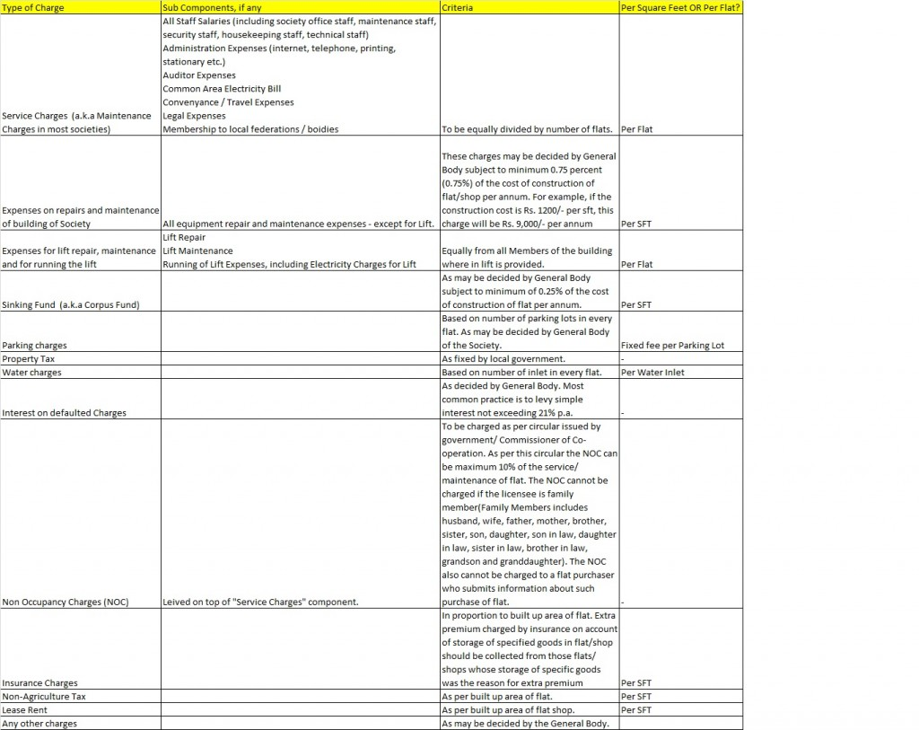](http://blog.apnacomplex.com/wp-content/uploads/2011/08/How-to-Calculate-Maintenance-Charges.jpg)

Conclusion

The article provides a framework for arriving at dues to be levied that is fair to all its members. A Housing Society that is ‘well managed’ needs to avoid taking the easy way out – by charging per flat or per sft basis. This is especially true for societies where there is no uniformity in size of the flats. Though at a first glance, it looks like there is much work and many heads for the amounts to be charged to adopt this, it is not really so. Once you get started you realize that its not as difficult as it appears. If you are new society, you can put this in practice right from day one. if you are an old society, but not following this model – its n

# Conserving Water In A Housing Society – Tips For Every Household – Housing Society

[Facebook](http://blog.apnacomplex.com/#facebook)[Twitter](http://blog.apnacomplex.com/#twitter)[Google+](http://blog.apnacomplex.com/#google_plus)[LinkedIn](http://blog.apnacomplex.com/#linkedin)[WhatsApp](http://blog.apnacomplex.com/#whatsapp)[Reddit](http://blog.apnacomplex.com/#reddit)[Share0](https://www.addtoany.com/share#url=http%3A%2F%2Fblog.apnacomplex.com%2F2011%2F07%2F06%2Fconserving-water-in-a-housing-society-tips-for-every-household-housing-society%2F&title=Conserving%20Water%20In%20A%20Housing%20Society%20%E2%80%93%20Tips%20For%20Every%20Household%20%E2%80%93%20Housing%20Society)

Water is a precious resource and the world over; it is also a dwindling resource – even in a housing society. Increasing human population is piling a huge demand on the overall water resources, and reservoirs are drying up and water tables are correspondingly going down. Housing societies everywhere are looking for ways to conserve water usage and replenish water reserves.

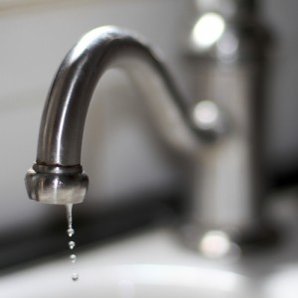  
There are several ways through which the residents in your housing society can conserve water:

* **Leaky Faucets** – Check for leaking taps. The eternally dripping water can slowly add up to gallons of waste water in a short time. Fix all leaks immediately after pointing them out.
* **Flush Tank Leaks** – Check to see if your toilet tank leaks water. If you suspect a leak but cannot be sure, add some coloring to the water in the tank. If the water in the toilet bowl colors up without the flush being used, it means you have a leak. Fix the leak as soon as you can.
* **Displace Water in Flush Tanks** – If you have a flush tank that takes in a lot of water, you can cut down on that extra water. Fill a water bottle with sand and put it inside the tank. This displaces the water in the tank, and the tank takes less water to fill up. Don’t displace too much water. Insufficient water won’t clear the toilet in one flush and will result in people doing multiple flushes.
* **Install New Flush Tanks** – Low flush or controlled flush systems can help you conserve a lot of water as the flush can be controlled throughout.
* **No Bathtubs** – Filling a bathtub takes a lot of water. So avoid using bathtubs and use showers instead. These are better and will keep you free of sweat.
* **Restrict Water Flow in Showers** – Use low flow shower heads or install flow restrictors in your showers. This way you can cut down the water flow through your showers.
* **Take Short Showers** – Do not take long baths. When you are soaping up, turn off the shower. Turn it on only when you need to wash off the soap. Letting the water run throughout can waste a lot of water.
* **Prevent Clogging of Water Pipes** – Salt content in water can quickly clog your water pipes. Your housing society should consider installing desalination or water softening systems to ensure clear water gets pumped through the water pipes.

**How can this help conserve water?**  
When water flows out slowly from taps, people have a tendency to leave it running for longer. Also, they leave it on to fill buckets with water, and then might forget to turn it off. In these and other ways, water pipe clogging may result in water wastage. Steady, smooth flow of water through pipes and taps ensure more efficient usage.

* **Don’t Leave Water Running** – When you are brushing your teeth or shaving, close the tap. Turn it on only when you need to clean the brush or the razor. Use a glass of water to rinse your mouth, instead of keeping the water running. Teach children to turn off water taps properly.
* **Washing Machines** – Use your washing machine only when it is on full load. Using the machine when it’s on half load can result in a lot of water wastage.
* **Washing Dishes** – When you are washing dishes, do not keep the water running. Turn the tap on only when you need to rinse the dishes.
* **Recycling –** Try installing water recycling systems. Recycle non-toilet water for use in non potable purposes – like flush tanks, car wash, watering the garden etc.
* **Rain Water Harvesting** – You housing society can harvest rain water by collecting it in overhead filter tanks, or by redirecting the rain water to the ground to replenish water beds.
* **Avoid Hoses –** Use a broom to clean your front porch or yard and don’t hose it clean. If you must use water to clean it, fill a bucket with water and sprinkle it, then sweep it. Use soap and sponge to clean your car.
* **Watering Your Garden –** Water your lawn and plants during early morning or at dusk. This decreases evaporation, and gives the plans more time to absorb the water.

Your housing society can get people to practice simple water saving techniques to conserve water. Recycling water and rain water harvesting systems are another way for a housing society to combat water shortage. If all these measures are practiced, you can help reduce the strain on water resources and help replenish them.

**How to Operate and Maintain Water Treatment Plant Efficiently – Easy Guide to Apartment Associations**

[Facebook](http://blog.apnacomplex.com/#facebook)[Twitter](http://blog.apnacomplex.com/#twitter)[Google+](http://blog.apnacomplex.com/#google_plus)[LinkedIn](http://blog.apnacomplex.com/#linkedin)[WhatsApp](http://blog.apnacomplex.com/#whatsapp)[Reddit](http://blog.apnacomplex.com/#reddit)[Share9](https://www.addtoany.com/share#url=http%3A%2F%2Fblog.apnacomplex.com%2F2011%2F05%2F07%2Fhow-to-operate-and-maintain-water-treatment-plant-efficiently-easy-guide-to-apartment-associations%2F&title=How%20to%20Operate%20and%20Maintain%20Water%20Treatment%20Plant%20Efficiently%20%E2%80%93%20Easy%20Guide%20to%20Apartment%20Associations)

Most Apartment Associations and Housing Societies are run by volunteers and most of them do not have necessary technical background that is necessary to ensure proper maintenance of the critical assets like Water Treatment Plants, RO Water Plants, DG Sets etc. Typically the operations and maintenance of these assets are outsourced by the managing committee with a hope that the agencies maintain them professionally. More often that not, no one in the managing committee is even aware how to check if the assets are being maintained and operated properly. Due to this, associations typically end up with sudden huge expenses towards the repair/re-installation of these assets.

In an attempt to help all housing societies and apartment associations, [ApnaComplex](http://www.apnacomplex.com/" \o "Apartment Management, Accounting and Communication Software" \t "_blank), with the help of Mr. Ranganathan – Water Management Consultant, presents below an guide / checklists on Water Treatment Plants Operation and Maintenance.

Why Water Treatment Plant?

Today water used in apartment complexes and gated communities is obtained partly from bore wells or from tanker water suppliers. Invariably, the water has a total mineral content higher than the “desirable” value specified in BIS-10500 which is the official Indian standard for water used for human consumption. A high mineral content means that the total hardness of the water will also be high and cause problems like scaling of hot water geysers, choking of pipes, poor quality of washing in machines etc. This is often taken care of by installing a water softening plant (also called as Water Treatment Plant). Refer our other article on “[Water Treatment in times of Water Scarcity](http://blog.apnacomplex.com/2011/04/02/water-treatment-in-times-of-water-scarcity-need-for-better-operation-and-maintenance-of-water-treatment-plants-in-your-housing-society/)” to know more about the importance of Water Treatment Plants

How does a Water Softener Plant work?

A water softener plant comprises a pressure vessel made of either mild steel or fiberglass composite. It contains a bed of ion exchanger( normally called resin) which softens water. The pressure vessel is fitted with external piping fitted with valves. The softener plant is also provided with a tank in which a specified quantity of salt is filled in and water allowed in by means of the valve provided for this purpose. The water dissolves the salt to make a solution of brine (this is what a salt solution is called).

The resin bed inside is capable of removing hardness from the hard water passing through it . The quantity of water thus softened depends entirely on the hardness of the water and the capacity of the resin. When the capacity of the resin to soften water is exhausted, it has to be regenerated by injecting a solution of salt solution (brine) into it to prepare the resin to soften more water. The manufacturer of the softener is normally supposed to provide a detailed Operation & Maintenance manual which gives detailed instructions on how to operate the unit and regenerate it.

This manual indicates the total capacity of the softener to soften water before it is exhausted (this capacity is called Output Between Regenerations or OBR). The manual also indicates how many kilos of salt are to be filled in to the salt tank to prepare brine for one re-generation. It gives detailed instructions on how to operate the valves on the unit to inject brine into the softener, rinse off the excess brine and then prepare it to produce soft water for another cycle of operation.

**Every softener plant must have a water meter fitted at the inlet so that the quantity of water softened can be monitored.** The water meter also helps in measuring the water used for regeneration since this water goes to drain and usually ends up in the STP (Sewage Treatment Plant). Every softener operator must have a hardness testing kit so that he will know when the softener is producing soft water and when it is exhausted.

Following two procedures must be followed by Operators for proper Operation of Water Treatment Plant. In most associations, the operations are outsourced to an agency, even then it is imperative that Managing Committee members verify the log books and the hardness reports once every fifteen days to ensure the softener plant is operating properly.

Procedure for regeneration of an exhausted softener

1. Make a note of the water meter reading in the log book.
2. Start backwash if the softener manual calls for it. Carry out backwash for the specified duration.
3. Inject the salt solution(brine) into the softener.
4. When brine injection is over, start the process of rinse to remove all the excess brine.
5. When end of rinse is approaching, take a sample of rinse water and test for hardness.
6. If the hardness is within the figure specified in the manual, usually about 10.00 ppm., stop rinse and open soft water outlet valve and make a note of the water meter reading.

How to know when to Re-generate

1. When water meter reading shows that softener has treated almost the quantity as per OBR, take a sample of soft water and test it using the test kit. It is critical to note that with out a proper log book and Water Meter, it is not possible to accurately know the amount of water treated since last regeneration.
2. If the hardness is higher than 10.00 ppm, and the OBR figure has been reached, shut down the softener, prepare it for regeneration and carry out the regeneration as per procedure given above.

Very Important Points

1. Approximately 95% of the apartment complexes Mr. Ranganathan visited in the last 8 years had no documents/manual for the softener and have operators without relevant knowledge, experience or training in softener operation. So, the first step is to **get the manual from the supplier/manufacturer** as it is critical. If this is not possible, approach an expert with correct/relevant expertise for help.
2. **The next step is to read the manual**. This is invariably the most difficult step – but there must be few members in the society who must read the manual and understand how their Water Treatment Plant works. If we buy a new electric/electronic appliance such as Microwave in the house, we do glance through the manual – don’t we? Water Treatment Plant is more costlier and many times more critical piece of equipment that owners of apartments have invested in. The more number of people know about the plant the better it is. Some members with relevant background can go through the manual and share the details with the larger community in meetings in simpler language. (By the way, you can upload the electronic/scanned versions of the manuals into the [Document Repository of ApnaComplex](https://www.apnacomplex.com/features/document-repository) – easy way to store all documents in a central place).
3. Timing given in the manual for the various sequences which are part of operation must be strictly followed.
4. All the sequences of operation given in the manual must be carried out exactly as specified. All this data must be logged into a log book as it will help with troubleshooting if needed. It is critical to ensure log book is maintained by the operator and monitored by the committee frequently.
5. If these procedures are not followed DO NOT WASTE TIME and MONEY on the softener. Any amount of salt will not help soften the water if the re-generation is not done in time.

**How to Carry out a Fire Drill in your Apartment?**

[Facebook](http://blog.apnacomplex.com/#facebook)[Twitter](http://blog.apnacomplex.com/#twitter)[Google+](http://blog.apnacomplex.com/#google_plus)[LinkedIn](http://blog.apnacomplex.com/#linkedin)[WhatsApp](http://blog.apnacomplex.com/#whatsapp)[Reddit](http://blog.apnacomplex.com/#reddit)[Share5](https://www.addtoany.com/share#url=http%3A%2F%2Fblog.apnacomplex.com%2F2010%2F10%2F01%2Fhow-to-carry-out-a-fire-drill-in-your-apartment%2F&title=How%20to%20Carry%20out%20a%20Fire%20Drill%20in%20your%20Apartment%3F)

ApnaComplex Recommends: A Fire Drill for your Housing Complex

With the number of high-rises increasing by the day, fire accidents in apartment complexes have the potential to cause huge damage to life and property. Especially vulnerable are children and senior citizens who get caught in the chaos and are unable to save themselves. While residents of high-rises should be particularly careful, even housing societies with smaller buildings or bungalows cannot take fire lightly. It is thus the duty of each and every housing association to treat fire prevention and fighting as an essential part of their responsibilities.

What does this responsibility involve?

First and foremost, the society should ensure that all fire equipments are in working order and that they can be easily accessible. In addition, a housing association should take proactive steps to prevent fires, and in the worst case, minimize the loss to life in the eventuality of a fire. **The best way to ensure that your society is equipped to respond to a fire emergency is by carrying out a fire drill at regular intervals**.

Research show that close to 50% of people who die in fires were those who were trying to escape. A fire drill helps members develop an exit plan that could easily save precious lives. It teaches them to take control of the situation and follow a pre-prepared plan of action instead of panicking at the situation around them.

We at ApnaComplex recommend each and every housing association to carry out a Fire Drill in your society. This article aims to create awareness about the importance of a Fire Drill and the process of carrying out one.

Carrying out a Fire Drill in your housing complex would involve the following three steps:

* Planning the fire drill
* Executing the plan
* Assessing the outcome

Planning:

* Fix a date and time for the drill that will suit everyone in the society. A good weekend or a public holiday will be preferable.
* Inform all the members of the housing society about the importance of the drill, as many might think it’s just a game.
* Plan how each member in every home will escape from their rooms, starting with the bedrooms. If possible, plan two escape routes from each house; incase the first route is blocked due to some reason. For instance, the second route may be to go out a window, or stand at a window where firefighters can see the member.
* No excuses should be allowed for not participating.  Everyone must leave the building during the drill period. Even babysitters, frequent visitors or overnight guests should be included.
* Decide where every member will meet once they are outside.
* Ask residents to lock their doors as usual while running out of their home during the drill.
* Allocate two persons to coordinate the drill; one person for creating the smoke to blow the fire alarm and the other person to keep track of the time taken by each family to arrive at the meeting point.
* Make a list of all the family members present in each family so that it would be easy to track the exit of all the members of the society.

Executing:

* At the determined time, ask one of the coordinators to create a smoke by lighting an incense-stick or some paper near any of the smoke sensors. The objective is to start the fire alarm in the building.
* Once the alarm sounds, everybody in their homes should proceed promptly to the outside of the building by means of the nearest exit. Ensure that everyone reaches the desired meeting point within 3-4 minutes. If some people are unable to do so, make them do the drill again.
* Ensure everyone in each household can open all doors and windows.
* All members should proceed to the designated meeting place outside.
* Once all people have reached the meeting place, reset the building alarm system.
* Notify the building occupants that they can return to the building by giving the “all clear” signal.

Assessing:

* Document every fire drill carried out and note the frequent problems faced. Seek the help of the nearby fire station for solutions.
* Share this document with all the members of the society within 48 hours. Discuss the problems and solutions in details.
* Put a timeline for the necessary actions to be carried and note its effectiveness during the next fire drill.

**Looking for a Fire Safety Equipment and Maintenance Supplier for your complex?**  
Check out verified [supplier database](http://www.apnacomplex.com/suppliers/) from ApnaComplex and request for quotations from multiple suppliers at the click of a button.

Good habits to follow:

* Test your smoke alarm once a month. Change standard batteries twice a year.
* Carry out a fire drill at least twice a year.
* Ensure that parking is not allowed near fire hydrants and that there is enough space for a fire truck to enter the society premises in case of an emergency.
* In a real fire, get out and stay out. Then call the emergency fire brigade number. Do not go back into the building until it has been cleared by the fire brigade.
* Residents can have windows with security bars that have an emergency release devices so they can be opened easily from the inside.

Taking adequate precautions and sincerely participating in Fire Drills can benefit everyone involved. If your housing association is planning to carry out a Fire Drill for the first time then do take the services of an expert who can guide you about it in a step-by-step manner. Also inform your nearest fire station about the exercise and seek any additional help in terms of information or personnel during the event.

**10 Eco-Living Tips for Everyone**

[Facebook](http://blog.apnacomplex.com/#facebook)[Twitter](http://blog.apnacomplex.com/#twitter)[Google+](http://blog.apnacomplex.com/#google_plus)[LinkedIn](http://blog.apnacomplex.com/#linkedin)[WhatsApp](http://blog.apnacomplex.com/#whatsapp)[Reddit](http://blog.apnacomplex.com/#reddit)[Share0](https://www.addtoany.com/share#url=http%3A%2F%2Fblog.apnacomplex.com%2F2010%2F09%2F12%2F10-eco-living-tips-for-everyone%2F&title=10%20Eco-Living%20Tips%20for%20Everyone)

Today, there is growing awareness and acceptance of the fact that our lifestyle directly or indirectly affects the environment. Whether it is global warming, changing climate patterns, shortage of drinking water and energy, dwindling forest cover, the extinction of species… we know that somewhere, it is the choices we make that is responsible for these events. Unfortunately, although most of us have good intentions and would like to make a positive difference, not many are sure how we, living in cities and struggling to cope with the challenges of daily life, can do anything to help the environment.

In this article, we present 10 simple and actionable ideas that almost each one of us can carry out to make a positive difference to the environment. These changes will not require you to change your lifestyle drastically, but they will leave a powerful and lasting impact on the world around us. In addition, these changes will help reduce expenses and lead to more balanced and healthy living.

Please read this article to see if you could change the way you’re living for the benefit of our beautiful world. At the end, if you feel these changes are helpful, we request you to forward it to your friends and relatives. Let’s do the best we can for the world around us. We owe it to the Earth and our future generations!

**1. Save energy:**

The easiest way to make a difference is by reducing energy consumption. Nowadays, energy-efficient bulbs are easily available. They are not only inexpensive they also consume up to five times lesser energy than ordinary bulbs. All it needs is a bit more effort from our side to make the change.

Also use cooking gas prudently. Plan your cooking such that you have all the ingredients handy before you light the gas. This can considerably reduce consumption over a period of a month. Similarly, avoid drying your clothes in a washing machine as it is very energy-consuming. Dry your clothes the natural way – using the abundant sunlight that our country receives by using any empty area in one of the rooms.

**2. Eco-friendly material for your home:**

Use water-based, lead-free paints for your home. Ensure that the paints do not give off fumes that will affect the air quality around you. While choosing furnishing, opt for those made from cotton, jute, silk, or other natural fibers as they are bio-degradable and healthier for the entire family. They can also be recycled for future use as a kitchen mop or for carrying out simple dusting and cleaning jobs. Wherever possible opt for environment-friendly cleaning liquids and soaps. Read the labels to check whether they have any detrimental affect on the environment.

**3. Reduce waste:**

If you keep a small garden patch or potted plants then you should collect organic and inorganic waste separately. Leftover food, fruit and vegetable peel, used tea leaves, etc. can be collected in the organic waste bin and used as compost for your plants. The inorganic waste can be disposed as usual. This will not only reduce the amount of waste in the city but also your dependency on fertilizers for your plants. The best way to reduce waste is to avoid it at the source itself. For example, you could carry your own shopping bags instead of bringing home plastic bags each time you shop and then disposing them. Similarly, while requesting a home-delivery, you can specify that you need the minimal packaging.

**4. Use public transport:**

Whenever possible, avoid using the car and walk or take the public transport. Not only will it improve your health and cut down your fuel bills, it will also reduce emissions into the atmosphere. Actively look for opportunities to form a carpool with members of your society for work or for dropping children at their school.

**5. De-clutter your surroundings:**

Keep only those things that you’d need on a regular basis. Dispose the ones that you do not foresee using for a long time. To avoid over-storage, dispose off the older items the moment you have bought a replacement for it. This policy will also ensure that you’ll seriously consider your buying decisions. In short, think before you buy. It will not only save you money but it will also ensure that as a society we consume only that much we need.

**6. Replace disposable with reusables:**

Try to change the way you shop. Buy stuff that you can keep for a longer duration rather than those that you’d have to throw after use. Switch to reusable razors, batteries, ink cartridges, bags, coffee filters, etc. If you use tissue papers, switch to cloth napkins. If you have a printer at home, then make it a point to use both sides of the paper.

**7. Reduce unnecessary consumption:**

If you are going to need something only once, try to borrow it from a friend. Similarly, you should offer anything that your friend may need only once in a while. This will reduce unnecessary consumption on our part. Some items that you could avoid buying double can include books, movie and music cds, games, etc.

**8. Switch to a vegetarian diet:**

Not only is it proven that livestock contribute more greenhouse gases (18%) than transportation (13.5%), they also consume enormous amounts of grain to feed them. This reduces the amount of food grains that are available to feed the world’s hungry. Switching to a vegetarian could change the imbalance and ensure that there is enough for everyone to eat.

**9. Conserve water:**

Water is a precious commodity we all know. That it will soon become (if it hasn’t already) a scarce commodity is a fact that we’ll have to accept. It’s time we learnt to conserve the limited amount of fresh water we have. Use water only when you need it. Eliminate wastage of water through leaking pipes and faucets. Also make sure that they are not left on while you are finishing a task. Use washing machines when you have a full load of laundry. Use recycled water while washing your car. Look around your home and identify tasks where you might be wasting water. Make a conscious effort to reduce wastage in your home.

**10. Buy local:**

Wherever possible, encourage manufacturers and producers of goods around your locality. Local goods will not only be fresher but also cheaper than branded items. You could also avoid all the unnecessary packaging and storage that accompanies items that have traveled from far. The greater the distance the goods you buy travel, greater is their impact on the environment in terms of fuel and effort involved in transporting them to your locality.  Your patronage of local items will also allow you to give direct feedback that could improve the quality of the goods and the service.