**Fire Safety Annual Report**

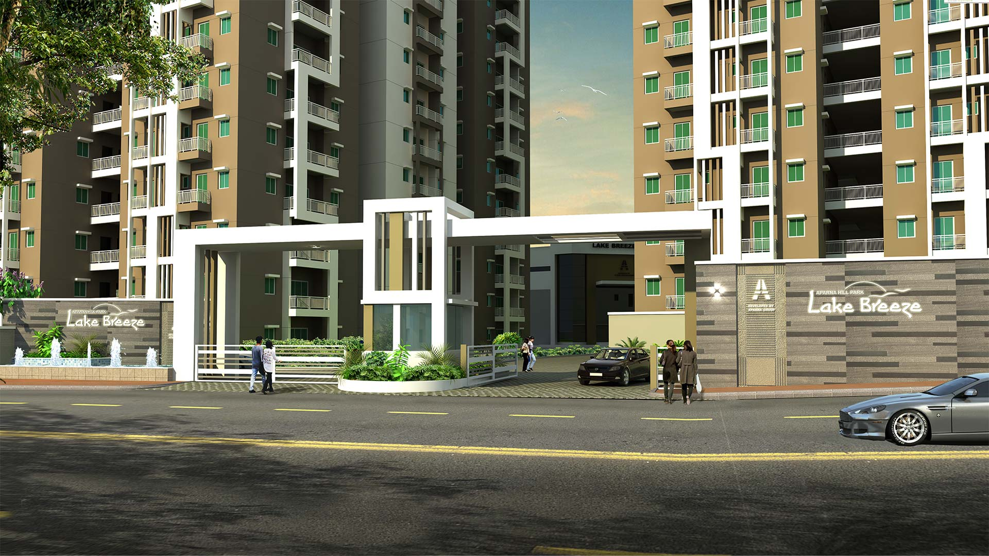

**APARNA HILL PARK LAKE BREEZE.**

**CHANDANAGAR**

**HYDERABAD.**

**From July 2016 – July 2018**

**Index**

**Aparna Lake Breeze Gated Community Fire Safety Report**

1. Fire safety education and training.
2. Procedures.
3. How to report that afire has occurred.
4. Sources of ignition (fire) in gated communities.
5. Status of fire No Objection Certificates.
6. Statistics.
7. Nearest Fire Station and Other Emergency Services

Thisfiresafetyreportcontainsfiresafetyguidelinesandproceduresrelatedto fire safety andstatisticsoffire accidents that occurred in community.

Aparna Lake Breeze Gated Community Fire Safety Report

1. **Fire Safety Education and Trainings:**

Fire safety education and training programs, including fire extinguisher training, are imparted continuously by APMS fire safety staff at Aparna Lake Breeze.

The purpose of the fire and evacuation drills is to prepare building occupants for an organized evacuation in case of a fire or other emergency. In addition to educating occupants of each building about fire safety and evacuation procedures during the drills, the process also provides the Department of Disaster Response/NDRF and Fire Services Department with an opportunity to test the operation of fire alarm and fire safety system components within the community.

As per the guidelines of the National Building Code and Local Telangana government regulations evacuation drills must be conducted in every 3 months where the communities are older than 2 years. The following are guide lines from Telangana Fire safety department to thegated communities:

**To Occupants/ Residents:**

1. All the Escape /exit roots shall not be kept locked or encroached.
2. All Occupants shall be trained to operate fire safety equipment’s during emergency.
3. Mock drills should be conducted once in 3 months for initial 2 years thereafter, once in every 6 months.
4. Raise the alarm if the fire cannot be controlled; evacuate the area by reaching nearest safe exit.

**To Security Personnel:**

1. All security personnel shall be trained to operate the fire safety equipment’s during emergency.
2. Attack the fire using available fire equipment only if you feel of controlling it, if not take all steps to isolate the area by closing the doors and windows.

**Training and drills conducted:**

We have conducted 4 Mock/Evacuation Drills and 4Fire Fightingtrainingprograms in Aparna Lake Breeze.

|  |  |  |  |
| --- | --- | --- | --- |
| Sl.No | Training program | Conducted On | No. of Attendees |
| 1 | Mock Drill | 04th Sep 2016 | 15 |
| 2 | Mock Drill | 21st Jan 2017 | 10 |
| 3 | Mock Drill | 18thMar 2017 | 30 |
| 4 | Mock Drill | 15th July 2017 | 20 |
| 5 | Fire Fighting training for APMS Staff | 29th Oct 2016 |  |
| 1st March 2017 | 70 |
| 27thJune 2017 |
| 26th July 2017 |

Fire Fighting training for APMS Staff

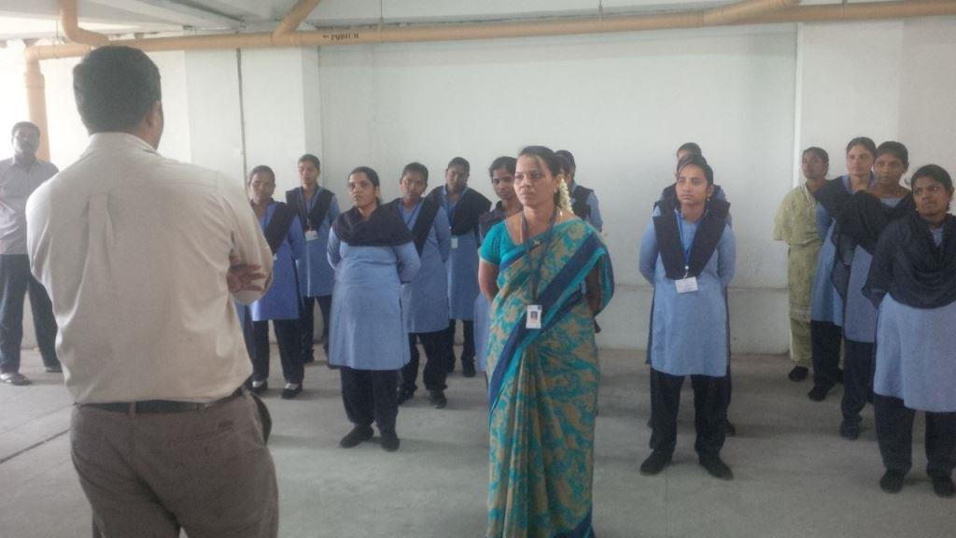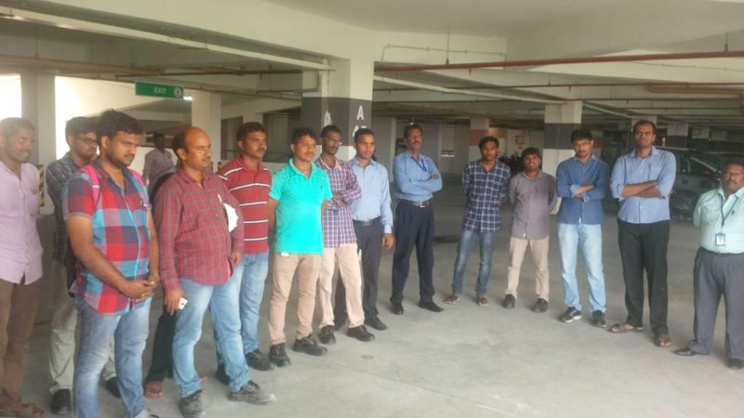

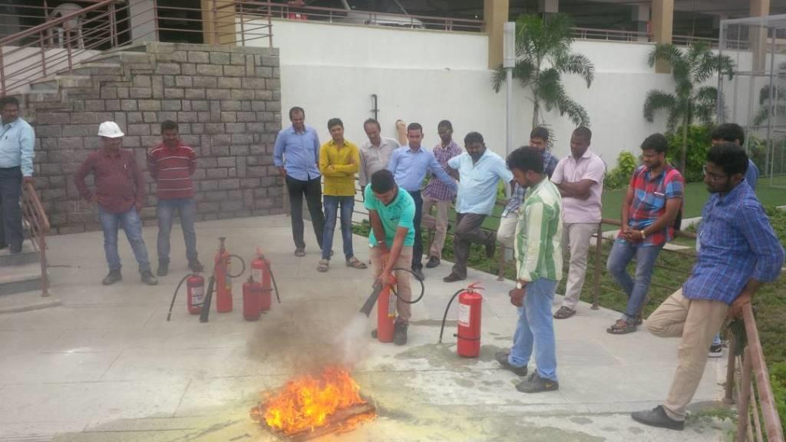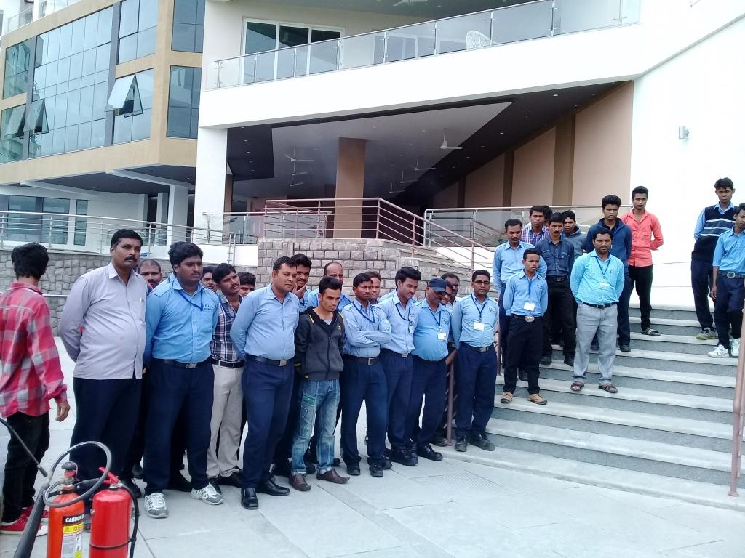

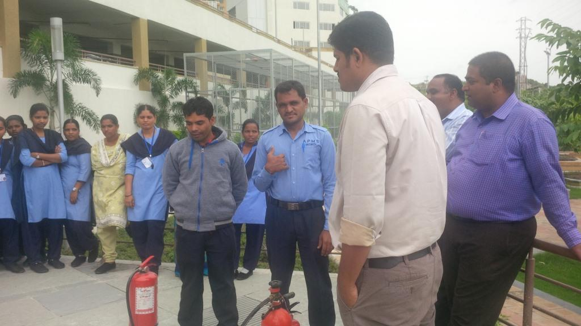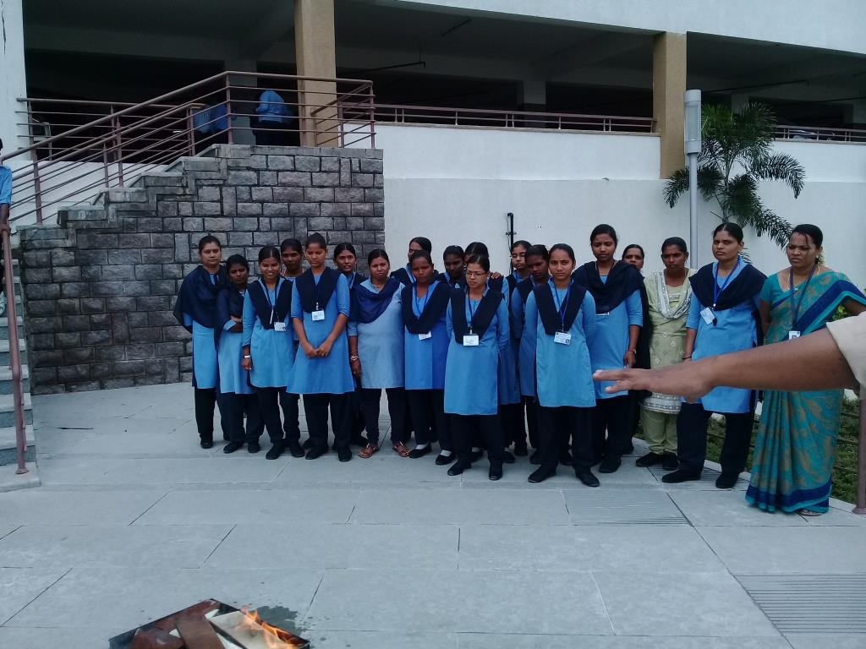

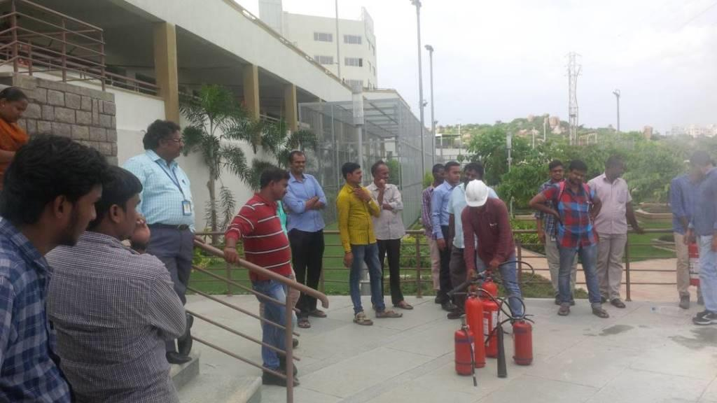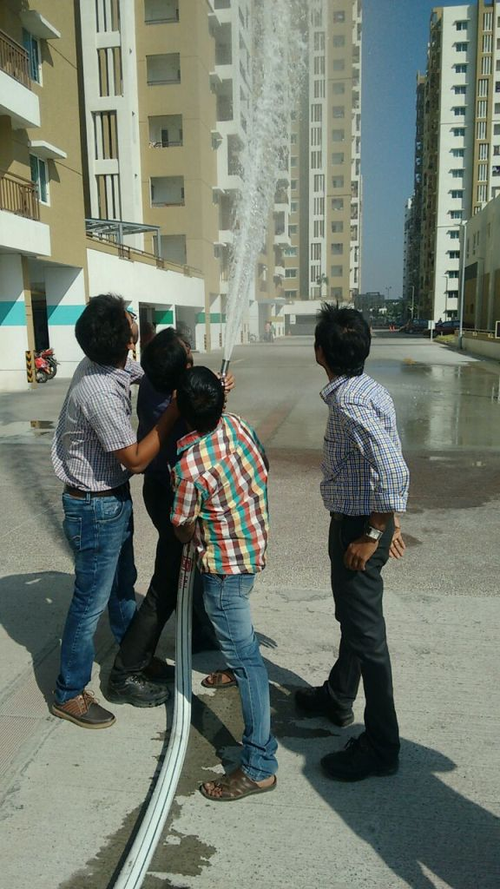

1. **Procedures:**

If a fire occurs, individuals are instructed to activate the fire alarm by breaking the glass of (Manual call point) MCP (A red box with a glass) and, if possible, Call the Telangana Fire safety Department by dialing 101 Or 9010378299.

**OR contact the main gate security to alert the other residents of the same block.**

Once a fire alarm has been sounded, individuals should evacuate immediately using the nearest fire exit door or staircase. Individuals should not use elevators (Lifts) because they may become inoperative due to the fire. If possible, bled persons should assist disabled persons in exiting the building. Disabled persons who cannot use stairs should wait in the staircase until the rescue team arrive OR Telangana Fire safety Department firefighters arrive. Individuals should notify Telangana Fire safety Department fire authorities of the location of any disabled persons remaining in the building. Individuals should also notify Telangana Fire safety Department officers or firefighters if they suspect that someone may be trapped inside.

The fire alarm may not sound continuously. Even if the alarm stops, individuals should continue the evacuation. Warn others who may enter the building after the alarm stops.

Individuals should evacuate to a distance of at least 500 feet from the building and out of the way of emergency personnel. Individuals should not return to the building until instructed to do so by the Public Safety officers or other authorized personnel.

When a fire alarm has been sounded or a fire otherwise reported to the Department of Public Safety, the Department of Public Safety dispatcher will initiate the notification procedures for contacting appropriate personnel.

1. **How to report that a fire has occurred**

Any individual can contact Telangana Fire Safety Department in **101**and inform the same in main gate security to alert the rescue team.

1. **Sources of ignition (fire) in gated communities.**

**Smoking:**

Smoking is prohibited in the community.

**Portable Electrical Appliances used in domestic purpose**

* + Air conditioning units.
  + Open flames, candles (lit or unlit), incense, oil lamps, halogen lamps.
  + Ceiling fans.
  + Combustible engines and materials, including grills and petroleum products.
  + Decorations made of flammable materials (including live Christmas trees and wreaths).
  + Electrical appliances including refrigerators larger than 4.5 cubic feet, microwaves drawing more than 750 watts, personal appliances drawing more than 400 watts.
  + Extension cords that are not are approved.

1. **Status of fire No Objection Certificates.**

|  |  |  |  |  |
| --- | --- | --- | --- | --- |
| Sl.No | Block | Occupancy NOC | Renewal NOC valid  From - To | NOC name changed to ASSOWS |
| 1 | A - Block | Yes | 2017 – 27.01.2022 | No |
| 2 | B – Block | Yes | 2017 – 27.01.2022 | No |
| 3 | C - Block | Yes | 2017 – 27.01.2022 | No |
| 4 | D - Block | Yes | 2017 – 27.01.2022 | No |
| 5 | E - Block | Yes | 2016 – 23.09.2021 | No |
| 6 | F - Block | Yes | 2016 – 23.09.2021 | No |
| 7 | G - Block | Yes | 2016 – 23.09.2021 | No |
| 8 | H - Block | Yes | 2016 – 23.09.2021 | No |
| 9 | I - Block | Yes | 2017 – 27.01.2022 | No |
| 10 | J - Block | Yes | 2017 – 27.01.2022 | No |
| 11 | K - Block | Yes | 2017 – 27.01.2022 | No |
| **Note:-** All Blocks inspection was completed by Telangana Fire Safety Department on  MARCH-2017. | | | | |

1. **Slapsticks :**

* **False Fire Alarms:**

One of the reason is activation of MCP by children playing in corridors and

Damaging the Manual call points (MCP) that activates the fire alarm.

It is noticed with concern that residents do not respond to falls alarms and mock drills. We must stop the practice of not responding to alarms and inculcate the spirit of enquiry in order we respond at the time of REAL EMERGENCY.

Other reason for false alarm is due to system failure and the frequency is controlled by continuous monitoring.

**Note:** Details of false alarm are available with APMS.

1. **Public Addressing System:**

Public addressing in all bocks is in working condition.

1. **Pump house Status:**

All Fire pumps are kept in AUTO Mode to keep them ready to deal with any kind of emergency at any point of time.

Breakdowns/repairs/NOT functioning status of the pumps is reported to the MC and a record is being generated for the same.

1. **Sprinkler System:**

* Sprinkler system is available in cellar and Sub- cellar area.

1. **Fire Accidents:**

* No fire incidents are reported in Lake Breezetill date.

**What the society can immediately do in order to contain more damage in case of fire.**

1. Clear all the corridors/stair case of all the wooden scrap/old belonging/unused electrical gadgets/newspapercontinuously for ANY REASON.
2. Carry out an audit of all the electrical appliances. FAULTY and age old material will flare up electrical fires.
3. Carry out an audit of all the combustible material like wooden panels, curtains, mattress, furniture, upholstery, carpets, stationary and books, shoe racks containing all the synthetic foot ware, interior decoration carried out in children bedrooms with cozy beds/wall stickers, grains/edible oils/snacks/pet jars/bottles and storage boxes in the kitchen and remove all the unused material (MATERIAL NOT USED FOR THE PAST 03 MONTHS).
4. Audit of pooja rooms and the storages like ghee/oils/dhoop/camphor/agarbatti/havan material/straw mats/candles.
5. Display fire awareness promos.
6. Gas cylinders stored in the dwellings.
7. Microwave ovens/grills/OTG/oily exhaust in the kitchen/press iron/BLENDERS.
8. Treadmills/yoga mats/synthetic dumbbells/skipping ropes.

**Nearest Fire Station and Other Emergency Services**

**Nearest Fire Station:**

1. **Madahpur Fire Station - Distance 15.0 KM**

**Contact No: 9849768019.**

Address: Phase 2, HITEC City, Hyderabad,

Telangana -500081.

1. **Film Nagar Fire Station – Distance 16.9 KM**

Contact No: **04023442953, 9963722560**

Address: Film Nagar, DurgaBhawani Nagar,

GianiZail Singh Nagar, Film Nagar,

Hyderabad, Telangana 500039.

1. **Kukatpally Fire Station**:

Contact No**04023155101.**

1. **Bronto Sky Lift Vehicle: Madahpur Fire Station Distance 15.0KM**
2. **HAZMAT Vehicle& Mobile Fire Fighting team:**

Located at Madahpur fire Station to control the small fires and control situation of fire till the fire tender come to the location where the fire accident is taken place

**In the event of fire we should not try to reach the GAS banks to turn it off OR not try to fight the fire if you are not competent enough.**

**Thank you**