Hey Swamy,

I have no idea what you did with trade capacity. If I don’t understand what you did then I don’t expect a new user to understand:

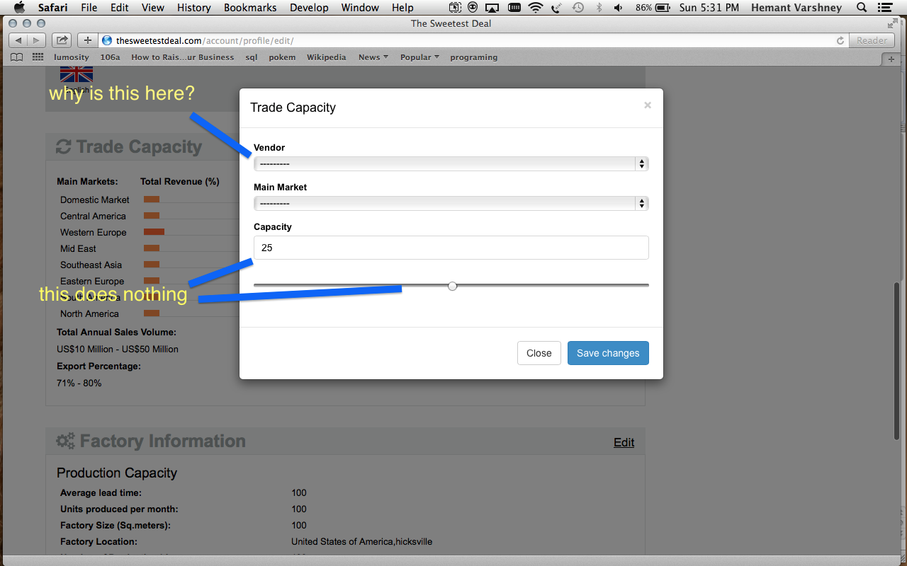

Can you make this simple as can be and change it entering numbers for percentage amount of capacity for main markets. IE:

Domestic Market: 12% - user enters 12% on the pop up screen

Central America : 15% - user enters 15% on the pop screen.

This is simple task and does not require any hard thinking, the user enters what percentage they export.

2. Please remove total annual sales by volume

3. Please remove export percentage.