User messaging from profile page:

Hey Swamy,

Whenever we send a message from the profile page, we get the following error:

“The following usernames are in correct”

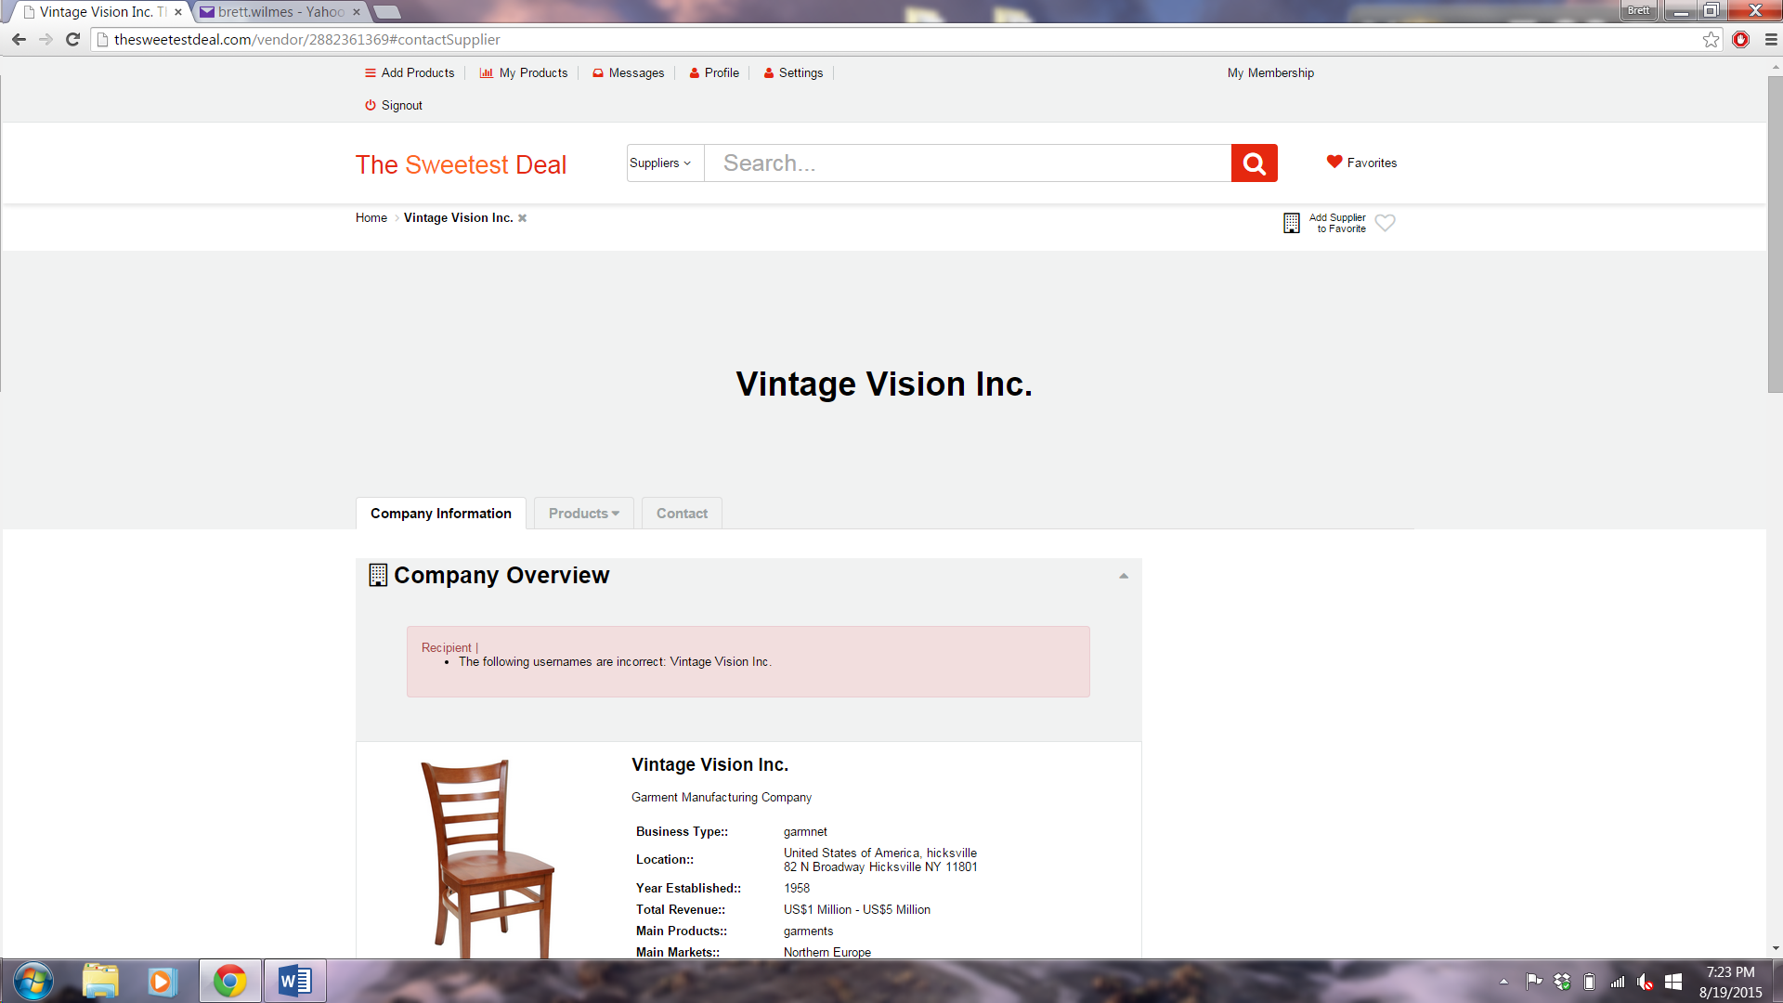

This should not happen. A message should go to the profile of the user.

Whenever we send a message from the product page, the email/message received looks like this:

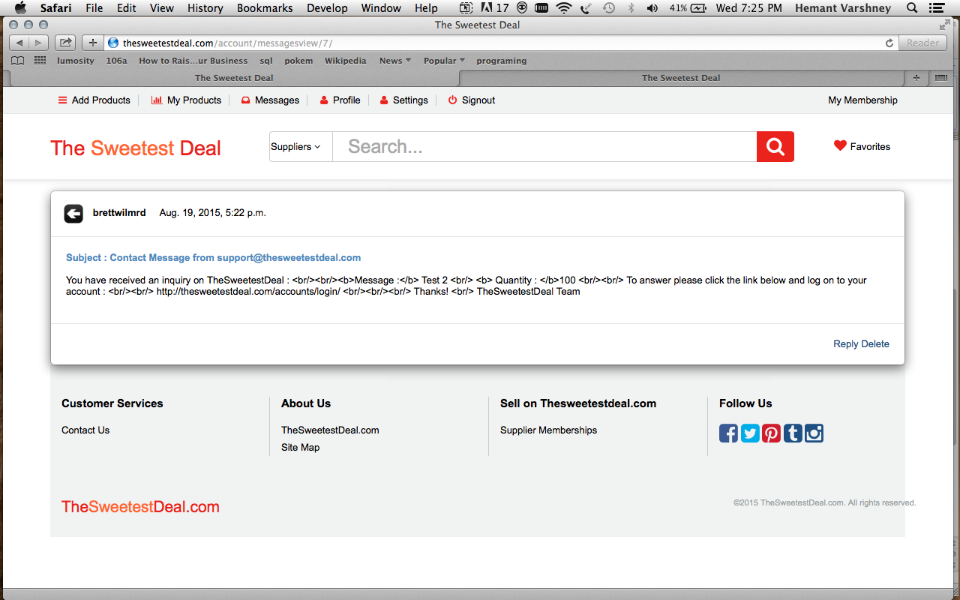

HTML code is displayed when it should not be displayed. Please look into this correct and advise.

Similarly the email received has the same errors:

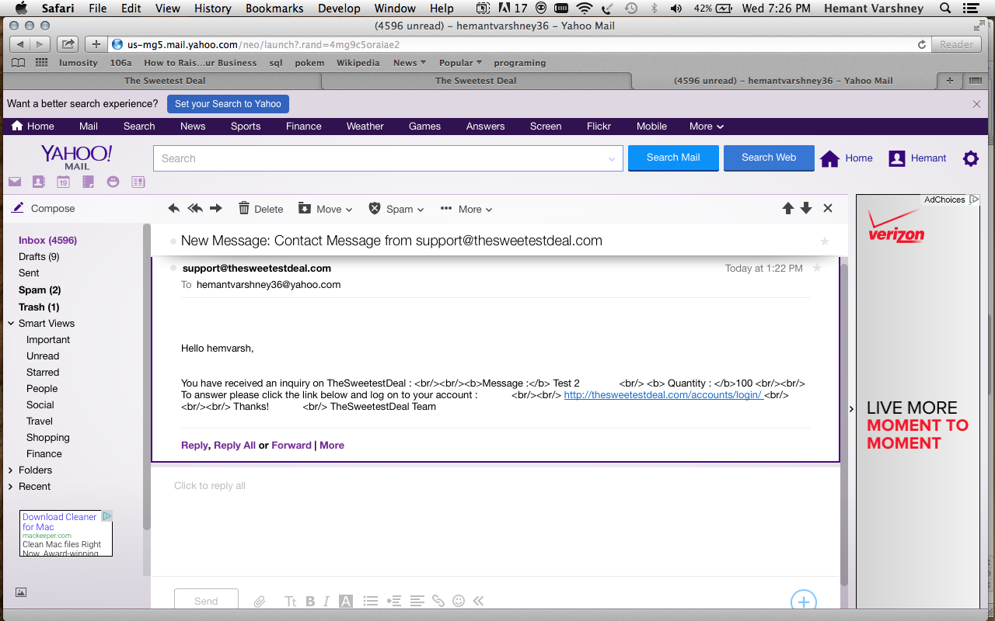

Can you please remove the HTML code displayed and have the information entered in proper format as sent by the recipient?

Thanks!