1. **Product- item specific details**

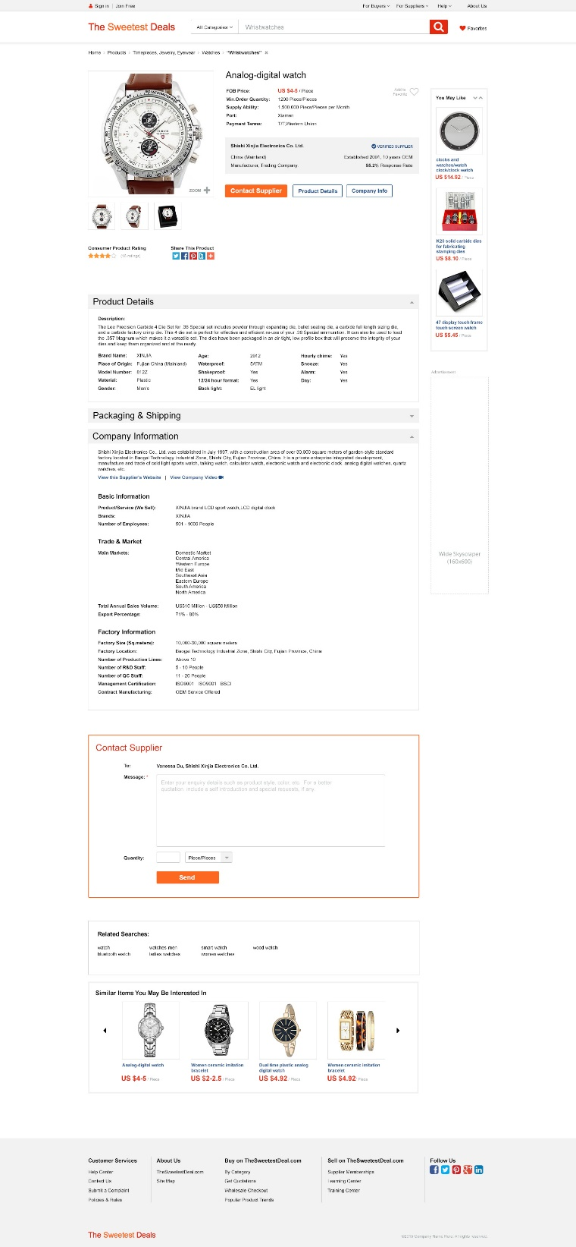design jpeg

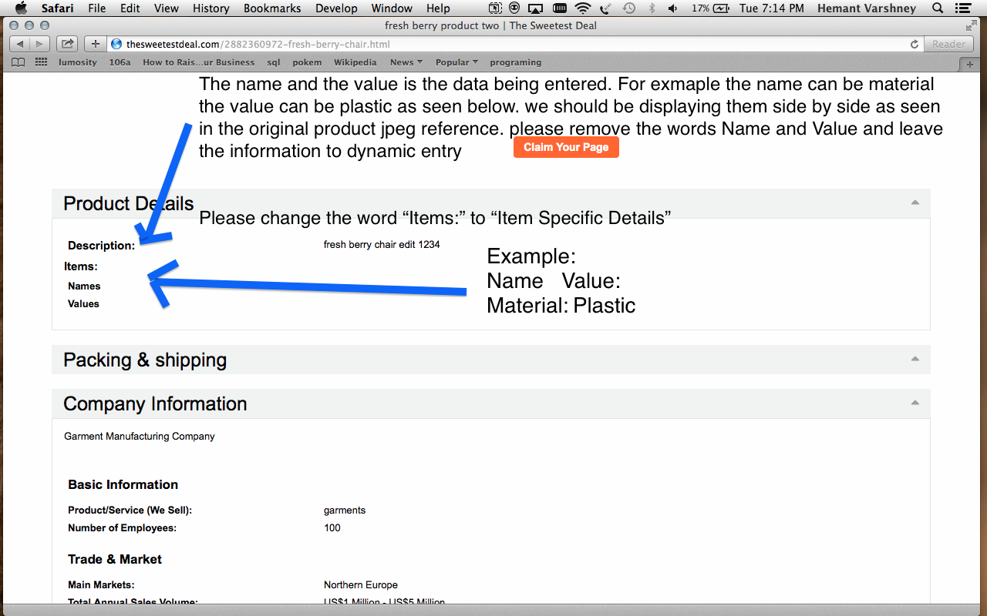

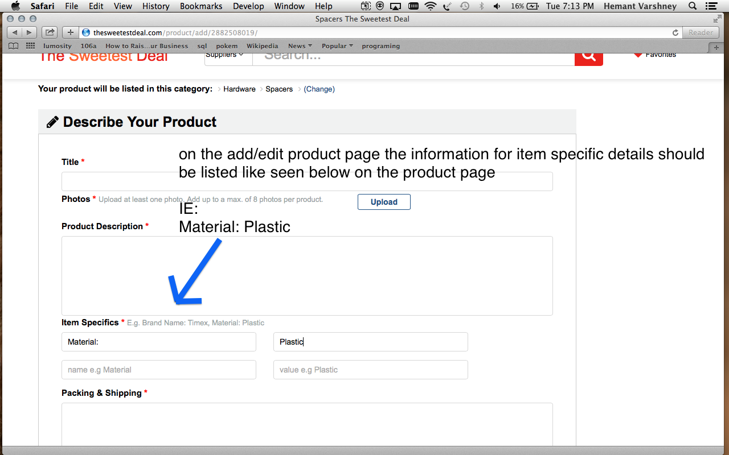

1. My products doesn’t work

Is it possible to have my products populate with the same logic as favorites. For example under the my product page the products are connected to the account just like favorites is? I believe this should speed up the recall as the information is connected to the account. Also the recall is really fast with the products tab under the supplier profile. Why do we not use this same logic for “My Products” ?

--If this is the better way to recall the prodcuts faster instead of having the program search for all products and propagate then adjust accordingly.