- Issue8 of java-diff-utils:
java-diff-utils is a library for comparing texts: computing diffs, applying patches, generating unified diffs,...
Problem: Exception occurs when we try to calculate the difference between two empty list:

Stacktrace:
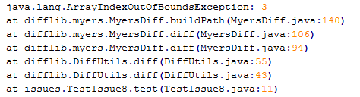
Bug: [see picture below], The exception happens because
middle + 1 > diagonal.length or middle + 1 > size - 1
the bug is in the implementation of myers differencing algorithm at the line 137, the assignment should be
middle = size / 2 instead of middle = (size + 1) / 2
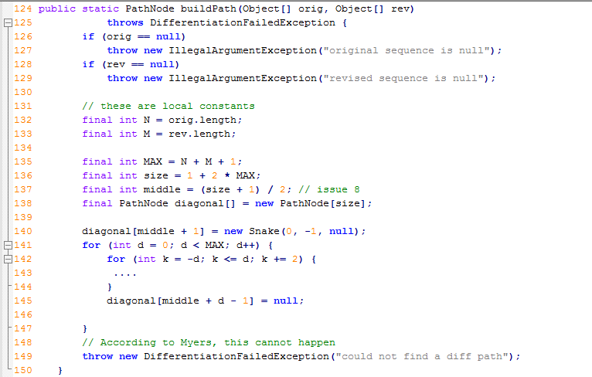

Result from Ziyuan:
[As in the picture below]
This is what we have learned at line 137: size >= 6
That means the there is a bug when size <= 5
Explaination:
From line 135, 136, we can easily see that size >= 1 + 2 * (N + M + 1) = 3
Or size always >= 3
But when the bug happens, we have middle + 1 > size - 1
After executing line 137, we will have:
middle + 1 > size – 1 ⬄ (size + 1)/2 + 1 > size – 1
⬄ size + 3 > 2size – 2 ⬄ size < 5
