Add tzuyu dependency for tzuyuEclipsePlugin

- In ..\trunk\app\tzuyuEclipsePlugin folder, create 2 symbolic link: tzuyuCore and tzuyuLib
Cmd:
..tzuyuEclipsePlugin>mklink /D tzuyuCore [..\trunk\app\tzuyu\target\classes]
..tzuyuEclipsePlugin>mklink /D tzuyuLib [..\trunk\app\tzuyu\lib]
In eclipse, refresh tzuyuEclipsePlugin project, we will have 2 new folder tzuyuCore and tzuyuLib.
- Open plugin.xml of tzuyuEclipsePlugin, open runtime tab, add tzuyuCore and all jars in tzuyuLib into classpath as below:
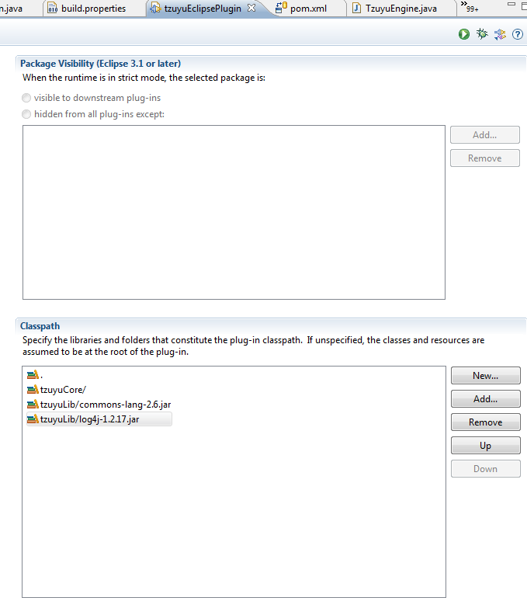
- In oder to easier for development, we add folder tzuyu into Java Build Path of tzuyuEclipsePlugin, and make sure that tzuyu folder is above tzuyuEclipsePlugin/tzuyuCore, so that the classes of tzuyu in tzuyuEclipsePlugin links directly to tzuyu source:
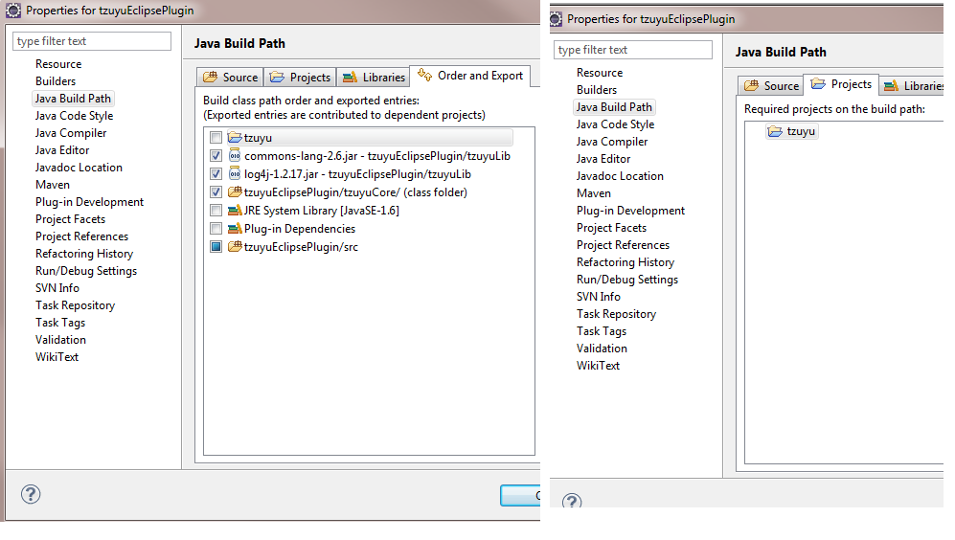
Run mvn clean install, you should have sucessful build
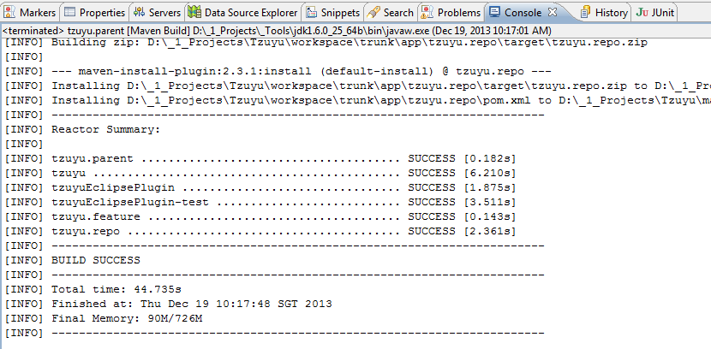

Install plugin
Prequisite: run mvn clean install
In eclipse, select Help/Install New Software
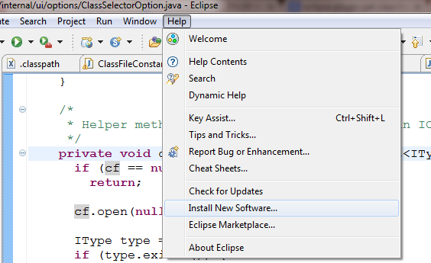
For location, choose tzuyu.repo.zip in ..\trunk\app\tzuyu.repo\target
